Amazon (Clone)

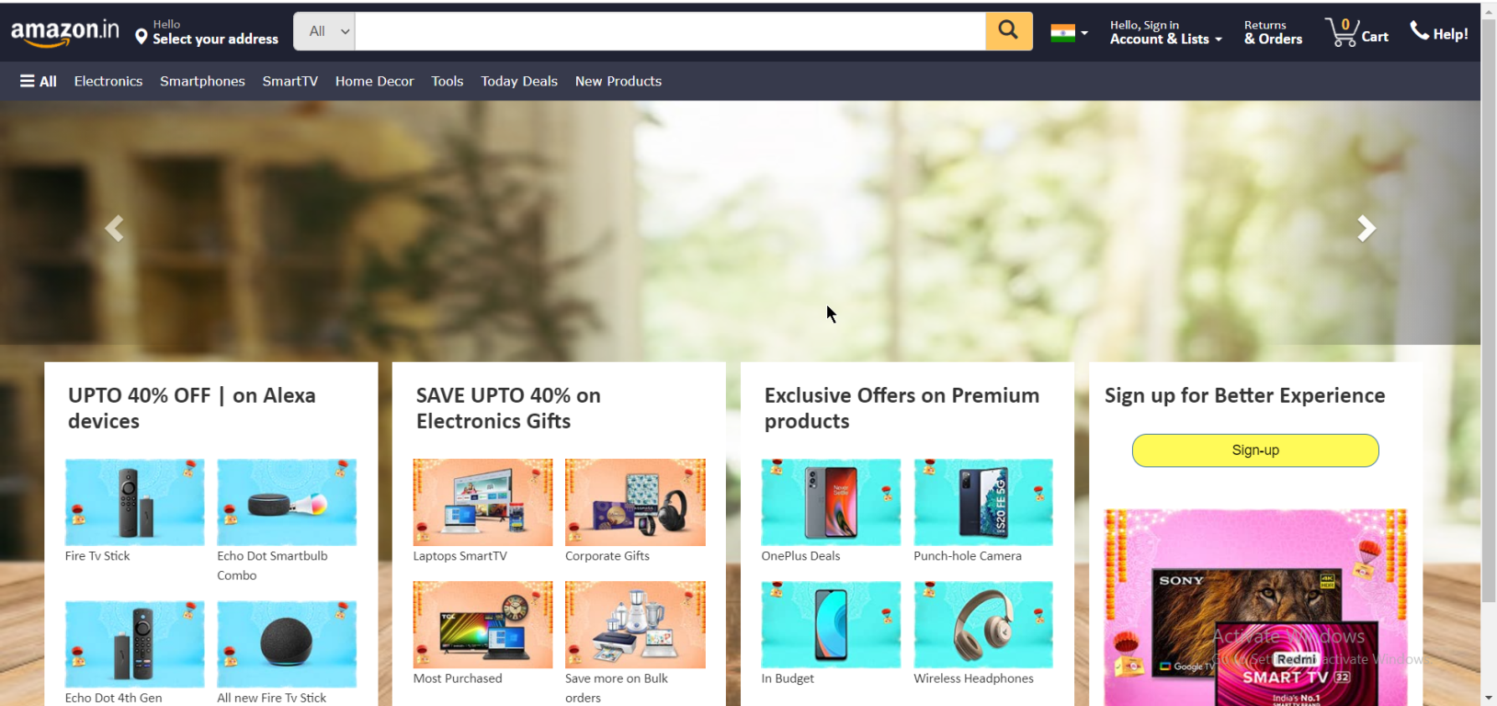

Overview

|  |
| --- |
| Amazon is an online shopping website, shop from wide range of genuine products like Electronics, Smartphones, Laptops, Home Decor, etc. 100% Purchase protection,  User can login to the website using mobile number, email and get products delivered at their doorsteps on time. |

**Website has:** Homepage, Filter page, Listing page, MyAccount, etc.

Technology Used

1. Front End:
   * HTML5
   * CSS
   * Bootstrap 3.4.1
2. Back End:
   * JavaScript
   * NodeJs
   * ExpressJs
   * Mongodb
   * React

**Features**

* User can browse from wide variety of products online
* Login using mobile number, email
* Pay using UPI, Debit/Credit Cards, EMI
* User can Check Order Status Online
* User can Cancel the Order
* Return Order if not described as on product page