International Institute of Information Technology Bangalore
AIT 511 — Machine Learning
Course Project-I
Final Report

Domestic Flight Price Prediction (Regression)
Vehicle Type Classification
Submitted by
Team #12 — Savage
Team member | Roll No.
Swapan Aggarwal | MT2026103
Anshuman Joshi | MT2026009
Vijay Kumar S | MT2026114
Aman Rajput | MT2026006
Teaching Assistant: Akshat Batra
Submitted: 15 October 2026
GitHub: https://github.com/Amanrajput1206/ML-Project-Submission

Contents
1. Introduction
Part A Domestic Flight Price Prediction: A1 Problem and Dataset · A2 EDA · A3 Preprocessing · A4 Models Used · A5 Hyperparameter Tuning · A6 Results and Discussion · A7 Best Model
Part B Vehicle Type Classification: B1 Problem and Dataset · B2 EDA · B3 Preprocessing · B4 Models Used · B5 Hyperparameter Tuning · B6 Results and Discussion · B7 Best Model
2. Key Insights
3. Limitations and Future Work
4. GitHub Repository and Reproducibility
5. Conclusion

1. Introduction
This project has two Kaggle competitions. The first is a regression task: predict the ticket price of a domestic flight. The second is a classification task: predict whether a vehicle is a Sedan, an SUV or a Sports Car from its measurements.
Only models from Part 1 of the course were allowed: linear and polynomial regression, Ridge and Lasso, the Bayes and Naive Bayes classifiers (with LDA/QDA), logistic regression and decision trees with pruning. On 11 October the TA confirmed that tree ensembles (Random Forest, XGBoost) were also allowed, since they are built from decision trees. We did not use SVMs, neural networks or KNN.
Both tasks used the same working method:
- One evaluation routine for every model. 5-fold cross-validation (CV) with a fixed random seed (42), so every model is tested on exactly the same splits.
- No data leakage. Any step that learns from data (medians, scaling, encoders) is fitted inside each CV fold, on the training part only.
- Every experiment logged. Each model's scores are saved to results/<task>/experiments.csv. The tables in this report come straight from those files.
- Models chosen by CV, not by the public leaderboard. The final grade uses the private leaderboard, so the public score was only used as a sanity check.
This report has two parts, one per competition. Each part follows the order asked for in the problem statement: problem and dataset, EDA, preprocessing, models used, hyperparameter tuning, results and discussion, and best model.
Part A — Domestic Flight Price Prediction (Regression)

A1. Problem and Dataset
The goal is to predict the price (in ₹) of a domestic flight ticket from its booking details. This is a supervised regression problem.
Table 1 — Dataset summary.
Item | Train | Test
Rows | 15,589 | 3,898
Columns | 11 features + id + price | 11 features + id
Target | price: ₹3,801 to ₹3,23,177 | (to predict)
Missing values | airline 19.8%, duration 19.9% | about the same rates

Table 2 — Features.
Feature | Type | Description
airline | Category | 19 airlines; about 20% missing
flight | Code | Flight code, e.g. "UK 819" (about 1,070 different codes)
source_city, destination_city | Category | 6 cities each; all 30 routes present
departure_time, arrival_time | Category | 6 time-of-day slots (Early_Morning … Late_Night)
stops | Ordered category | zero / one / two_or_more
flight_class | Category | Economy or Business
duration | Number (hours) | Flight duration; about 20% missing
days_left | Number (days) | Days between booking and departure (1 to 57)

Evaluation metric. Kaggle did not state the metric, so we worked it out from our first (baseline) submission. Its public score was 0.31495. Our CV R² for the same model was 0.289, and the leaderboard ranks higher scores as better, so the metric is R² on the raw price:
R² = 1 − (sum of squared errors) / (sum of squared differences from the mean price)
This matters for every later decision. Maximising R² is the same as minimising squared error in rupees, so the expensive Business tickets dominate the score.

A2. Exploratory Data Analysis (EDA)
Each EDA question was chosen to support a preprocessing or modelling decision. The main findings, from the strongest effect on price to the weakest:

Target distribution
- Price is heavily right-skewed: median ₹10,183 vs mean ₹29,817 (skewness 2.70). Taking the log reduces the skew, but log(price) still has two humps. That means two separate groups of tickets, not just a long tail.
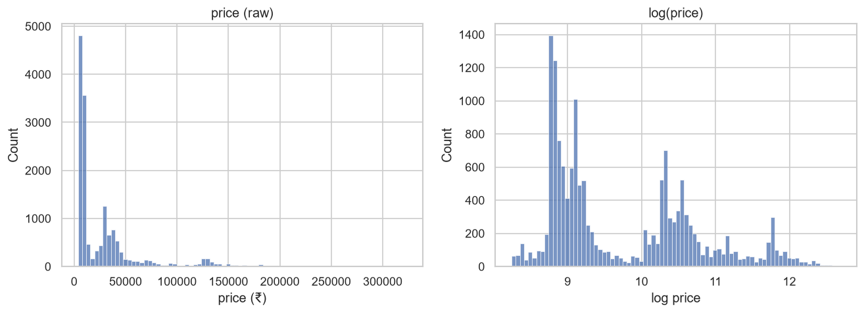
Figure 1 — Price distribution (left) and log(price) (right). The two humps come from the two cabin classes.

Cabin class is the main factor
- The two humps are Economy (median ₹7,587) and Business (median ₹38,546), a 5.1× gap. On its own, class explains R² = 0.78 of log(price).
- Business prices also vary far more (std ₹46k vs ₹4.7k).
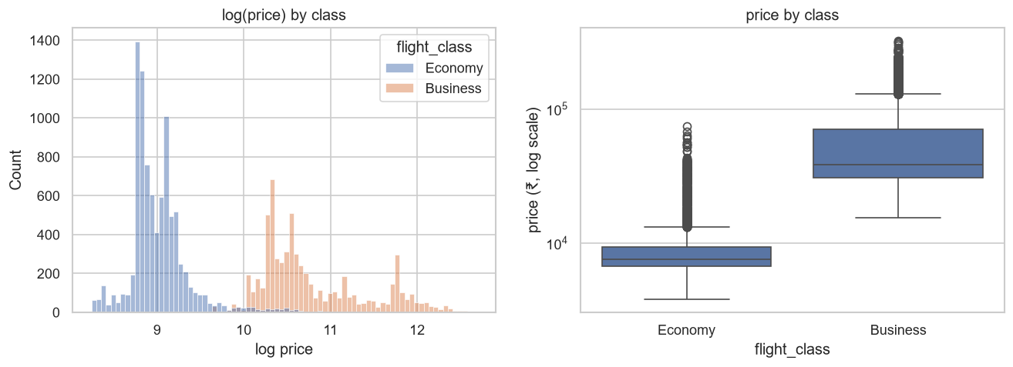
Figure 2 — Price by cabin class. The two classes barely overlap.

Airline matters, but only when compared within the same class
- Within Business, airline explains R² = 0.76 of log(price). Airlines split into budget and premium carriers. Premium Economy tickets cost about as much as budget Business.
- So a plain additive model can't capture this. It needs class × feature interactions. A decision tree can find these splits on its own.
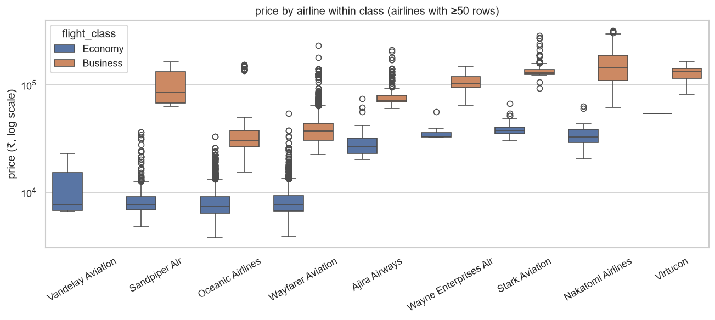
Figure 3 — Price by airline, shown separately for each class.

Other features
- Stops and duration both increase price, and they overlap (more stops means longer flights).
- days_left is weaker than expected. The only clear pattern is a rise in the last ~4 days before departure (+22% Economy, +29% Business). Beyond that the daily medians jump around with no clear trend.
- Routes matter moderately. Departure/arrival time slots barely matter.
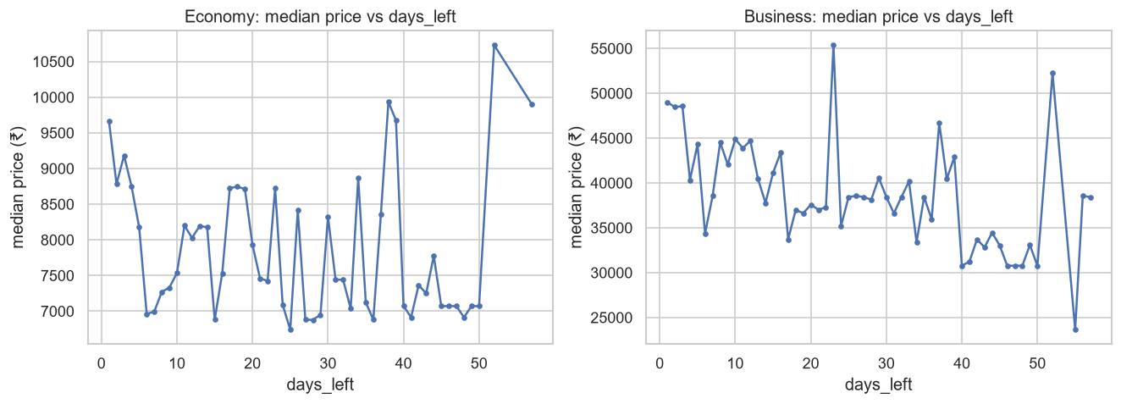
Figure 4 — Median price vs days left before departure. Only the last few days show a clear rise.

Data quality
- airline and duration are each about 20% missing, and they go missing independently of each other and of price.
- airline can be recovered exactly. Every flight-code prefix (e.g. "6E" in "6E 285") belongs to exactly one airline.
- duration can be recovered for about 98% of rows. The same flight on the same route with the same stops has almost the same duration.
- The data has exact duplicate rows (same features and same price). If left in, a copy in the validation fold would "leak" its twin's answer.
- Train and test look alike. Every category's share differs by at most 2.1 percentage points, so CV should predict leaderboard performance well.

A3. Data Preprocessing
Key rule: "once before CV" vs "inside CV". A step can run once on all the data only if it learns nothing from the data, like a fixed lookup. Any step that learns numbers (a median, a mean for scaling, a list of categories) must be re-learned inside each CV fold from the training part only. Otherwise the validation rows influence the model and the CV score is too optimistic (data leakage).
Table 3 — Regression preprocessing steps.
# | Step | Where | Why / evidence
1 | Fill missing airline from the flight-code prefix | Once, before CV | 20 prefixes, each maps to one airline with no conflicts. All 3,089 train and 799 test gaps filled exactly.
2 | Drop exact duplicate rows (after step 1) | Once, before CV | 279 duplicates in the raw data, but 422 after step 1: 143 pairs only showed up once the airline was filled. 15,589 → 15,167 rows. The order of steps matters.
3 | Fill missing duration: median of the same (flight, route, stops) group, then the (route, stops) median | Inside CV | Test: we hid 1,815 known durations and filled them back. 86% came back exactly right, mean error 0.34 h, vs 2.25 h for one overall median.
4 | Scale duration and days_left; stops as 0/1/2; one-hot encode the other categories | Inside CV | Ridge/Lasso penalties need features on the same scale. stops has a natural order.
5 | Group airlines with < 50 rows into one "infrequent" column | Inside CV | Their own coefficients would be noise. This also handles the one airline that appears only in test.
6 | Drop id; ignore unseen categories in test | — | id is just a row number. 35 test rows have flight codes never seen in train.
7 | Add a flight code × class key (one-hot) for Ridge | Inside CV | The same flight number sells Economy and Business at very different prices (see A5).
8 | Floor predictions at the cheapest training price (₹3,801) | Inside CV | Linear models predicted negative prices for some cheap tickets (178 test rows below ₹3,801).
9 | For tree models: integer codes, no scaling | Inside CV | A tree only compares a value with a threshold, so scale does not matter. Integer codes keep the flight key as 1 column instead of ~1,500.

Target transform. We tried training on log(price) and converting predictions back. It lowered CV R² (0.8264 vs 0.8345 for plain OLS) because it systematically under-predicts expensive tickets, and R² on raw price punishes that most. So all final models train on the raw price.

A4. Models Used
We started with a simple baseline and added one idea at a time. Each idea came from an EDA finding. Train R² is shown next to CV R²: a big gap means overfitting (high variance), and two low, close scores mean underfitting (high bias).
Table 4 — All regression models with their best CV R² (5-fold). Public = Kaggle public score, shown only for the models we submitted (—: not submitted). Models were compared by CV because final grading uses the private leaderboard; the public score was used only as a check on the chosen models.
# | Model | CV R² | Train R² | Public
0 | Baseline: median price of the ticket's class | 0.2891 | — | 0.31495
1 | Linear regression (OLS) | 0.8345 | 0.8366 | —
2 | OLS on log(price) | 0.8264 | 0.8275 | —
3 | OLS + class interactions | 0.8805 | 0.8826 | —
4 | Separate OLS per class | 0.8763 | 0.8785 | —
5 | Polynomial features (degree 2) + OLS | 0.9070 | 0.9329 | —
6 | Polynomial (degree 2) + Ridge, α = 10 | 0.9174 | 0.9291 | 0.94450
7 | Lasso on class-interaction features, α = 10 | 0.8804 | 0.8824 | —
8 | Decision tree (fully grown) | 0.8634 | 0.9993 | —
9 | Decision tree (pruned) | 0.9073 | 0.9390 | —
10 | Ridge + flight × class one-hot, α = 3, floored | 0.9262 | 0.9424 | 0.94922
11 | Random Forest | 0.9278 | 0.9628 | —
12 | XGBoost | 0.9271 | 0.9766 | —
13 | Average of Ridge (#10) + Random Forest | 0.9311 | 0.9553 | —
14 | Average of Ridge (#10) + XGBoost | 0.9323 | 0.9646 | —
15 | Average of Ridge (#10) + Random Forest + XGBoost | 0.9325 | 0.9649 | 0.96080

What each model is, and what we saw
- OLS (1). Price = weighted sum of the features, weights chosen by least squares. Train and CV are almost equal, so it underfits. It gives each airline one fixed price shift for both classes, which EDA showed is wrong.
- Log target (2). Lower R² because converting back from log under-predicts the expensive tickets (Business by about −3.5% on average).
- Class interactions (3) / separate model per class (4). Every feature gets a different effect in Economy and Business. This was the biggest single gain in the linear family (+0.046). Models 3 and 4 are the same idea built two ways, and they score about the same.
- Polynomial features (5). All pairwise products of features (about 600 columns), still fitted by least squares. +0.027, but the first clear overfitting appears (train–CV gap 0.026).
- Ridge (6). Least squares plus a penalty α × (sum of squared weights), which shrinks the weights. Same features as model 5, +0.010 CV, smaller gap.
- Lasso (7). The penalty is α × (sum of absolute weights), which sets some weights to exactly zero. At α = 100 it kept 35 of 78 features. It dropped time slots, days_left and stops, the same weak features the EDA found.
- Decision tree (8, 9). Repeatedly splits the data on one feature at a time and predicts the average price in each leaf. Grown fully (8,695 leaves, ~1.7 rows per leaf) it memorises the data: train 0.9993, CV 0.8634. Pruning it to 563 leaves raised CV to 0.9073.
- Ridge + flight key (10). Adding a one-hot of flight code × class (~1,500 columns) gave +0.006. Ridge's penalty keeps a code with only a few rows close to zero.
- Random Forest (11). Many deep trees, each trained on a random sample of the rows, and at each split choosing only from a random subset of features. Their predictions are averaged. Each single tree overfits, but in a different way, so averaging cancels much of the error.
- XGBoost (12). Gradient boosting: small trees are added one after another. Each new tree is fitted to the errors (residuals) left by the trees before it, and only a small step (learning rate 0.02) of its output is added. A single shallow tree underfits; adding many of them reduces that bias.
- Averages (13–15). The plain average of the predictions of different model types. It helps because a linear model and tree models make partly different mistakes.
We also tried CatBoost in a test run (CV 0.922, 6.5 minutes per CV run). It was not better, so we did not keep it.

A5. Hyperparameter Tuning
Approach. Grid search: every setting in the grid is scored with the same 5-fold CV, and the one with the best mean CV R² is kept. Only the best setting of each grid goes into the table above. For the final average we used equal weights, because tuning the weights on the same folds would fit the folds' noise.
Table 5 — Regression hyperparameter search.
Model | Settings explored | Chosen
Polynomial + Ridge | α ∈ {0.1, 1, 10, 100} | α = 10
Lasso | α ∈ {10, 100, 1000} | α = 10 (58 of 78 features kept)
Pruned tree | max_depth ∈ {8, 12, none} × min_samples_leaf ∈ {1, 5, 10, 20} × ccp_alpha ∈ {0, 10⁵, 10⁶} (36 settings) | depth 12, leaf ≥ 5, ccp_alpha 0
Ridge + flight key | α ∈ {1, 3, 10, 30}; validation curve over α from 0.01 to 3,000 | α = 3
Random Forest | max_features ∈ {0.33, 0.5, 1.0} × min_samples_leaf ∈ {1, 2, 3, 5} (12 settings); 300 trees; number of trees checked from 1 to 300 | max_features 0.5, leaf ≥ 3
XGBoost | max_depth ∈ {4, 6, 8} × min_child_weight ∈ {5, 20} (6 settings); 2,000 trees, learning rate 0.02, row sample 0.8, column sample 0.6, L2 penalty 5; number of trees checked from 50 to 2,000 | depth 8, min_child_weight 20
Average | pairs and the triple of Ridge, RF, XGBoost | all three, equal weights

Validation curves. Figure 5 shows the bias–variance trade-off on our own data. Ridge with very large α (3,000) underfits: train and CV are both about 0.83. CV peaks at α = 1–3 (0.926). With very small α the train–CV gap widens (train 0.948, CV 0.913). For the tree, CV peaks at depth 10 (0.899). Deeper trees push train R² towards 1.0 while CV falls to 0.862.
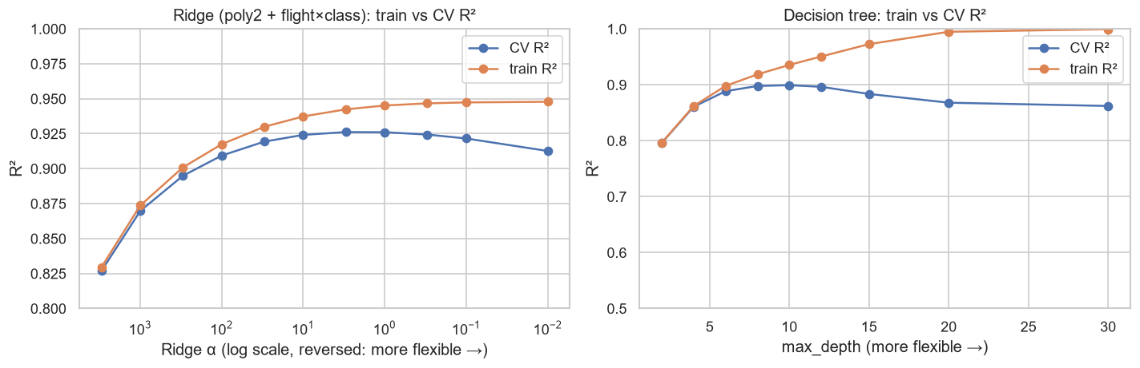
Figure 5 — Validation curves: train vs CV R² for Ridge (α, left; more flexible to the right) and decision tree depth (right).
- Random Forest: CV rose from 0.881 (1 tree) to 0.914 (5), 0.924 (20) and 0.927 (100), then flattened. More trees never made it worse. Random feature subsets helped: max_features 1.0 (plain bagging) scored 0.9249 vs 0.9278 with 0.5.
- XGBoost: 50 trees badly underfit (CV 0.737). CV levelled off at about 0.927 after 1,000 trees, while train R² kept rising. Unlike a forest, boosting can start to overfit with too many trees.

A6. Results and Discussion
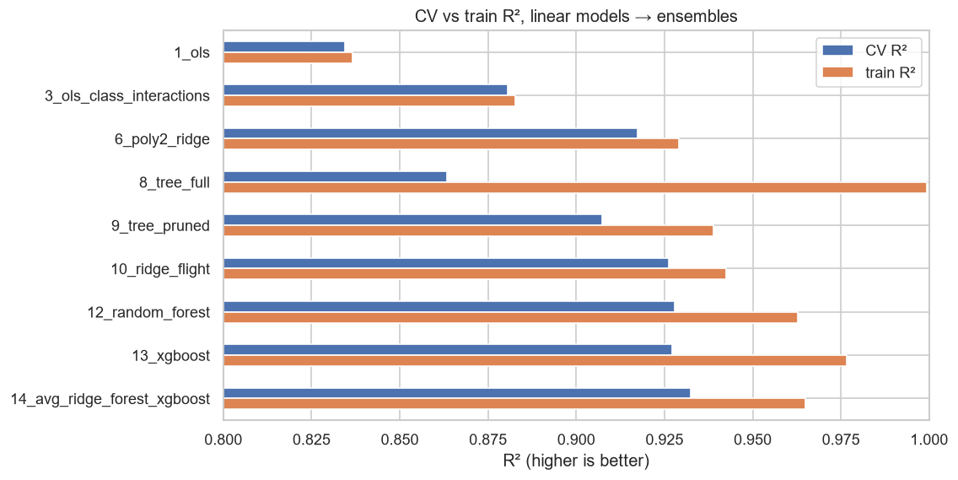
Figure 6 — CV R² of all regression models (with train R² for comparison).
- Interactions carried most of the signal. Class × feature (+0.046), then all pairwise products (+0.027), then the flight code (+0.006). This is what the EDA predicted ("premium Economy ≈ budget Business").
- Complexity control was needed once models became flexible. Ridge beat plain polynomial OLS, and pruning added +0.044 over the full tree.
- Combining model types gave the last gain. Ridge, Random Forest and XGBoost each score about 0.927 alone, and their average reaches 0.9325. The pair whose errors were least alike (Ridge + XGBoost, error correlation 0.85) gained the most. The two tree models (correlation 0.93) gained the least.
- The remaining error is mostly noise. Business tickets cause 94% of the remaining squared error. The worst 1% of rows cause 57% of it. Example: flight EK 567 (Business, same route) appears 17 times with identical features apart from days_left. 11 of those tickets cost exactly ₹130,960, but one costs ₹288,886. No feature explains that, so about 0.93 CV is close to the limit for these features.
- Negative results. Training on log(price) lowered R². days_left bins added only +0.0005, far below the fold-to-fold spread (±0.007), so we did not keep them.
- CV vs public score. Public scores were consistently 0.023–0.028 above CV, for very different models. That is a fixed offset from the public rows, and CV ranked all submissions in the same order as the public leaderboard.

A7. Best Model
Equal-weight average of Ridge (polynomial + flight × class features, α = 3, floored), Random Forest and XGBoost. CV R² 0.9325 (± 0.0027, the most stable across folds), public leaderboard 0.96080.
Table 6 — Regression submissions. The top three are selected for the private leaderboard.
Submission | CV R² | Public
14_avg_ridge_forest_xgboost (best) | 0.9325 | 0.96080
10_ridge_flight | 0.9262 | 0.94922
6_poly2_ridge | 0.9174 | 0.94450
baseline_class_median | 0.2891 | 0.31495

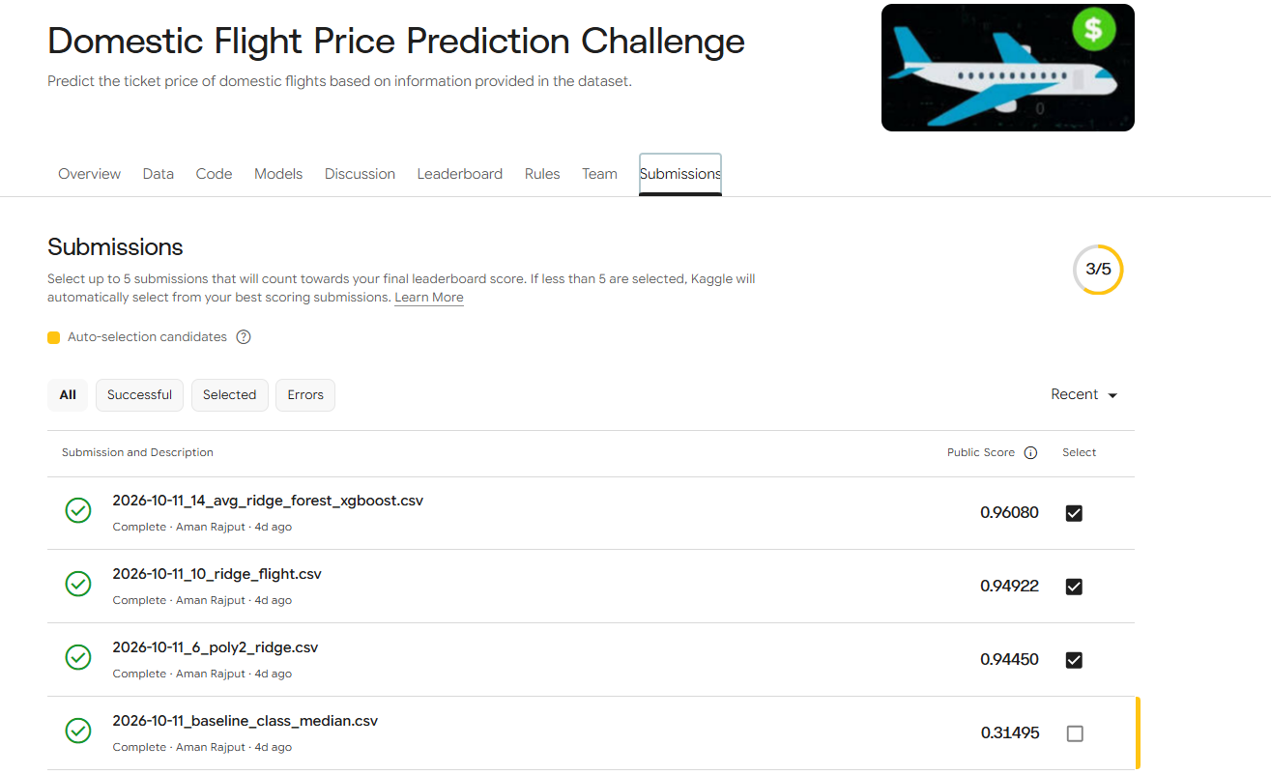
Figure 7 — Kaggle submissions page (regression), with the three selected submissions.
Part B — Vehicle Type Classification

B1. Problem and Dataset
The goal is to classify a vehicle as Sedan (0), SUV (1) or Sports Car (2) from 20 numeric measurements. The metric is accuracy. The competition page warns that the hidden evaluation data may contain extra random measurement noise. So the best model is not just the one with the highest CV accuracy. It must also keep its accuracy when the inputs are noisier.
Table 7 — Classification dataset summary.
Item | Value
Train / test rows | 10,000 / 2,500 (7,500 unique training rows; see B2)
Features | 20 numeric: engine (displacement, horsepower, torque, cylinders), size (weight, length, width, height, wheelbase, fuel tank), performance (acceleration 0–100, braking distance, turning radius), and others (fuel efficiency, ground clearance, cargo, tyre width, drag coefficient, battery capacity)
Classes | Balanced: Sedan 33.9%, SUV 33.2%, Sports Car 32.9%
Missing values | None
Metric | Accuracy

B2. Exploratory Data Analysis (EDA)
- 2,500 exact duplicates. Rows 7501–10000 are copies of earlier rows, with the same features and the same label. We train on the 7,500 unique rows.
- Classes are balanced, so accuracy is a fair metric (chance ≈ 34%). We used stratified folds and no class weights.
- Scales differ hugely (drag coefficient std 0.04 vs weight std 306 kg), so logistic regression needs standardisation.
- No single feature is enough. The best one on its own (braking distance) reaches only 0.69 accuracy, so models must combine many features.
- Features are strongly correlated, even within each class. Two groups stand out: size (weight, length, width, wheelbase, fuel tank; r = 0.90–0.95) and power (displacement, horsepower, torque, tyre width; r = 0.91–0.96). This breaks the Naive Bayes independence assumption.
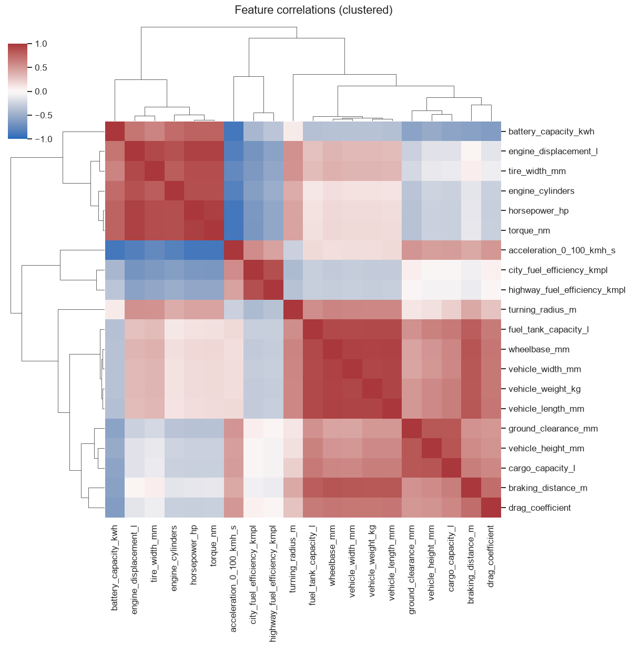
Figure 8 — Correlation between the 20 features. Two blocks stand out: size and power.
- PCA: two directions (size and power) carry 80% of the variance. The classes overlap at their borders, so 100% accuracy is impossible. The boundaries look roughly linear, which favours logistic regression and LDA.
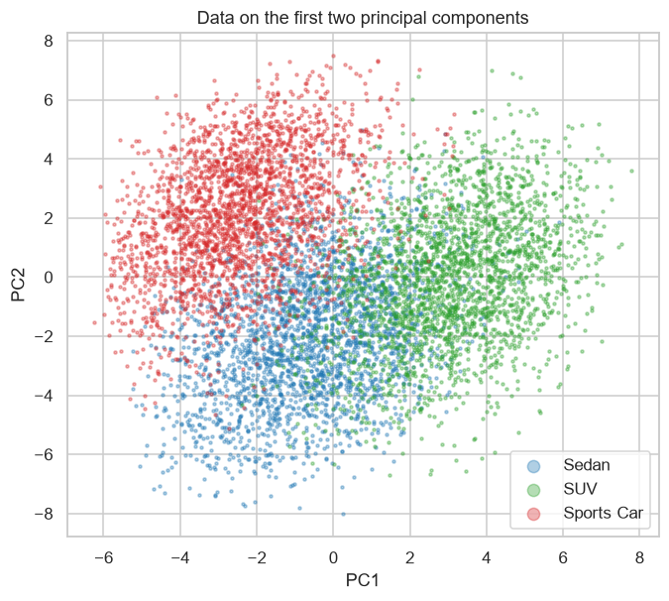
Figure 9 — Data projected onto the first two principal components (size, power), coloured by class.
- Is there noise in the public test? The spreads match train (std ratio 0.98–1.04), so there is no large noise. But some "floor" spikes are partly smoothed out (e.g. 23% of train cars sit at exactly 110 mm ground clearance vs 17% in test). That suggests mild noise. The private set may be noisier.
- Noise preview. Logistic regression lost only 2.1 points with noise k = 0.3, while a full decision tree lost 4.9. So noise changes which model is best, not just the overall level.

B3. Data Preprocessing
This dataset needed little cleaning (no missing values, no categories). We measured why each step matters:
Table 8 — Classification preprocessing steps.
Step | Evidence
Drop the 2,500 duplicates (once, before CV) | With duplicates, about 40% of validation rows had an identical twin in training. CV accuracy was inflated by +7.2 points for the full tree, +4.7 for Random Forest and only +0.2 for logistic regression. The model ranking would flip: Random Forest would look best (0.929) when it is actually 1.2 points behind logistic.
Standardise features (inside each fold, for logistic regression) | Without scaling, logistic regression lost 1.9 points and did not converge. Its penalty judged features by their units: the strongest feature (acceleration) was pushed to almost zero. Trees, Naive Bayes and LDA are not affected by scaling.
Keep clipped values and rounding | Test has the same floors and rounding. The floor is informative: 75% of cars at the 110 mm ground-clearance floor are Sports Cars.

Simulating the noise. To choose a model for the noisy private set, we add Gaussian noise to the validation features only: noisy value = value + k × (feature std) × random N(0, 1). We do this for k = 0, 0.1, 0.2 and 0.3, and every model gets the same noise draws. Our selection score is the average accuracy over these four noise levels, because we don't know the true noise level.

B4. Models Used
Table 9 — All classification models: clean 5-fold CV accuracy, train accuracy, accuracy with noise k = 0.3, and the average over k ∈ {0, 0.1, 0.2, 0.3} (our selection score). Public = Kaggle public score, shown only for the models we submitted (—: not submitted). Models were compared by CV because the public split is only ~1,000 rows (standard error ≈ 0.0095), too small to rank models that differ by < 0.01, and final grading uses the private leaderboard.
# | Model | Clean CV | Train | k = 0.3 | Noise-avg | Public
0 | Majority class | 0.3385 | 0.3385 | 0.3385 | 0.3385 | 0.34800
1 | Gaussian Naive Bayes | 0.8465 | 0.8467 | 0.8417 | 0.8444 | —
2a | LDA | 0.8924 | 0.8943 | 0.8720 | 0.8847 | —
2b | QDA (reg_param 0.1) | 0.8845 | 0.8916 | 0.8592 | 0.8742 | —
3 | Logistic regression, L2 (C = 0.1) | 0.8941 | 0.8960 | 0.8772 | 0.8871 | —
4 | Logistic regression, L1 (C = 1) | 0.8937 | 0.8956 | 0.8728 | 0.8858 | —
5 | Logistic on degree-2 features (C = 0.01) | 0.8893 | 0.8950 | 0.8749 | 0.8835 | —
6a | Decision tree (full) | 0.8241 | 1.0000 | 0.7753 | 0.8044 | —
6b | Decision tree (pruned) | 0.8607 | 0.8908 | 0.8281 | 0.8478 | —
7a | Random Forest | 0.8828 | 1.0000 | 0.8697 | 0.8775 | —
7b | XGBoost | 0.8880 | 0.9087 | 0.8673 | 0.8810 | —
8a | Logistic + noise augmentation | 0.8957 | 0.8963 | 0.8765 | 0.8875 | 0.90000
8b | Noise-aware LDA | 0.8933 | 0.8943 | 0.8772 | 0.8869 | 0.90200
9 | Soft-voting ensemble (3, 8b, 7a, 7b) | 0.8921 | 0.9275 | 0.8759 | 0.8851 | —

What each model is, and what we saw
- Naive Bayes (1). Bayes classifier that assumes the features are independent within each class. Here five size features are correlated at r ≈ 0.9, so it counts "this car is big" about five times. It is 4.6 points behind LDA, with no overfitting: it is limited by its assumption (high bias).
- LDA / QDA (2). Bayes classifier with a full Gaussian covariance, so correlated features are handled properly. LDA shares one covariance across classes (linear boundary). QDA fits one covariance per class (curved boundary). LDA wins (0.8924 vs 0.8845) because all three classes have the same correlation shape, so QDA's extra parameters mostly fit noise.
- Logistic regression (3–5). Models the class probabilities directly with a softmax of linear scores, fitted by maximum likelihood with an L2 or L1 penalty. L2 with C = 0.1 was the best plain model. L1 hurt under noise. It keeps only one feature from each correlated group, so nothing averages out that feature's noise. Degree-2 features did not help, which confirms the boundary is linear.
- Decision trees (6). The full tree memorises (train 1.000) and is the most noise-fragile model: a small shift can send a row across a threshold and down a different branch. Pruning helps, but axis-aligned steps fit a diagonal boundary poorly.
- Random Forest (7a). Averages 500 deep trees, each trained on a random sample of the rows and choosing each split from a random subset of features. A noisy row changes only a few of the 500 votes, so it has the second-flattest noise curve (−1.3 points at k = 0.3).
- XGBoost (7b). Shallow trees (depth 2) added one after another, each one correcting the errors of the trees before it. Better than one tree, but still below the linear models.
- Logistic + noise augmentation (8a). Logistic regression (C = 0.1) trained on the 7,500 rows plus 4 noisy copies of them (k = 0.2). The model learns that a slightly shifted car still has the same class, so it can't rely on very fine boundaries. It works like extra regularisation.
- Noise-aware LDA (8b). If each measurement gets independent extra noise, the spread of every feature within a class grows by the noise's variance. So we use LDA with its covariance increased by that amount: Σ + diag((k · std)²). Only the covariance changes. This raised LDA's accuracy at k = 0.3 from 0.872 to 0.877.
- Soft voting (9). Averages the predicted class probabilities of logistic, noise-aware LDA, Random Forest and XGBoost. It scored below its best members (see B6).

B5. Hyperparameter Tuning
Approach. Grid search with the same 5 stratified folds. The setting with the best noise-averaged accuracy (mean over k = 0, 0.1, 0.2, 0.3) was chosen, not the best clean accuracy.
Table 10 — Classification hyperparameter search.
Model | Settings explored | Chosen
QDA | reg_param ∈ {0, 0.05, 0.1, 0.3} (shrinks each class covariance towards a diagonal one) | 0.1
Logistic L2 | C ∈ {0.001, 0.01, 0.1, 1, 10} (small C = stronger penalty) | C = 0.1
Logistic L1 | C ∈ {0.01, 0.03, 0.1, 1} | C = 1 (keeps all 20 features)
Logistic degree-2 | C ∈ {0.003, 0.01, 0.1} | C = 0.01
Pruned tree | max_depth ∈ {4, 6, 8, 12} × min_samples_leaf ∈ {10, 50} | depth 6, leaf ≥ 10
Random Forest | min_samples_leaf ∈ {1, 5, 20}; 500 trees, √20 features per split | leaf ≥ 1
XGBoost | max_depth ∈ {2, 4}; 600 trees, learning rate 0.03 | depth 2
Noise augmentation | training noise k ∈ {0.1, 0.2, 0.3}; 4 noisy copies | k = 0.2
Noise-aware LDA | assumed noise k ∈ {0.1, 0.2, 0.3} | k = 0.2

- C for logistic regression mainly controlled robustness, not overfitting. C = 1–10 and C = 0.1 had the same clean accuracy (0.894), but C = 0.1 was +0.4 points better at k = 0.3. Smaller weights spread the decision over many correlated features, so noise on any one feature matters less. C = 0.001 shrank the weights too much (0.870, underfitting).
- Models 8a and 8b were insensitive to the assumed noise level. Results for k = 0.1, 0.2 and 0.3 were within 0.001–0.002 of each other. That matters, because we don't know the true noise level.

B6. Results and Discussion
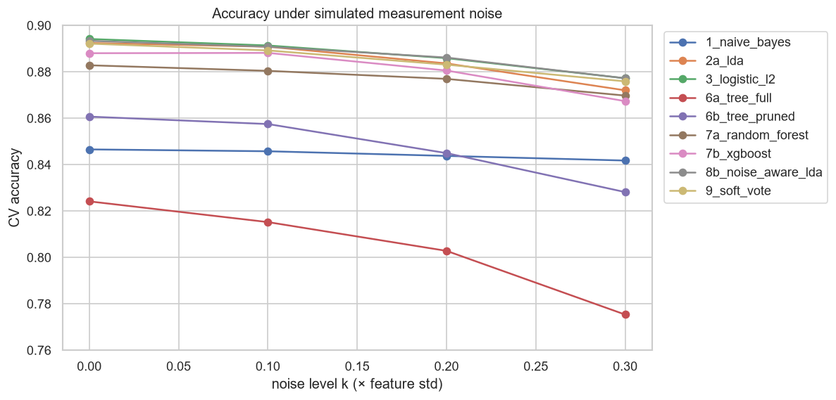
Figure 10 — Accuracy vs noise level k for every model (same noise for every model).
- Three tiers. (1) Linear models (logistic, LDA and their variants): 0.885–0.888. (2) Tree ensembles: 0.878–0.881. (3) Single trees and Naive Bayes: 0.80–0.85.
- Use the correlation, don't ignore it. LDA beats Naive Bayes by 4.6 points with the same Bayes rule. The only difference is that it models the covariance.
- Robustness comes from avoiding fine detail and keeping redundancy. Regularisation, pruning, averaging and noise augmentation all made the noise curves flatter. L1 (dropping redundant features) made them steeper.
- Averaging did not help here, unlike regression. Averaging helps when the members are about equally good and make different mistakes. Here the boundary is linear, so the tree models are weaker and find nothing extra. Adding them only dilutes the best models (0.8851 vs 0.8871).
- Accuracy is capped at about 0.89 because the classes genuinely overlap. 97% of the errors (771 of 794) involve Sedan, which sits between SUV and Sports Car.
- The top three models are tied. 0.8875, 0.8871 and 0.8869 differ by less than a tenth of the fold-to-fold spread (± 0.007), so their exact order doesn't mean much.

B7. Best Model
On the public leaderboard the best model was noise-aware LDA (0.90200), with logistic regression + noise augmentation at 0.90000. The public set is about 1,000 rows, so the difference is 2 rows. The standard error of an accuracy near 0.9 on 1,000 rows is about 0.0095, so the two are tied, just as CV said. By our pre-set rule (noise-averaged CV), logistic + noise augmentation was first (0.8875). Both are selected for the private leaderboard: they are built in different ways (one learns the probabilities directly, the other models the data and applies Bayes), and both were chosen with the private set's extra noise in mind.
Table 11 — Classification submissions. 8a and 8b are selected for the private leaderboard.
Submission | Clean CV | Noise-avg CV | Public
8b_noise_aware_lda | 0.8933 | 0.8869 | 0.90200
8a_logistic_noise_aug | 0.8957 | 0.8875 | 0.90000
0_majority (baseline) | 0.3385 | 0.3385 | 0.34800

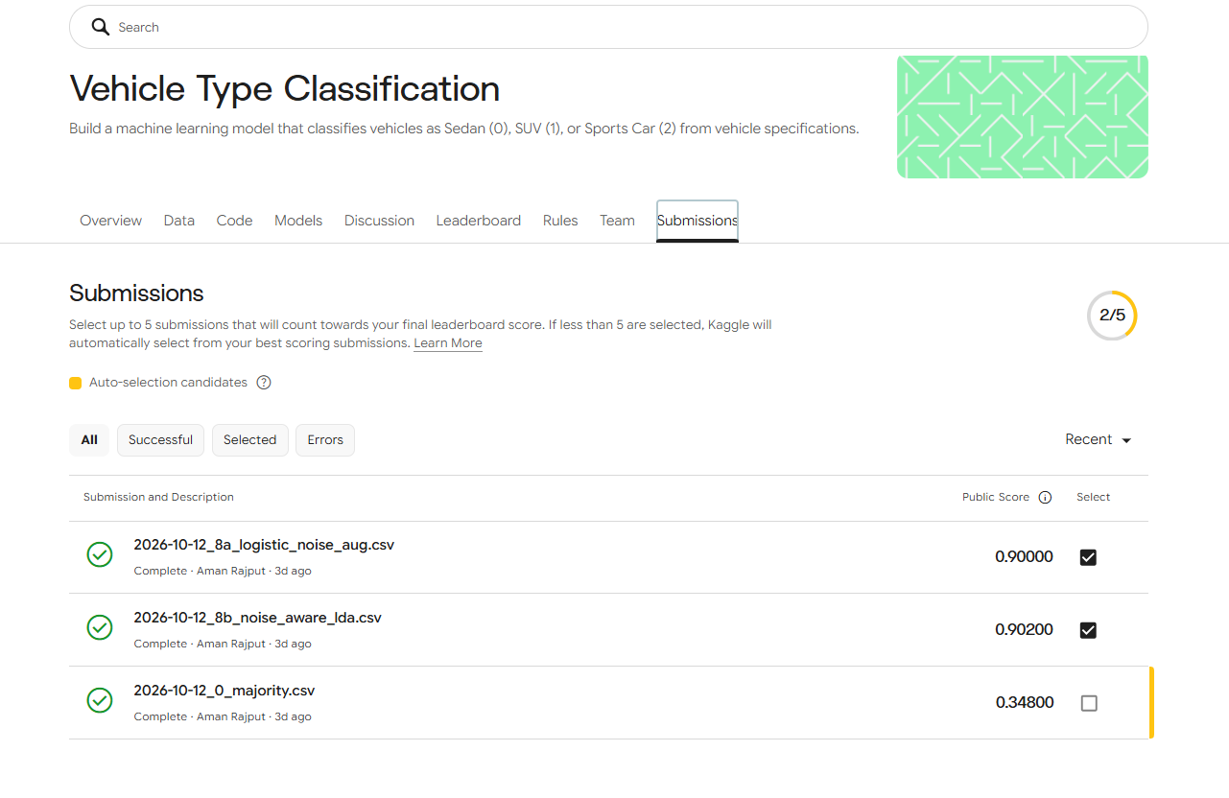
Figure 11 — Kaggle submissions page (classification), with the two selected submissions.

2. Key Insights
- Let the EDA drive the model. In regression, the EDA finding "airline acts differently per class" led to interactions, the largest gains. In classification, "features are correlated within class" explained why LDA ≫ Naive Bayes and why L1 hurts under noise.
- Duplicates must be removed before CV. Otherwise CV rewards memorising models, and in classification it would have ranked the models in the wrong order.
- Know the metric. R² on raw price made us reject the log-target model, which would otherwise look like the natural choice.
- Bias–variance in practice. Every time a model became flexible enough to overfit (polynomial features, deep trees), controlling complexity (Ridge, pruning, averaging) gave the next gain.
- Combining models helps only when they make different mistakes. It gave the best regression model, but did nothing for classification, where the linear models were already best.
- Choose for the test conditions, not the clean score. Simulated noise in CV let us choose classification models for a noisy private set we can't see.

3. Limitations and Future Work
- Regression: about 1% of rows are price spikes that the features can't explain, so about 0.93 CV R² is near the limit. More booking information (e.g. seats left) would be needed to go further.
- Classification: the true noise level of the private set is unknown. We guarded against it by averaging over k = 0–0.3, but if the noise is larger, all models will lose accuracy.
- Small differences: several top models are tied within fold-to-fold noise, so their exact order is not reliable.
- Possible next steps: repeated CV with different seeds to tighten the comparisons. In regression, a simple model just for Business tickets.

4. GitHub Repository and Reproducibility
Repository: https://github.com/Amanrajput1206/ML-Project-Submission
- notebooks/ — the full story, one notebook per phase: regression/01_eda → 05_ensembles and classification/01_eda → 03_models. Each step has a short heading, and its key results are noted below the output.
- src/ — shared code: data loading and preprocessing (preprocess.py), custom models (models.py), and one CV routine used by every model (evaluate.py).
- results/ — experiments.csv (every model's scores) and all figures.
- submissions/ — every file submitted to Kaggle.
Reproducibility: one random seed (42) is used everywhere: CV splits, trees, forests, boosting and the simulated noise. Running the notebooks in order (see the README) reproduces every number in this report and recreates the exact files submitted to Kaggle.

5. Conclusion
For flight price prediction, the best model is an equal-weight average of Ridge regression (with polynomial and flight × class features), Random Forest and XGBoost: CV R² 0.9325, public score 0.96080. Most of the gains came from letting features interact, then from controlling complexity, and finally from combining a linear model with tree models.
For vehicle type classification, the boundary between classes is essentially linear and the features are strongly correlated. The best models are logistic regression trained with noise augmentation and noise-aware LDA: noise-averaged CV about 0.887, public scores 0.900 and 0.902. We chose them for accuracy that holds up under the extra measurement noise of the private set, not just for their clean score.

