

**SYNOPSIS**

**ON**

**E-Commerce Website**

Submitted By: Submitted To:

Vishesh Parihar 2115001134 Mr. Sachin Barpande

Aman Singh 2115000134

**Title of the Project: E-Commerce Website**

**Objective:**

### Manage Online Selling Costs In A Strategic Way

When you start selling online, the investment cost of starting and operating a business goes down. However, with Builderfly, you can begin your business absolutely free at zero cost investment. By establishing an eCommerce store, you literally need no physical presence of your store and save on several fixed expenses – rent, hiring, stock maintenance, and more. To manage your eCommerce business effectively, all you need is Builderfly’s one-stop management dashboard that will allow you to do so. And by having Builderfly in your corner, you get to start an eCommerce store with zero investment. And you get access to several in-house tools to run your marketing campaigns and grow your business online. Get started with Builderfly and increase traffic to your online store for free!

1.1 INTDUCTION TO WEB DEVLOPMENT

Web development is the work involved in developing a website for the Internet (World Wide Web) or an intranet (a private network). Web development can range from developing a simple single static page of plain text to complex web applications, electronic businesses, and social network services. A more comprehensive list of tasks to which Web development commonly refers, may include Web engineering, Web design, Web content development, client liaison, client-side/server-side scripting, Web server and network security configuration, and e-commerce development. In a simpler way it Web development refers to the building, creating, and maintaining of websites. It includes aspects such as web design, web publishing, web programming, and database management. It is the creation of an application that works over the internet i.e., websites.

The word Web Development is made up of two words, that is:

* + - **Web:** It refers to websites, web pages or anything that works over the internet.
    - **Development:** Building the application from scratch.

**Frontend Development:** The part of a website that the user interacts directly is termed as front end. It is also referred to as the ‘client side’ of the application.

In a nutshell, Front-End Web Development, also called client-side development, refers to writing HTML, CSS and JavaScript code for a website or web application so that users can see and interact directly with them. It is important to know the basic differences between Front-End development, Back-End development, and Full-Stack deve Front-End developer works on the aspects of an application or a website that users get to see and interact with whereas a Back-End developer handles the behind-the-scenes aspects of the application or website, saying the infrastructure and databases. On the other hand, a Full- Stack developer does both, so it’s someone who deals with the whole designing and functional process of an application or a website from start to finish. There are some websites and web applications that only need Front-End development.

For an instance, a single page information website, however, anything functional generally needs Back-End development. Anything that provides data from a server comes under Back- End Development. The Front-End renders the web page with styling, whereas the Back end is the code on the server, and its job is to communicate with the database.

There are several tools and platforms, such as WordPress, Joomla, and Drupal, available that can be used to develop the front end of a website.

* + 1. **HYPER TEXT MARKUP LANGUAGE (HTML)**

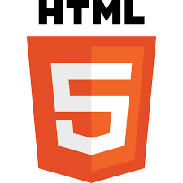

Hyper Text Markup Language (HTML) is the backbone of any website development process, without which a web page does not exist. Hypertext means that text has links, termed hyperlinks, embedded in it. When a user clicks on a word or a phrase that has a hyperlink, it will bring another web-page. A markup language indicates text can be turned into images, tables, links, and other representations. It is the HTML code that provides an overall framework of how the site will look. HTML was developed by Tim Berners-Lee. The latest version of HTML is called HTML5 and was published on October 28, 2014 by the W3C recommendation. This version contains new and efficient ways of handling elements such as video and audio files.

* + 1. **CASCADING STYLE SHEETS (CSS)**

Cascading Style Sheets (CSS) controls the presentation aspect of the site and allows your site to have its own unique look. It does this by maintaining style sheets that sit on top of other style rules and are triggered based on other inputs, such as device screen size and resolution.

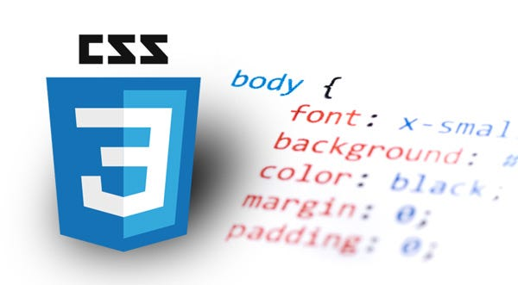

The CSS can be added externally, internally, or embedded in the HTML tags.

* + 1. **JAVASCRIPT (JS)**

JavaScript is an event-based imperative programming language (as opposed to HTML's declarative language model) that is used to transform a static HTML page into a

dynamic interface. JavaScript code can use the Document Object Model (DOM), provided by the HTML standard, to manipulate a web page in response to events, like user input.



Using a technique called AJAX, JavaScript code can also actively retrieve content from the web (independent of the original HTML page retrieval), and react to server-side events as well, adding a truly dynamic nature to the web page experience.

# AIM FOR DEVELOPMENT

The developer of the front end keeps these points in mind, utilizing available tools and techniques to reach this end.

# ACCESSIBILTY

With continuing development for mobile devices, such as smart phones and tablets, designers need to ensure that their site comes up correctly in browsers on all devices. This can be done by creating a responsive web design using stylesheets in CSS.

# PERFORMANCE

Performance goals are chiefly concerned with render time, manipulating the HTML, CSS, JavaScript and React Js to ensure that the site opens quickly.