YUVA INTERN
Logistics Data Analyst Internship
WEEK 3 REPORT
Advanced Data Analysis and Visualization in Logistics
Prepared by: Aman Tiwari

1. Introduction
Week 3 focuses on exploratory data analysis and visualization of logistics data using Python. The objective is to move from a cleaned dataset to meaningful operational insights by studying distributions, central tendencies, group-level performance, relationships among variables, correlations and time-based trends. The analysis uses the cleaned Week 2 logistics dataset so the four-week project follows one continuous workflow.
The dataset is illustrative/simulated and contains shipment-level information including delivery date, region, vehicle type, traffic level, distance, shipment volume, promised delivery time, actual delivery time, transportation cost, on-time status and delay status.

2. Objectives
- Perform systematic exploratory data analysis (EDA).
- Calculate descriptive statistics and logistics KPIs.
- Analyze distributions and central tendencies.
- Compare delivery performance across regions and vehicle types.
- Study relationships between distance, delivery time and transportation cost.
- Use correlation analysis to identify numerical relationships.
- Create visualizations that support logistics interpretation and decision-making.
- Document analytical findings and practical recommendations.

3. Dataset Overview
The cleaned dataset contains 500 unique shipment records and 12 fields. The data covers delivery dates and operational attributes required to examine service performance and cost patterns. Because this is a simulated dataset, the findings should be interpreted as an analytical demonstration rather than real company performance.
Variable | Type | Analytical role
delivery_date | Date | Time trend analysis
region | Categorical | Regional comparison
vehicle_type | Categorical | Vehicle performance comparison
traffic_level | Categorical | Operational condition
distance_km | Numeric | Distance and route relationship
shipment_volume | Numeric | Shipment-load analysis
promised_time_hours | Numeric | Service commitment
delivery_time_hours | Numeric | Primary delivery performance metric
transportation_cost | Numeric | Cost analysis
on_time / delayed | Binary | Service-level KPIs

4. Exploratory Data Analysis Methodology
The analysis follows a structured EDA sequence: inspect the dataset, calculate descriptive statistics, calculate key performance indicators, examine distributions, compare groups, study numerical relationships, analyze correlations, and inspect monthly trends. Python libraries pandas and matplotlib are used for analysis and visualization.

5. Key KPI Results
KPI | Result
On-Time Delivery Rate | 28.60%
Delay Rate | 71.40%
Average Delivery Time | 8.22 hours
Average Transportation Cost | 797.83
Average Distance | 224.26 km
Average Shipment Volume | 10.17

6. Descriptive Statistics
Descriptive statistics summarize the center and spread of numerical logistics variables. Mean, standard deviation, minimum, quartiles and maximum help explain typical operating levels and variation.
Variable | Mean | Std Dev | Min | Max
distance_km | 224.26 | 128.06 | 4.40 | 449.60
shipment_volume | 10.17 | 5.51 | 1.00 | 19.00
promised_time_hours | 7.50 | 2.65 | 2.33 | 12.72
delivery_time_hours | 8.22 | 3.24 | 0.80 | 16.33
transportation_cost | 797.83 | 304.67 | 136.96 | 1517.38

7. Visualization 1 – Delivery Time Distribution
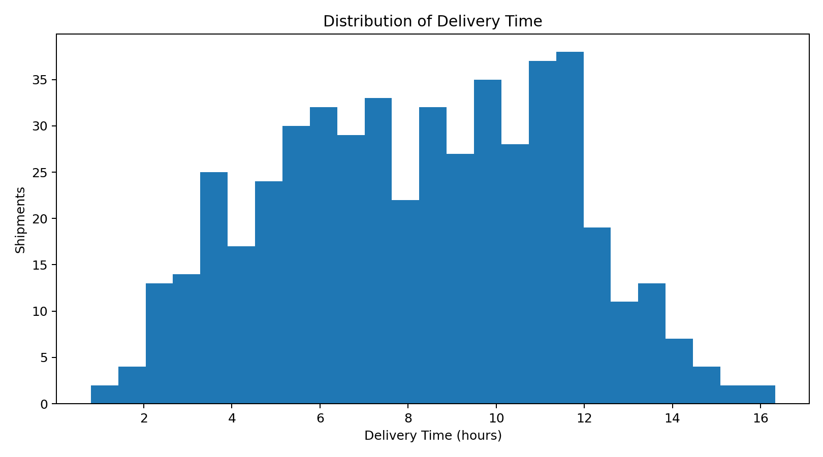
A histogram is appropriate for a continuous variable. It shows the typical delivery-time range, spread and unusual observations, helping assess service consistency.

8. Visualization 2 – Delivery Time by Vehicle Type
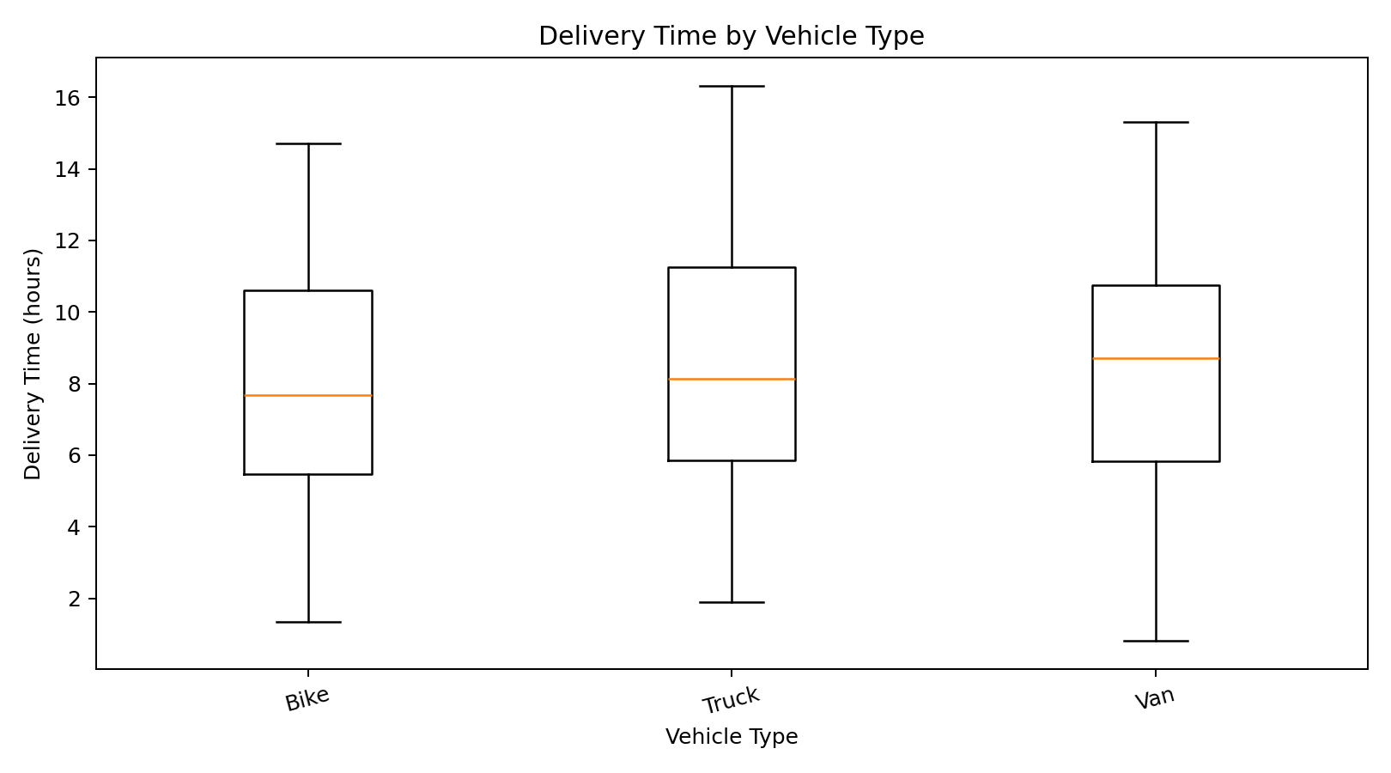
A box plot compares median, spread and extreme delivery-time observations across vehicle categories.

9. Visualization 3 – On-Time Delivery by Region
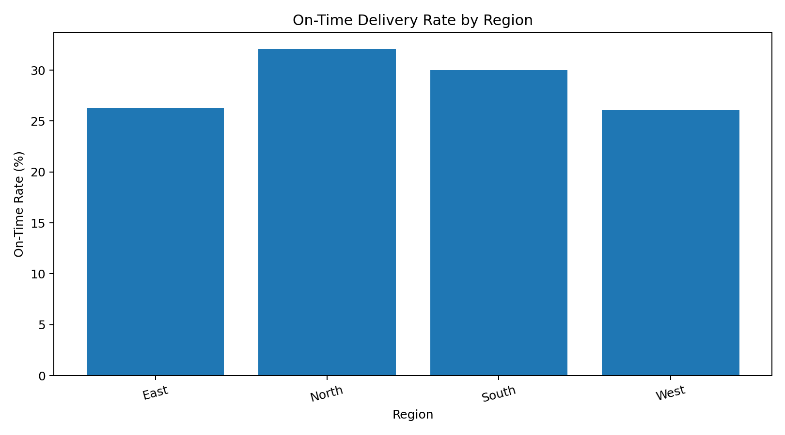
A regional bar chart makes service-level differences easy to compare and can highlight areas for deeper operational investigation.

10. Visualization 4 – Distance vs Delivery Time
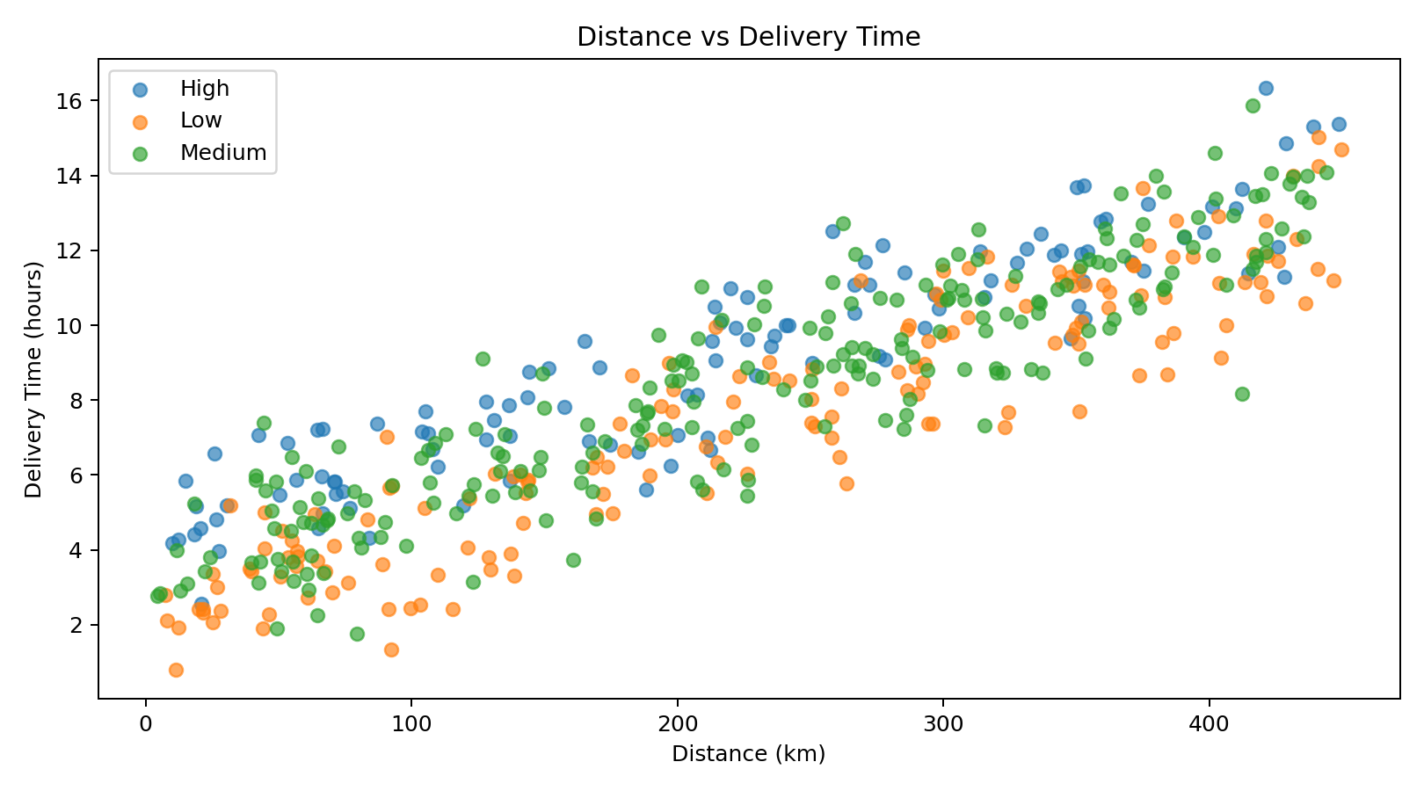
A scatter plot examines the relationship between route distance and delivery time while using traffic level as an additional category. This is descriptive and does not establish causation.

11. Visualization 5 – Distance vs Transportation Cost
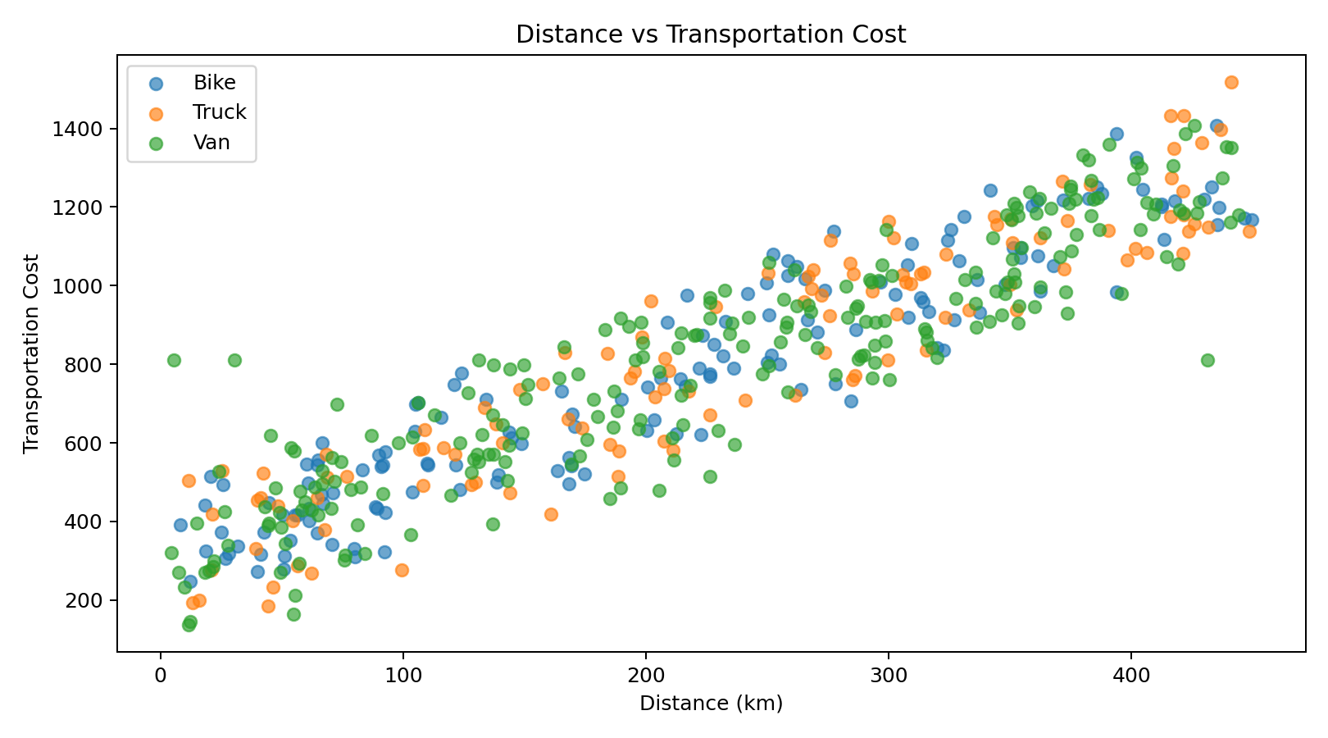
This scatter plot examines distance as a potential cost-related variable and separates observations by vehicle type.

12. Visualization 6 – Correlation Heatmap
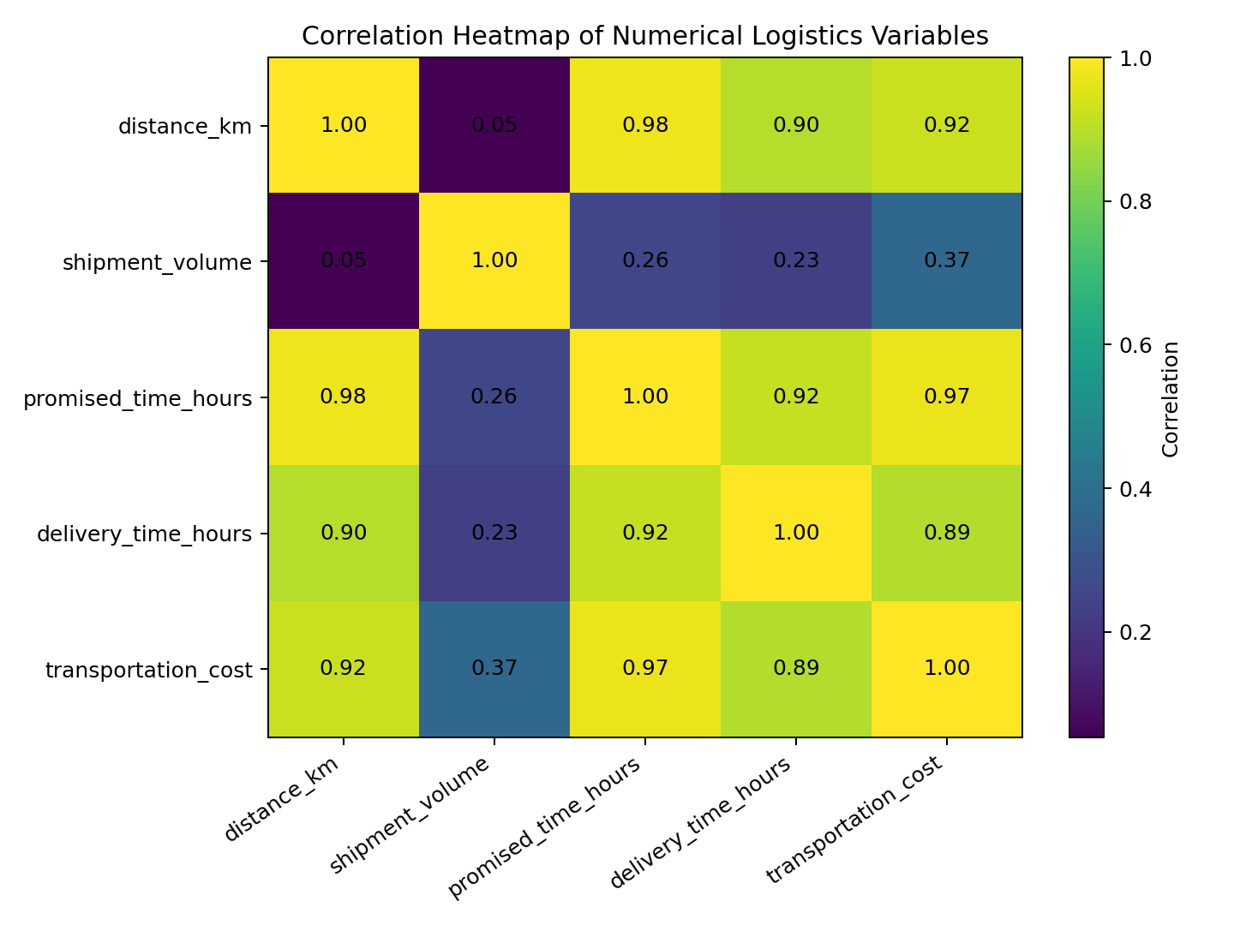
The heatmap summarizes pairwise linear correlation among numerical variables. Correlation supports feature understanding but does not establish causation.

13. Visualization 7 – Monthly Delivery Trend
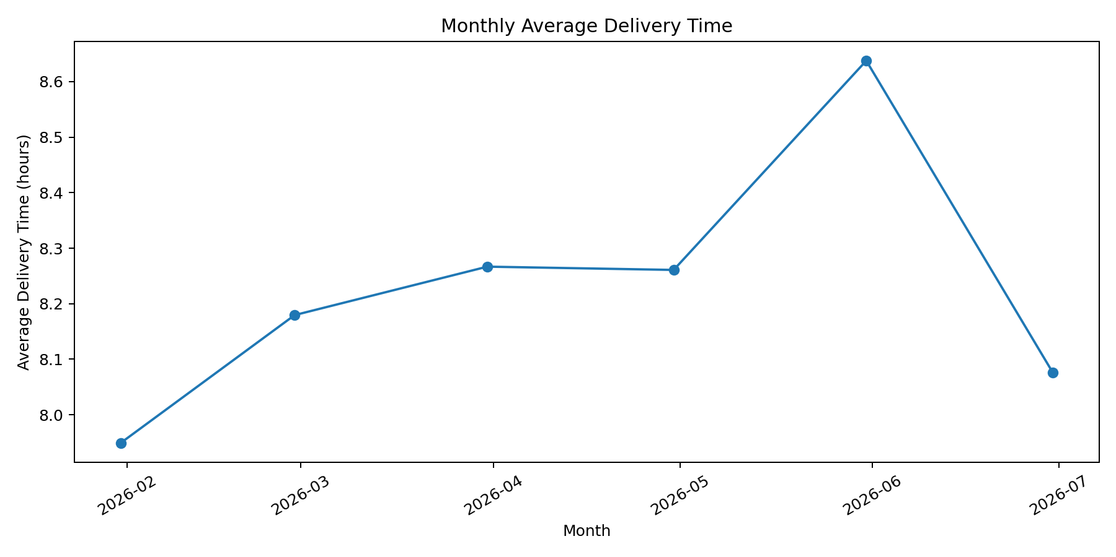
The line chart adds a time dimension and helps identify months with different average delivery-time patterns.

14. Regional Analysis
Region | Shipments | Avg Delivery | Avg Cost | On-Time %
East | 137 | 8.15 | 796.75 | 26.28
North | 134 | 7.92 | 780.37 | 32.09
South | 110 | 8.11 | 778.10 | 30.00
West | 119 | 8.72 | 836.95 | 26.05

15. Vehicle Analysis
Vehicle | Shipments | Avg Delivery | Avg Cost | On-Time %
Bike | 152 | 7.87 | 767.17 | 30.92
Truck | 116 | 8.44 | 822.69 | 31.90
Van | 232 | 8.33 | 805.48 | 25.43

16. Analytical Insights
- The overall on-time delivery rate is 28.60% and the delay rate is 71.40% in the simulated dataset.
- Distance and delivery time have a correlation of 0.896, showing the strength and direction of their linear association in this dataset.
- Distance and transportation cost have a correlation of 0.923, providing a descriptive view of distance as a cost-related variable.
- Delivery time and transportation cost have a correlation of 0.891; this relationship can be explored further using predictive modeling.
- Regional and vehicle-level summaries show how aggregated KPIs can reveal operational differences that may be hidden in overall averages.
- The monthly trend provides a time dimension that can be used for further operational investigation and future forecasting.

17. Practical Recommendations
- Use regional KPI comparisons to prioritize deeper operational investigation in areas with weaker service metrics.
- Track delivery time by vehicle type to identify categories that may need route, capacity or scheduling review.
- Use distance and traffic-related variables as candidate features in future delivery-time prediction models.
- Monitor transportation cost alongside distance and shipment volume to understand cost patterns.
- Continue using the standardized preprocessing pipeline so future analyses receive consistent data.
- Validate these descriptive patterns with real operational data before making business decisions.

18. Python Code Excerpt
df = pd.read_csv("logistics_data_cleaned.csv")
df["delivery_date"] = pd.to_datetime(df["delivery_date"])
print(df.describe())
plt.hist(df["delivery_time_hours"].dropna(), bins=25)
plt.title("Distribution of Delivery Time")
plt.show()
corr = df[[
"distance_km", "shipment_volume",
"promised_time_hours", "delivery_time_hours",
"transportation_cost"
]].corr()
plt.imshow(corr.values, aspect="auto")
plt.colorbar()
plt.show()

19. Limitations
- The dataset is simulated and should not be interpreted as actual company performance.
- The analysis is descriptive and does not establish causal relationships.
- The dataset size and variables are limited compared with a production logistics system.
- Additional variables such as weather, driver availability, route restrictions and warehouse processing time could improve future analysis.

20. Conclusion
Week 3 demonstrates how cleaned logistics data can be transformed into useful analytical evidence through EDA and visualization. Distribution analysis, KPI comparisons, correlation analysis, scatter plots and time trends provide different perspectives on delivery performance and cost behavior. These outputs create the analytical foundation for Week 4, where predictive modeling and optimization can be applied.

21. Submission Files
- YuvaIntern_Week3_Logistics_EDA_Visualization.py
- logistics_data_cleaned.csv
- descriptive_statistics.csv
- correlation_matrix.csv
- regional_kpi_summary.csv
- vehicle_kpi_summary.csv
- monthly_logistics_summary.csv
- charts/ (7 visualization images)
- README.md

