Yuva Intern – Week 4 Report
Predictive Modeling and Optimization in Logistics Systems
Prepared by: Aman Tiwari
Logistics Data Analyst Internship
Yuva Intern

1. Introduction
Week 4 focuses on applying predictive modeling and optimization techniques to a logistics problem. The selected problem is delivery-time prediction because delivery time is a directly useful operational metric: it can support planning, exception management, route decisions, and customer-service monitoring. The analysis continues the cleaned dataset used in Weeks 2 and 3.
The dataset is simulated and illustrative. Therefore, the model results demonstrate the analytical workflow rather than representing actual company performance or guaranteed operational savings.

2. Problem Definition
Prediction problem: estimate actual delivery_time_hours for a shipment using operational and contextual features available before or around the delivery process.
- Target variable: delivery_time_hours
- Prediction type: supervised regression
- Unit of target: hours
- Business purpose: support delivery planning, identify potentially slow shipments, and provide inputs for route and scheduling decisions.

3. Dataset and Features
The model uses 500 shipment records from the cleaned Week 3 dataset. The selected features combine categorical, numerical, and calendar information.
- region – shipment operating region
- vehicle_type – vehicle category
- traffic_level – traffic condition
- distance_km – shipment distance
- shipment_volume – shipment volume
- promised_time_hours – promised delivery duration
- transportation_cost – transportation cost
- day_of_week – derived weekday index
- month – derived calendar month
- is_weekend – derived weekend indicator
- delivery_time_hours – prediction target

4. Data Preparation and Feature Engineering
The delivery date is converted to a date field and used to derive day_of_week, month, and a weekend indicator. Categorical variables are one-hot encoded so that regression and ensemble models can process them. Numerical missing values are handled with median imputation and categorical missing values with the most frequent category.
The data is split into 80% training and 20% testing using a fixed random state of 42. A preprocessing pipeline is used so that transformations are learned from the training data and applied consistently to test data.

5. Model Selection
Three regression models are compared. Linear Regression provides a simple baseline and is easy to interpret. Random Forest Regressor captures non-linear relationships and interactions through an ensemble of decision trees. Gradient Boosting Regressor builds an ensemble sequentially and can model complex relationships while often performing strongly on structured tabular data.
- Linear Regression: baseline model for approximately linear relationships.
- Random Forest Regressor: non-linear ensemble model that can capture interactions.
- Gradient Boosting Regressor: sequential ensemble model suited to structured regression data.

6. Model Training and Evaluation
The models are trained on the training partition and evaluated on the held-out test partition. Three metrics are used: MAE, RMSE, and R². MAE represents average absolute prediction error in hours. RMSE gives greater weight to larger errors. R² measures the proportion of variance explained by the model relative to a mean-based baseline.
Model | MAE | RMSE | R²
Linear Regression | 0.9594 | 1.2282 | 0.8788
Random Forest | 0.9900 | 1.2806 | 0.8683
Gradient Boosting | 1.0074 | 1.2901 | 0.8663
Based on the held-out test-set RMSE, the model selected for the next validation and tuning stage is Linear Regression. The selection is based on the evaluation metric rather than assuming a particular algorithm is always superior.
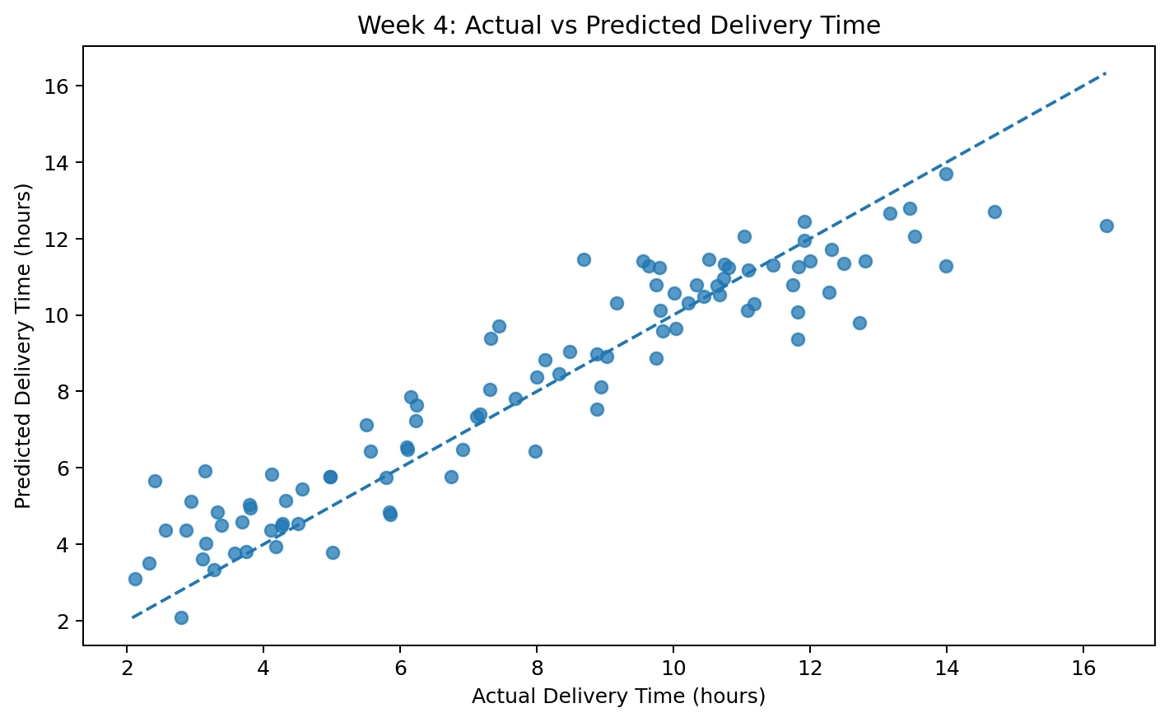
Figure 1. Actual versus predicted delivery time for the tuned model.
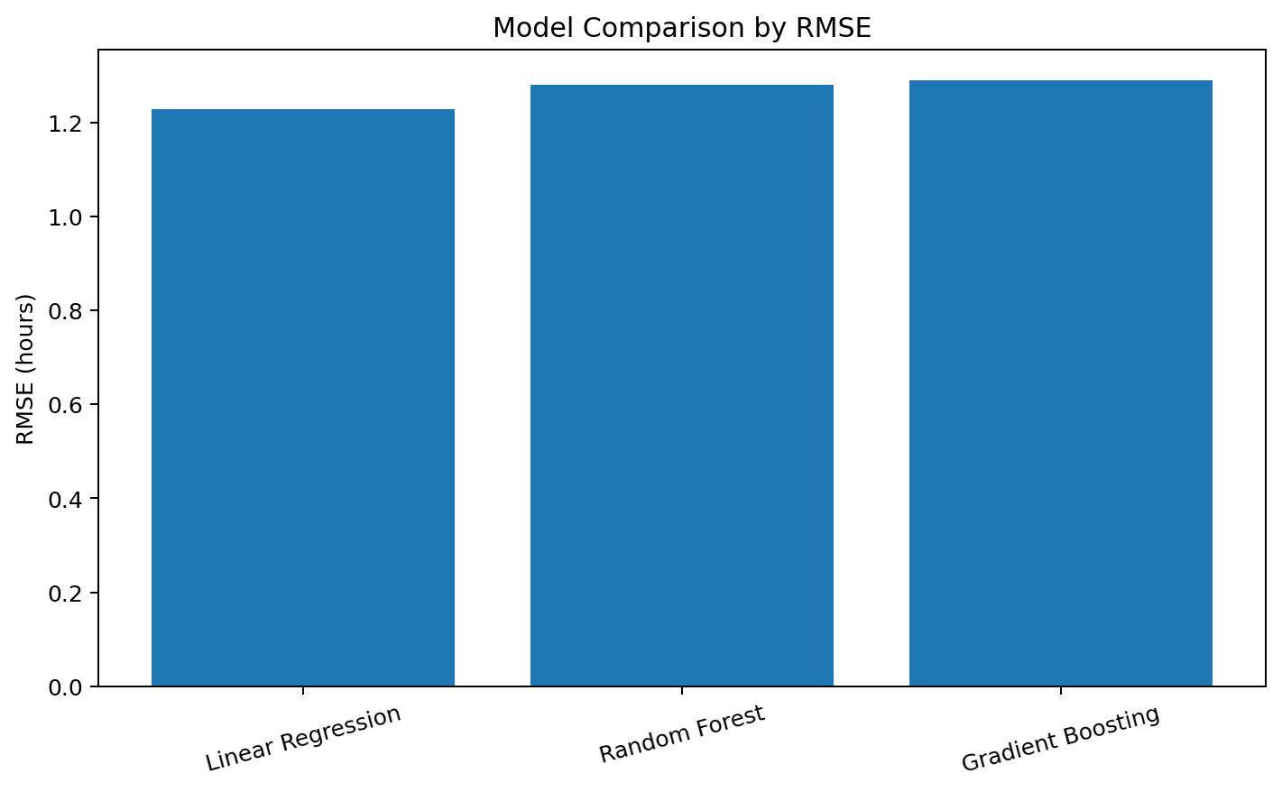
Figure 2. Comparison of model RMSE values.

7. Cross-Validation and Hyperparameter Tuning
A five-fold shuffled cross-validation is used to estimate model stability across different training/validation partitions. The selected model family produced a mean cross-validation RMSE of 1.1302 hours with a standard deviation of 0.0736 hours.
GridSearchCV is used to test a small set of hyperparameter combinations using five-fold cross-validation. The tuned model is then evaluated on the untouched test partition. This reduces the risk of selecting parameters based only on one split.
Best parameter configuration: {'model__learning_rate': 0.03, 'model__max_depth': 2, 'model__n_estimators': 200}
Tuned test MAE: 0.9618 hours; tuned test RMSE: 1.2497 hours; tuned test R²: 0.8746.

8. Optimization Strategies
Predictive modeling becomes more useful when predictions are connected to operational decisions. The following strategies are proposed from the variables represented in the dataset:
- Route planning: use predicted delivery time as an input when comparing alternative routes, especially for long-distance shipments.
- Traffic-aware scheduling: shift dispatch or delivery windows where traffic conditions are expected to create higher delivery times.
- Resource allocation: prioritize vehicles and delivery capacity for shipments predicted to require longer service times.
- Exception management: create an early-warning list for shipments whose predicted delivery time is materially above the promised duration.
- Cost-aware planning: jointly monitor transportation cost and predicted delivery time instead of optimizing only one metric.
- Continuous monitoring: retrain the model periodically as new operational records become available.

9. Illustrative Optimization Scenario
To demonstrate how the predictive model can support optimization, an illustrative scenario is simulated. The scenario reduces route distance by 10% and changes High traffic observations to Medium traffic as a representation of route-planning and scheduling improvements. The same trained model then predicts delivery time under the adjusted conditions.
Across 500 modeled records, the baseline mean predicted delivery time is 8.2522 hours. Under the illustrative scenario, the mean predicted delivery time is 8.0022 hours, corresponding to an estimated mean reduction of 0.2500 hours.
This is a scenario analysis, not a measured causal effect. Actual savings or time reductions would need to be validated with real route, traffic, capacity, and operational constraints.

10. Python Implementation
The accompanying Python script contains the complete workflow: feature engineering, preprocessing, train-test split, model training, metric calculation, five-fold cross-validation, GridSearchCV tuning, prediction, and the illustrative optimization scenario.
# Train and evaluate a regression model
pipe = Pipeline([
("preprocessor", preprocessor),
("model", GradientBoostingRegressor(random_state=42))
])
pipe.fit(X_train, y_train)
pred = pipe.predict(X_test)
mae = mean_absolute_error(y_test, pred)
rmse = mean_squared_error(y_test, pred) ** 0.5
r2 = r2_score(y_test, pred)
# 5-fold validation
cv = KFold(n_splits=5, shuffle=True, random_state=42)
cv_rmse = -cross_val_score(
pipe, X, y, cv=cv,
scoring="neg_root_mean_squared_error"
)

11. Analytical Insights
The model comparison demonstrates why multiple algorithms should be evaluated instead of selecting a model without validation. The linear baseline establishes a reference point, while ensemble methods can capture non-linear relationships among distance, traffic, vehicle type, shipment volume, and other operational variables.
- Prediction error should be interpreted in hours because that is the target unit and the operational unit used for delivery planning.
- Cross-validation provides an additional stability check beyond a single train-test split.
- Hyperparameter tuning can improve a model while preserving an untouched test set for final evaluation.
- The model is most useful as a decision-support component; operational teams should combine predictions with capacity, route, traffic, and service constraints.

12. Recommendations
- Integrate delivery-time predictions into a dispatch monitoring dashboard.
- Flag shipments with predicted delivery time above the promised threshold for proactive intervention.
- Use traffic-aware scheduling and route alternatives for shipments with high predicted delivery times.
- Track prediction error over time and retrain when data patterns change.
- Combine predicted time with transportation cost when evaluating operational alternatives.
- Validate optimization scenarios through controlled operational pilots before applying them at scale.

13. Limitations
- The dataset is simulated and does not represent actual company operations.
- The optimization scenario uses illustrative assumptions rather than live route-engine or traffic data.
- The model does not include every possible factor such as weather, depot congestion, driver availability, loading time, or real-time road incidents.
- Correlation and predictive association should not be interpreted as proof of causation.
- Real deployment would require monitoring for data drift, prediction bias, latency, and operational constraints.

14. Conclusion
Week 4 completes the analytical progression from logistics data exploration and cleaning to advanced analysis and predictive modeling. A delivery-time regression problem was defined, multiple models were trained and compared, performance was evaluated with MAE, RMSE and R², cross-validation and hyperparameter tuning were applied, and the predictive output was connected to practical logistics optimization strategies. The final workflow demonstrates how predictive analytics can support route planning, scheduling, exception management, and resource allocation while recognizing the limitations of a simulated dataset.

15. Submission Files
- DOC report – detailed Week 4 predictive modeling and optimization report
- Python script – complete model training, validation, tuning and optimization workflow
- Cleaned CSV – dataset used for the analysis
- Model comparison metrics – MAE, RMSE and R²
- Five-fold CV results – fold-level RMSE
- Hyperparameter tuning summary
- Optimization scenario summary
- Charts – actual vs predicted and model comparison
- README and 200+ word submission description

References
- Yuva Intern Week 4 task brief – Predictive Modeling and Optimization in Logistics Systems.
- Scikit-learn documentation concepts used in the implementation: regression estimators, pipelines, cross-validation, GridSearchCV, and regression metrics.
- Dataset continuity from the cleaned illustrative logistics dataset developed for Weeks 2 and 3.

