Aerial Simulation Planning (ASP) Console
Presentation Document with Architecture Flow Diagram

High-Level Architecture Flow Diagram
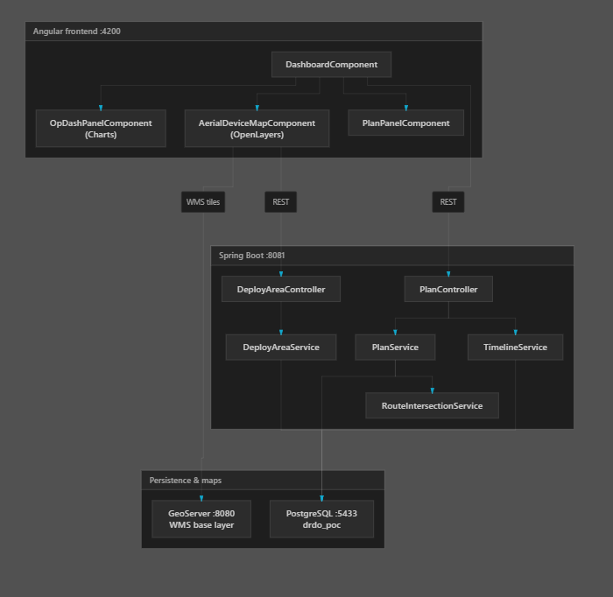
Figure 1: ASP architecture showing Angular frontend components, Spring Boot services, REST communication, GeoServer WMS integration, and PostgreSQL persistence.

Architecture Summary
DashboardComponent orchestrates Planning, Map Simulation, and Analytics modules. OpenLayers consumes GeoServer WMS tiles, while Spring Boot manages plans, timeline, deploy areas, and route intersection analysis. PostgreSQL stores plans, deploy areas, and timeline configuration.

