ASP Console — Architecture & Flow Documentation
Aerial Simulation Planning (ASP) Console
Project: issapoc/source | Stack: Angular 21 + Spring Boot + PostgreSQL + GeoServer + OpenLayers

1. Executive Summary
ASP Console is a full-stack geospatial application for planning up to three aircraft mission routes, simulating movement over time on an interactive map, managing deploy areas, and analyzing fuel consumption. The frontend is an Angular single-page dashboard; the backend is a Spring Boot REST API backed by PostgreSQL. Map imagery is served by GeoServer via WMS.

2. System Architecture Diagram
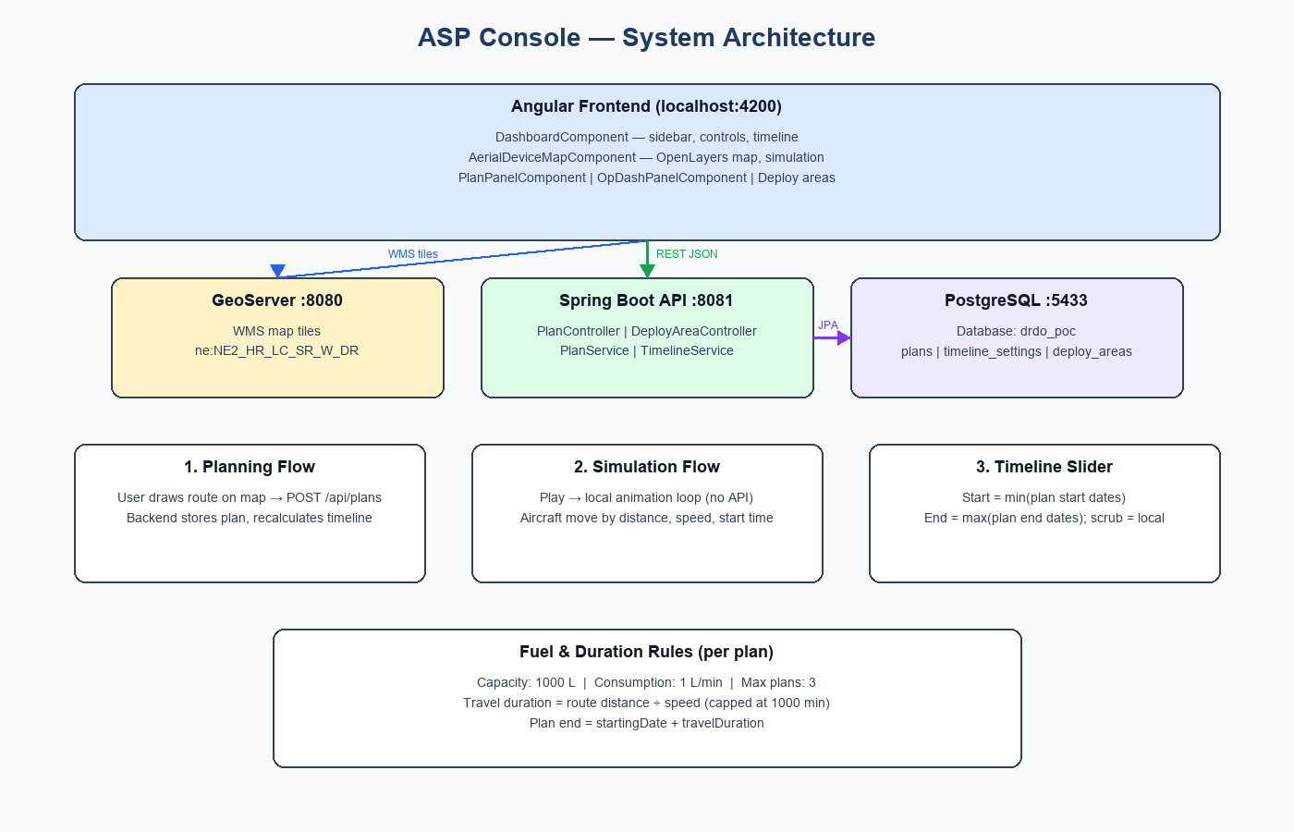

3. Technology Stack
Layer | Technology | Purpose
Frontend | Angular 21, PrimeNG 21 | UI, forms, charts, routing
Map | OpenLayers 10 | 2D map, routes, aircraft markers, deploy ellipses
Backend | Spring Boot, JPA | REST API, business logic, persistence
Database | PostgreSQL (drdo_poc) | Plans, timeline settings, deploy areas
Map server | GeoServer :8080 | WMS base map tiles
API port | Spring Boot :8081 | Plans and deploy-area endpoints

4. Application Structure
- Routing: — root route loads ShellComponent → DashboardComponent
- Dashboard layout: — collapsible sidebar with Planning, Deployment, Analysis, History tabs
- Map area: — OpenLayers map with top simulation controls and bottom timeline slider
- Sidebar footer: — aircraft status cards (speed, fuel, route progress)

5. Backend API Endpoints
Method | Endpoint | Description
GET | /api/plans/dashboard | Load plans, route events, timeline in one call
GET | /api/plans/timeline | Slider start/end times
POST | /api/plans | Save new plan (max 3)
DELETE | /api/plans | Clear all plans
GET | /api/deploy-areas | List deploy ellipses
POST | /api/deploy-areas | Create deploy area
PUT | /api/deploy-areas/{key} | Update deploy area geometry
DELETE | /api/deploy-areas/{key} | Delete deploy area

6. Core Data Flows

6.1 Startup / Page Load
On dashboard init, GET /api/plans/dashboard returns all saved plans, computed route intersection events, and timeline bounds. The frontend restores routes on the map, configures simulation vehicles, and sets the timeline slider range.

6.2 Planning Flow
- User enters plan name, speed, and start date/time in the Planning tab.
- User clicks Map Route and adds waypoints by clicking on the map.
- User clicks Finish → POST /api/plans with route waypoints.
- Backend computes route distance (haversine), stores plan in PostgreSQL, recalculates timeline.
- Frontend adds the plan, starts a simulation vehicle, and reloads timeline settings.

6.3 Simulation Flow
When the user clicks Play, a requestAnimationFrame loop runs entirely in the browser. Each aircraft waits until its own startingDate offset, then moves along its route at the configured speed. Fuel decreases based on distance traveled. No API calls occur during playback.

6.4 Timeline Slider
Timeline bounds are computed from all saved plans:
- Slider START — earliest startingDate among all plans
- Slider END — latest plan end time among all plans
- Each plan end — startingDate + travelDuration (distance ÷ speed, capped at 1000 min)
Moving the slider forward or backward recalculates aircraft position and fuel locally in the browser. It does NOT call the backend API. The API is only used on page load, after saving a plan, or after clearing plans.

7. Fuel & Duration Rules
Rule | Value
Fuel capacity (per plan) | 1000 liters
Fuel consumption | 1 liter per minute of travel time
Max flight time (fuel cap) | 1000 minutes
Travel duration | route distance ÷ speed (capped by fuel limit)
Fuel during simulation | 1000 L − (distance traveled converted to minutes × 1 L/min)
Maximum plans | 3

8. Route Events & Analysis
Route intersection events are computed when two plan route segments cross. These appear as markers on the map and as snap points on the timeline in Event playback mode. The Analysis tab (O/P dash) shows Chart.js fuel charts derived from plan routes and events.

9. Deployment Areas
In the Deployment tab, users place elliptical deploy areas on the map. Areas are persisted via /api/deploy-areas and can be moved, resized, or reshaped. Geometry is stored in PostgreSQL and rendered on a separate OpenLayers vector layer.

10. Key Source Files
- frontend/src/app/pages/dashboard/dashboard.component.ts — Main dashboard orchestration
- frontend/src/app/pages/dashboard/aerial-device-map/aerial-device-map.component.ts — Map, simulation, deploy areas
- frontend/src/app/services/plan-api.service.ts — REST client for plans
- backend/.../controller/PlanController.java — Plan REST endpoints
- backend/.../service/TimelineService.java — Timeline start/end calculation
- backend/.../util/PlanTimelineUtil.java — Travel duration and plan end time
- backend/.../util/RouteDistanceUtil.java — Route length (haversine)
- frontend/src/app/utils/plan-fuel.util.ts — Fuel calculations

11. Running the Application
- Frontend: cd frontend && npm start → http://localhost:4200
- Backend: cd backend && mvn spring-boot:run → http://localhost:8081
- Swagger UI: http://localhost:8081/swagger-ui.html
- GeoServer: http://localhost:8080/geoserver (configure in geoserver.config.ts)
- PostgreSQL: localhost:5433, database drdo_poc

Document generated from issapoc/source project documentation.

