
Department of computer science

Formal Language & Automata Theory
Web-Based Lexical Analyzer Report

GROUP MEMBERS ID

- Amanuel Shiferaw 16,095/23
- Robera Jifar 16,102/23
- Naod Tamene 16,122/23
- Kaleb Mulugeta 16,079/23
- Tesfa Getu 16,157/23

Submission Date : Jun 27 , 2026 G.C.

Table of Content

Introduction 1
1. System Architecture 1
2. Token Specification 2
3. Implementation Details 3
3.1. State Machine Design 3
3.2. Frontend Features 3
3.3. Key Functions: 3
4. Testing & Results 4
4.1. Test Cases 4
4.2. Sample Output 4
5. How to Use 6
6. GitHub Repository 7
Conclusion 8
Reference 8

Introduction

This project implements a web-based lexical analyzer that converts source code into lexemes and tokens. The system supports multiple programming languages and provides accurate line and column number tracking. It is built using a hand-written state machine for maximum accuracy.

System Architecture
- Frontend : HTML/CSS/JS for user interaction
- Backend: Flask server handling /tokenize and /upload routes.
- Lexer Engine: Hand-written state machine for tokenization.
- File Handler: Extracts text from .docx files using python-docx.
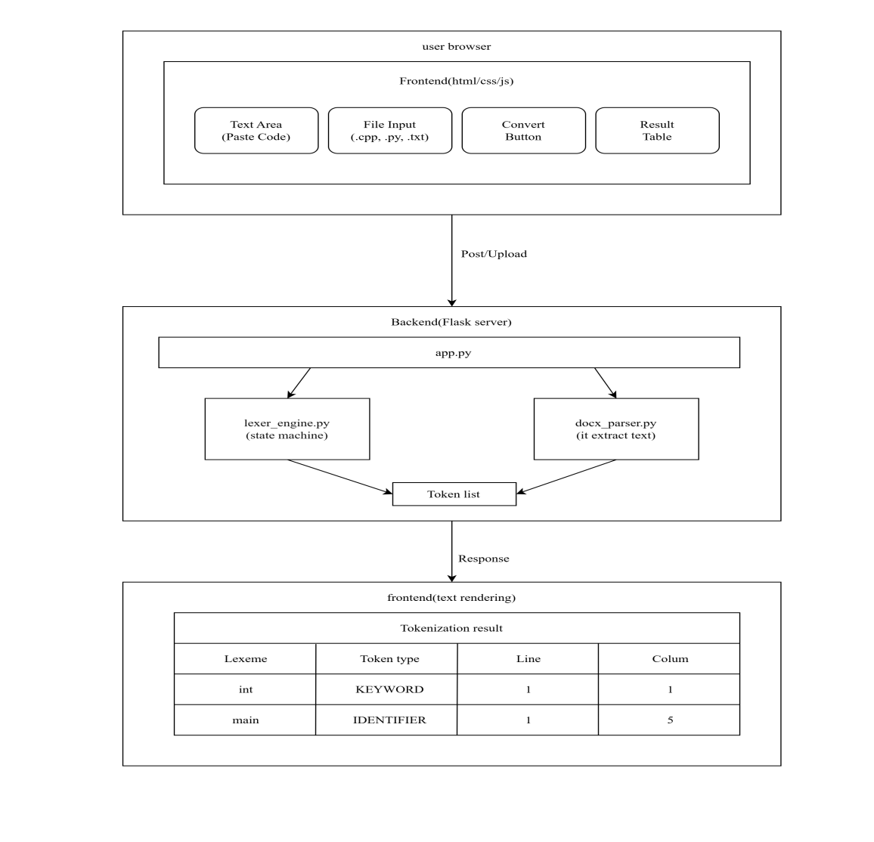

Token Specification
Token Type | Description | Pattern/Rule | Examples
KEYWORD | Reserved words of the language | Combined set from C, C++, Python, Java | if, while, int, return, for, def, class, public, static, void
IDENTIFIER | Variable and function names | [A-Za-z_][A-Za-z0-9_]* (hand-written DFA) | x, myVar, calcTotal, _temp
OPERATOR | Arithmetic, relational, assignment | Multi-char first, then single-char | +, -, =, *, /, %, ==, !=, ++
NUMBER | Integer and decimal literals | Hand-written DFA with scientific notation support | 42, 3.14, 0.001, 1e-5, .5
STRING | String literals | Hand-written DFA with escape sequence support | "hello", 'world', "Hello \"World\""
DELIMITER | Punctuation and grouping symbols | Character-by-character state machine | ; , , , :, {, }, (, ), [, ]
COMMENT | Single-line and multi-line comments | Skipped (no token emitted) | // comment, # comment, /* comment */
ERROR | Unrecognized characters | Any character not matched above | @, #, $, % (when not an operator)

- Whitespace (spaces, tabs, newlines) is skipped entirely but newlines are tracked for line numbering.

Implementation Details

State Machine Design
- Process characters one at a time.
- Maintain line and col counters.
- Handle edge cases: nested comments, string escapes, scientific notation.

Frontend Features
- Auto-grow textarea.
- File upload with auto-fill.
- Color-coded token types.
- Responsive design.

Key Functions:
- tokenize(source_code) → Returns list of tokens.
- extract_text_from_docx(file_obj) → Extracts text from Word files.

Testing & Results

Test Cases

The system was tested against 8 comprehensive test cases covering all token types, edge cases, and error handling.
Test Case | Description | Result
Basic C code | int main() { int x = 10; return x; } | Passed - 14 tokens identified
Python Code | For I in range (10):  Print(i)#with comments | Passed - Comments skipped correctly
Nested Comments | /* Outer /* Inner */ Still here */ | Passed - Entire comment skipped
Scientific Notation | 3.14e-10 and .5 | Passed - Correctly identified as NUMBER
Java code | public class Main { public static void main(String[] args) { ... } } | Passed - All Java keywords identified
Invalid Characters | @#$ invalid | Passed - ERROR tokens generated, no crash
Multi-Character Operators | !=, <=, >=, ++, --, &&, || | Passed - Correctly matched before single-char
String Escapes | "Hello \"World\"!" | Passed - String correctly parsed with escape

Sample Output
Input (C Code) :-

int main() {
int x = 10;
float y = 5.5;
return x + y;
}

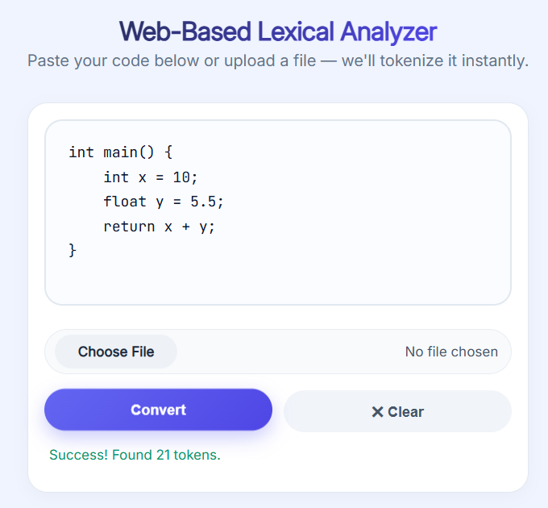
Figure 1: Main Interface
The web-based lexical analyzer interface showing the input textarea, file upload, and convert button.

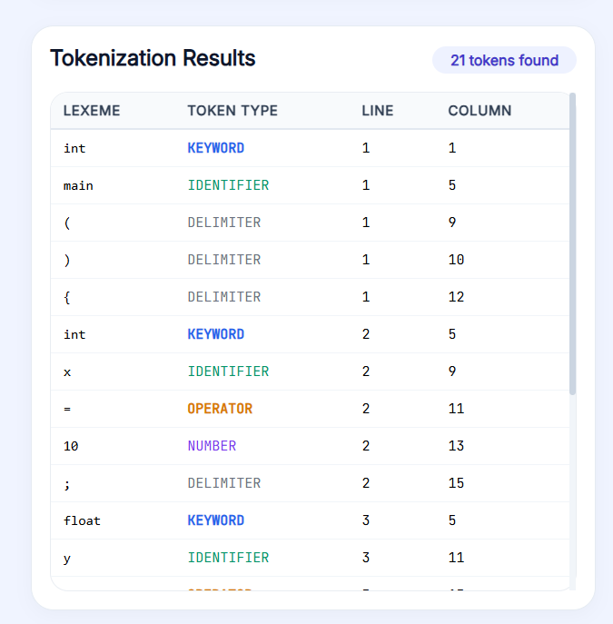
Figure 2: Tokenization Results
Output table showing lexemes, token types, line numbers, and column numbers.

How to Use
- Paste Code: Type or paste source code into the textarea.
- Upload File: Click "Choose File" and select a .txt, .py, .cpp, .docx, or .java file.
- Convert: Click the "Convert" button to tokenize your code.
- View Results: The table shows Lexeme, Token Type, Line Number, and Column Number.

GitHub Repository
The complete source code is available on GitHub:
Repository: https://github.com/Amanuel-Manazie/web-lexical-analyzer

Repository Structure:
web-lexical-analyzer/
├── .gitignore
├── README.md
├── architecture-diagram.png
├── src/
│ ├── backend/
│ │ ├── app.py # Flask server
│ │ ├── lexer_engine.py # State machine tokenizer
│ │ ├── docx_parser.py # .docx text extractor
│ │ ├── requirements.txt # Python dependencies
│ │ └── venv/ # Virtual environment
│ └── frontend/
│ ├── index.html # Main UI
│ ├── style.css # Styling
│ └── script.js # Frontend logic
└── docs/
├── report.docx
└── demo.mp4

Conclusion
The web-based lexical analyzer successfully tokenizes source code from multiple programming languages with high accuracy. The hand-written state machine ensures robust error handling, precise line and column tracking, and no crashes on invalid input. All deliverables were completed successfully.

Reference
- https://flask.palletsprojects.com/en/stable/
- https://app.diagrams.net/
- https://python-docx.readthedocs.io/en/latest/

