## Steps to launch

0. Open and source unity_ws

1. roslaunch ros_tcp_endpoint endpoint.launch
2. rostopic echo /vr_right_controller_pose
3. rostopic echo /vr_headset_pose
4. rostopic echo /vr_left_controller_pose
5. rosrun unity_robotics_demo color_publisher.py
6. Rqt_plot
7. Rqt_topic
8. rqt_graph

## Unity-Oculus coordinate system

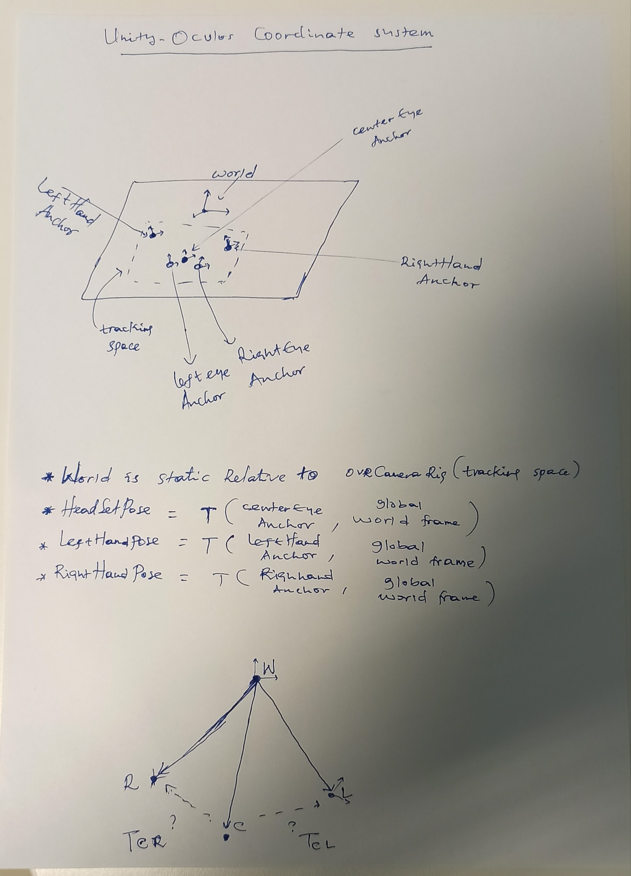

## Publish controller inputs

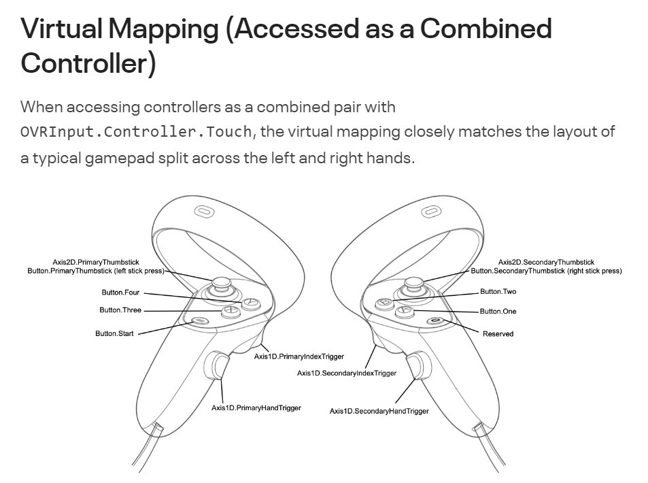

| **Button** | **Function** | **Value** |  |
| --- | --- | --- | --- |
| Button.One | shot | true/false |  |
| Button.Two | record/stop | true/false |  |
| Button.Three | play/stop | true/false |  |
| Axis1D.SecondaryHandTrigger | Activate/Deactivate | [-1.0 +1.0] |  |
| Axis1D.SecondaryIndexTrigger | grip | [-1.0 +1.0] |  |

JoyMsg

joy.Axis[] = [activate, grip]

Joy.buttons[] = [one, two, three]

## UI Slider/button

## Visible Background/ AR style

#### Read controller inputs using interrupts

* <https://www.youtube.com/watch?v=UWSClCz0c_0>

#### Polling controller inputs

* <https://www.youtube.com/watch?v=Kh_94glqO-0>