BABU BANARASI DAS
UNIVERSITY

2026-2027

SCHOOL OF COMPUTER APPLICATIONS
No SQL Project
Student Management System Using MongoDB

Submitted to: Submitted by:
Mr. Harendra Singh Aman Vishwakaram
Department: BCA (DS & AI) Roll no: (BCADS21)
Date: 25th September University Roll no: 1250258074

1. CREATE DATABASE
MongoDB Query:
use Students
Explanation: Creates or switches to the Student database.

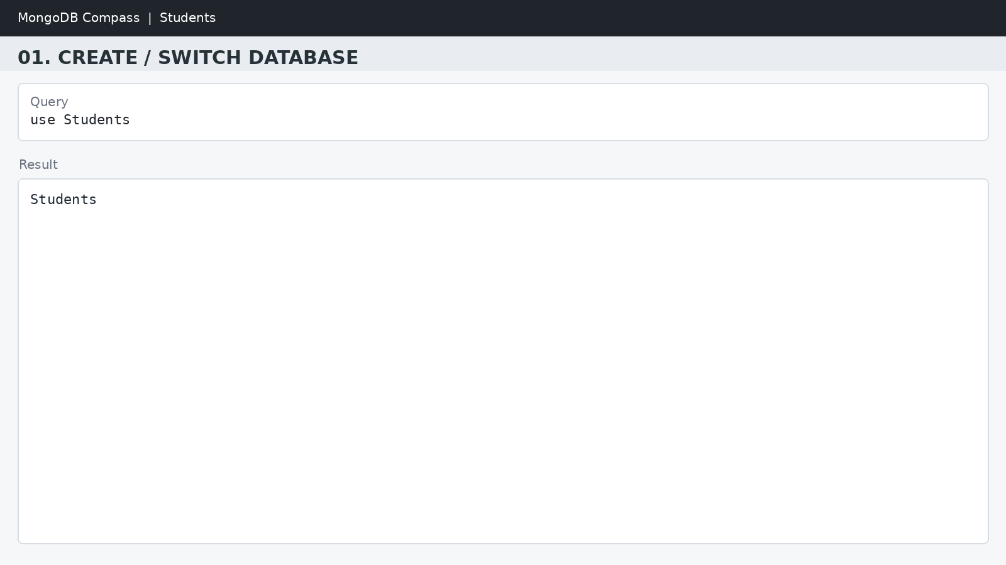

2. CREATE COLLECTION
MongoDB Query:
db.createCollection("students")
Explanation: Creates a collection named students.
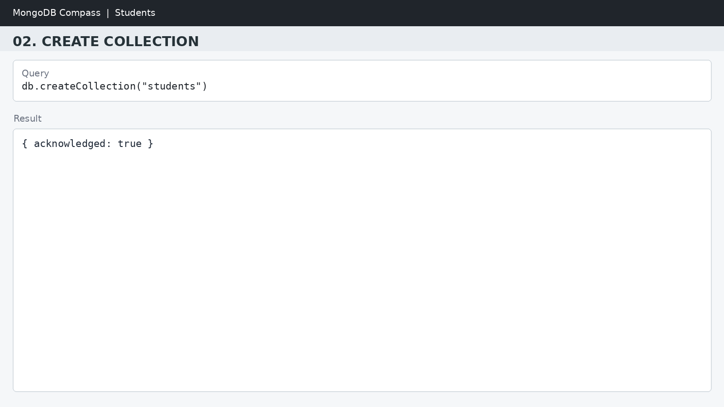
3. INSERT 50 STUDENTS
MongoDB Query:
db.students.insertMany([
{roll:1, name:"Olivia", age:19, marks:88, city:"London"},
{roll:2, name:"Emma", age:19, marks:94, city:"Paris"},
{roll:3, name:"Sophia", age:18, marks:94, city:"Toronto"},
{roll:4, name:"Amelia", age:18, marks:80, city:"Sydney"},
{roll:5, name:"Isabella", age:19, marks:79, city:"Berlin"},
{roll:6, name:"Mia", age:19, marks:80, city:"Madrid"},
{roll:7, name:"Charlotte", age:20, marks:90, city:"Rome"},
{roll:8, name:"Harper", age:20, marks:66, city:"Dublin"},
{roll:9, name:"Evelyn", age:19, marks:72, city:"Amsterdam"},
{roll:10, name:"Luna", age:19, marks:72, city:"Vienna"},
{roll:11, name:"Camila", age:18, marks:85, city:"London"},
{roll:12, name:"Gianna", age:19, marks:59, city:"Paris"},
{roll:13, name:"Abigail", age:18, marks:72, city:"Toronto"},
{roll:14, name:"Ella", age:18, marks:96, city:"Sydney"},
{roll:15, name:"Scarlett", age:20, marks:81, city:"Berlin"},
{roll:16, name:"Grace", age:20, marks:73, city:"Madrid"},
{roll:17, name:"Chloe", age:19, marks:65, city:"Rome"},
{roll:18, name:"Victoria", age:19, marks:90, city:"Dublin"},
{roll:19, name:"Lily", age:19, marks:81, city:"Amsterdam"},
{roll:20, name:"Aria", age:19, marks:68, city:"Vienna"},
{roll:21, name:"Sofia", age:18, marks:92, city:"London"},
{roll:22, name:"Nora", age:20, marks:96, city:"Paris"},
{roll:23, name:"Hazel", age:19, marks:75, city:"Toronto"},
{roll:24, name:"Ellie", age:20, marks:54, city:"Sydney"},
{roll:25, name:"Aurora", age:20, marks:78, city:"Berlin"},
{roll:26, name:"Layla", age:19, marks:61, city:"Madrid"},
{roll:27, name:"Zoey", age:18, marks:77, city:"Rome"},
{roll:28, name:"Riley", age:18, marks:93, city:"Dublin"},
{roll:29, name:"Stella", age:19, marks:80, city:"Amsterdam"},
{roll:30, name:"Lucy", age:19, marks:64, city:"Vienna"},
{roll:31, name:"Maya", age:19, marks:90, city:"London"},
{roll:32, name:"Ivy", age:18, marks:66, city:"Paris"},
{roll:33, name:"Emilia", age:19, marks:91, city:"Toronto"},
{roll:34, name:"Naomi", age:19, marks:60, city:"Sydney"},
{roll:35, name:"Elena", age:20, marks:98, city:"Berlin"},
{roll:36, name:"Claire", age:19, marks:90, city:"Madrid"},
{roll:37, name:"Alice", age:20, marks:97, city:"Rome"},
{roll:38, name:"Ruby", age:19, marks:57, city:"Dublin"},
{roll:39, name:"Julia", age:19, marks:96, city:"Amsterdam"},
{roll:40, name:"Eva", age:19, marks:68, city:"Vienna"},
{roll:41, name:"Sarah", age:19, marks:81, city:"London"},
{roll:42, name:"Leah", age:19, marks:97, city:"Paris"},
{roll:43, name:"Anna", age:19, marks:85, city:"Toronto"},
{roll:44, name:"Madison", age:19, marks:95, city:"Sydney"},
{roll:45, name:"Hannah", age:18, marks:52, city:"Berlin"},
{roll:46, name:"Zoe", age:18, marks:70, city:"Madrid"},
{roll:47, name:"Ariana", age:20, marks:71, city:"Rome"},
{roll:48, name:"Natalie", age:19, marks:85, city:"Dublin"},
{roll:49, name:"Violet", age:19, marks:76, city:"Amsterdam"},
{roll:50, name:"Bella", age:19, marks:93, city:"Vienna"}
])
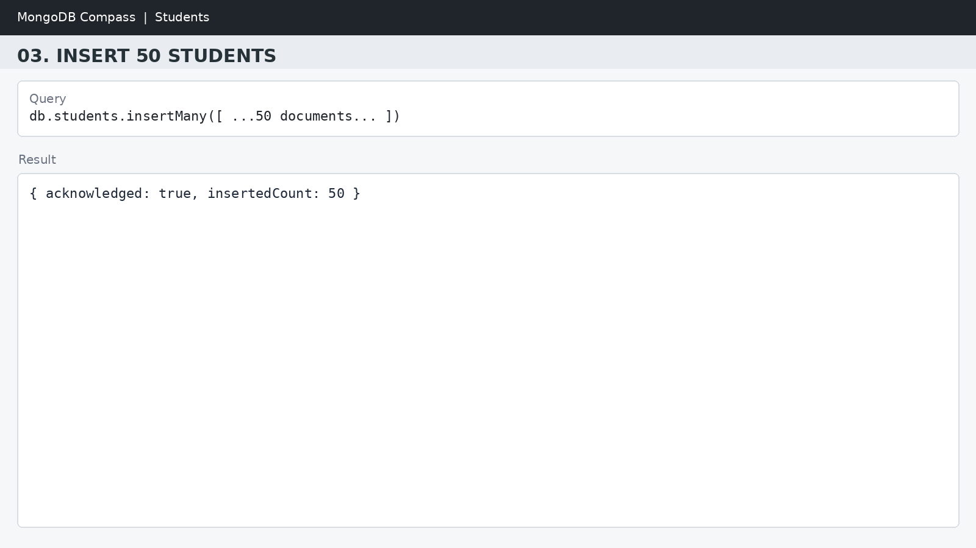
Explanation: Inserts multiple student documents into the collection.

4. DISPLAY ALL STUDENTS
MongoDB Query:
db.students.find()
Explanation: Retrieves documents from the students collection.
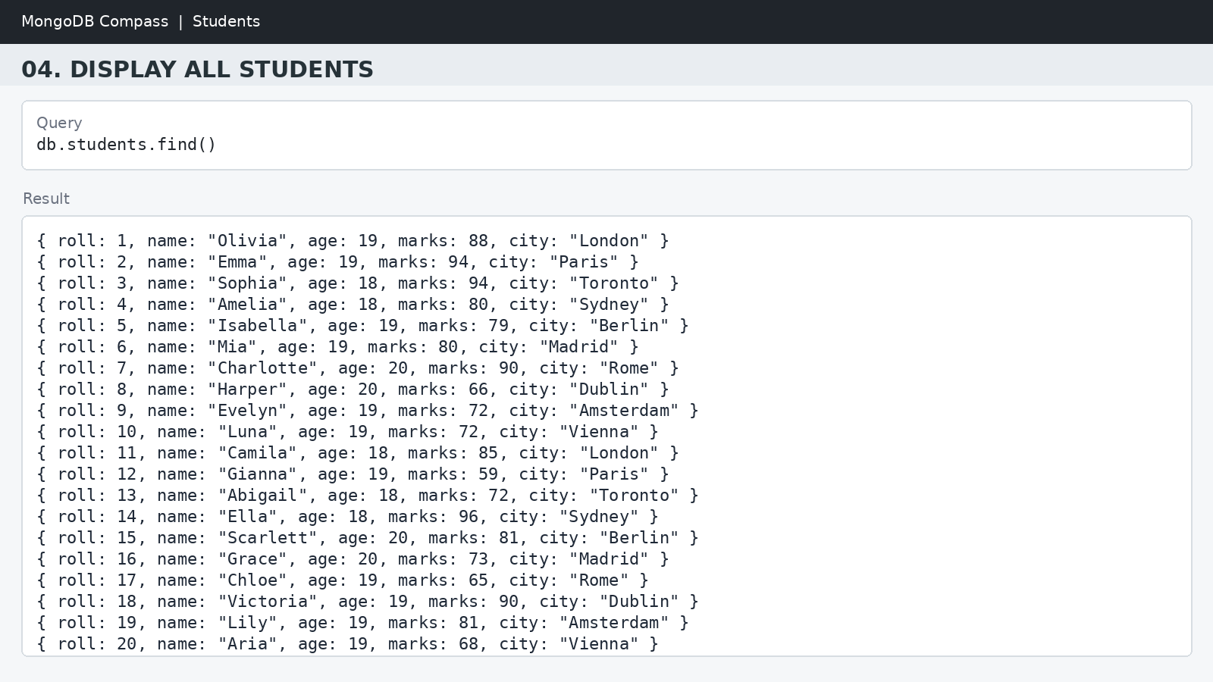
5. EQUAL TO — $eq
MongoDB Query:
db.students.find({marks: {$eq: 88}})
Explanation: Finds students whose marks are exactly 88.

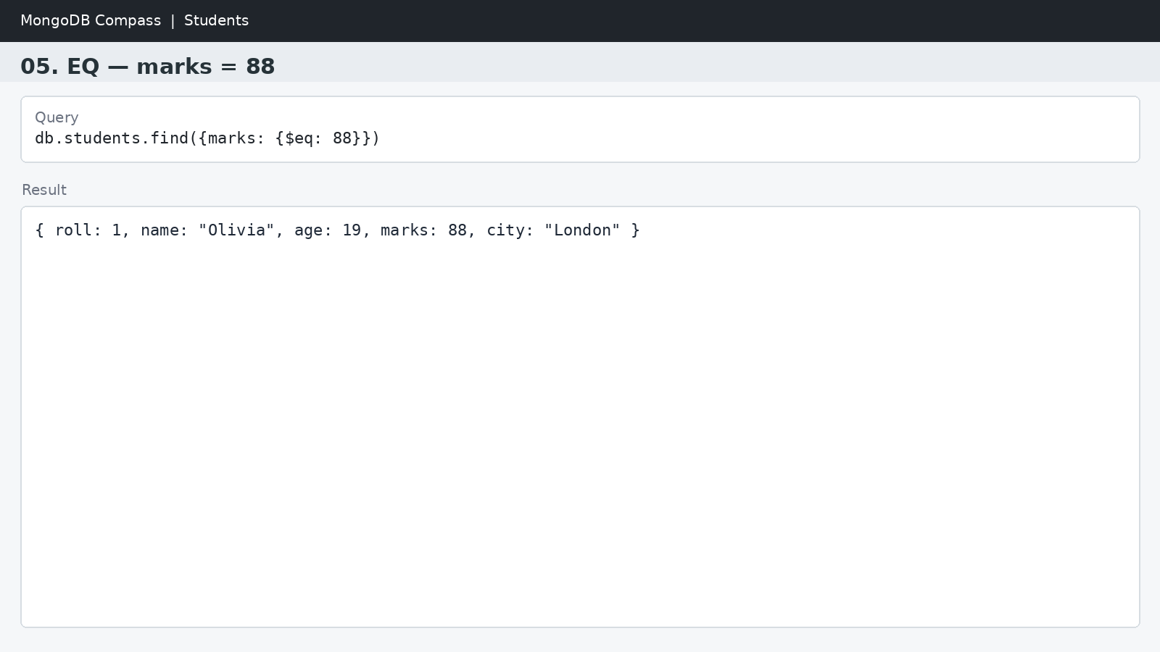
6. GREATER THAN — $gt
MongoDB Query:
db.students.find({marks: {$gt: 85}})
Explanation: Finds students whose marks are greater than 85.
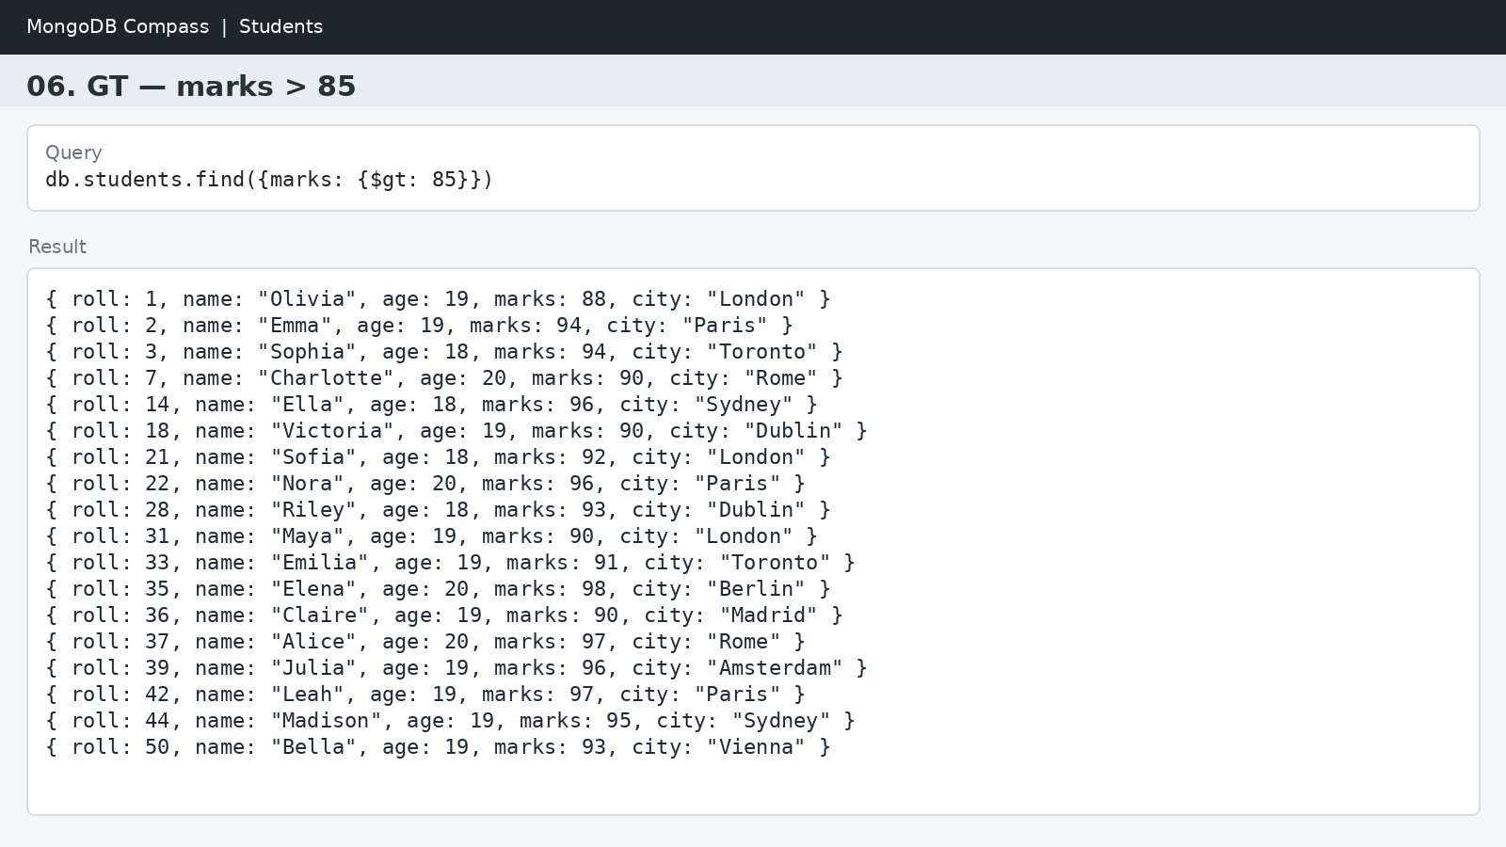

7. LESS THAN — $lt
MongoDB Query:
db.students.find({marks: {$lt: 60}})
Explanation: Finds students whose marks are less than 60.

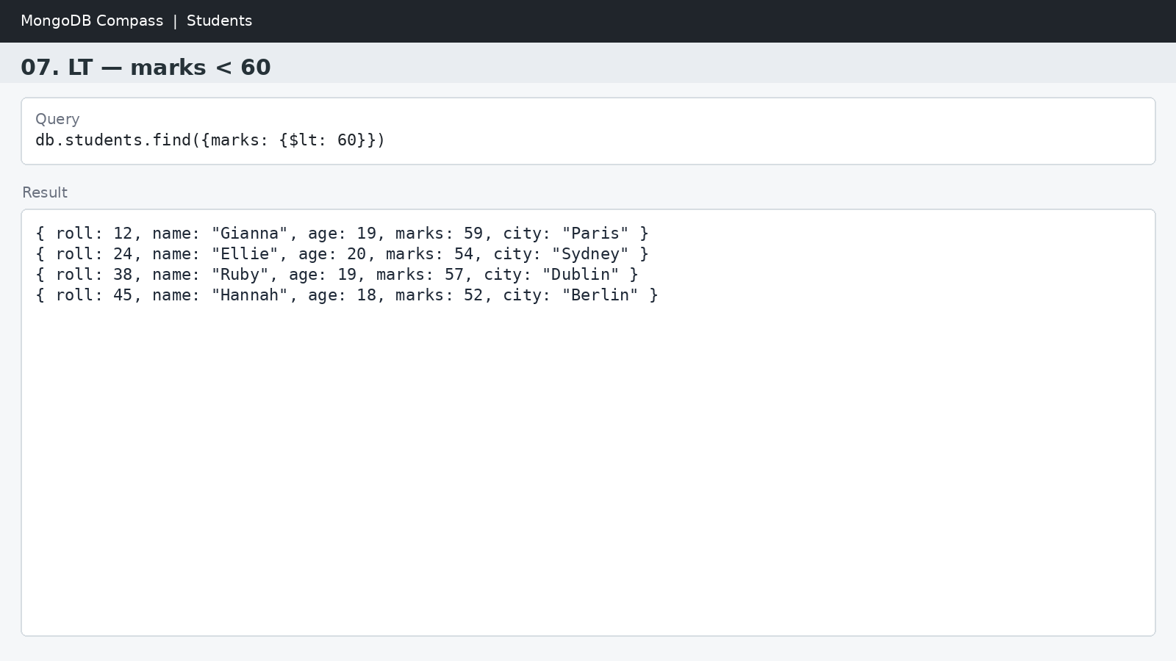
8. GREATER THAN OR EQUAL TO — $gte
MongoDB Query:
db.students.find({marks: {$gte: 90}})
Explanation: Finds students whose marks are 90 or above.

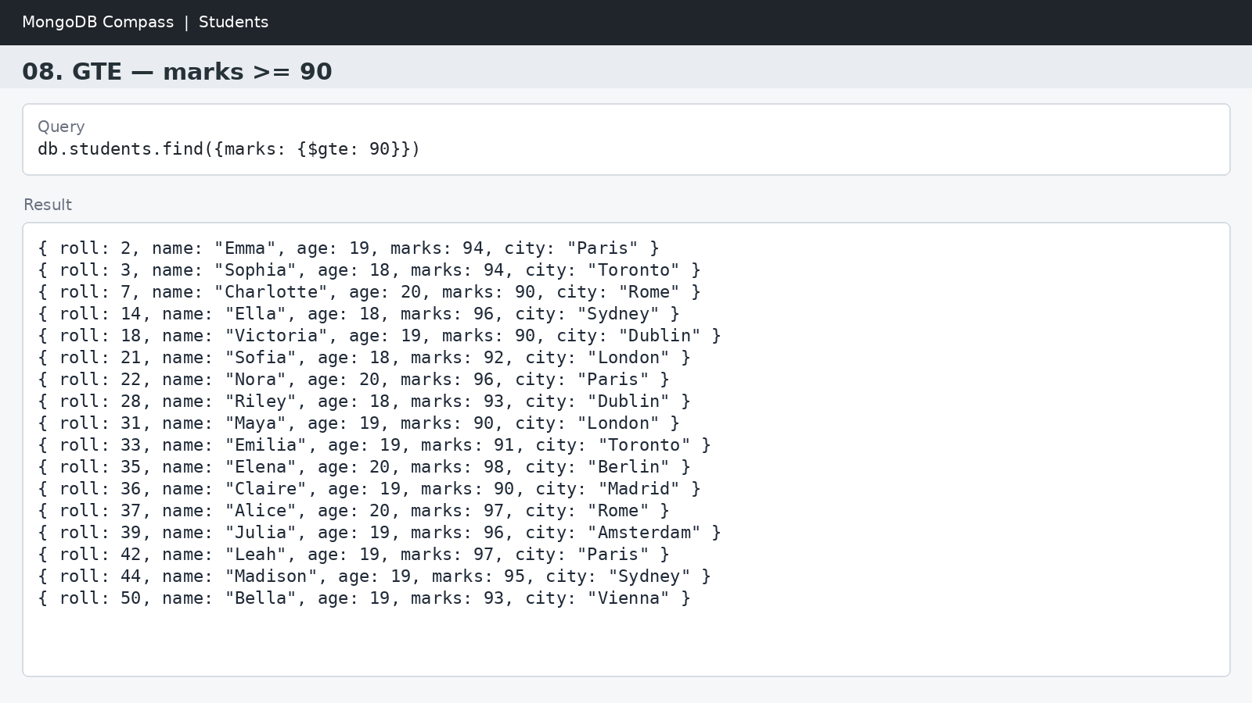

9. LESS THAN OR EQUAL TO — $lte
MongoDB Query:
db.students.find({marks: {$lte: 70}})
Explanation: Finds students whose marks are 70 or below.

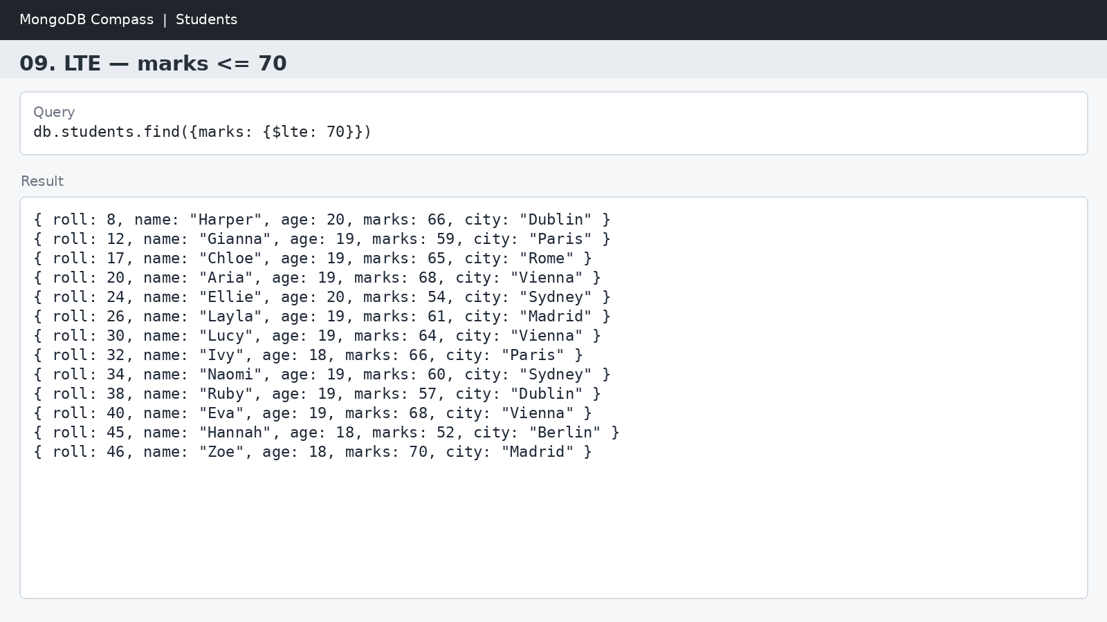

10. UPDATE OPERATION
MongoDB Query:
db.students.updateOne(
{roll:5},
{$set:{marks:95}}
)
Explanation: Updates the marks to 95 of the student with roll number 5. Updates the marks to 95 of the student with roll number 5.

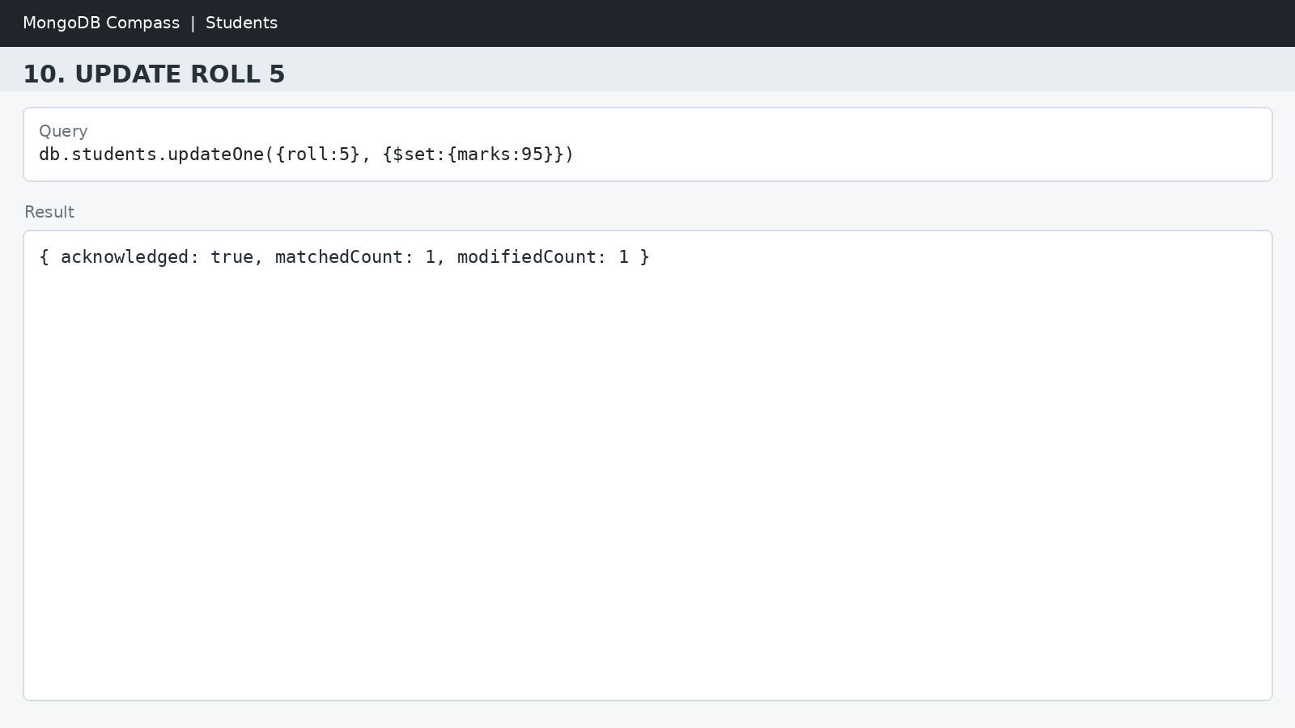

11. DELETE ONE OPERATION
MongoDB Query:
db.students.deleteOne({roll:10})
Explanation: Deletes one document matching roll number 10.

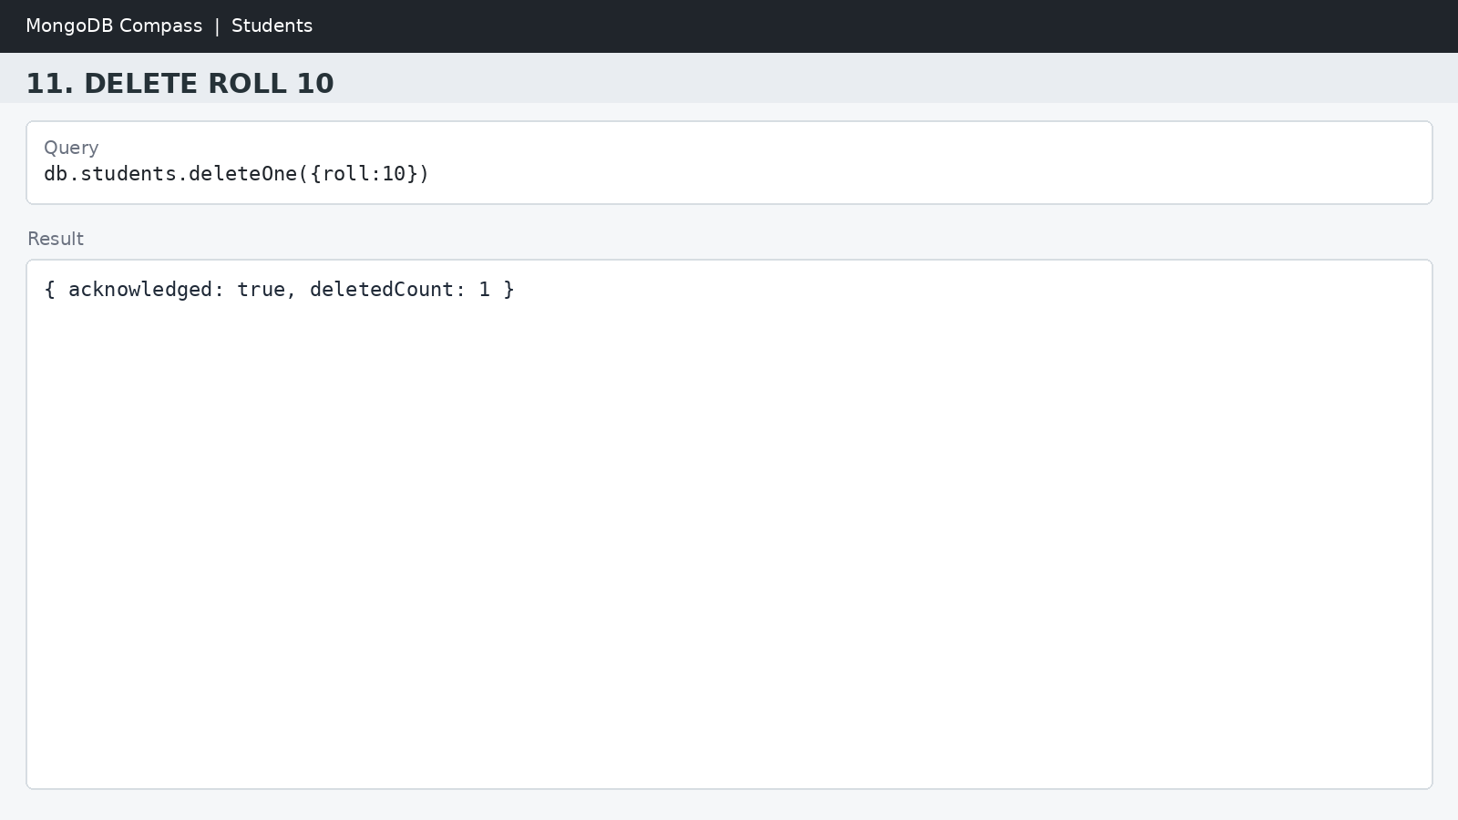

12. DELETE MANY OPERATION
MongoDB Query:
db.students.deleteMany({
marks: {$lt:60}
})
Explanation: Deletes all students having marks below 60.

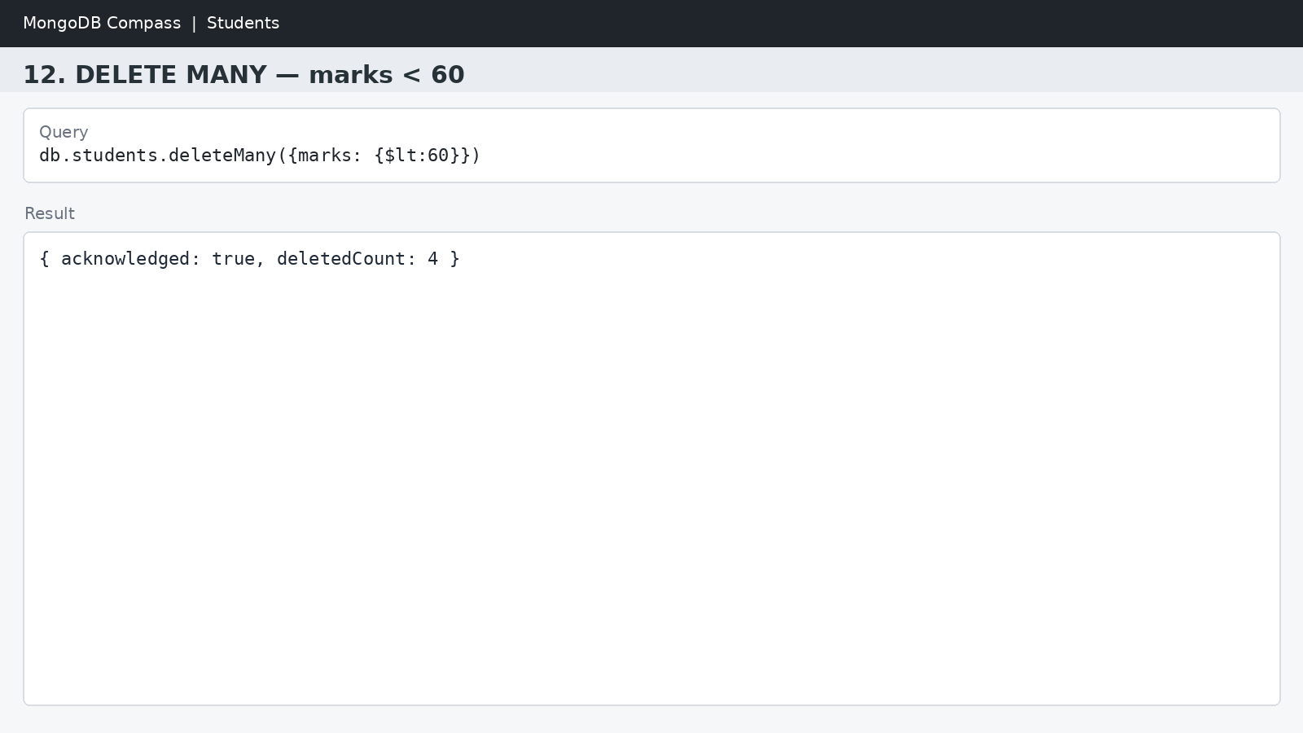

13. AND OPERATION — $and
MongoDB Query:
db.students.find({
$and:[
{marks:{$gt:80}},
{age:19}
]
})
Explanation: Finds students satisfying both conditions.
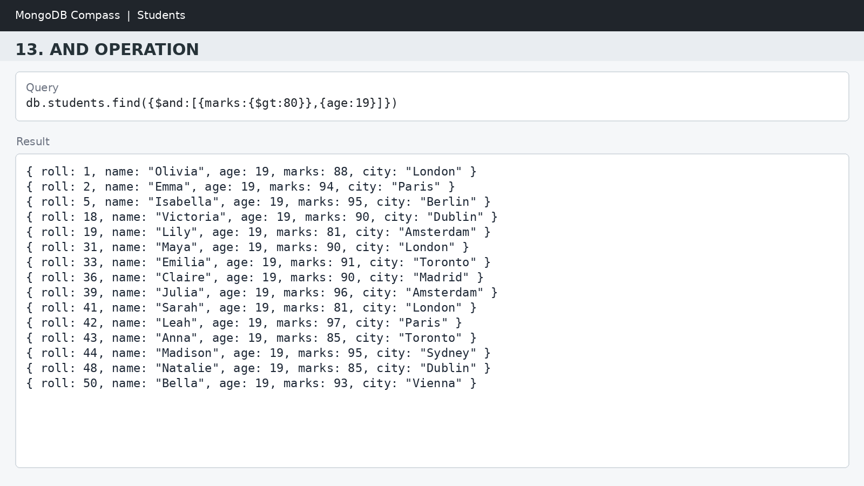

14. OR OPERATION — $or
MongoDB Query:
db.students.find({
$or:[
{city:"London"},
{city:"Paris"}
]
})
Explanation: Finds students from London or Paris. Finds students from Lucknow or Kanpur.
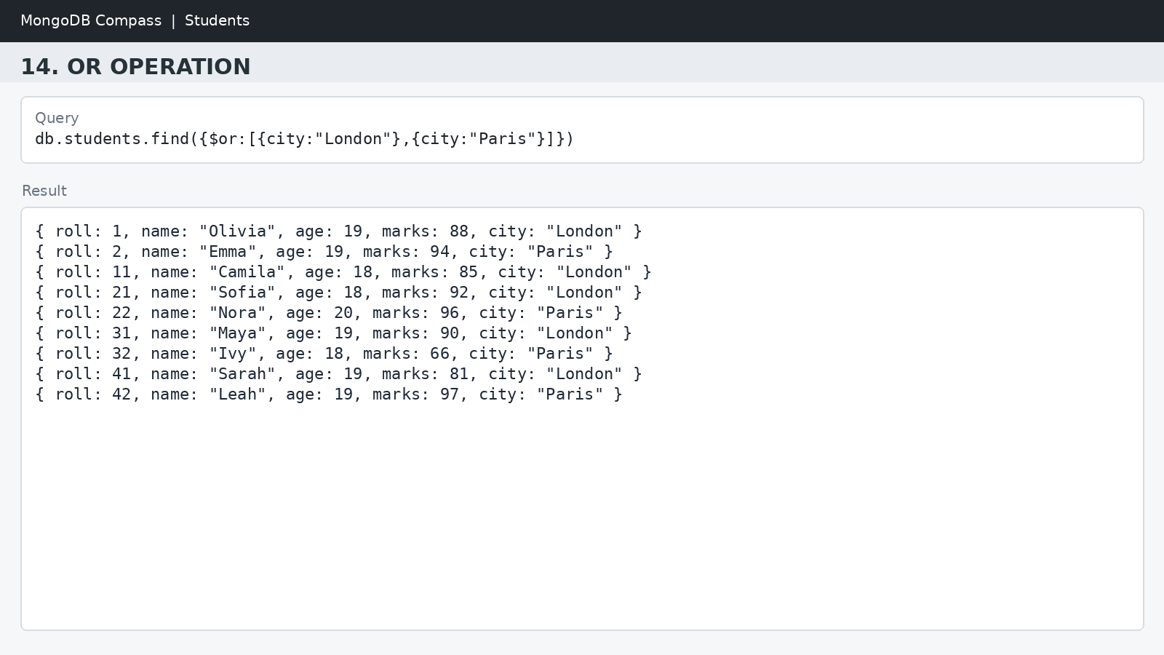

15. SORT OPERATION
A.MongoDB Query:
db.students.find().sort({marks: 1})
Explanation: Sorts students by marks from lowest to highest. Use 1 for ascending order.
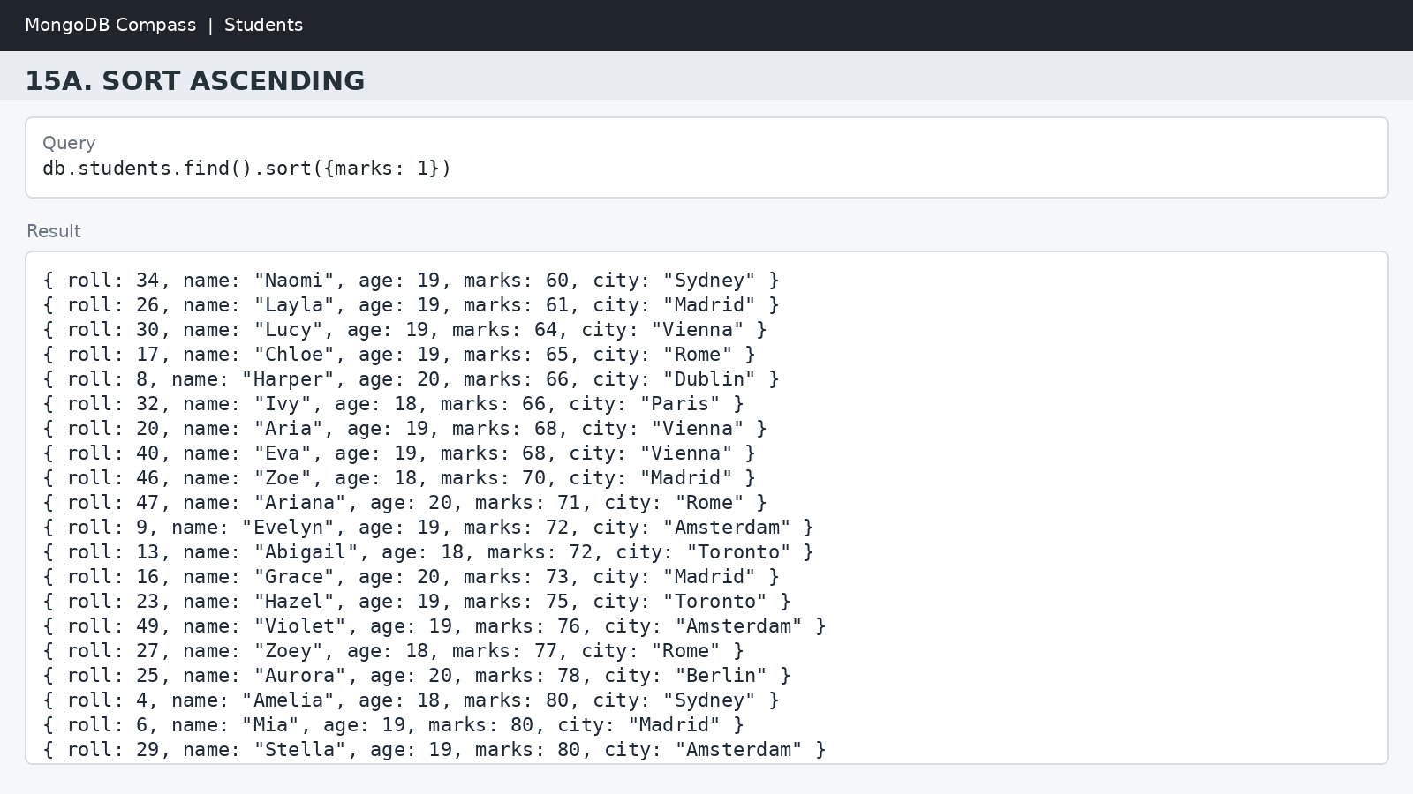

B. MongoDB Query:
db.students.find().sort({marks: -1})
Explanation: Sorts students by marks from highest to lowest. Use -1 for descending order.
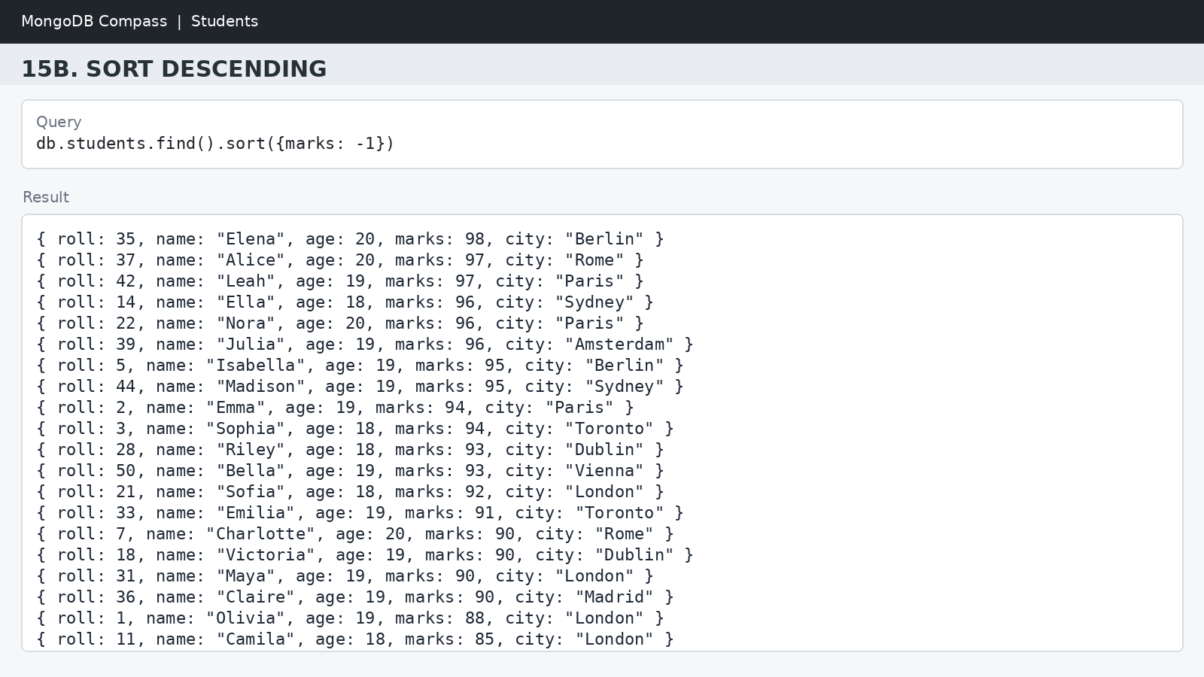
16. LIMIT OPERATION
MongoDB Query:
db.students.find().limit(5)
Explanation: Displays only the first five documents.

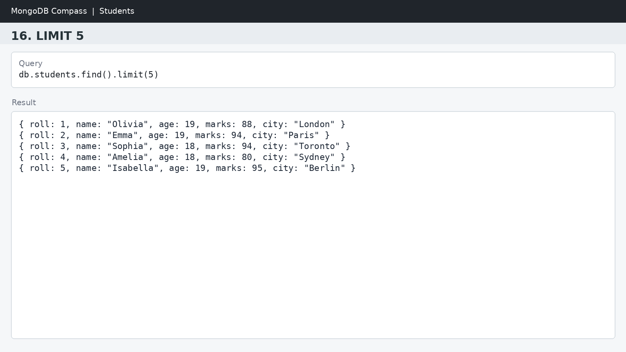

17. SEARCH BY CITY
MongoDB Query:
db.students.find({city:"London"})
Explanation: Finds all students whose city is London. Finds all students whose city is Lucknow.
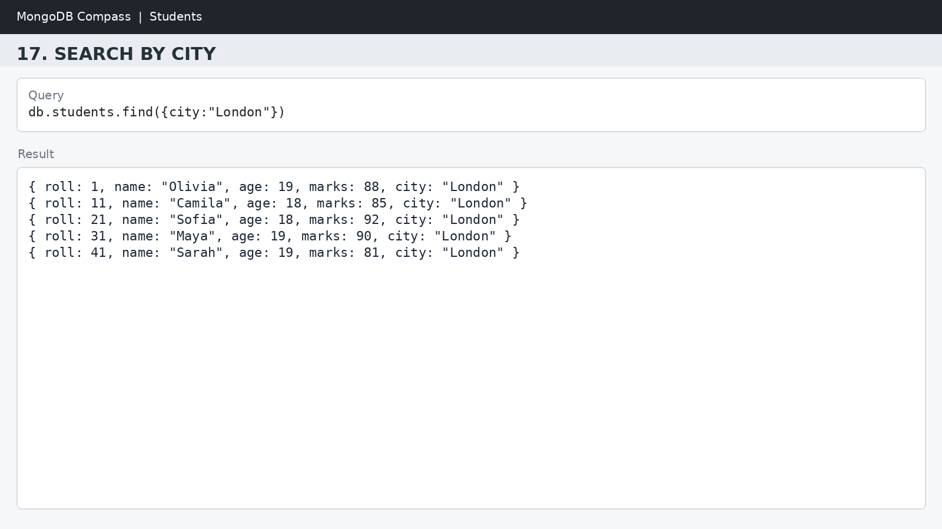

18. COUNT DOCUMENTS
MongoDB Query:
db.students.countDocuments()
Explanation: Counts documents currently present in the collection (performing after the delete function).
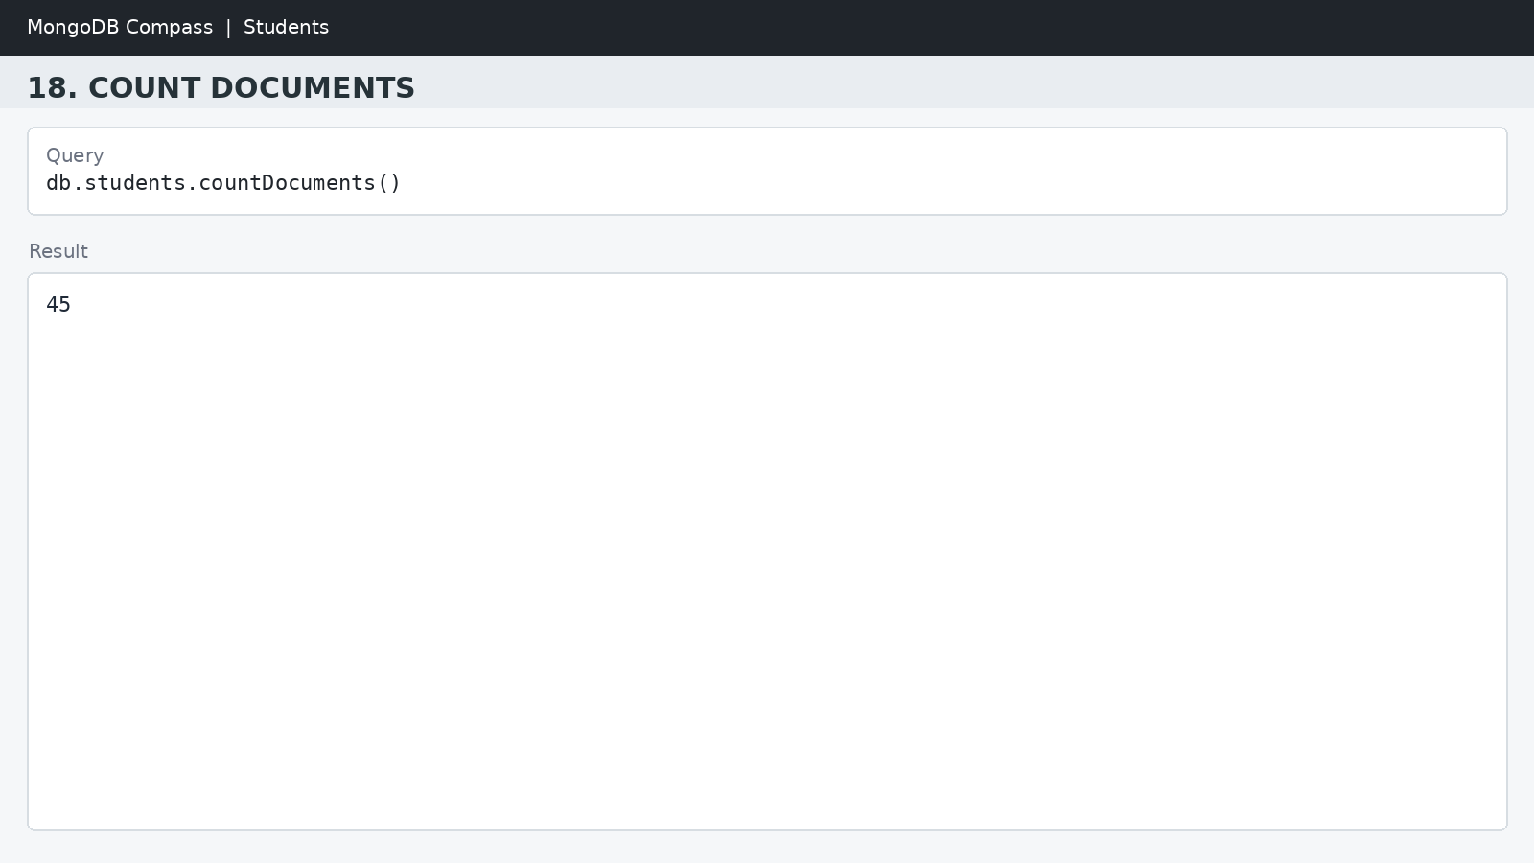

MONGODB OPERATORS USED:

Operator | Meaning | Example
$eq | Equal to | marks: {$eq:88}
$gt | Greater than | marks: {$gt:85}
$lt | Less than | marks: {$lt:60}
$gte | Greater than or equal to | marks: {$gte:90}
$lte | Less than or equal to | marks: {$lte:70}
$and | All conditions true | $and:[...]
$or | At least one condition true | $or:[...]

CONCLUSION
This project provided practical knowledge of NoSQL databases using MongoDB. A Student Management System containing student information was created and different MongoDB operations were performed on the data.
Through this project, I learned how to insert, retrieve, update, and delete documents. I also learned how to Ascending order & descending order data, comparison operators such as $eq, $gt, $lt, $gte, and $lte work, along with logical operators such as $and and $or.
Overall, this project helped me understand how MongoDB can be used to manage and query student data efficiently.

