**PIZZA SALES SQL QUERIES**

A . KPI’s

1. Total Revenue:

SELECT SUM (total_price) AS Total_Revenue FROM pizza_sales;

1. Average Order Value:

SELECT SUM (total_price) / COUNT(DISTINCT order_id) AS Avg_Order_value FROM pizza_sales;

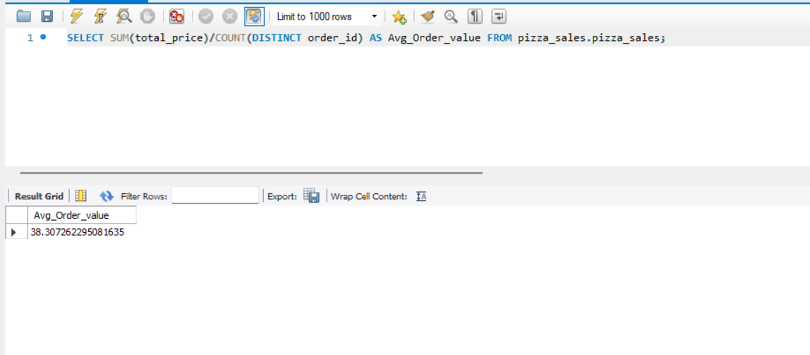

1. Total Pizzas Sold:

SELECT SUM(quantity) AS Total_Pizzas_Sold FROM pizza_sales;

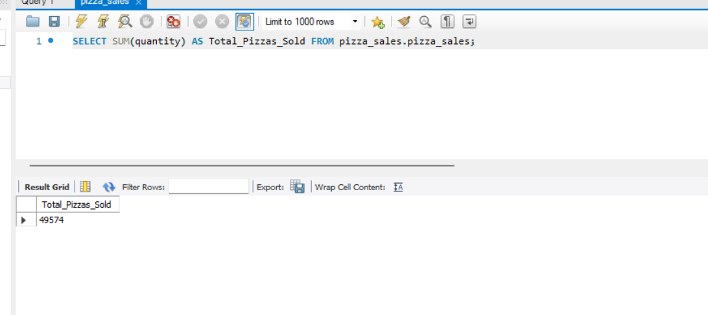

1. Total Orders:

SELECT COUNT(DISTINCT order_id) AS Total_Orders FROM pizza_sales;

1. Average Pizzas Per Order:

SELECT ROUND(SUM(quantity) / COUNT(DISTINCT order_id),2) AS Average_Pizzas_per_Order FROM pizza_sales;

B . Daily Trend for Total Orders

SELECT

DAYNAME(STR_TO_DATE(order_date, %d-%m-%Y)) AS order_day,

COUNT(DISTINCT order_id AS total_orders

FROM pizza_sales

GROUP BY DAYNAME(STR_TO_DATE(order_date, %d-%m-%Y))

ORDER BY FIELD(order_day,

‘Monday’, ‘Tuesday’, ‘Wednesday’, ‘Thursday’, ‘Friday’, ‘Saturday’, ‘Sunday’);

Output:

C . Monthly Trend for Total Orders

SELECT

MONTHNAME(STR_TO_DATE(order_date, %d-%m-%Y)) AS order_month

COUNT(DISTINCT order_id) AS total_orders

FROM pizza_sales

GROUP BY MONTHNAME(STR_TO_DATE(order_date, %d-%m-%Y))

ORDER BY total_orders DESC;

Output:

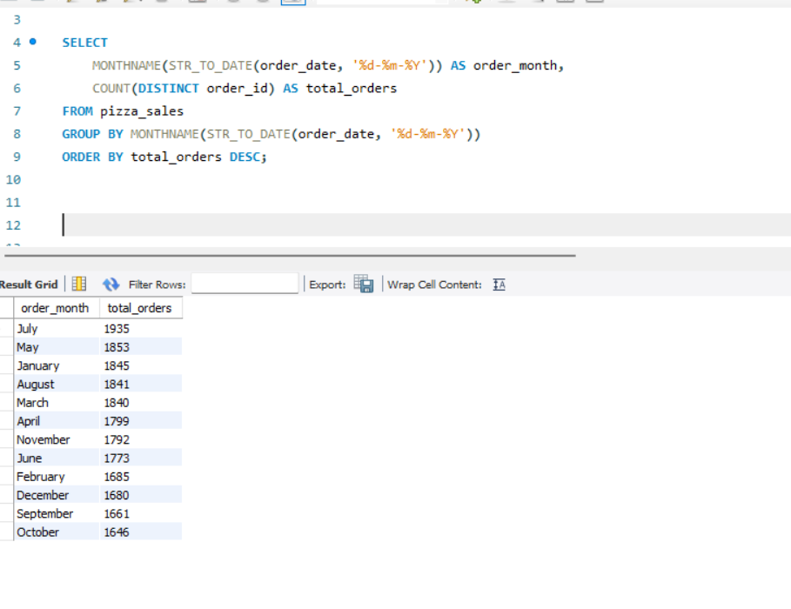

D . % of Sales by Pizza Category

SELECT pizza_category,

SUM(total_price)*100/(SELECT SUM(total_price) FROM pizza_sales) AS Total_Sales

FROM pizza_sales

GROUP BY pizza_category;

Output:

E . % of Sales by Pizza Size

SELECT pizza_size,

ROUND(SUM(total_price*100/(SELECT SUM(total_price) FROM pizza_sales),2) AS PCT

FROM pizza_sales

GROUP BY pizza_size;

Output:

F . Total Pizzas Sold by Pizza Category

SELECT pizza_category, SUM(quantity AS Total_Quantity_Sold

FROM pizza_sales

GROUP BY pizza_category

ORDER BY Total_Quantity_Sold DESC;

Output:

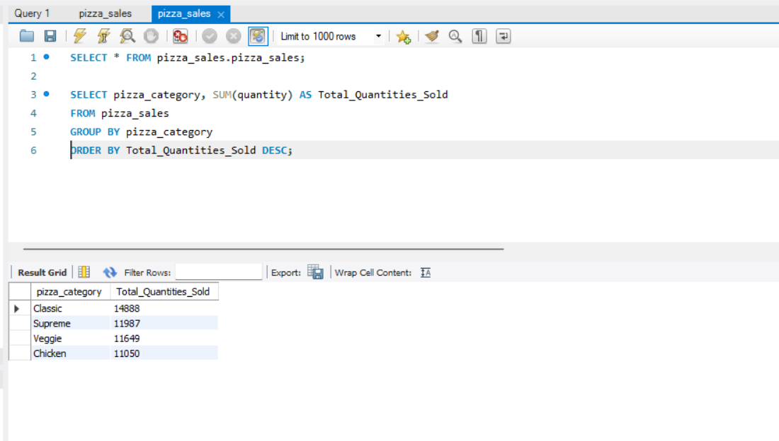

G . Top 5 Pizzas by Revenue

SELECT pizza_name , SUM(total_price) AS Total_Revenue

FROM pizza_sales

GROUP BY pizza_name

ORDER BY Total_Revenue DESC LIMIT 5;

Output:

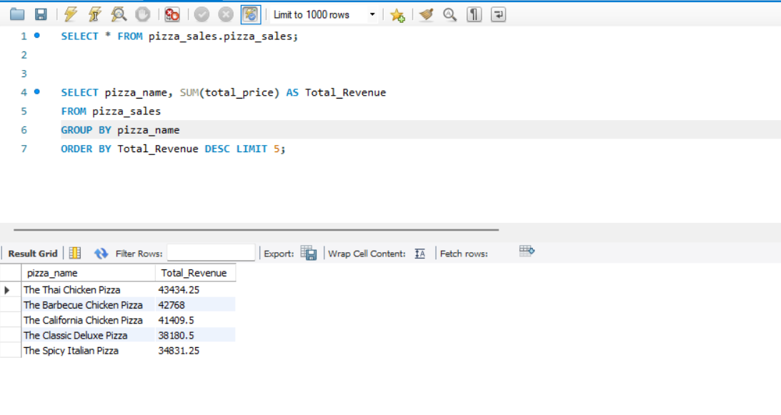

H . Bottom 5 Pizzas by Revenue

SELECT pizza_name , SUM(total_price) AS Total_Revenue

FROM pizza_sales

GROUP BY pizza_name

ORDER BY Total_Revenue ASC LIMIT 5;

Output:

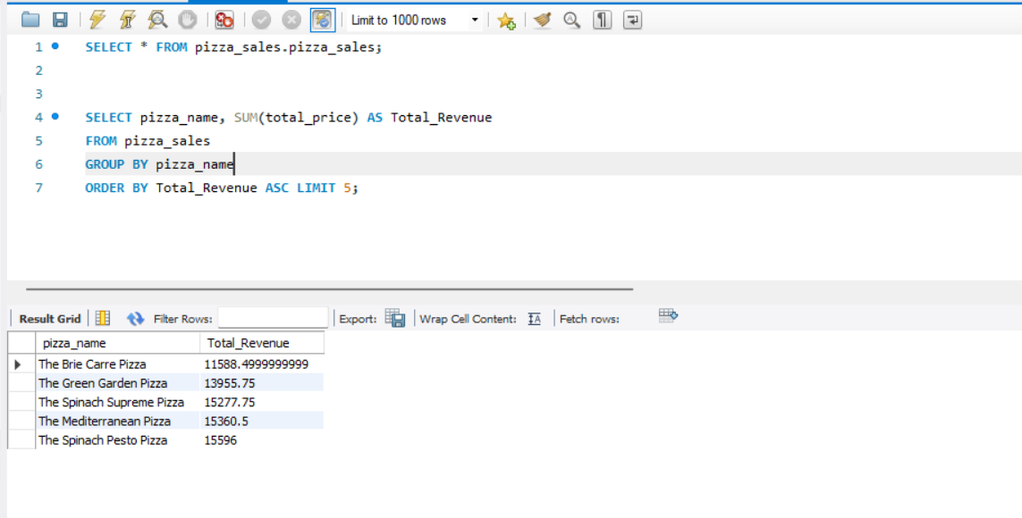

I . Top 5 Pizzas by Quantity

SELECT pizza_name , SUM(quantity) AS Total_Quantity

FROM pizza_sales

GROUP BY pizza_name

ORDER BY Total_Quantity DESC LIMIT 5;

Output:

J . Bottom 5 Pizzas by Quantity

SELECT pizza_name , SUM(quantity) AS Total_Quantity

FROM pizza_sales

GROUP BY pizza_name

ORDER BY Total_Quantity ASC LIMIT 5;

Output:

K . Top 5 Pizzas by Total Orders

SELECT pizza_name , COUNT(DISTINCT order_id) AS Total_Orders

FROM pizza_sales

GROUP BY pizza_name

ORDER BY Total_Orders DESC LIMIT 5;

Output:

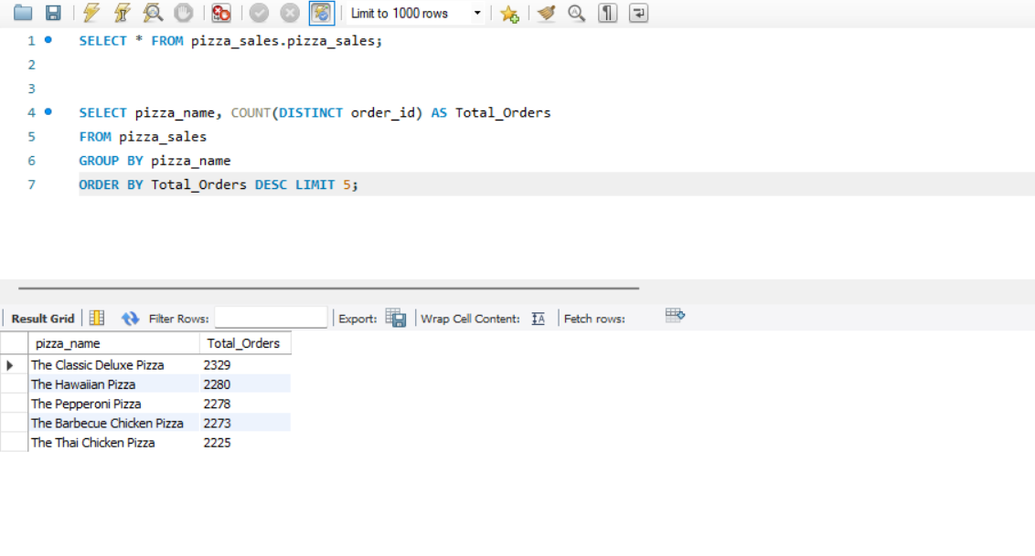

L . Bottom 5 Pizzas by Total Orders

SELECT pizza_name , COUNT(DISTINCT order_id) AS Total_Orders

FROM pizza_sales

GROUP BY pizza_name

ORDER BY Total_Orders ASC LIMIT 5;

Output:

