Customer Shopping Behavior Data Analysis

- Project Overview:
In this project I have analyzed ‘Customer Shopping Behavior’ data. This dataset has contains the 3900 purchase records across various product categories.
The goal is to uncover insights into spending patterns, customer segments, product preferences and subscription behavior to guide strategic business decisions.

- Dataset Summary :
- Rows : 3900
- Columns : 18
- Key Features:
- Customer Demographics (Age, Gender, Location, Subscription Status)
- Purchase details (Item Purchased, Category, Purchase Amount, Season, Size)
- Shopping behavior (Discount Applied, Promo Code Used, Previous Purchases, Frequency of Purchases, Review Rating, Shipping Type)
- Missing Data: 37 values in Review Rating Column

- Exploratory Data Analysis using Python
I have began with data preparation and cleaning in Python:
- Data Loading : imported the dataset using Pandas.
- Initial Exploration: Used df.info() to check structure and .describe() for summary statistics.
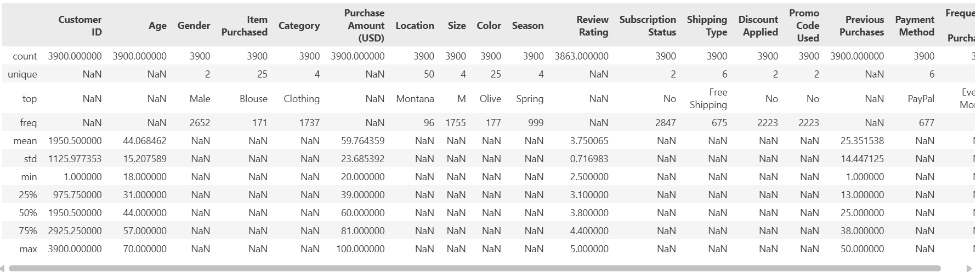

- Missing Data Handling : Checked for null values and imputed missing values in the Review Rating Column using the median rating of each product category.

