Weather Data Analysis – Project Report

This report summarizes the analysis performed in the Jupyter Notebook titled “Weather Data Analysis”. The project involves exploring a real-world weather dataset containing 8,784 observations and 8 key meteorological variables.

1. INTRODUCTION
The goal of this project is to perform exploratory data analysis on weather conditions, extract useful patterns, analyze distribution of weather events, and compute statistical insights.
Data set is loaded using python pandas library.
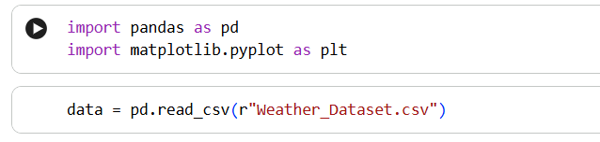
2. DATASET OVERVIEW
Columns:
- Date/Time
- Temperature (°C)
- Dew Point Temperature
- Relative Humidity (%)
- Wind Speed (km/h)
- Visibility (km)
- Pressure (kPa)
- Weather Condition
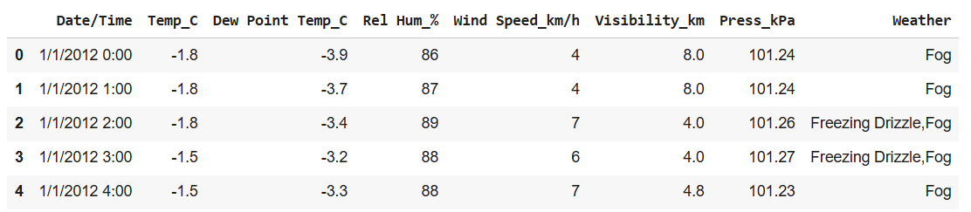
Total Rows: 8784
Total Columns: 8
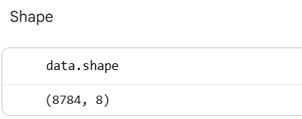
3. INITIAL DATA INSPECTION
- All columns contained non-null values.
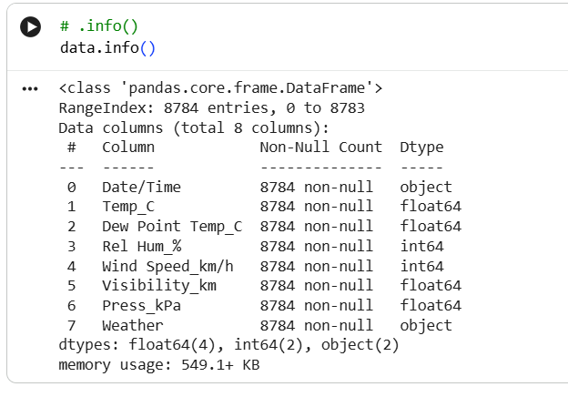
- Data types included float, integer, and object (strings).
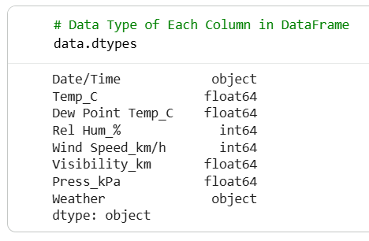
- Unique Weather Conditions: 50+ (Fog, Clear, Rain, Snow, etc.)
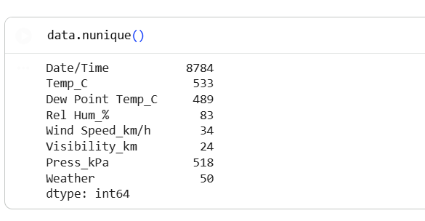
4. KEY ANALYSIS PERFORMED
a. Displaying head(), shape, columns, and dtypes of dataset.
b. Counting unique values using .unique() and .nunique().
c. Value distribution of weather conditions using value_counts().

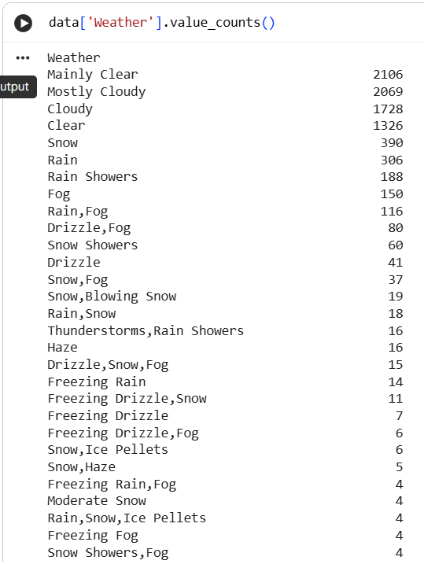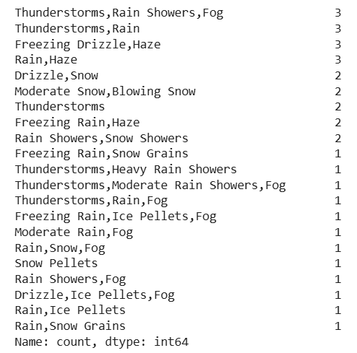

d. Identifying rows where:
- Weather is exactly "Clear"
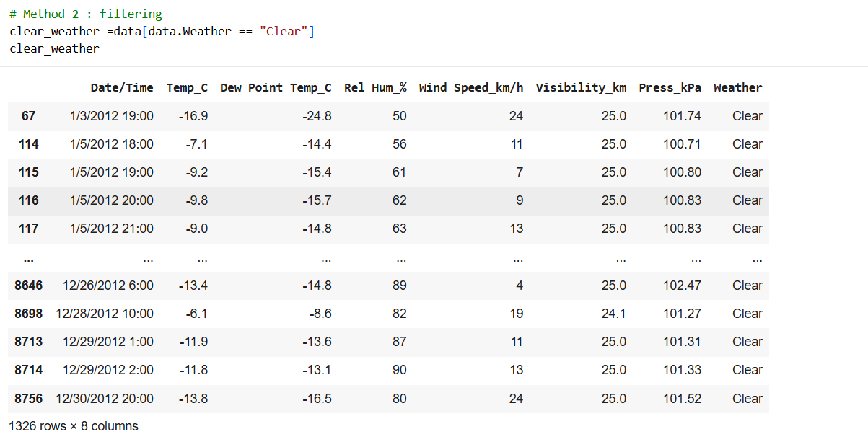
- Wind Speed = 4 km/h
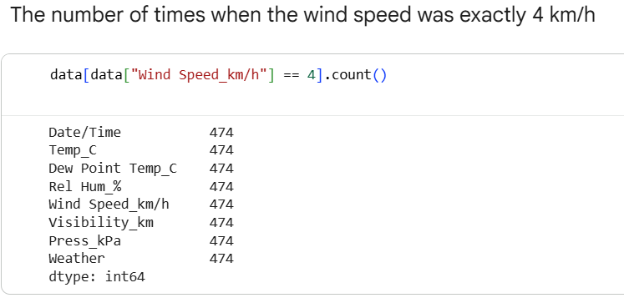
- Snow or Snow-related conditions occurred

e. Checking for null values using isnull().
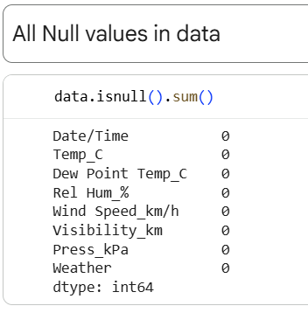
f. Renaming “Weather” column to “Weather Condition”.
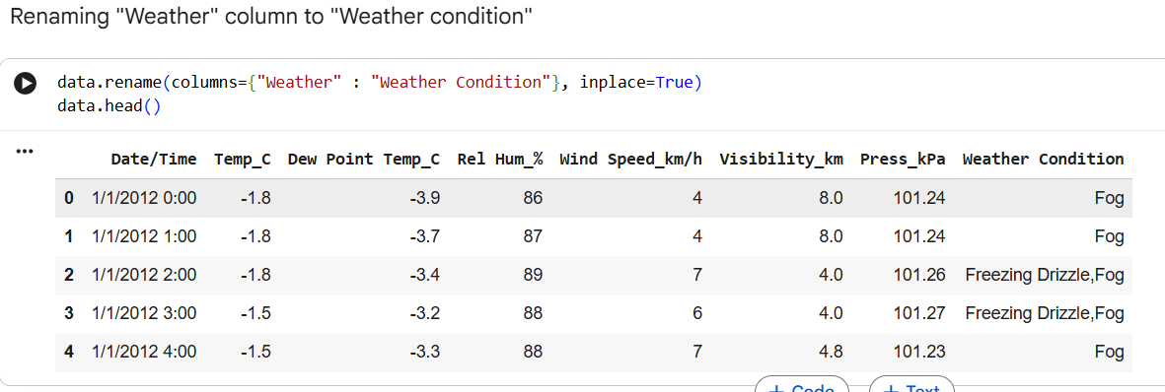
g. Statistical computations:
- Mean visibility ≈ 27.66 km
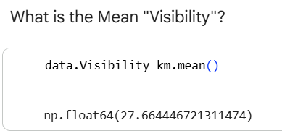
- Standard deviation of pressure ≈ 0.84 kPa
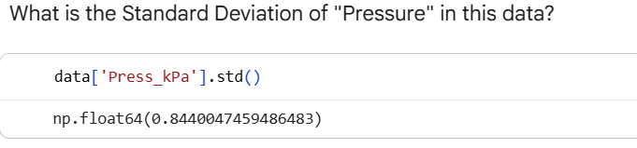
- Variance of relative humidity ≈ 286.24
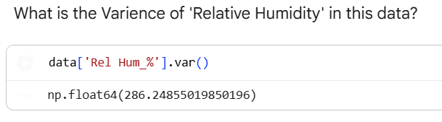

5. CONCLUSION
This project demonstrates the use of Python pandas for effective weather data analysis. It highlights
methods for handling large datasets, performing descriptive statistics, filtering data, and extracting
meaningful insights. The dataset shows a wide range of weather patterns across an annual timespan.

