**BLINKIT Analysis**

Exploring the data using SQL

* See all data imported:

SELECT * FROM blinkit_data

* DATA CLEANING:

Cleaning the Item_Fat_Content field ensures data consistency and accuracy in analysis. The presence of multiple variations of the same category (e.g., LF, low fat vs. Low Fat) can cause issues in reporting, aggregations, and filtering. By standardizing these values, we improve data quality, making it easier to generate insights and maintain uniformity in our datasets.

UPDATE blinkit_data

SET Item_Fat_Content =

CASE

WHEN Item_Fat_Content IN ('LF', 'low fat') THEN 'LowFat'

WHEN Item_Fat_Content = 'reg' THEN 'Regular'

ELSE Item_Fat_Content

END;

After executing this query check the data has been cleaned or not using below query

SELECT DISTINCT Item_Fat_Content FROM blinkit_data;

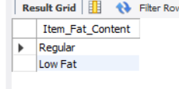

**A. KPI’s**

**1.Total Sales:**

SELECT CAST(SUM(Total_Sales) / 1000000.0 AS DECIMAL(10,2)) AS Total_Sales_Million

FROM blinkit_data;

This code displays the total sales in millions

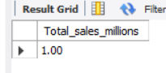

**2.Average Sales:**

SELECT CAST(AVG(Total_Sales) AS INT) AS Avg_Sales

FROM blinkit_data;

This code displays the total average of sales

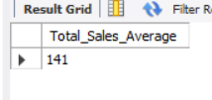

**3.Number of Sales**

SELECT COUNT(*) AS No_of_Orders

FROM blinkit_data;

This code shows the total number of transactions in the dataset

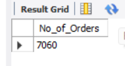

**4.Average Rating**

SELECT CAST(AVG(Rating) AS DECIMAL(10,1)) AS Avg_Rating

FROM blinkit_data;

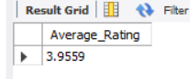

**B.Total Sales by Fat Content**

SELECT Item_Fat_Content, CAST(SUM(Total_Sales) AS DECIMAL(10,2)) AS Total_Sales

FROM blinkit_data

GROUP BY Item_Fat_Content

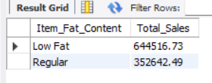

**C. KPI’s by Item Type**

SELECT

Item_Type,

COUNT(*) AS total_items,

CAST(SUM(Total_Sales) AS DECIMAL (10 , 2 )) AS Total_Sales,

CAST(AVG(Total_Sales) as DECIMAL(10,0)) as Total_Sales_Average ,

CAST(AVG(Rating) AS DECIMAL (10 , 2 )) AS Average_Rating

FROM

blinkit_data

GROUP BY Item_Type

ORDER BY Total_Sales DESC;

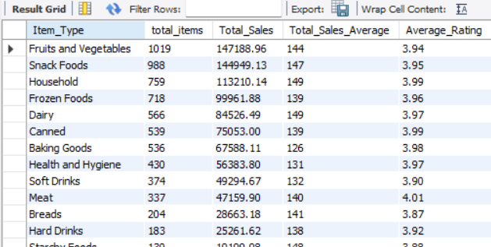

**D. Total sales of fat content on Outlet location type**

SELECT Outlet_Location_Type,

ROUND(SUM(CASE WHEN Item_Fat_Content='Low Fat' THEN Total_Sales ELSE 0 END)) AS Low_Fat,

ROUND(SUM(CASE WHEN Item_Fat_Content='Regular' THEN Total_Sales ELSE 0 END)) AS Regular,

ROUND(SUM(CASE WHEN Item_Fat_Content='Low Fat' THEN Total_Sales ELSE 0 END) + SUM(CASE WHEN Item_Fat_Content='Regular' THEN Total_Sales ELSE 0 END)) AS Total_Sales

FROM blinkit_data

group by Outlet_Location_Type;

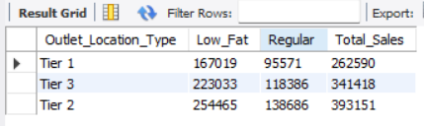

**E. Total sales by Outlet establishment**

SELECT Outlet_Establishment_Year, ROUND(SUM(Total_Sales),2) AS Total_Sales

FROM blinkit_data

GROUP BY Outlet_Establishment_Year

ORDER BY Outlet_Establishment_Year;

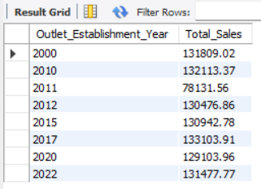

**F. Percentage of Sales by Outlet Size**

SELECT Outlet_Size, round(sum(Total_Sales)) as Total_Sales,

concat(Round((sum(Total_Sales)*100 / sum(sum(Total_Sales)) over()),2), '%') AS Sales_Percentage from blinkit_data

group by Outlet_Size;

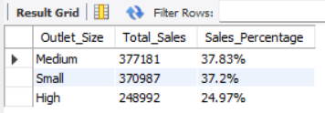

**E. All metrics on outlet type**

SELECT Outlet_Type,

round(sum(Total_Sales),2) AS Total_Sales,

round(avg(Total_sales),2) as Average_Sales,

count(*) AS No_of_Items,

round(AVG(Rating),2) as Average_Rating,

round(AVG(Item_visibility),2) AS Item_Visibility

FROM blinkit_data

group by Outlet_Type

order by Total_Sales desc;

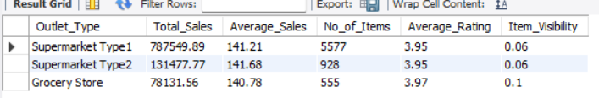

**Insights from The SQL Data Analysis**

**Customer Preference for Low-Fat Items**

Analyzing total sales by item fat content reveals a clear customer preference for "Low Fat" items. "Low Fat" products generated $644,516.73 in total sales, significantly outperforming "Regular" items which accounted for $352,642.49 in sales. This disparity strongly suggests that customers are more inclined to purchase products labeled as "Low Fat," indicating a potential trend in consumer behavior towards healthier options or a perception of such products being more desirable. This insight can inform inventory management, marketing strategies, and product development to align with customer preferences

**Dominance of Fruits, Vegetables, and Snack Foods Categories**

Fruits and Vegetables" and "Snack Foods" emerge as the top two performing categories in terms of total sales. "Fruits and Vegetables" generated $147,188.96 in sales, closely followed by "Snack Foods" with $144,949.13 in sales. This indicates a strong customer preference for ready-to-eat options and essential produce over meal-like ingredients or other item types. This trend suggests that consumers may be prioritizing convenience and healthier snacking or fresh produce choices in their purchases.

**Sales Performance Across Outlet Sizes**

When analyzing total sales by outlet size, the order of sales volume is "Medium" > "Small" > "High." "Medium" outlets generated the highest total sales at $377,181 (37.83%), closely followed by "Small" outlets with $370,987 (37.2%). "High" outlets recorded $248,992 (24.97%) in total sales. While "Medium" outlets lead, the sales difference between "Medium" and "High" outlets is substantial, at over $128,000. However, it's particularly noteworthy that "Medium" and "Small" outlets perform almost identically in terms of total sales and percentage contribution, indicating both sizes are highly effective sales channels.

**"Supermarket Type 1" as Key Sales Driver**

Among the outlet types, "Supermarket Type 1" significantly dominates in total sales and item volume. "Supermarket Type 1" generated $787,549.89 in total sales from 5,577 items, while "Supermarket Type 2" had $131,477.77 in total sales from 928 items, and "Grocery Store" recorded $78,131.56 in total sales from 555 items. Although the average sales per transaction and average ratings are remarkably similar across all three outlet types (around $141 and 3.95 respectively), the substantial difference in the number of items sold clearly highlights "Supermarket Type 1" as the primary driver of volume and overall revenue

**Quick overview of all the insights above**

* **Low-Fat Product Preference:** Customers show a clear preference for "Low Fat" items over "Regular" ones.
* **Top-Selling Categories:** "Fruits and Vegetables" and "Snack Foods" are the highest-performing categories, indicating a demand for convenience and fresh produce.
* **Tier 2 Outlets Lead Sales:** "Tier 2" outlets generate the highest total sales among all location types, with "Medium" and "Small" outlet sizes performing similarly well.
* **"Supermarket Type 1" Dominance:** "Supermarket Type 1" is the primary driver of sales volume and overall revenue, significantly outselling other outlet types