1. **Query : List all Customers along with their city who placed an order on or after ‘2023-01-01’ …?**

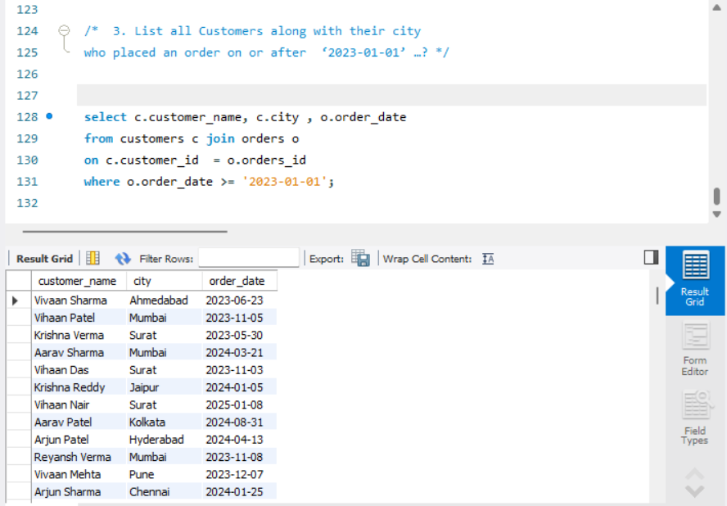

1. **Query : show resturants name and order ids for order placed from resturants Mumbai**

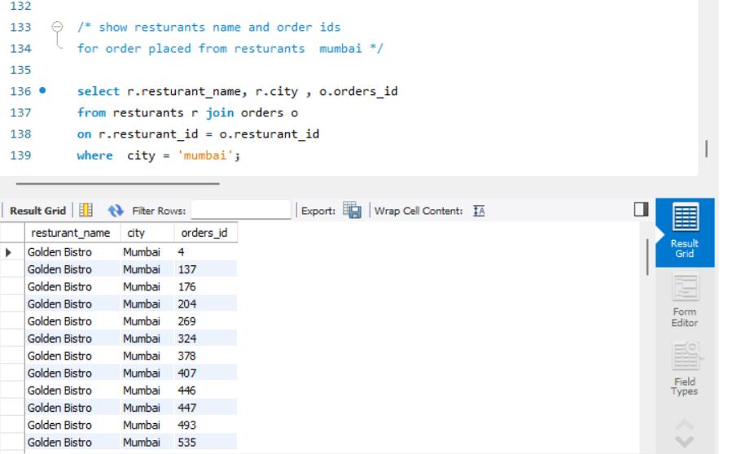

1. **Query : Customers who have ordered from specific resturants ( - any name of choice )**

