



1. **Query : Find the Total Number of times each food item was ordered**

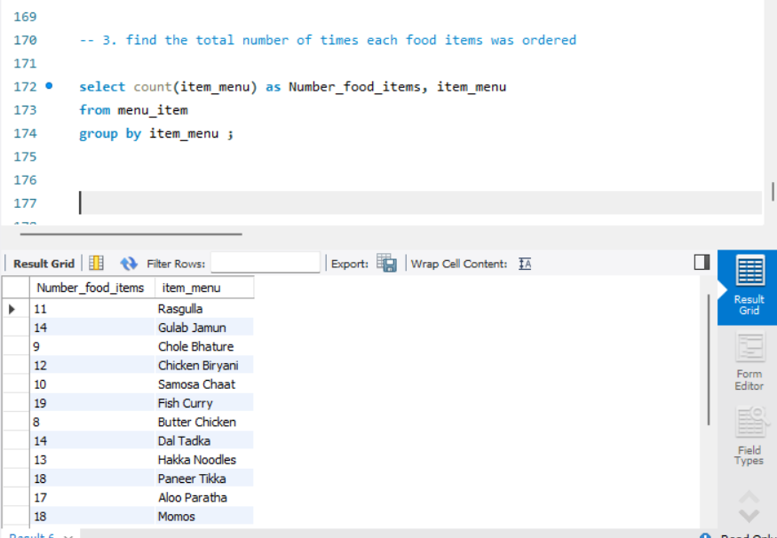

1. **Query : Calculate the average order value for each customer city**

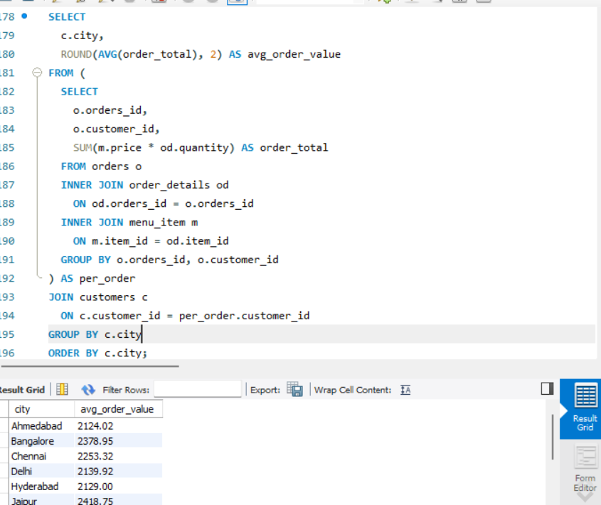

1. **Query : Find how many different food items were ordered per restaurant**

