1. **Query : List customers who placed more than 3 orders**

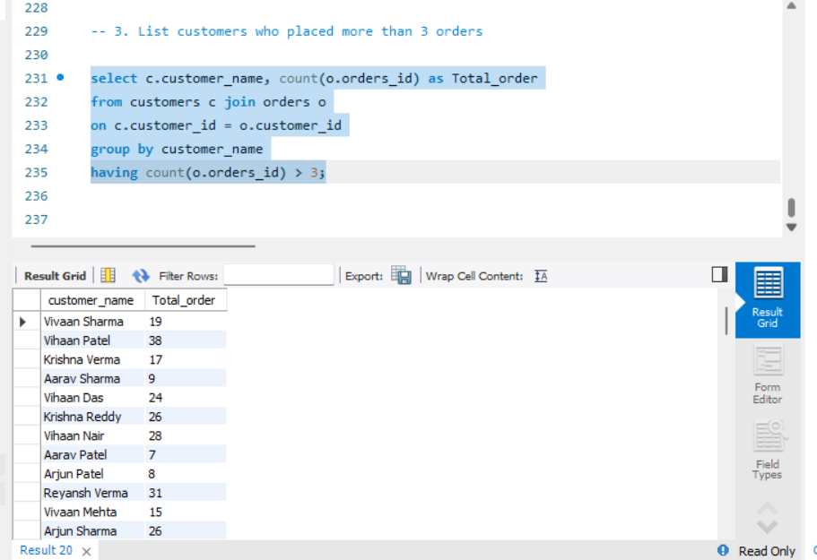

1. **Query : display menu items that were ordered more than 2 times**

1. **Query : Find categories where the average item price is greater than 300/-**

