1. **Show each food item and below how much more it costs than the average..?**

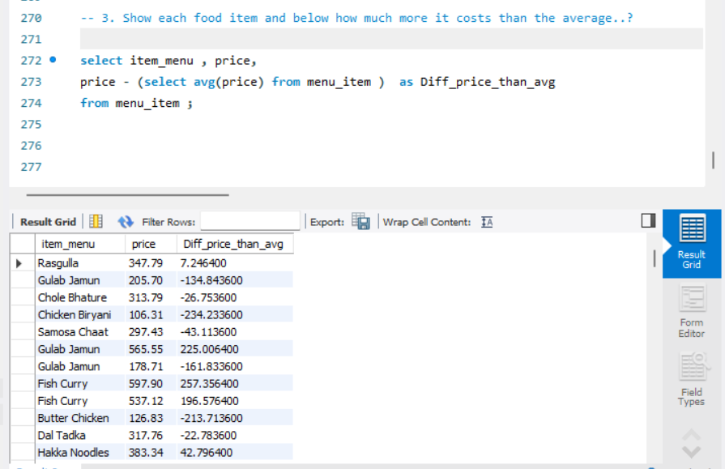

**2. List Food items that cost more than the average price**

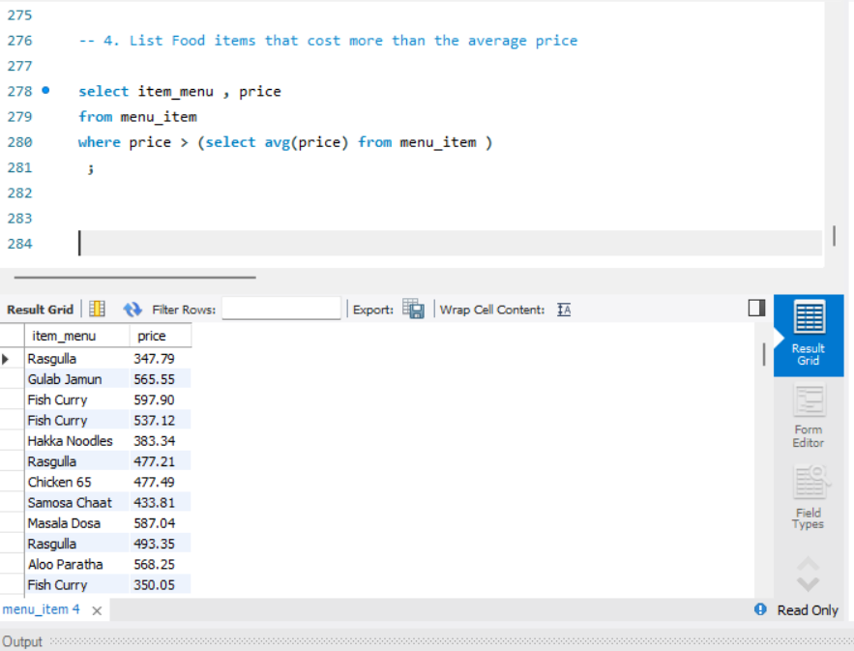

1. **Show Customer who haven’t placed any order**

