1. **Top Spending customers**

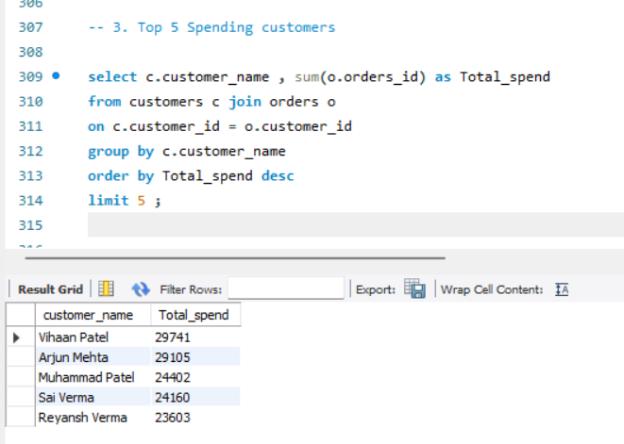

1. **Resturant Wise Order Counts**

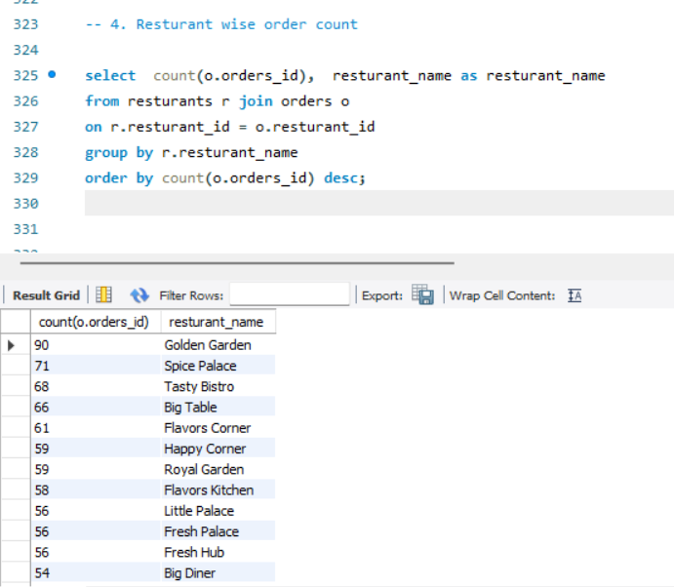

1. **Average Order value Per city**



