

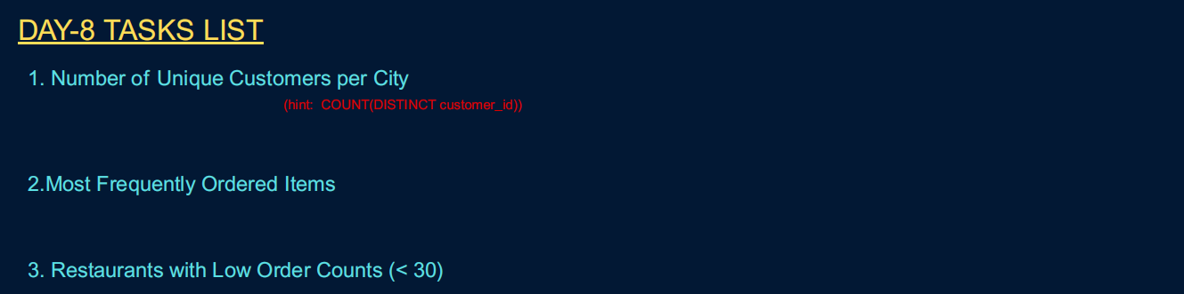

1. Number of unique customers per cities .

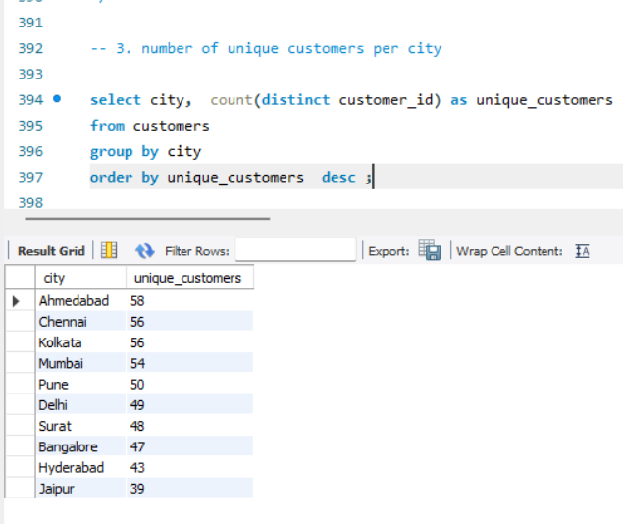

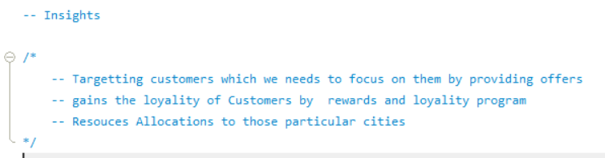

1. Most Frequents Order items

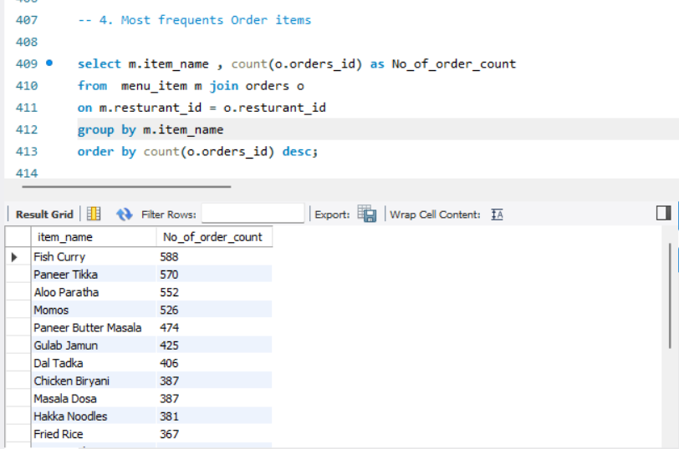

1. Resturants with low orders Counts less than 30



