

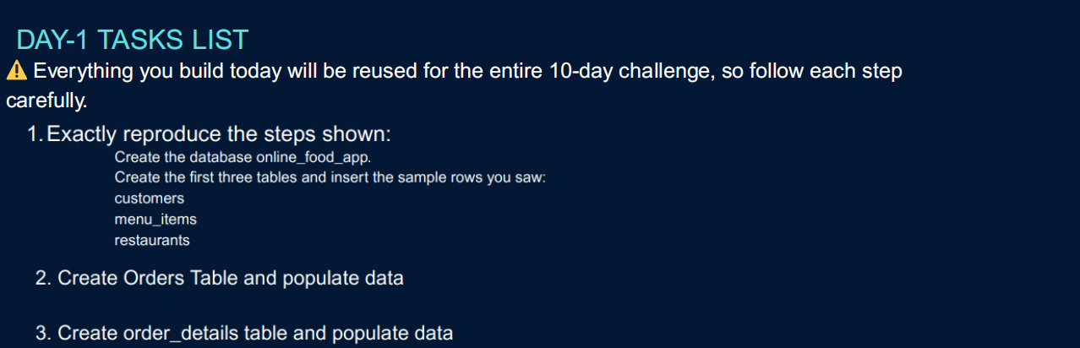

**2. Create the orders table and Populate data**

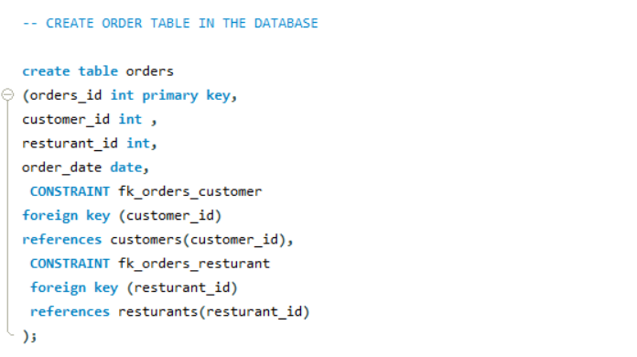

**3. Create orders_details table and populated the data**



