



**3.Query 3 : List all restaurants located in Delhi**

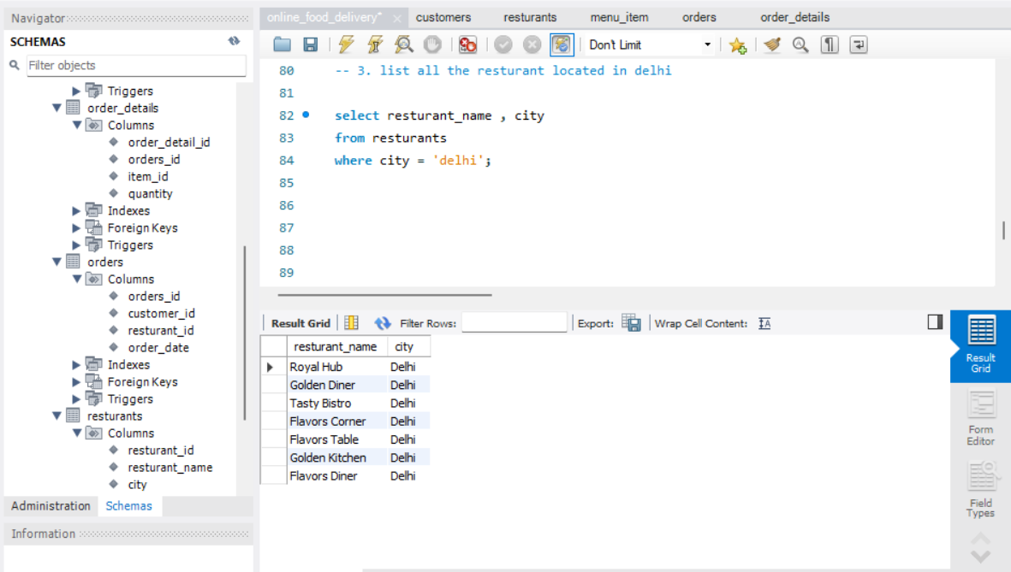

2.Query 4 : Show Top Three most expensive menu items

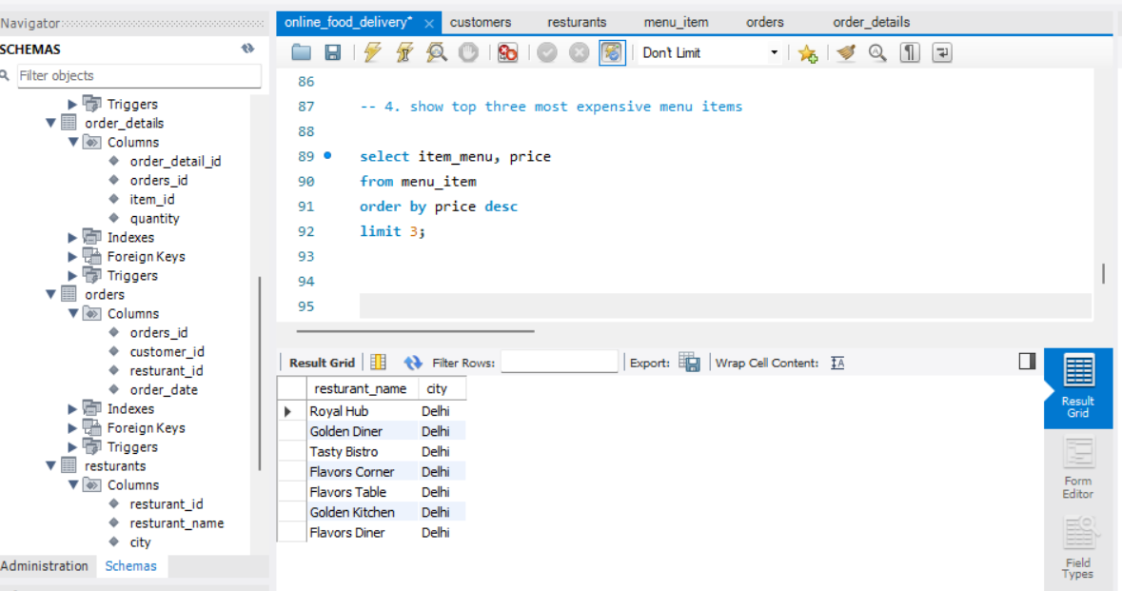

**3. Query : List order IDs where quantity is greater than 2**

