Project
Low Dropout Regulator

By: Amar Bharat Khatri

- Introduction

The objective of this project was to design a fully integrated Low Dropout (LDO) voltage regulator operating from a 1.8 V input to generate a regulated 1.6 V output for load currents ranging from 20 mA to 100 mA. The design targeted high power efficiency (≥ 91.1%), PSRR of around −40 dB at 100 kHz, low output voltage error, and tight line and load regulation. To ensure on-chip integration, the output and compensation capacitors were constrained to 500 pF and 15 pF, respectively. The regulator was also designed to achieve fast transient response with minimal voltage overshoot/undershoot and stable operation across the specified temperature range.

- Circuit Diagram

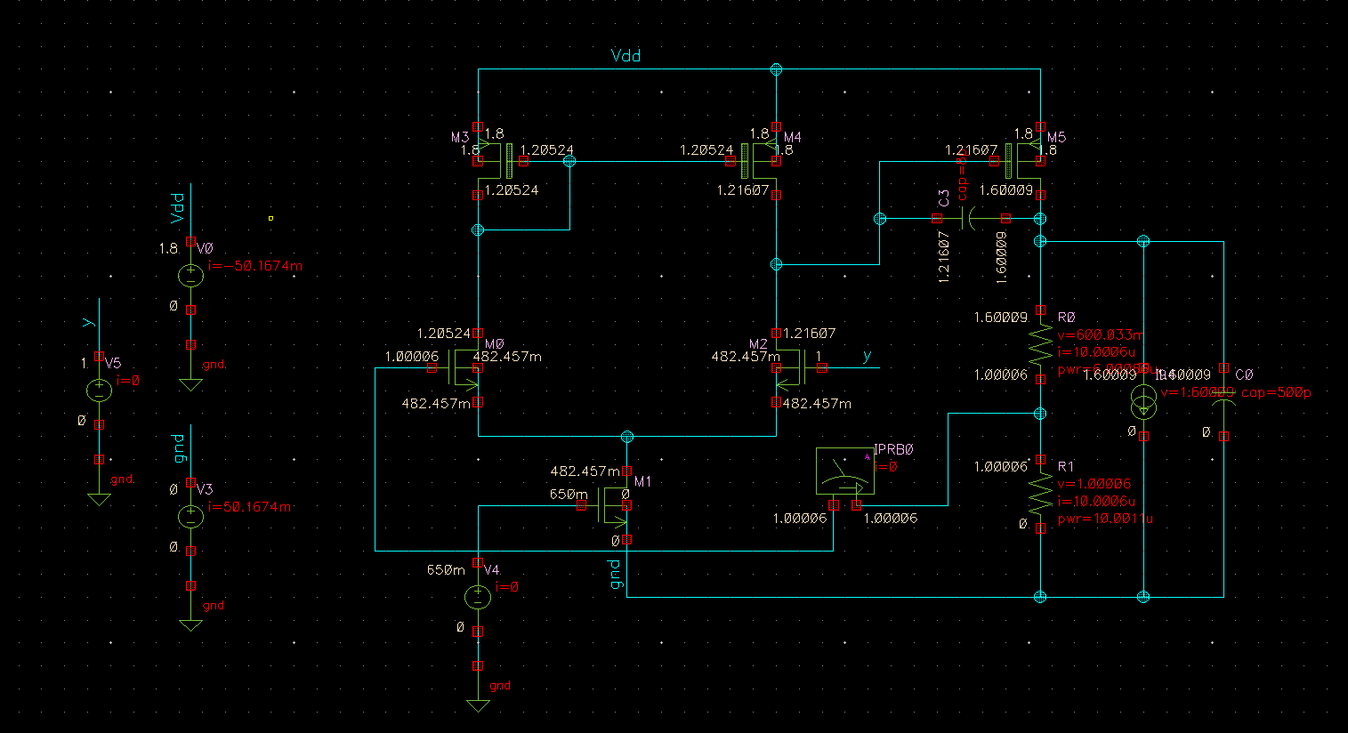
Fig 1: LDO Schematic

Parameters | Values
Vin | 1.8V
Load Capacitance | 500p F
Vref | 1V
R1 | 60K
R2 | 100K
Load current range | 20mA to 100mA
Nominal Load | 50mA
Miller Capacitor | 8p
Table1 : Parameters

Calculations:

- Transistor Sizing:

Transistor | Width (W) (um) | Length (L) (um) | Multiplier | W/L | Vov (mV) (Nominal)
M3 &M4 (Pmos current mirror) | 85 | 1 | 1 | 85/1 | 186
M0 & M2 (Nmos diff Pair) | 45 | 1 | 1 | 45/1 | 95
M1 (Tail of OTA) | 75 | 5 | 1 | 75/1 | 190
M5 (Pass Transistor) | 100 | 0.18 | 200 | 20000/0.18 | 101
Table 2 : Sizings

- Stability Table:

Load (mA) | Phase Margin | BandWidth | Loop Gain | Gain Margin
20 | 62.865 degree | 7.49M | 69.78 dB | 16.474 db
50 | 68.32 degree | 7.29M | 67.57 dB | 19.908 dB
100 | 71.269 degree | 6.69M | 63.25 dB | 22.883 dB
Table 3: Stability

- Power Consumption Table:

Blocks | Light Load | Nominal Load | Full Load
OTA | 282.6 uW | 282 uW | 284 uW
Feedback resistors | 16 uW | 16 uW | 16 uW
Pass Transistor | 4 mW | 10 mW | 20 mW
Table 4: Power

- Line regulation: Target was to achieve < 1% variation for variation of 2% of Line Voltage above and below Vout = 1.6.

Achieved..

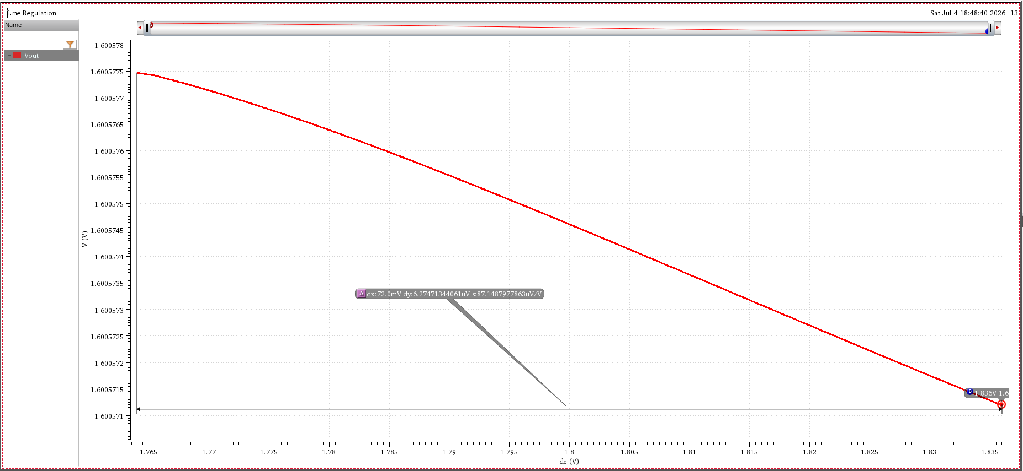
Plot : Line regulation.

- Load Regulation: Target was to achieve < 2% variation from light load to full load.

Achieved..

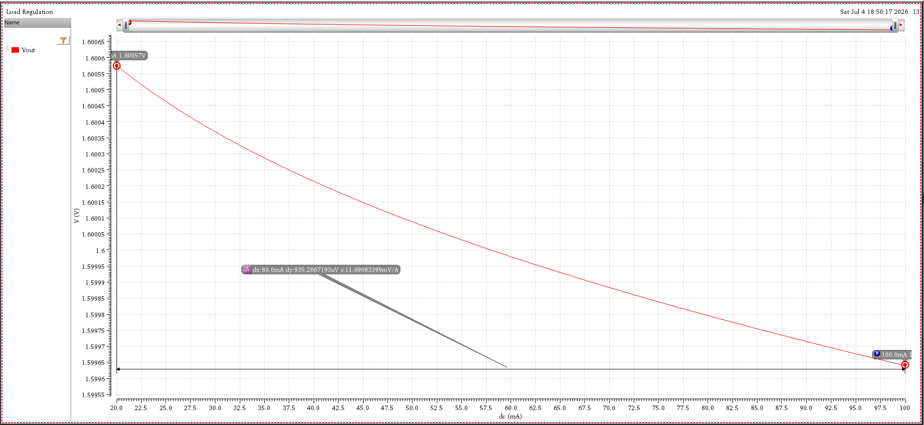
Plot : Load Regulation

- Power Supply Rejection Ratio : Target @100Hz approx -40db

Achieved..
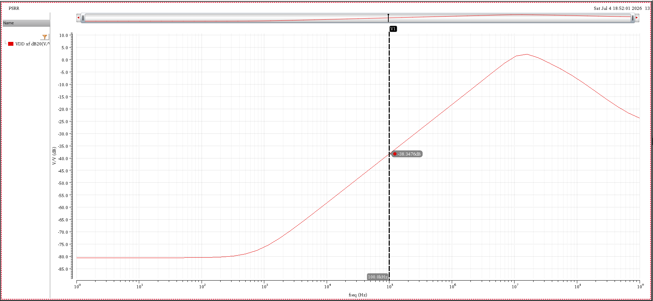
Plot : PSRR (Vdd)

- Transient Response : Target ≤ 150 mV overshoot/undershoot for a 20 mA to 50 mA load step (both up and down with edge time of 10 ns) with settling time (output voltage within ±2% of the regulated value) less than 150 ns.

Achieved..

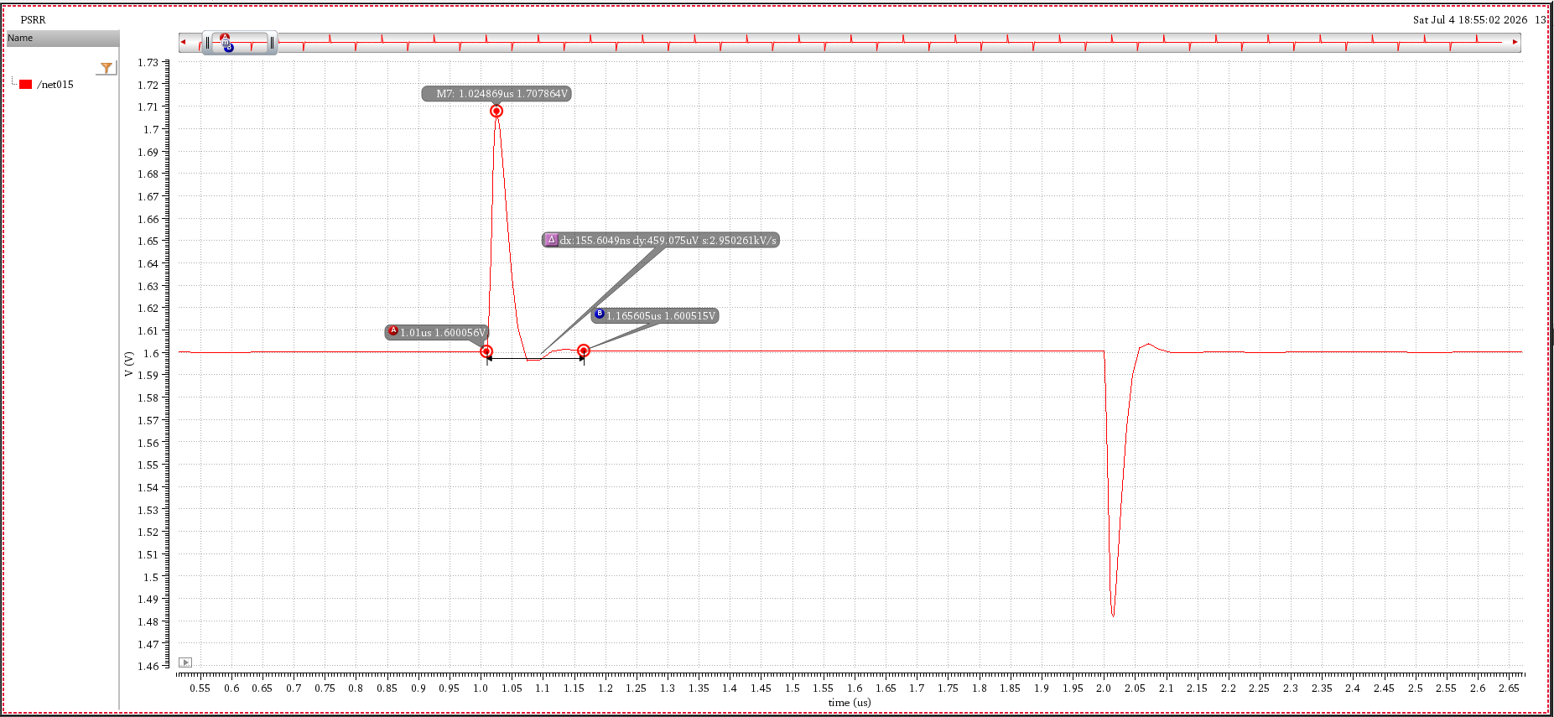
Plot : Transient response with overshoot

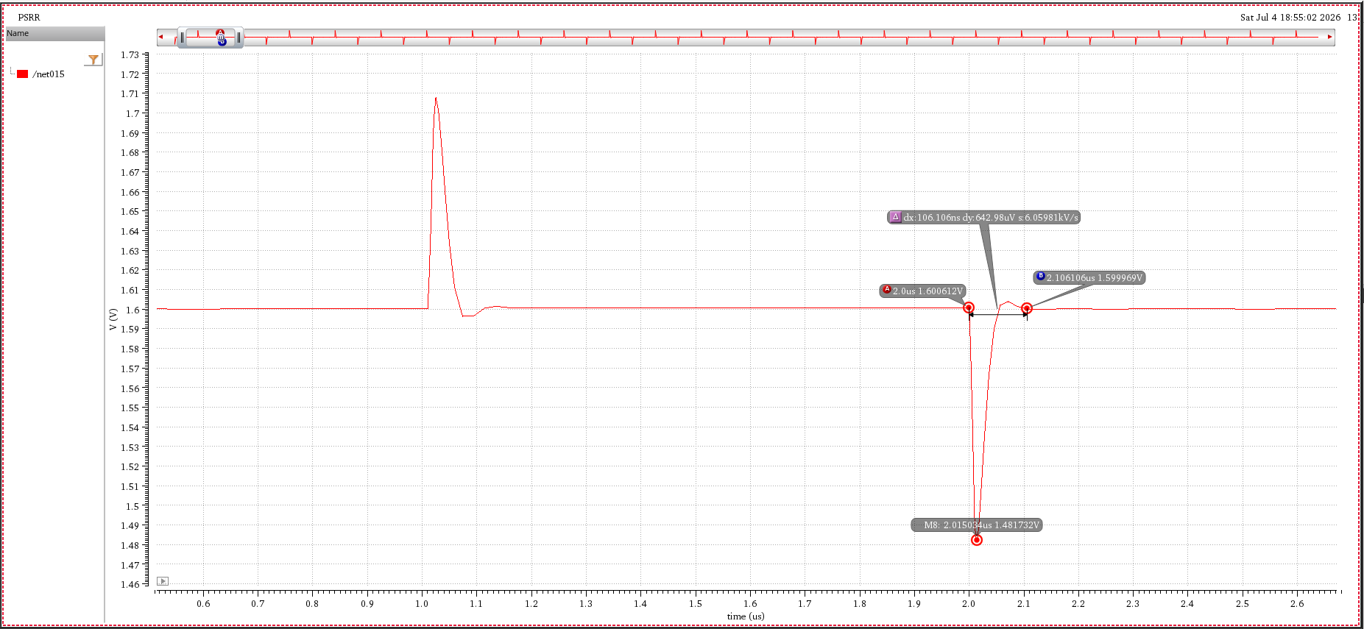
Plot : Transient response with undershoot.

- Loop Stability graphs:

- I_load = 20mA (Light Load)

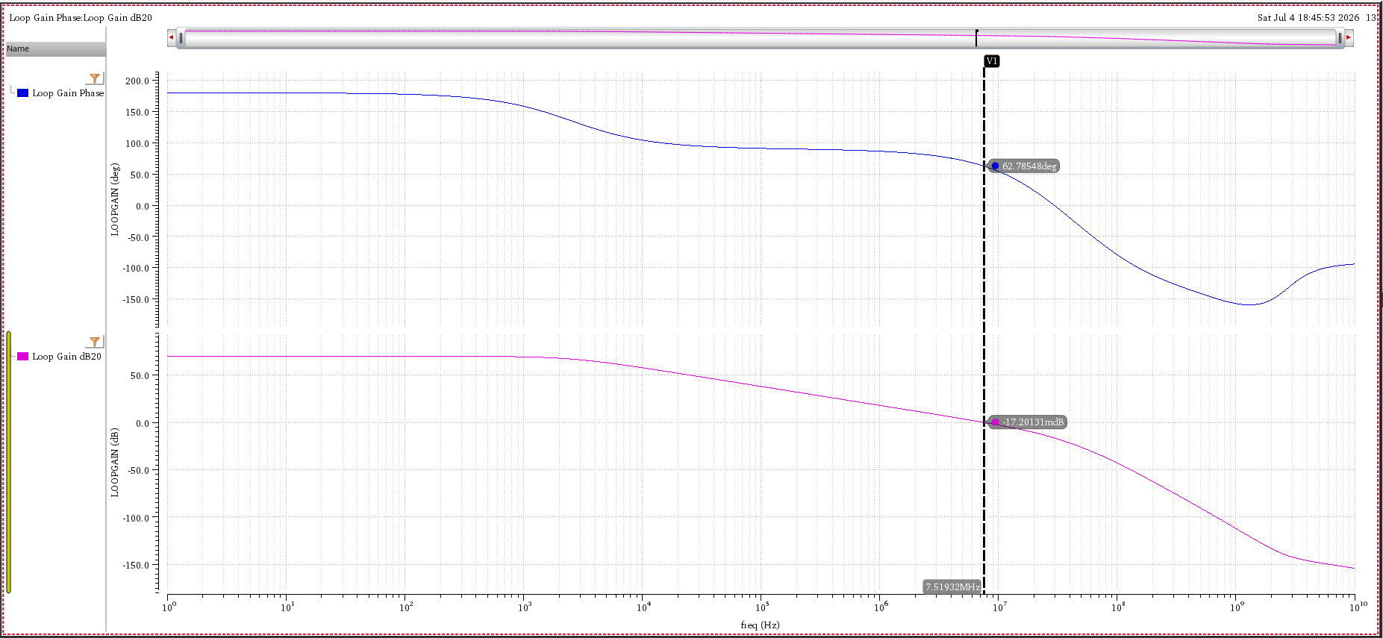

- I_load = 50mA (Nominal Load)

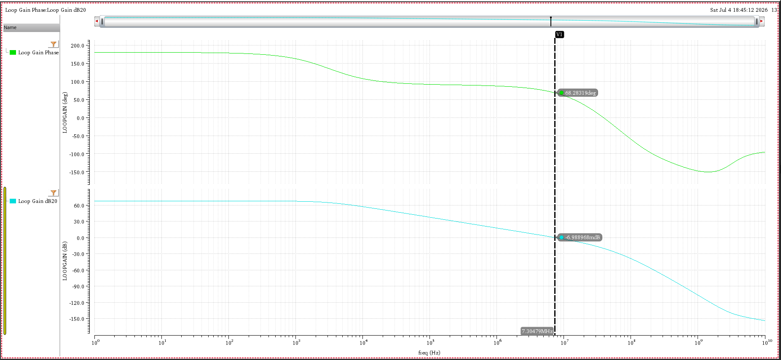

- I_load = 100mA (Full Load)

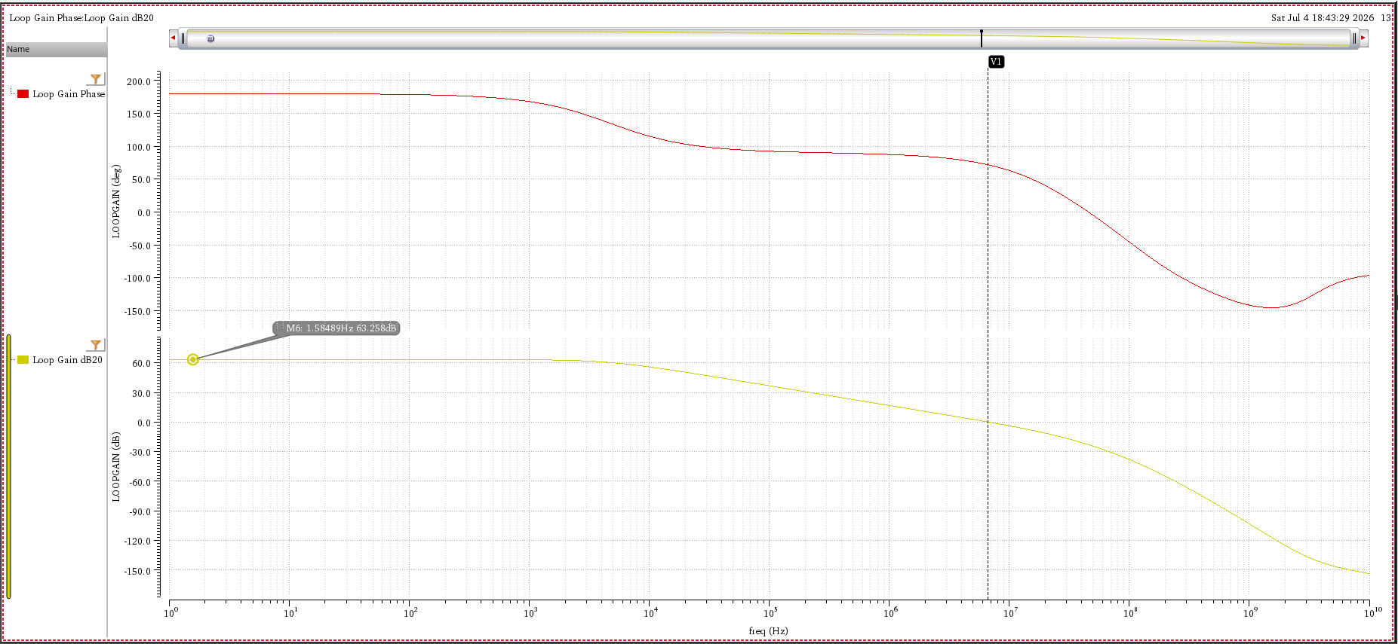

- Final Summary Table:

Parameters | Results
PSRR | -38.347 @ 100KHz
Load Regulation ( ΔVout/ΔLoad *100) | <1.1% across load range
Line Regulation | <0.862% for ± 2% of Input Voltage
Phase Margin | > 63° across load range
Efficiency | > 88.45% across Load Range
DC error | 0.09mV at Nominal Load and <57mV across Load Range
Transient response | Settling Time < 155ns
 | Overshoot and Undershoot < 120mV
Table 5: Summary

