SE LAB-1
Name:Amar
SRN:PES1UG24AM340
SEC:’F’
DATE:21/08/2026
Software Engineering Lab 1
Requirements Table
Problem Statement #40: Student Startup Crowdfunding Platform
Req ID | Type | Description | Priority | Acceptance Criteria | Rationale | Comments
FR-001 | Functional | The system shall collect backer pledges and disburse funds to the student venture in tranches only upon verification of predetermined project milestones. | High | Pass: Milestone evidence is reviewed and the corresponding tranche is released only after approval.  Fail: Campaign funds are released without milestone sign-off. | Ensures secure and milestone-based funding.
FR-002 | Functional | The system shall allow a Student Founder to create and publish a crowdfunding campaign with funding targets and project details. | High | Pass: The founder enters valid mandatory campaign details and the campaign is successfully created and displayed.  Fail: A campaign is created with missing mandatory details. | Required for student ventures to raise funds.
FR-003 | Functional | The system shall allow a Campaign Backer to browse available campaigns and select a campaign for funding. | High | Pass: The system displays available campaigns and allows the backer to open campaign details.  Fail: Available campaigns cannot be viewed or selected. | Allows backers to discover student ventures.
FR-004 | Functional | The system shall allow a Campaign Backer to select a reward tier before confirming a pledge. | Medium | Pass: The selected reward tier is displayed with its associated pledge amount or benefit.  Fail: The system records a reward tier that was not selected by the backer. | Supports reward-based crowdfunding.
FR-005 | Functional | The system shall allow the Faculty Committee to review submitted milestone evidence and approve or reject the milestone. | High | Pass: The committee can approve or reject submitted milestone evidence, and the decision is recorded.  Fail: Funds are released without an approval decision. | Ensures accountability before fund release.
NFR-001 | Non-Functional | The system shall process payment transactions through a payment gateway compliant with PCI-DSS guidelines using tokenized payment authorizations. | High | Pass: Payment transactions use tokenized authorization and meet the required security standard during testing.  Fail: Sensitive payment information is processed without the required security protection. | Protects backer payment information.
NFR-002 | Non-Functional | The system shall display campaign search and browsing results within 3 seconds under normal operating conditions. | Medium | Pass: Test results show campaign results loading within 3 seconds.  Fail: Results take more than 3 seconds. | Provides a smooth experience for backers.

UML Diagram:
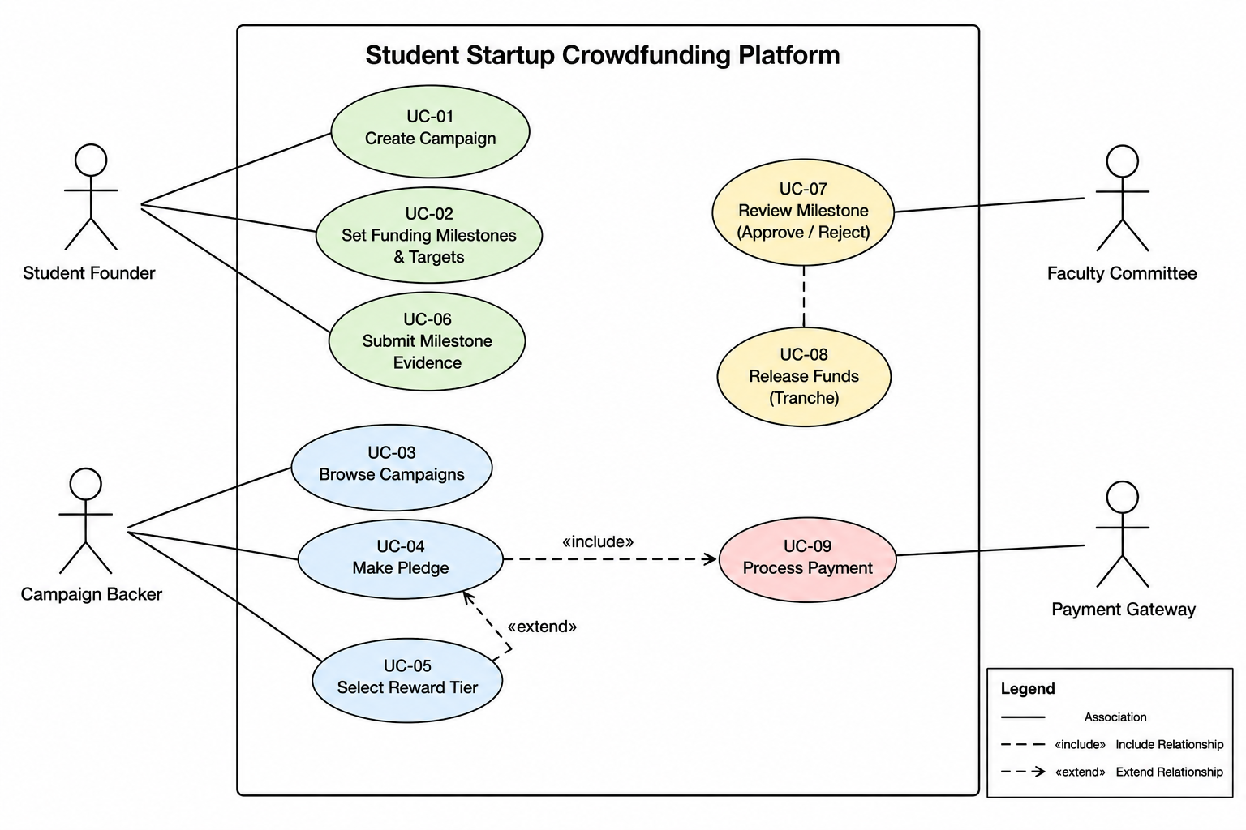

Software Engineering Lab 1
Use-Case Flow Specification

Problem Statement: Student Startup Crowdfunding Platform
Use Case ID: UC-04
Use Case Name: Make Pledge
Primary Actor: Campaign Backer

Preconditions
The selected campaign exists and is active.
The Campaign Backer has selected a campaign to support.
The payment gateway is available.
Postconditions
The pledge is successfully recorded.
The payment transaction is completed.
The campaign funding amount is updated.
Main Success Scenario
The Campaign Backer opens the crowdfunding platform.
The system displays the available campaigns.
The Campaign Backer selects a campaign.
The system displays the campaign details and available reward tiers.
The Campaign Backer enters a pledge amount.
The Campaign Backer optionally selects a reward tier.
The system displays the payment options.
The Campaign Backer selects a payment method.
The system sends the payment request to the Payment Gateway.
The Payment Gateway authorizes the payment.
The system records the pledge.
The system updates the campaign funding amount.
The system displays a successful pledge confirmation.
Alternate Flow: Payment Authorization Failed
The Payment Gateway declines the transaction.
The system displays a payment failure message.
The Campaign Backer is prompted to retry using another payment method.
If the payment is successful, the use case continues from recording the pledge.
If the Campaign Backer cancels or the payment fails again, the pledge is not recorded and the use case ends.

