Assigmwntv `

1 Write a query to display the first day of the month (in date time format) three months before the current month. Sample current date : 2014-09-03 Expected result : 2014-06-01

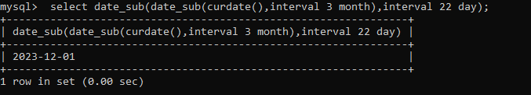

2 Write a query to display the last day of the month (in datetime format) three months before the current month.

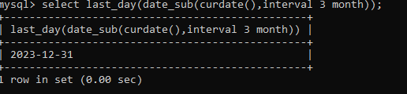

3 Write a query to get the distinct Mondays from hiredate in emp tables.

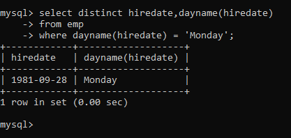

4. Write a query to get the first day of the current year.

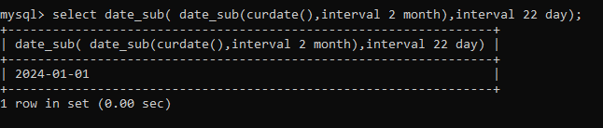

5. Write a query to get the last day of the current year.

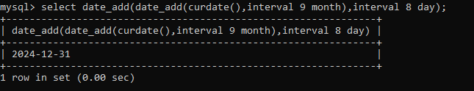

6. Write a query to calculate your age in year

7. Write a query to get the current date in the following format

. Sample date : 04-sep-2014

Output : September 4, 2014

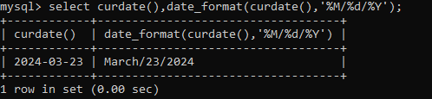

8. Write a query to get the current date in Thursday September 2014 format. Thursday September 2014

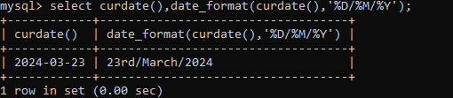

9. Write a query to extract the year from the current date.

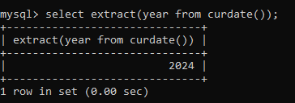

10. Write a query to get the first name and hire date from employees table where hire date between '1987-06-01' and '1987-07-30



11. Write a query to display the current date in the following format. Sample output: Thursday 4th September 2014 00:00:00

12. Write a query to display the current date in the following format. Sample output: 05/09/2014

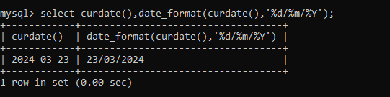

13. Write a query to display the current date in the following format. Sample output: 12:00 AM Sep 5, 2014

14. Write a query to get the employees who joined in the month of June

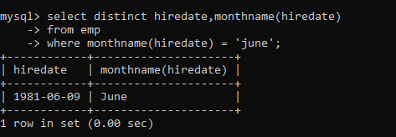

15. Write a query to get the years in which more than 10 employees joined.

16. Write a query to 1

18. Write a query to get employee ID, last name, and date of first salary of the employees.

19. Write a query to get first name, hire date and experience of the employees. Sample table: employees

20. Write a query to get the department ID, year, and number of employees joined.

29. Display empid,name,sal,comm,remark Remark should base on following conditions

comm >= 600 "excellent Keep it up"

if it < 600 or not null "good"

otherwise "Need improvement"

30. Display empid, name, deptno and department name by using following conditions.

dept 10 then "Hr"

if 20 then "Admin"

if 30 then "accounts"

otherwise purchase