**PREREQUISITES**: a mysql DB

make changes to the ConnectDB.class change **username password** and **db(db1)** name in the get **connection string** according to your mySQL settings

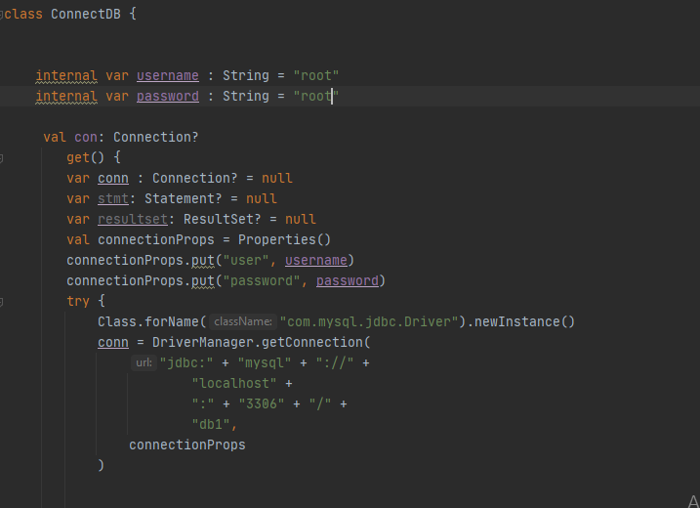

build the code (*after making changes to the connectDB and using the gradle provided*) into a jar

**or make simpy make changes in the jar file's ConnectDB**.class and directly run it from command prompt.

help structure

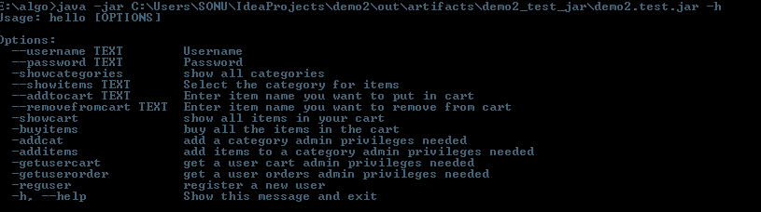

for using customer options always provide username and password cli parameters

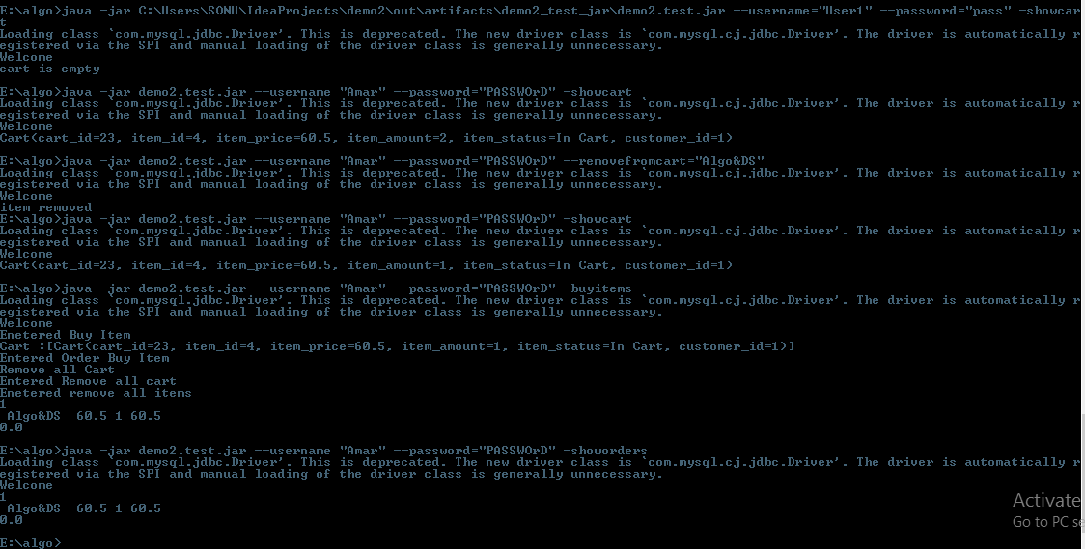

for using admin operations too use the username and password(Admin default set to admin check **createTables class**)

