First thing we need to do check how many no of domains and data element we need to create

We will create 5 Domain and 5 Data element

Domaim:- Technical Characteristic of any field or coloumn (Techninal Characteristic means Data type, Length)

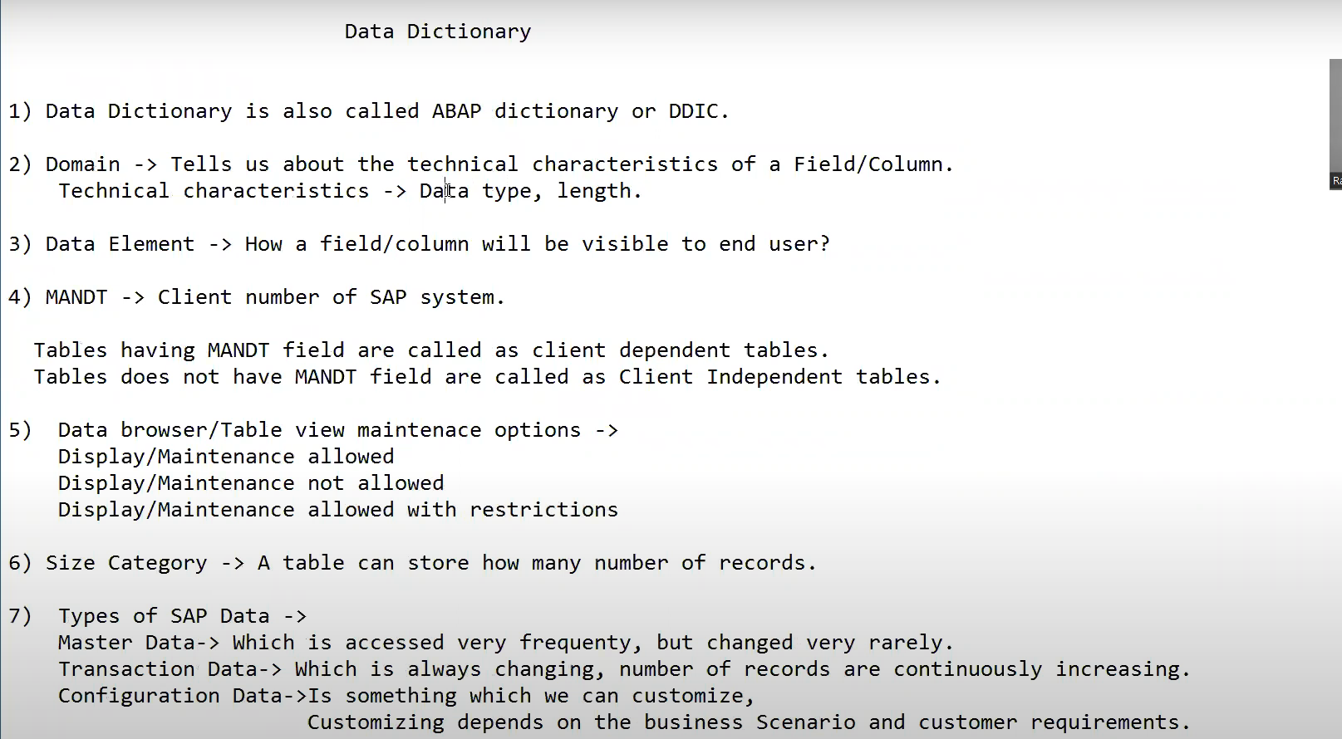

## Domain Creation

Go to SE11 Transaction Code

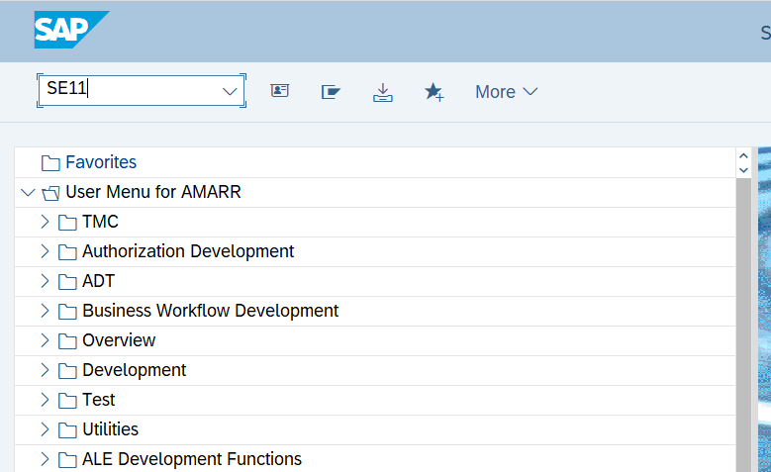

Figure 1 Navigating to SE11

Figure 2 Creating Domain for Order No

Figure 3 Allocating type to Domain.

Figure 4 Saving Domain in Local Object



Figure 5 No Consistency Means Domain is correct.

Figure 6 Check the Status is Activate

We can also give default value or Range of value while creating domain

## Data Element Creation

Figure 7 Go to SE11

Figure 8 Creating Data Element

Figure 9 Selecting Data element.

Figure 10 Pass the Order Number in Data element.

We use data element because it will be visible to end user so we can add the label here.

Whatever we add in the field label that will be available to end users

Visible to user

Figure 11 Visible to End user

Save it and Activate it

Figure 12 Save Data Element

## Table Creation

Figure 13 Go to SE11

Creating Order Header ZORDH_28

Figure 14 Creating Custom Table

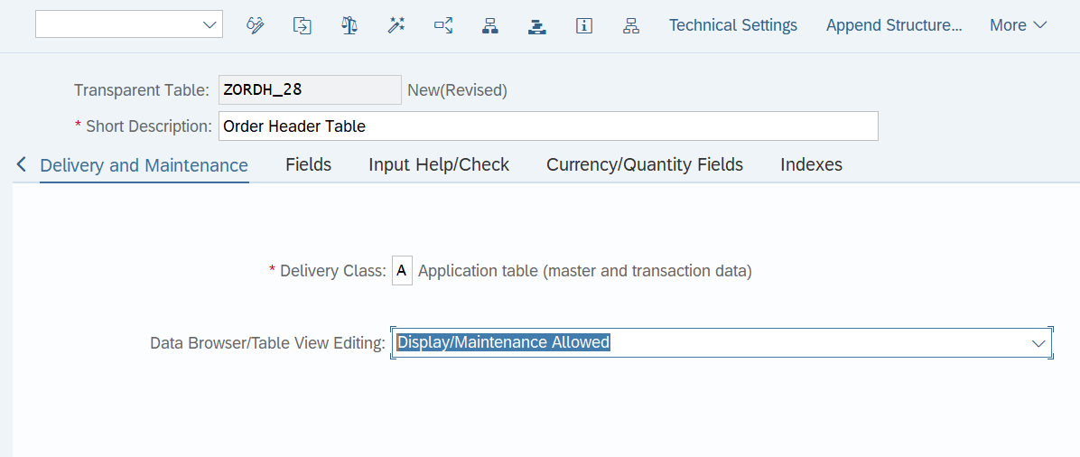

Figure 15 Selecting Delivery Class and Data Browser

Figure 16 We should add MANDT field it will give the user no

Figure 17 Creating Table using Data Elements

Primary key: - It is a key which Identify a record uniquely here **order number** is uniquely identified a particular record

SAP will except table only if primary keys are at the top of the table

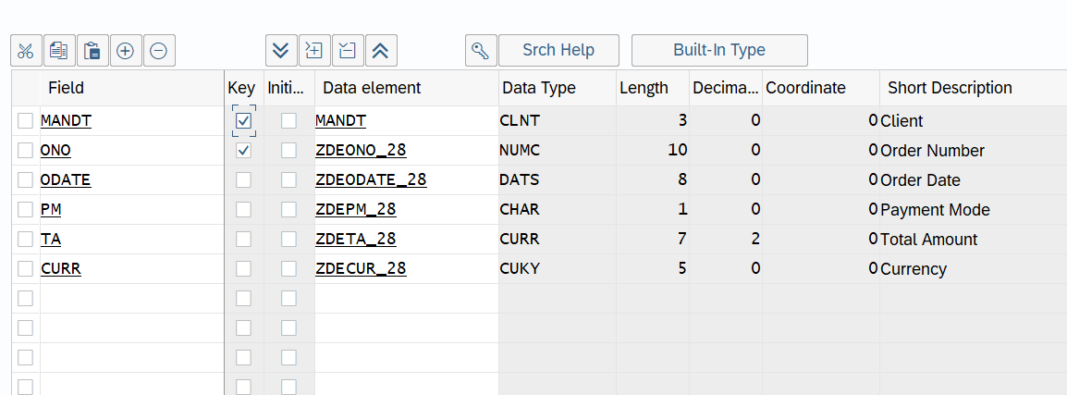

Figure 18 Primary key should always be at top

Figure 19 Go to technical Settings

Figure 20 Defining the Technical Settings

Figure 21 Allocating Data class and Size Category

We need to go back and check the reference.

Figure 22 Asking for reference field

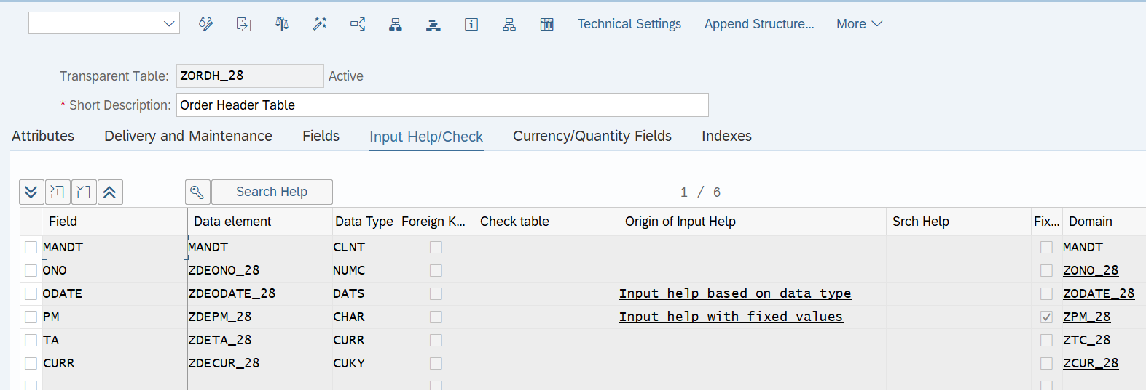

Figure 23 Check Syntax and Activate it

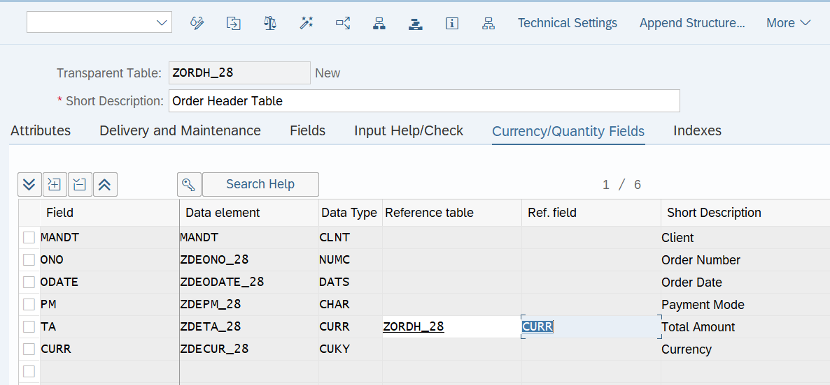

Figure 24 Giving Reference table and Field to Total Amount

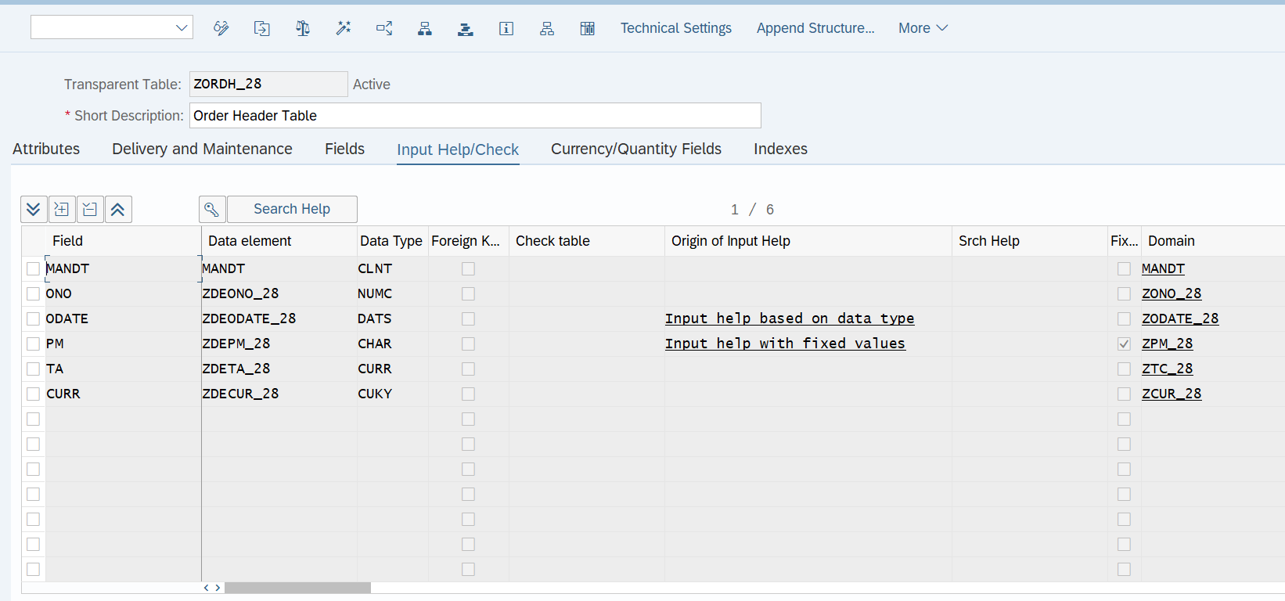

Figure 25 Make sure table is Activate

## Maintaining the Data in the Table

* Insert Record
* Update Record
* Delete Record

### Inserting Record

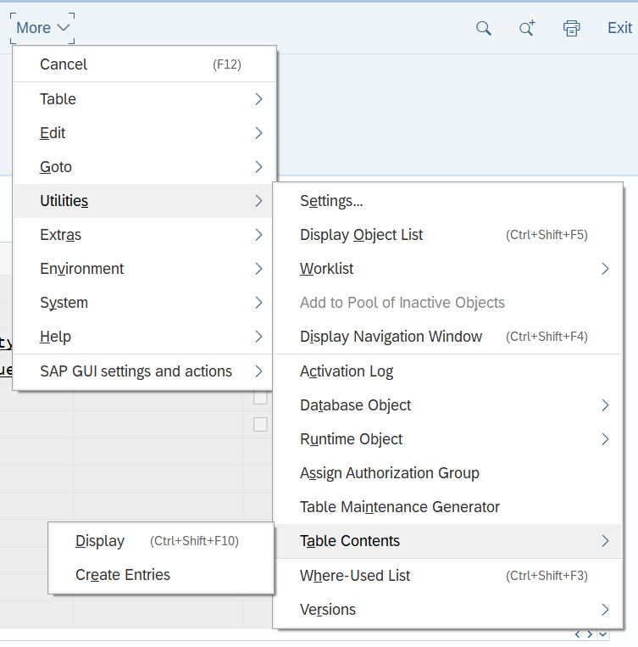

Figure 26 Creating New entry in table

Figure 27 Inserted Record in the Database Table

Figure 28 To see Inserted Data(ctrl + shift F10)

Figure 29 Data Preview

To switch the display mode

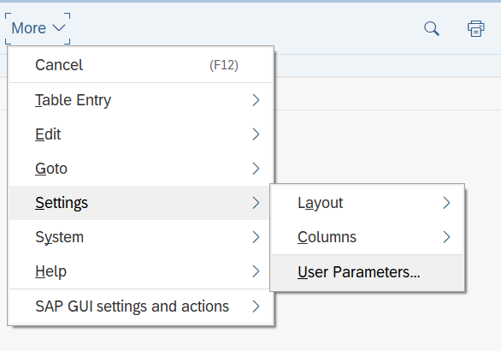

Figure 30 Go to User Parameters

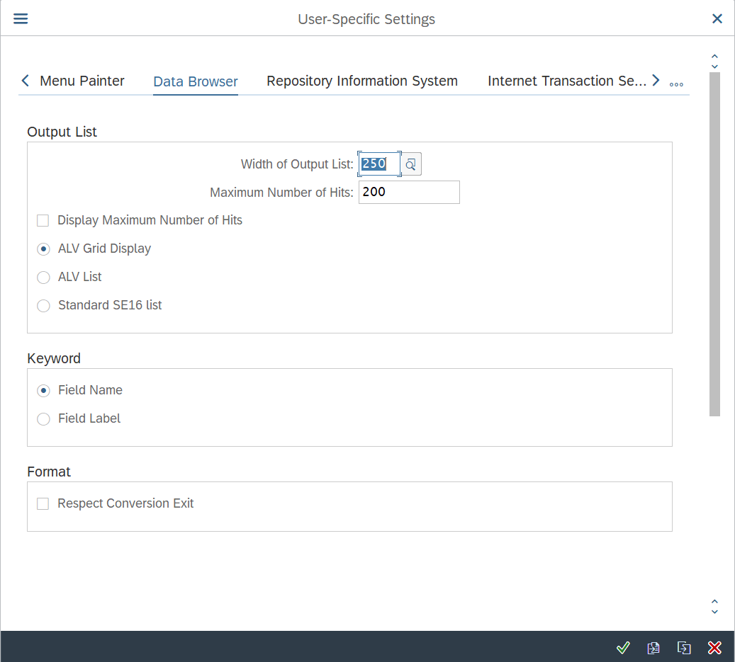

Figure 31 Changing to ALV Grid Display

### Updating Record

But we will not able to update the primary key record

Figure 32 Changing the Existing Data

### Deleting Record

Figure 33 Deleting the Record

Figure 34 Deleting Entry

## SE16

Figure 35 Creating new Entry

## SE16N

It is new version of SE16

Figure 36 Creating Record from SE16N

## TMG (Table Maintenance Generator)

In Production system user don’t have access to SE11 , SE16 or SE16N in this scenario we cannot use them directly so we need to use TMG(Table Maintenance Generator)

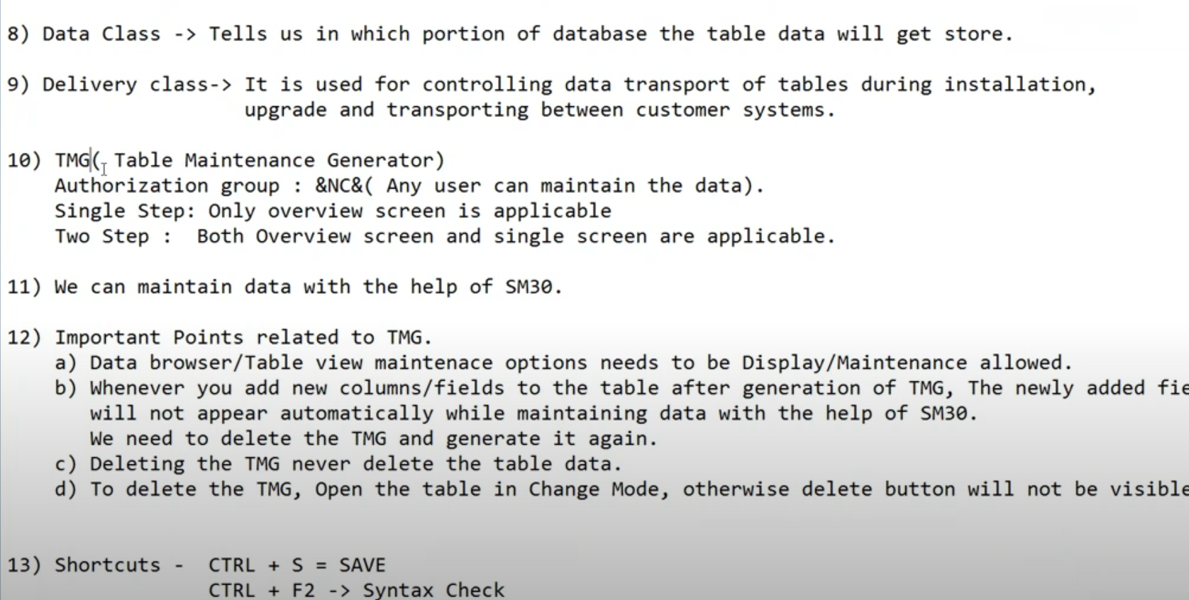

We can maintain the Data using SM30 rights for SM30 is given to user

### Creating TMG

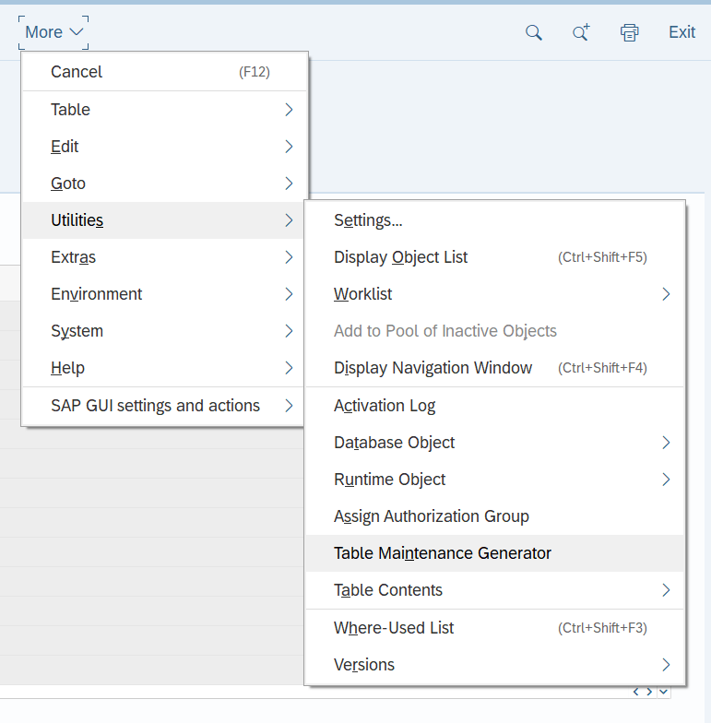

Figure 37 Creating Table Maintenance Generator

Authorization Group:- A group in which we have specific people those are authorized to maintain the table

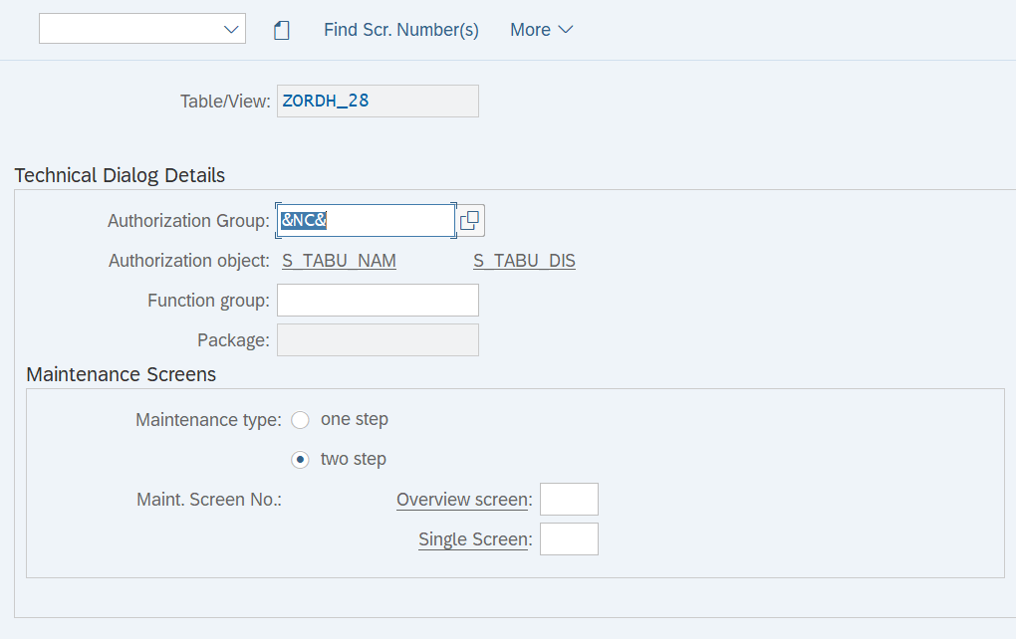

Figure 38 &NC& anyone can maintain the table

This means it will not check for any authorization

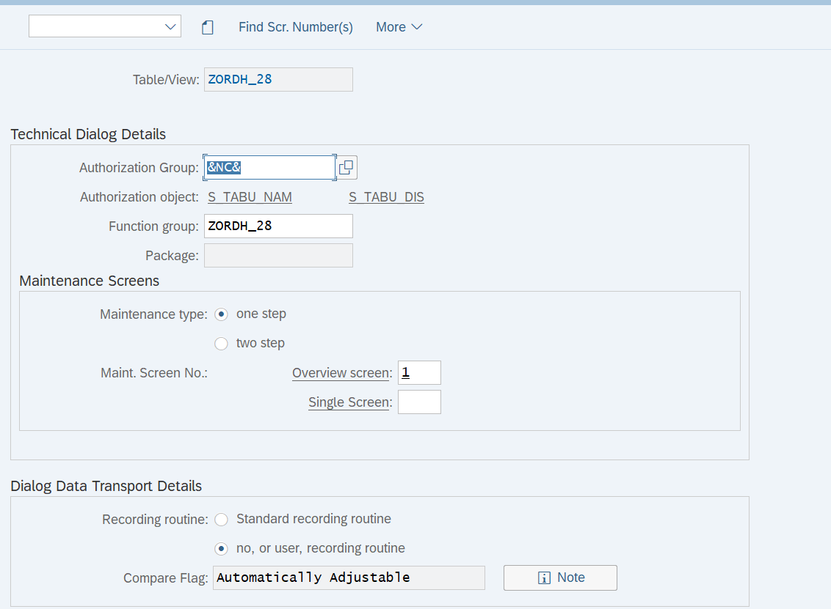

Figure 39 Function Group and No of Screens

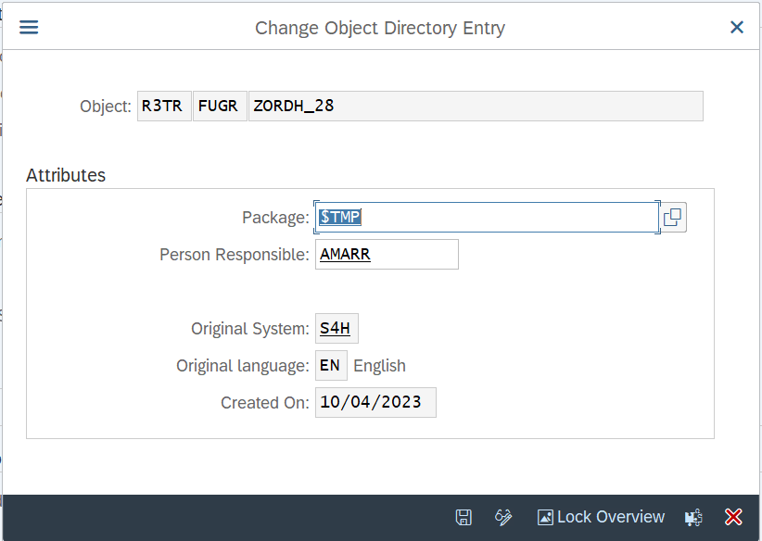

Figure 40 Saving in the Local Object

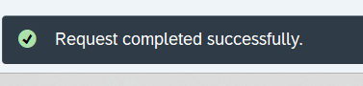

Figure 41 Table maintenance Generated Successfully

### Maintaining Data using generated TMG

**Once the TMG is generated we can maintain the data in the table using SM30**

#### Go to SM30

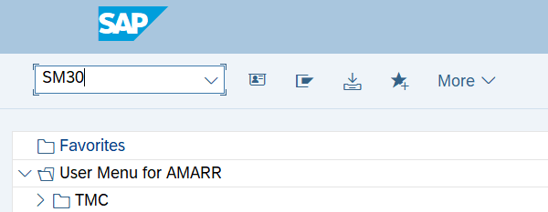

Figure 42 Go to SM30

#### Click on Edit(Maintain)

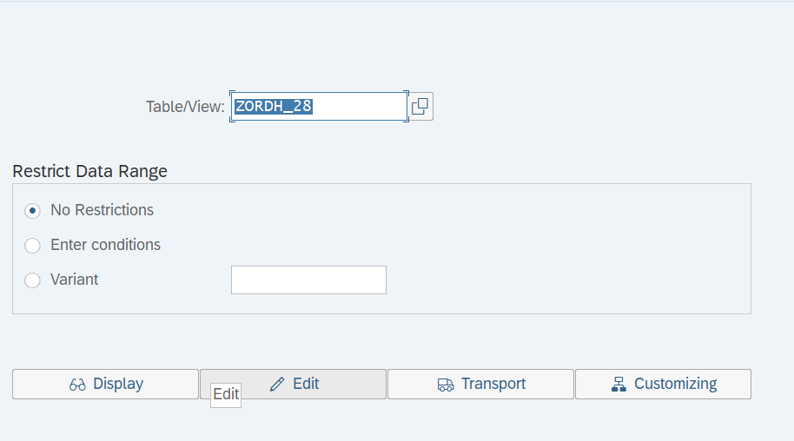

Figure 43 Go to Edit to Maintain the data

#### New Entry

Figure 44 Adding New Entries

Figure 45 Save the Entry

#### Deleting the Record

Figure 46 Deleting the Record

#### To verifying the Screen no

Figure 47 Go to Status

Figure 48 Verified its one step using Screen number

#### Deleting TMG

If you want to delete the TMG from SE11 we need to make sure you are doing in Edit mode, then go to Table maintenance generator mode we will able to delete

Figure 49 When you open table that is in Display mode

Figure 50 When table is in Display mode

We can also delete TMG from SE55

Figure 51 Go to SE55 to delete the TMG

Figure 52 Delete the TMG

Figure 53 Deleting the TMG

Create again TMG with 2 step

Figure 54 Creating New Entry but it is 2 step

Figure 55 We can add multiple records on different screen.

**Preferred is one step.**

#### Tips