# Contents

Contents 1

# Prety Printer Settings.

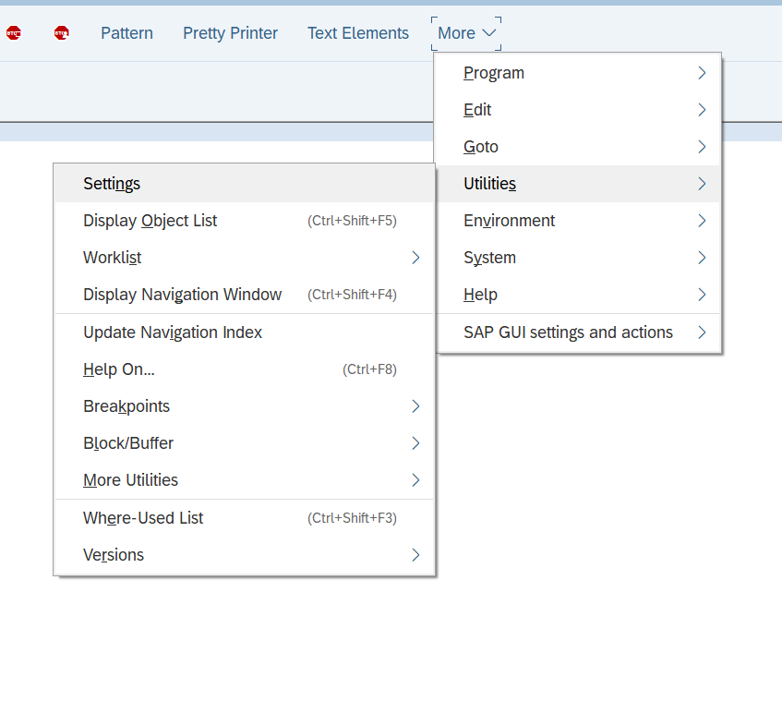

Figure Navigate to settings.

Figure Preferred settings.

# Comment Options.

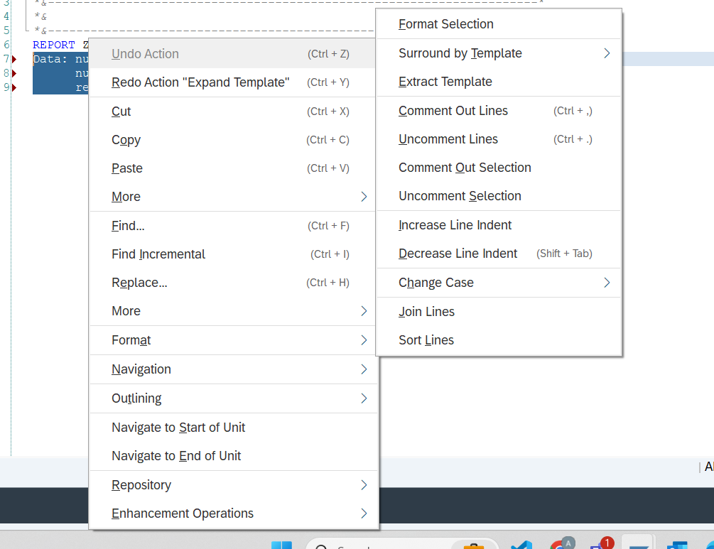

Figure Right click on the selected text under format you will this options.

Figure Comments theory

# Data type.

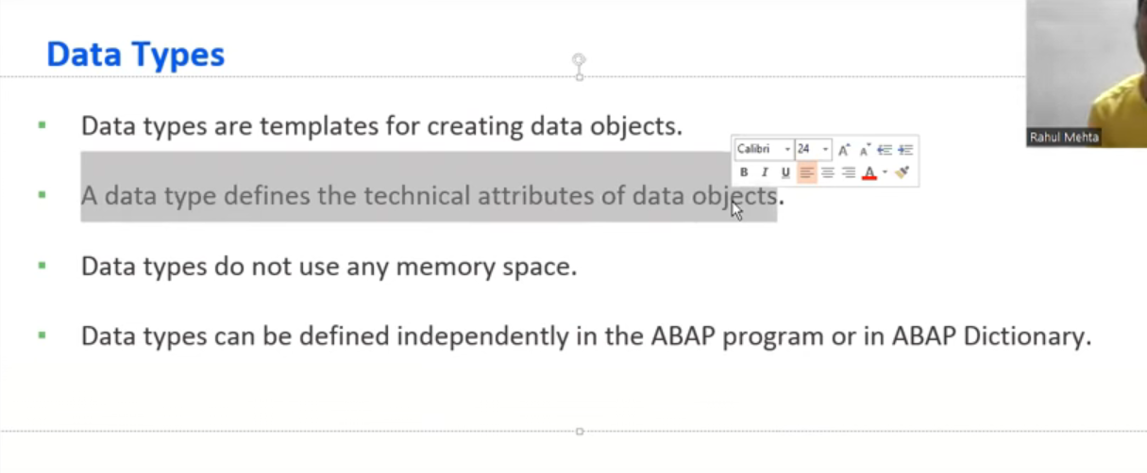

Figure Data types.

Figure Data Object.

## Elementary Data types

Figure Elementary Data type.

## Complex Data type.

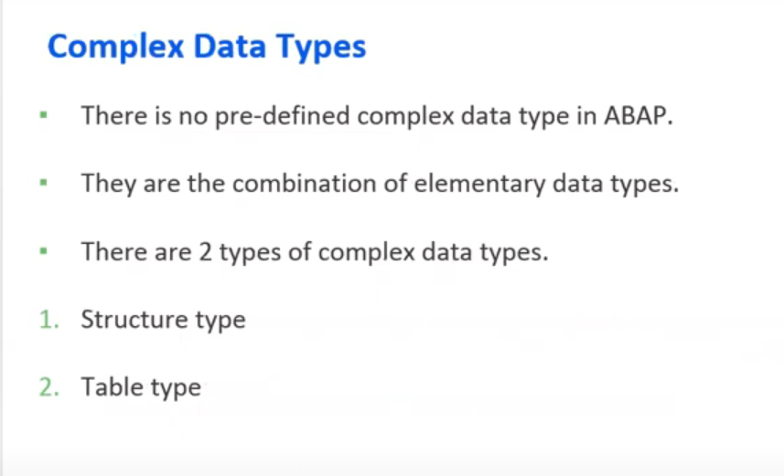

Figure Complex Data type.

## Reference Data type.

Figure Reference data type.

# Data Objects.

## Literals (unnamed data objects)

Figure Literals data objects.

## Named data objects.

Figure Named data object.

Figure Constant data object.

Figure Text symbol.

SE38-> Go to -> Text element -> text symbol.

# Write Statement.

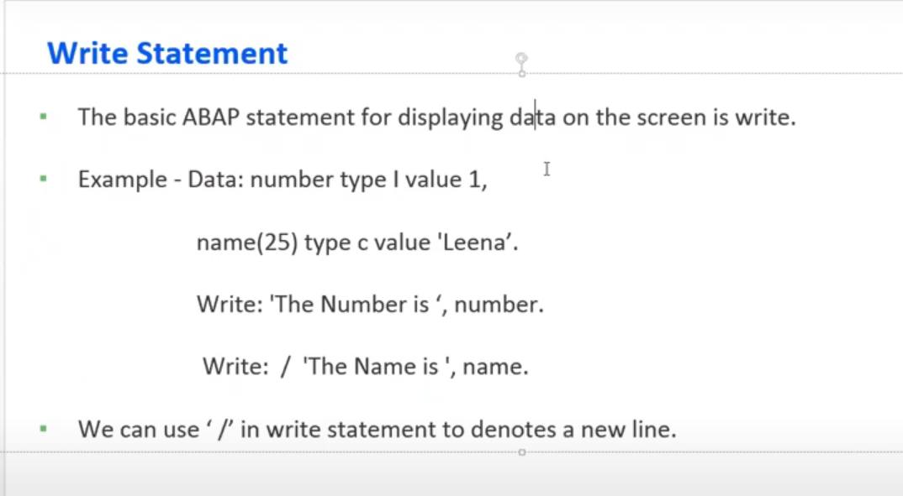

Figure Write statement.

# Chain Operator.

Figure Chain Operator.

# Conditional Statements.

Figure Conditional Statements.

## If Statements.

Figure If statements.

## Case Statement.

Figure Case statement.

## Difference between case and if.

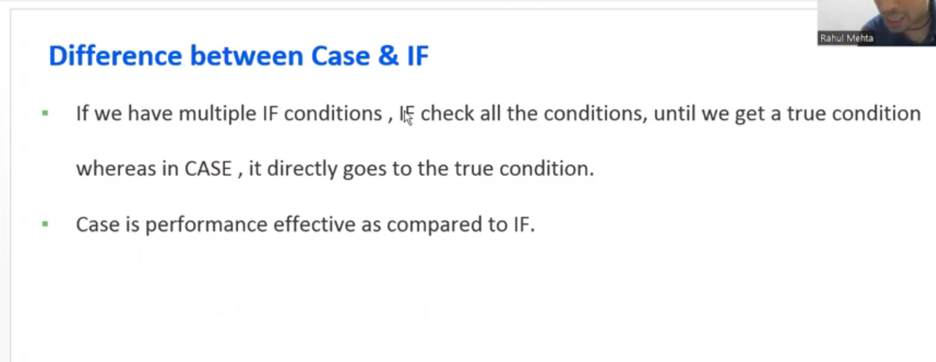

Figure Difference between case and if.

1. Without checking every statement, How the system know that it's not looking for that case.it has to check in order to reach the final when statement.

* In case of CASE Statement, System Internally creates a Jump table which has all the conditions, When the code executes, It will directly jump to true condition of Jump table.

1. In SE38 of ABAP editor, why is that dotted lines and stars appearing for every program?

*&............Report...........

*&...............................

What these lines are going to tell us?

* This is the commented lines of code which is available at the top of every program. In projects, We write the information like purpose, Date, Time, Last change other necessary information at the top of the program in the form of commented lines.

# Loop.

Figure Loops.

## Do Loop.

Figure Do loop.

### Exit keyword.

When we are in the loop and we want to exit the loop we use the keyword exit.

Exit statement helps us to exit from the current loop.

Figure Exit keyword.