First thing we need to do check how many no of domains and data element we need to create

We will create 5 Domain and 5 Data element

Domaim:- Technical Characteristic of any field or coloumn (Techninal Characteristic means Data type, Length)

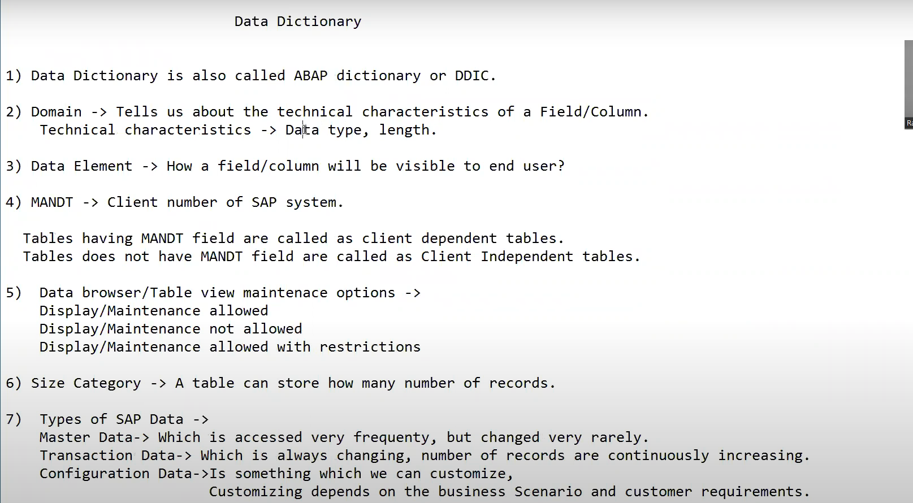

## Domain Creation

Go to SE11 Transaction Code

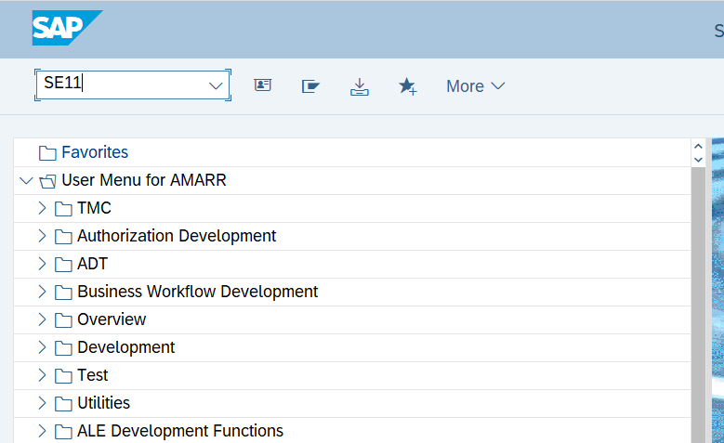

Figure Navigating to SE11

Figure Creating Domain for Order No

Figure Allocating type to Domain.

Figure Saving Domain in Local Object



Figure No Consistency Means Domain is correct.

Figure Check the Status is Activate

We can also give default value or Range of value while creating domain

## Data Element Creation

Figure Go to SE11

Figure Creating Data Element

Figure Selecting Data element.

Figure Pass the Order Number in Data element.

We use data element because it will be visible to end user so we can add the label here.

Whatever we add in the field label that will be available to end users

Visible to user

Figure Visible to End user

Save it and Activate it

Figure Save Data Element

## Table Creation

Figure Go to SE11

Creating Order Header ZORDH_28

Figure Creating Custom Table

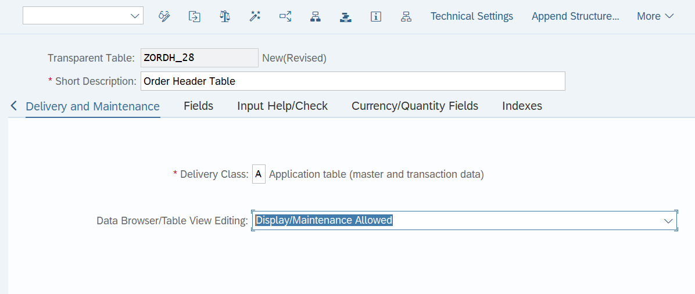

Figure Selecting Delivery Class and Data Browser

Figure We should add MANDT field it will give the user no

Figure Creating Table using Data Elements

Primary key: - It is a key which Identify a record uniquely here **order number** is uniquely identified a particular record

SAP will except table only if primary keys are at the top of the table

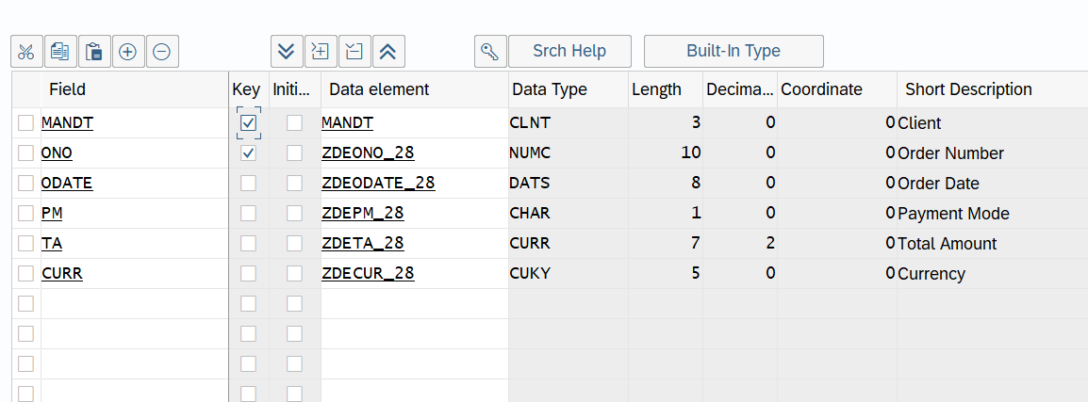

Figure Primary key should always be at top

Figure Go to technical Settings

Figure Defining the Technical Settings

Figure Allocating Data class and Size Category

We need to go back and check the reference.

Figure Asking for reference field

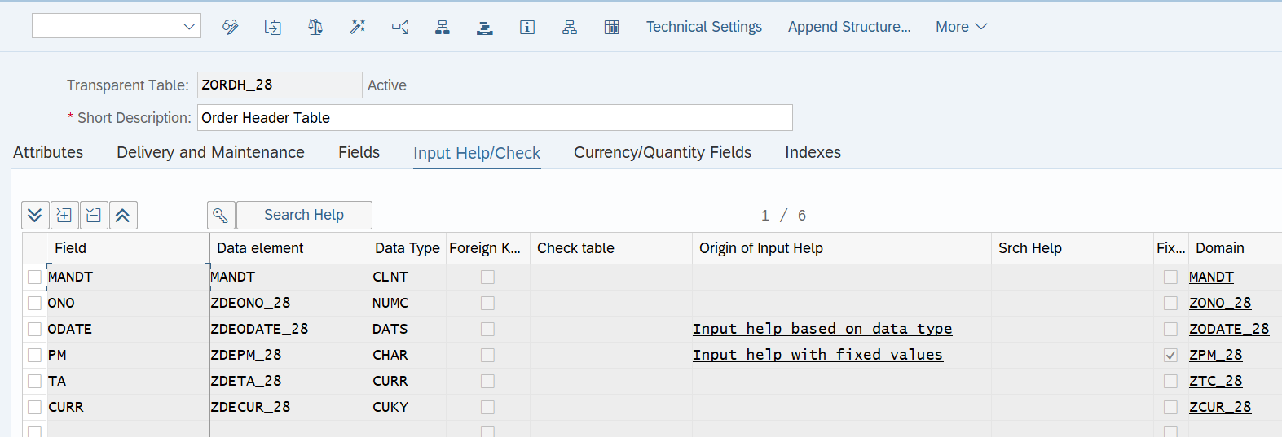

Figure Check Syntax and Activate it

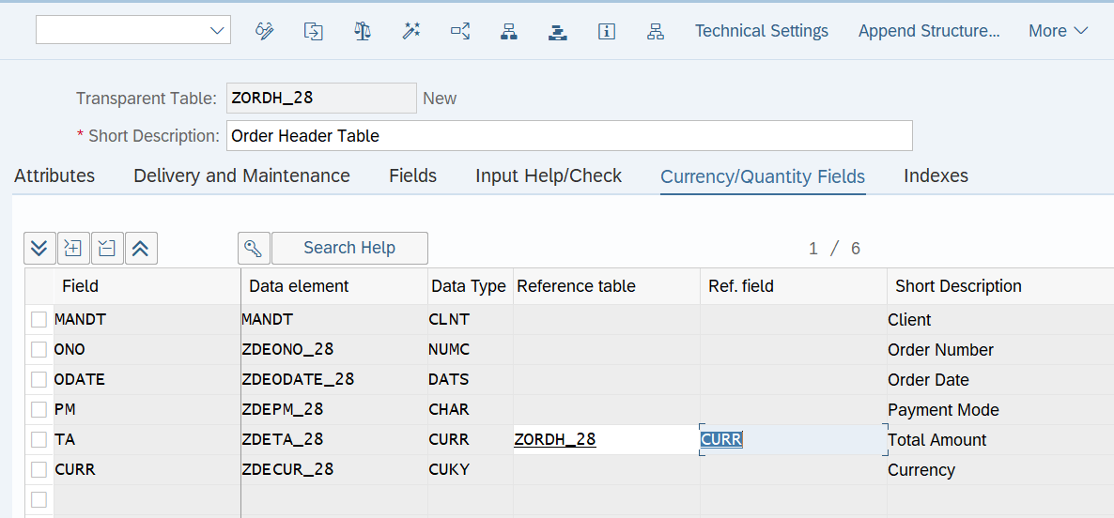

Figure Giving Reference table and Field to Total Amount

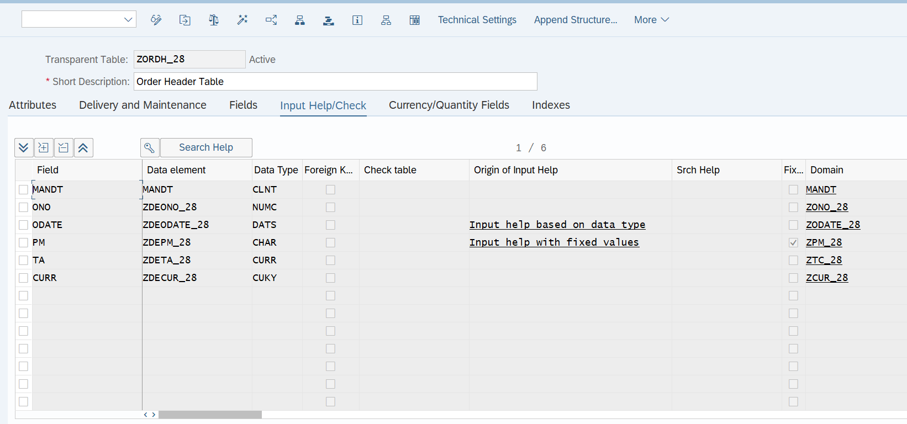

Figure Make sure table is Activate.

### Composite key

Figure Composite key creation for Item Table

Refer to link :- [Composite key creation](https://www.youtube.com/watch?v=out7tXrNXc8&list=PLM3lhmHjSeIReozQTHsvSXCPx_4l98mI0&index=15)

### Primary Foreign key relation ship

Figure Primary Foreign Key Relation Ship

Both the table are independent table so if we add data in item table there will no reference in header table it should not happen

Header table is independent table and item table should be dependent table.

Item table is foreign key table and Header table is primary key table that means Item level table should take reference from Header table.

Figure Go to dependent table and use the common field click on foreign key.

Figure Pass the name of independent column and click on Create Proposal.

Figure Give the Cardinality to the table.

## Maintaining the Data in the Table

* Insert Record
* Update Record
* Delete Record

### Inserting Record

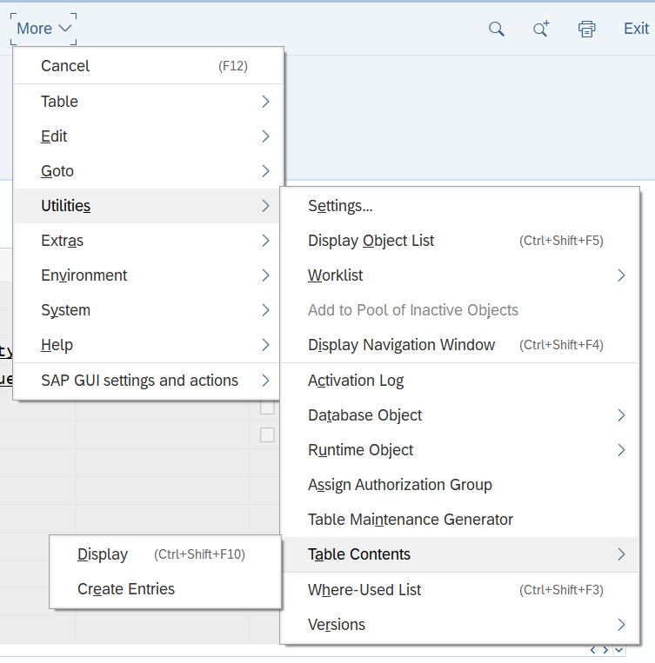

Figure Creating New entry in table

Figure Inserted Record in the Database Table

Figure To see Inserted Data(ctrl + shift F10)

Figure Data Preview

To switch the display mode

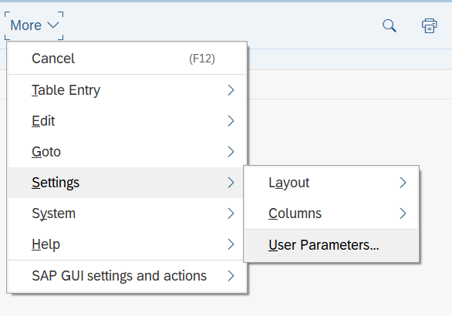

Figure Go to User Parameters

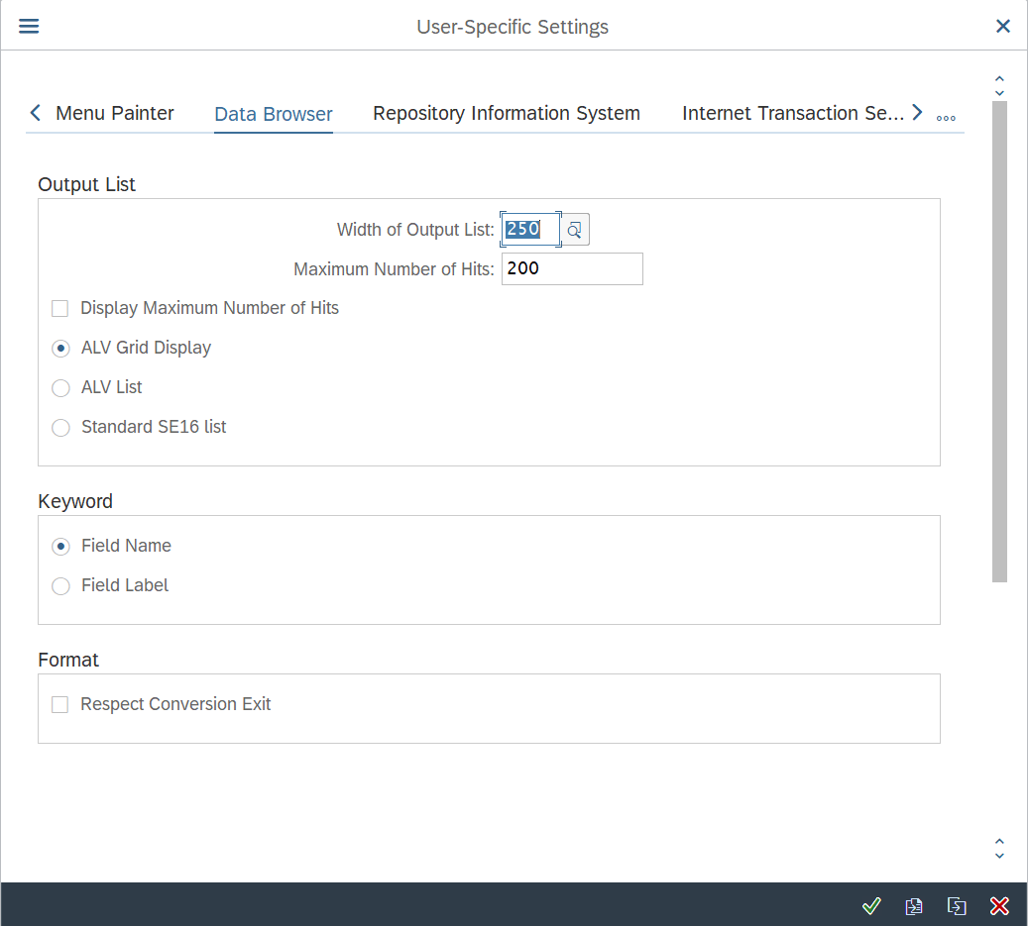

Figure Changing to ALV Grid Display

### Updating Record

But we will not able to update the primary key record

Figure Changing the Existing Data

### Deleting Record

Figure Deleting the Record

Figure Deleting Entry

## SE16

Figure Creating new Entry

## SE16N

It is new version of SE16

Figure Creating Record from SE16N

## TMG (Table Maintenance Generator)

In Production system user don’t have access to SE11 , SE16 or SE16N in this scenario we cannot use them directly so we need to use TMG(Table Maintenance Generator)

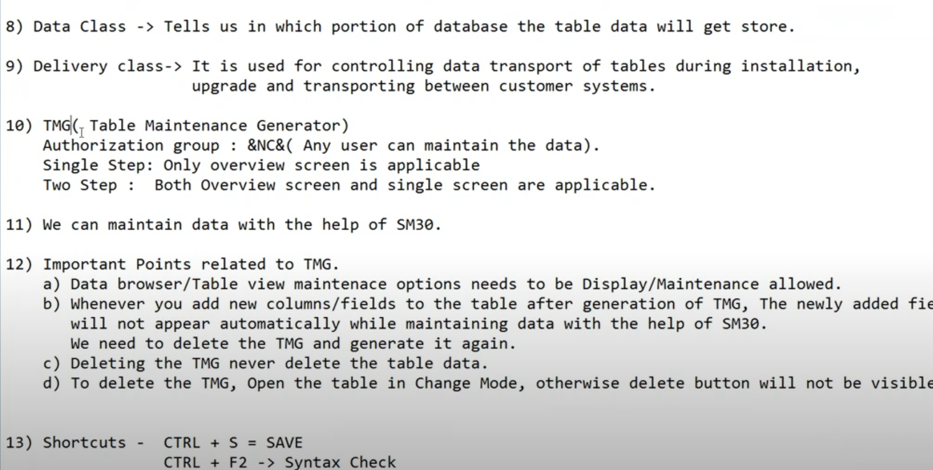

We can maintain the Data using SM30 rights for SM30 is given to user.

### Creating TMG

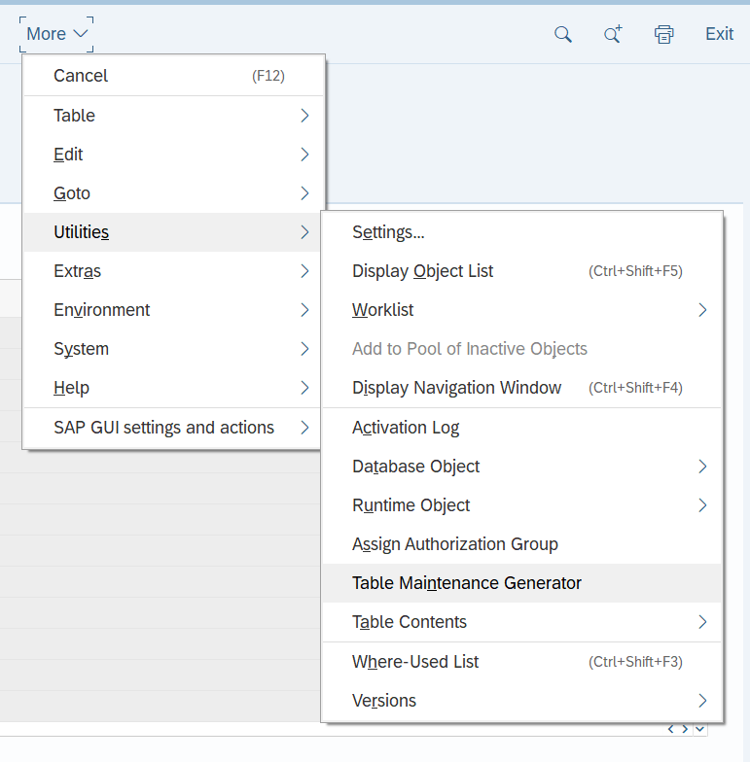

Figure Creating Table Maintenance Generator

Authorization Group: - A group in which we have specific people those are authorized to maintain the table

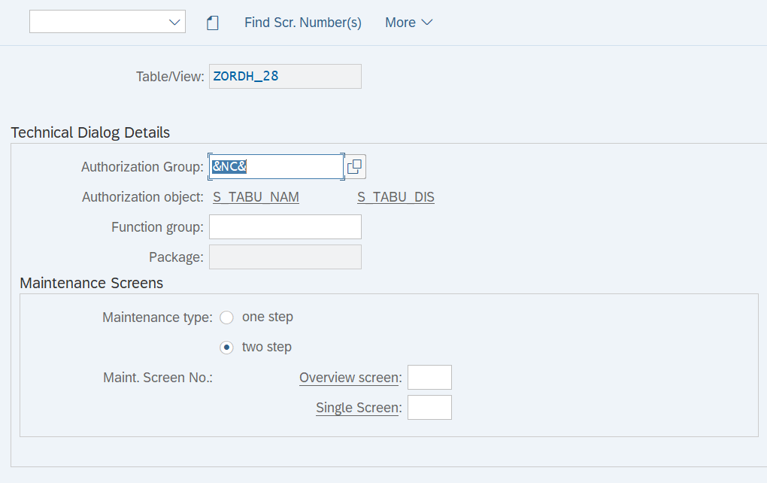

Figure &NC& anyone can maintain the table

This means it will not check for any authorization.

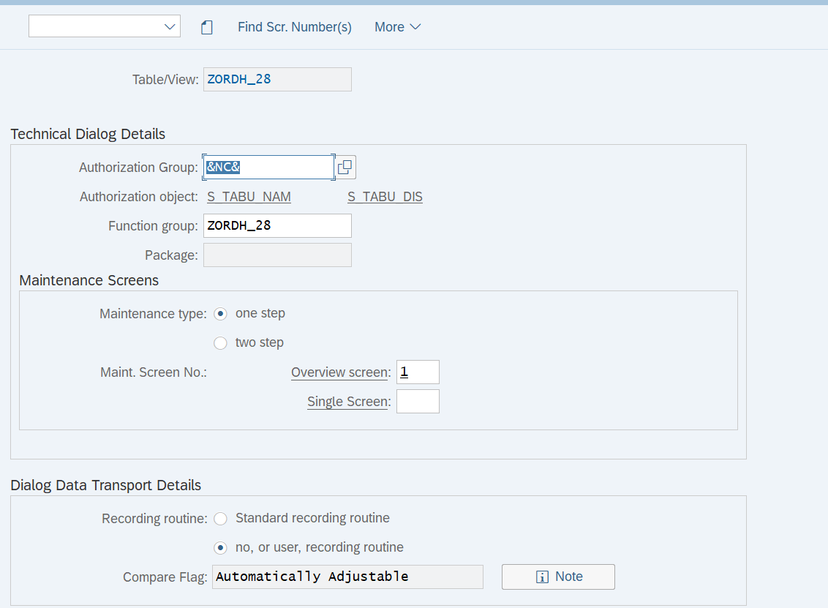

Figure Function Group and No of Screens

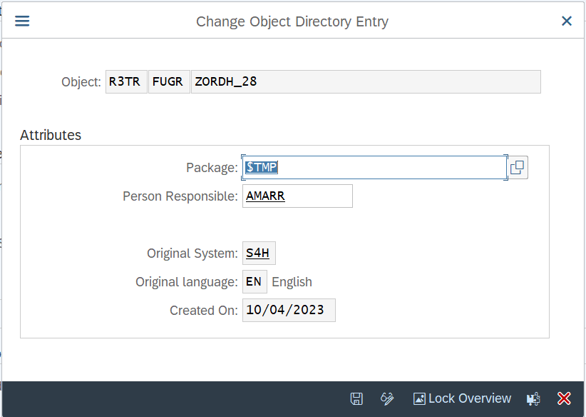

Figure Saving in the Local Object

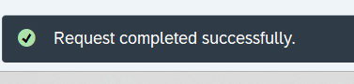

Figure Table maintenance Generated Successfully

### Maintaining Data using generated TMG

**Once the TMG is generated we can maintain the data in the table using SM30**

#### Go to SM30

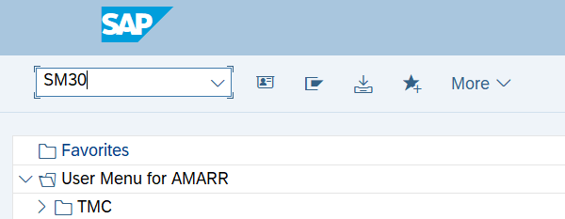

Figure Go to SM30

#### Click on Edit(Maintain)

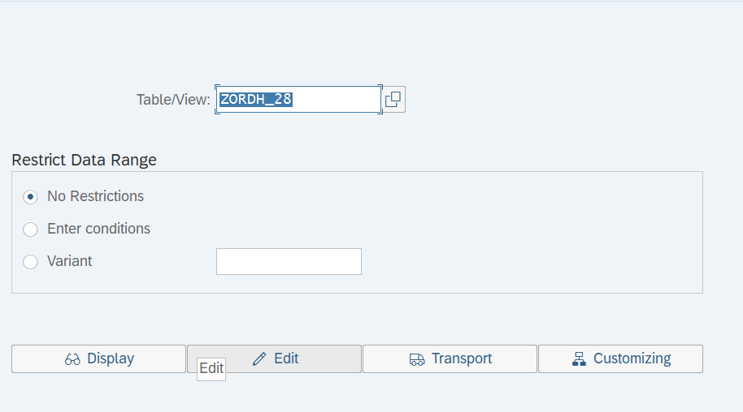

Figure Go to Edit to Maintain the data

#### New Entry

Figure Adding New Entries

Figure Save the Entry

#### Deleting the Record

Figure Deleting the Record

#### To verifying the Screen no

Figure Go to Status

Figure Verified its one step using Screen number

#### Deleting TMG

If you want to delete the TMG from SE11 we need to make sure you are doing in Edit mode, then go to Table maintenance generator mode we will be able to delete

Figure When you open table that is in Display mode

Figure When table is in Display mode

We can also delete TMG from SE55

Figure Go to SE55 to delete the TMG

Figure Delete the TMG

Figure Deleting the TMG

Create again TMG with 2 step

Figure Creating New Entry but it is 2 step

Figure We can add multiple records on different screen.

**Preferred is one step.**

#### Tips

* When you want to generate TMG and maintain table using SM30 always keep

Data Browser/Table View Editing:- Display/Maintenance Allowed

* When we create TMG for table and we add field in table it will not get reflected in SM30 you need to regenerate the TMG
* When you Delete TMG still data will be there in table
* SM30 From SE11 Utilities->Table Content ->Create Entries

## Table specifications and usage

### Significance of MANDT column in Table

It will give you the client number of SAP System

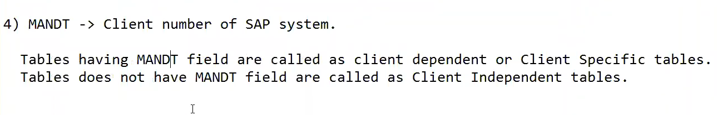

Figure Significance of MANDT

Whenever we take MANDT in table that table is Client specific

* **Table that has MANDT is called Client Specific Table**
* **Table that doesn’t have MANDT is called Client Independent Table**

Example:-

800 -> Z1( MANDT ) , Z2

900

We have 2 clients, 800 and 900, we have Z1 table in which we have MANDT field it is in 800 clients.

* We are putting data in Z1 table now this table is **client dependent as we have MANDT field in table** whenever we insert data into Z1 table the data of that table **will be reflected only in 800 clients**.
* Now we have table Z2, and **we don’t have MANDT field** in it then that **table will be client independent table** now we insert data it will automatically **reflect in 800 as well as 900 clients.**

Tip:- It is always prefer to use MANDT filed in table in projects

### Significance of size category

Figure Go to technical settings.

Figure What is size Category.

Size Category: - A table can store how many numbers of records.

### What is Data Class

These types of Data: -

Master Data: - Which is accessed very frequently but changed very rarely (or never changed).

e.g., Employee Data of company ABC which customer id which will never change.

Transaction Data: - Which is always changing, the number of records is continuously increasing.

e.g., Transaction in the company (Banking Transaction, Revenue transactions).

Configurational Data: - Is something which we can customize, Scenario and customer requirements.

(Employee Designation -> Senior Consultant (Vehicle allowance applicable)).

(Employee Designation -> other than Senior Consultant (Vehicle allowance not applicable).

Data class: - Tells us in which portion of database the table data will get store.

Figure Go to technical settings.

Figure Search help in Data Class

APPL0: - Master Data

APPL1: - Transactional Data

APPL2: - Configurational Data

### Delivery Class

It is used for controlling data transport of table during installation, upgrade, and transport between customer system.

|  |  |  |  |  |
| --- | --- | --- | --- | --- |
| Data Browser/ Table View Maintenance Options | Display in Data Browser (Via SE11, SE16 or SE16N) | Maintenance in Data Browser (Via SE11, SE16 or SE16N) | Generation of table maintenance Generator | Maintenance and Display in View Maintenance (SM30) |
| Display/Maintenance Allowed | Yes | Yes | Yes | Yes |
| Display/Maintenance Not Allowed | No | No | No | No |
| Display/ Maintenance Allowed with Restrictions | Yes | No | Yes | No |