# Selection Screen

* The selection screen is also called as Input screen.
* With the help of the selection screen user provides input to the program
* There are 2 ways to provide input to the program.
  + Parameters
  + Selection-options

## What is the screen number of the selection screen?

The important question from the interview perspective is whether every selection screen or input screen always has the number 1000.

### How to check the screen number

System -> Status -> Screen number (1000)

## Parameters

* Parameters are used to pass a single input.
* The various parameter variations are as follows.
  + PARAMETERS <p>…………… DEFAULT <f>
  + PARAMETERS <p>…………… OBLIGATORY ……
  + PARAMETERS <p>…………… AS CHECKBOX ……
  + PARAMETERS <p>…………... RADIOBUTTON GROUP <radi>

To give label that means the thing that is visible to user

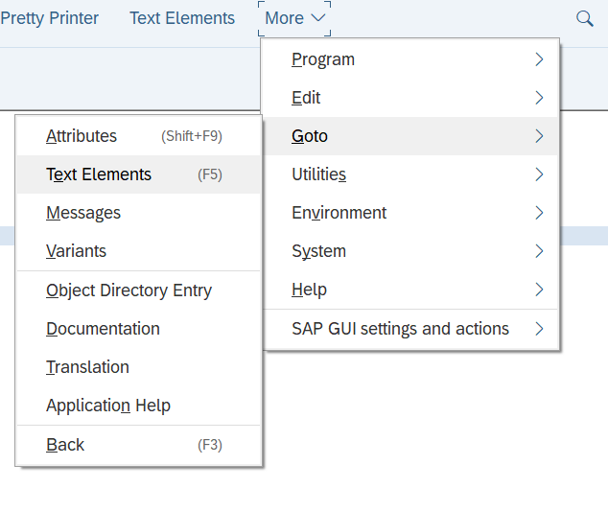

Figure 1 Giving label to selection parameter.

Figure 2 Give caption in selection text.

Just make sure that you have activated it

Figure 3 We can give a reference from the table.

While declaring the table we have used a field label it is referring to that.

Just activate it then the description will come automatically.

We can also give default values.

PARAMETERS: p_ono TYPE ZDEONO_28.

### Default

It will pass the default value when selection screen is visible

PARAMETERS: p_ono TYPE ZDEONO_28 DEFAULT 5.

### Obligatory (Compulsory Filed)

## Select-Options

* Select options are used to pass a range of inputs.
* The various Select options variants are as follows.
  + SELECT-OPTIONS <seltab> FOR <f> …
  + DEFAULT <g> [TO <h>]
  + SELECT-OPTIONS <seltab> FOR <f> …NO-EXTENSION
  + SELECT-OPTIONS <seltab> FOR <f> …NO INTERVALS
  + SELECT-OPTIONS <seltab> FOR <f> …OBLIGATORY