# History

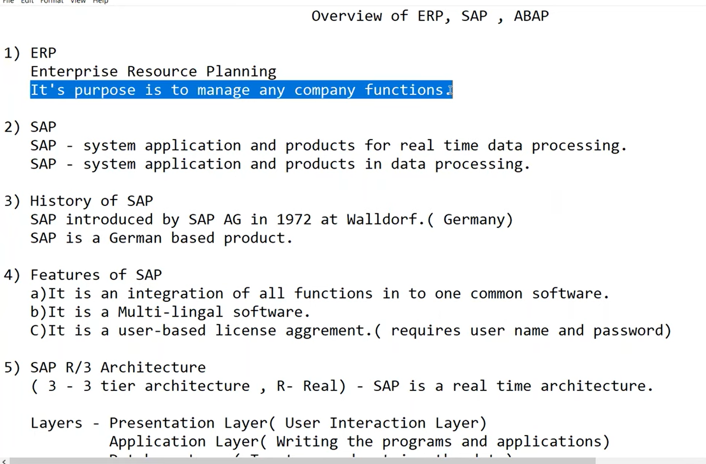

Figure 1 What is SAP and ERP

Never say SAP as ‘SAP’ because SAP means pig in Germany

Multi-lingal :- Multiple Language

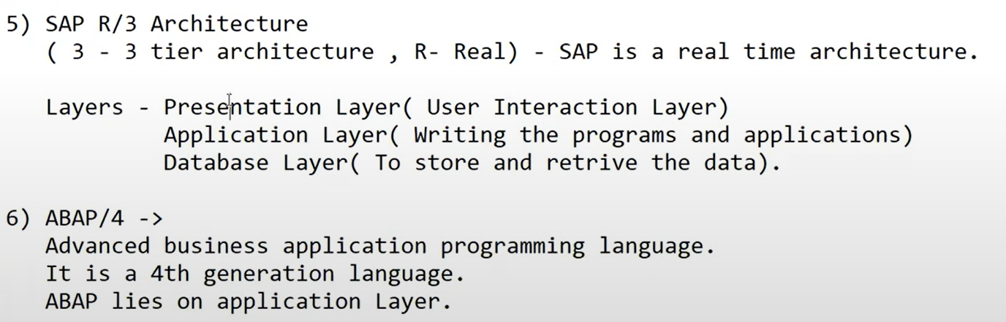

Figure 2 R/ 3 Architecture and ABAP/4

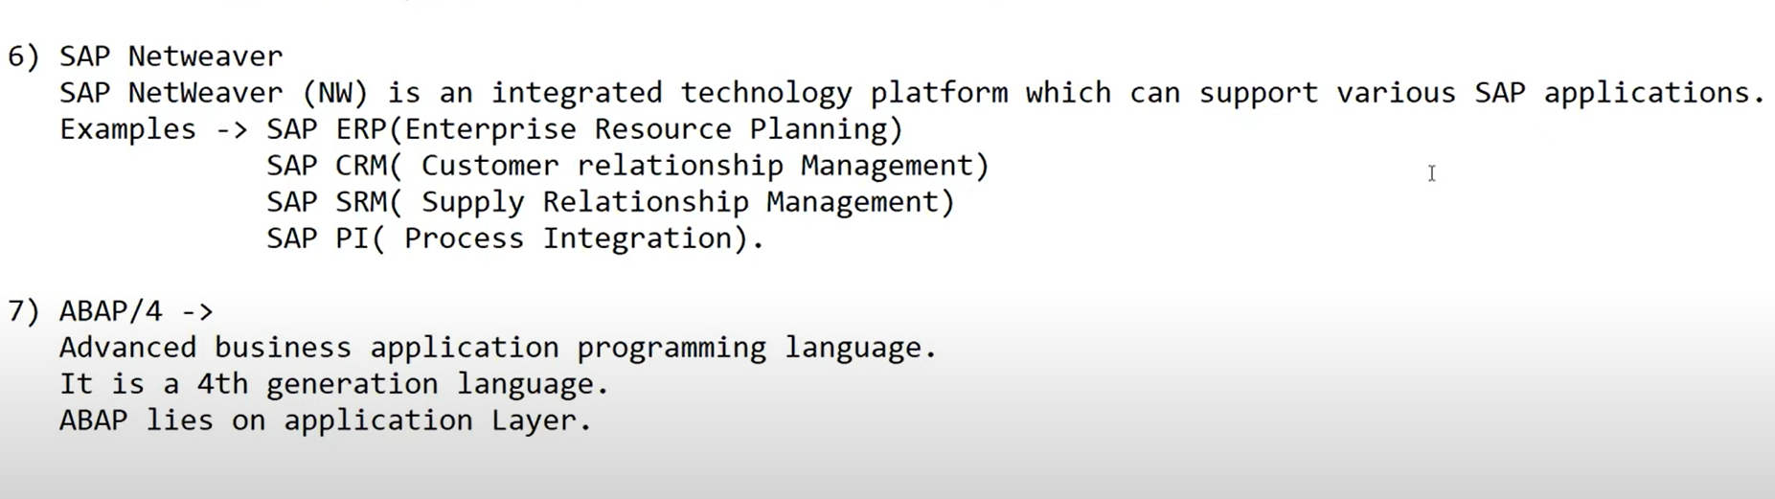

Figure 3 SAP NetWeaver it integrates e.g. ERP CRM SRM PI

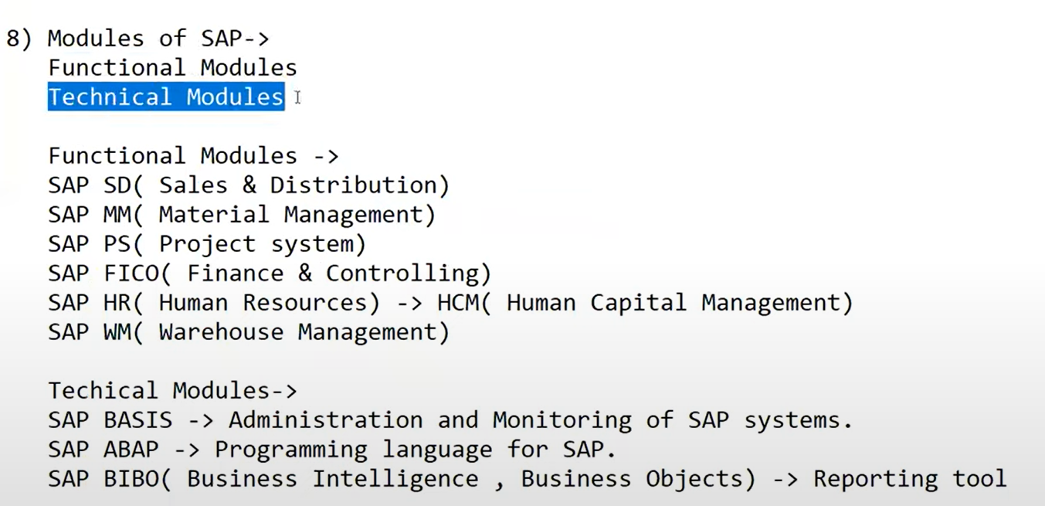

Figure 4 Models in SAP

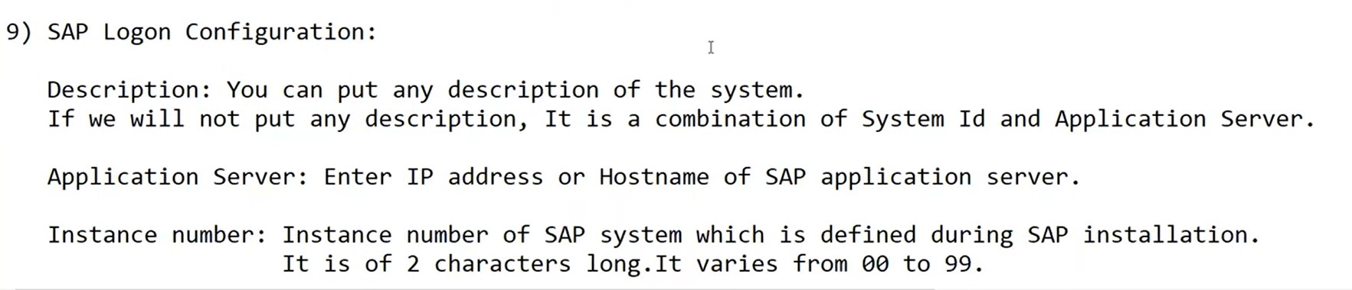

Figure 5 Login Configuration

# Application Sever Architecture

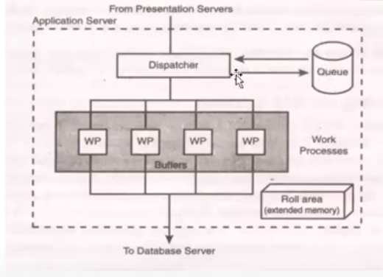

Figure 6 Application Server Architecture

## Dispatcher

Input given from presentation layer it is received by Dispatcher it will first put your request in the Queue and from the queue it will in FIFO first come first serve

* All the request that come in from presentation sever are directed first to dispatcher
* The dispatcher writes them first to the dispatcher queue
* The dispatcher pulls the request from the queue on the first-in. first-out basis

## Work Process

* Each Request from the dispatcher is then allocated to the first available work process
* **A work process handles one request at a time**
* A process needs to address two special memory areas – the user context and the program roll area

## User Context

* The user context is a memory area the contains information about the user.
* When a user logs on, a user context is allocated for that logon
* When user log off, it is freed.

## Roll Area

* Roll Area is a memory area that contain information about the program’s execution
* When program runs, a roll area is allocated for that program
* The roll area is freed when the program ends

# SAP System Landscape

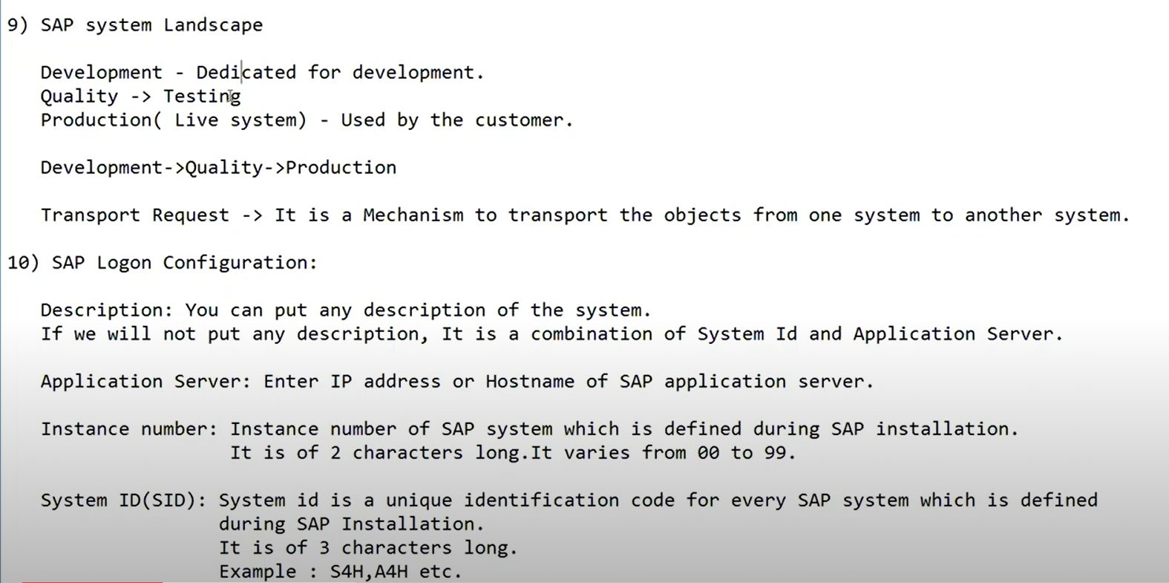

Figure 7 SAP system landscape

## Development

Whatever development we do creating program, tables, classes, function that all things are done in development system

## Quality

It is used for testing purpose

## Development

It is used by the user or by the customer

## How do they move the code?

They move the code using work bench request

It is a Mechanism to transport the object from one system to another system

# Types of SAP GUI

GUI

G – Graphical

U – User

I – Interface

It allows end user to use various SAP application by providing easy to use graphical interface

## SAP GUI for Windows

SAP GUI for Windows is a Windows operating system that offers a windows-like user experience.

## SAP GUI for JAVA

SAP GUI for JAVA environment is written in JAVA and is the platform-independent implementation of SAP GUI

## SAP GUI for HTML

Consist of Internet Transaction (IST) on the server and a web browser on the client side

# SAP Logon Configuration

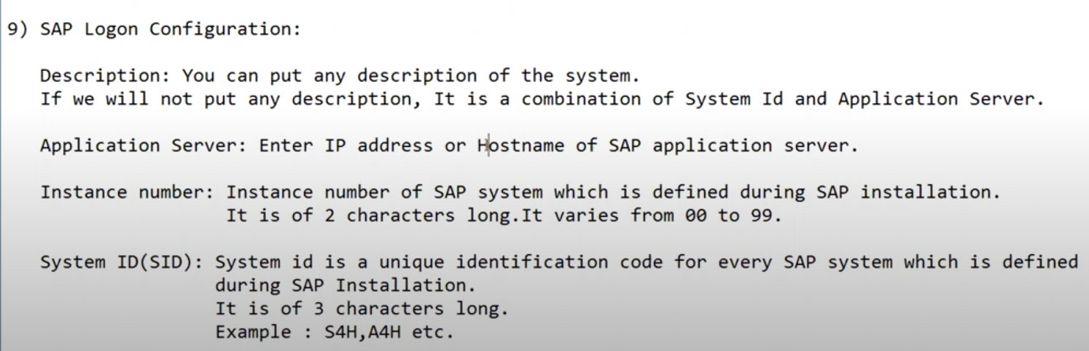

Figure 8 SAP Logon Configuration