## Inner Join

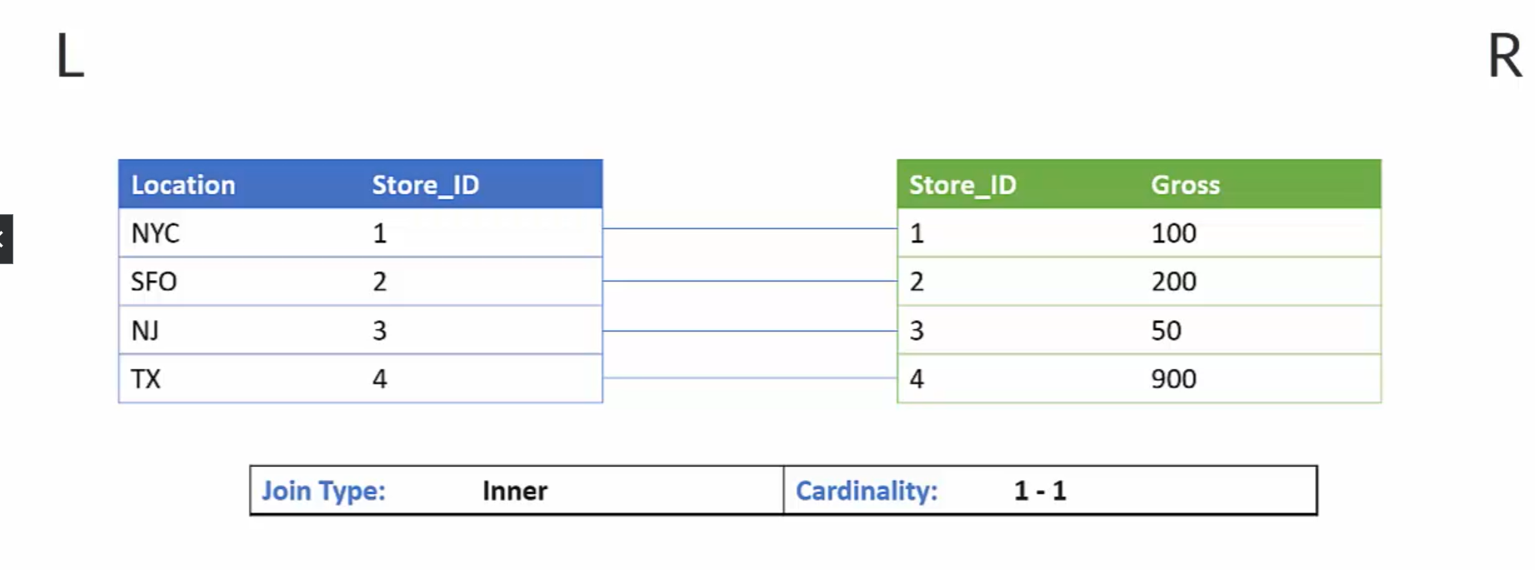

Figure Inner Join Cenario.

Figure Result of Inner Join.

Figure I-N cardinality for Inner Join.

In MD.Address table we have ADDRESSID as key figure

Querry: -

select * from "FL_HDI_DB_1"."MD.BusinessPartner" as A

Inner Join "FL_HDI_DB_1"."MD.Addresses" as B

on A."ADDRESSES.ADDRESSID" = B."ADDRESSID"

1-N Cardinality

We will join the Products table with Business partner table.

Products we have PRODUCTID as primary key

1 Partner has multiple products

In sql querry we cannot give the cardinality depending on the data it takes the cardanility

In this case for one partner we have multiple product to it

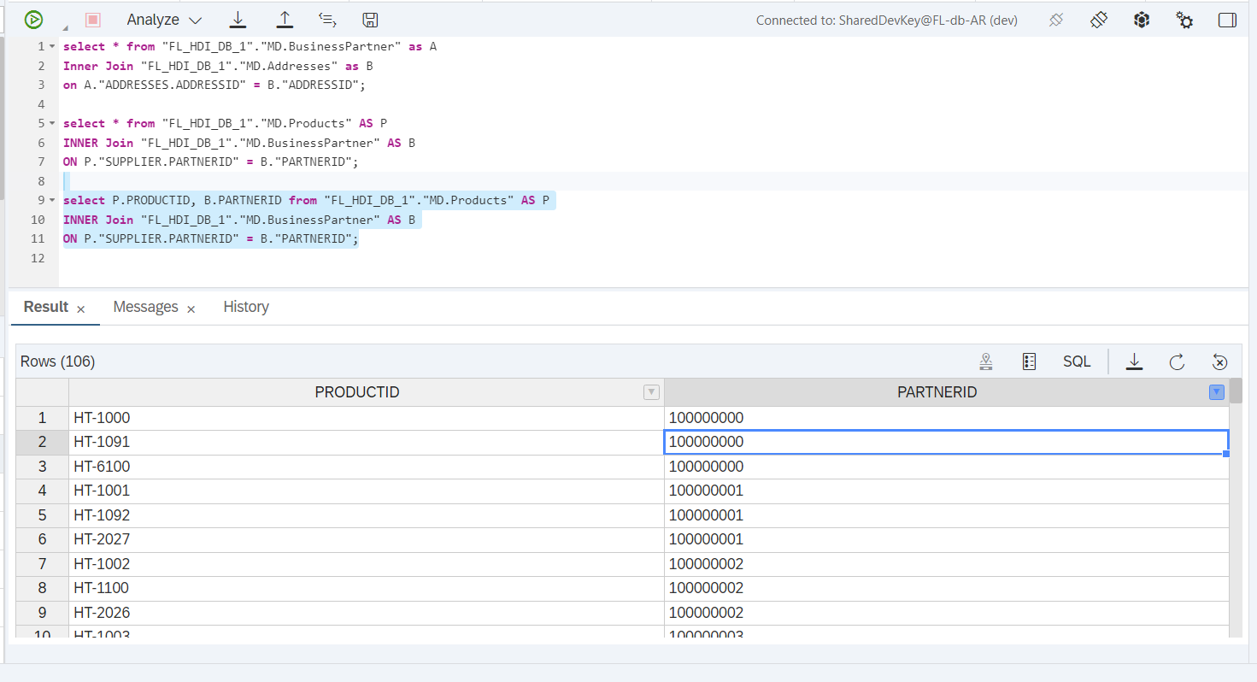

## Left Outer Join

Left outer join means we want all the data from the left table weather or not it have matching records in the right table

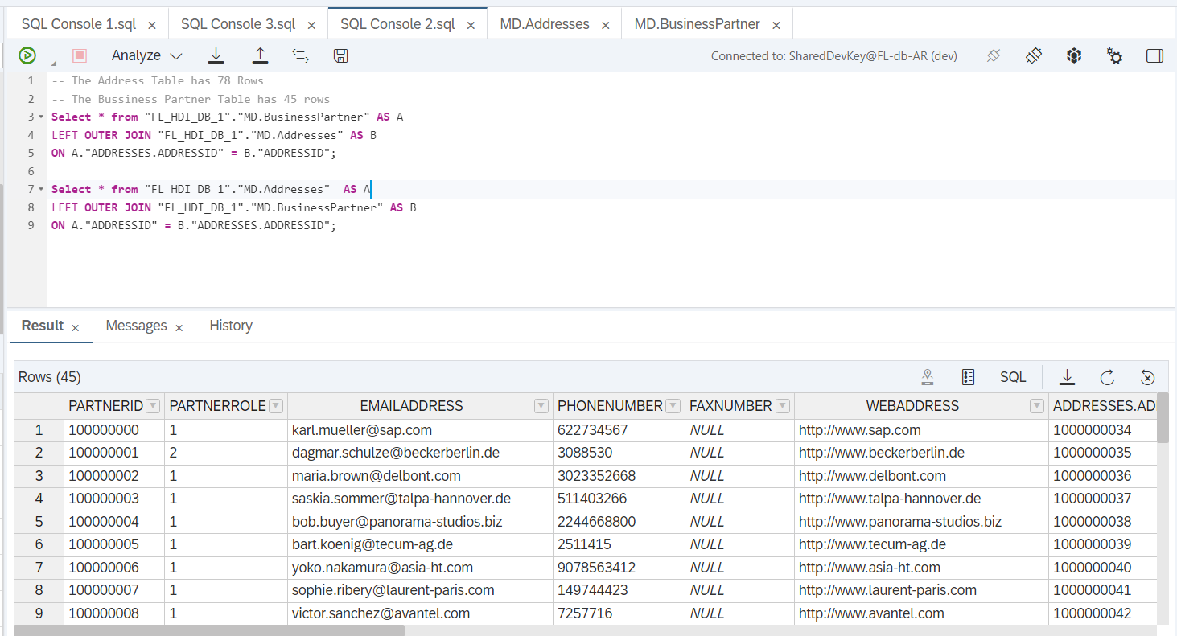

Here in this case left table has 45 rows so in the output it is displaying 45 rows and vice versa in 2nd Querry we have the left table as Address table it have 78 rows so in the output it is showing us 78 rows in output.

## Right Outer Join

In this case of right outer join we need to take the whole data from right table whether there is any matching element or not from the left table

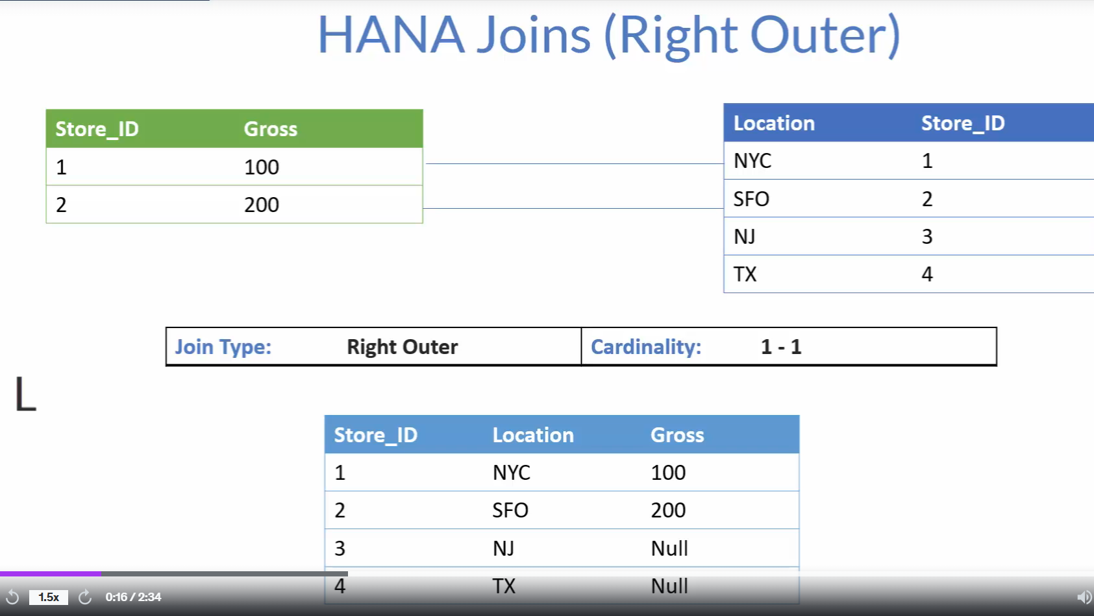

Figure Right Outer Join.

## Full Outer Join

In Full Outer Join the data from both tables gets fetched that means it the left table doesn’t have any common elements from the right table it will also get fetched and vice versa if the right table doesn’t have any common elements from the left table even though it will fetch the entire data common data as well.

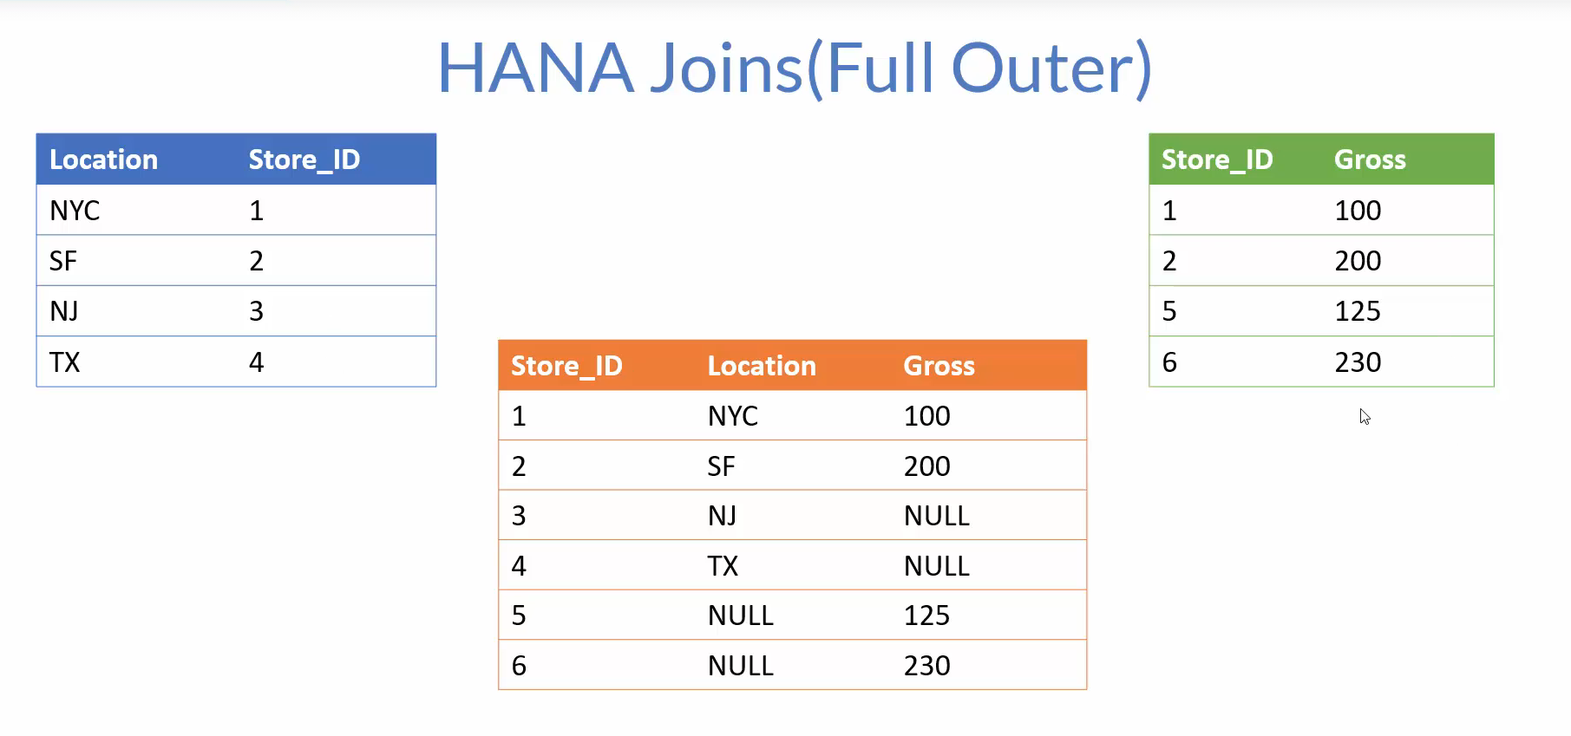

Figure Full Outer Join Example.

Even we swap the position of tables we will still get the same result.

## Referential Join

They were introduced in the hana to improve the performance this are fundamental inner join with some special characteristics.

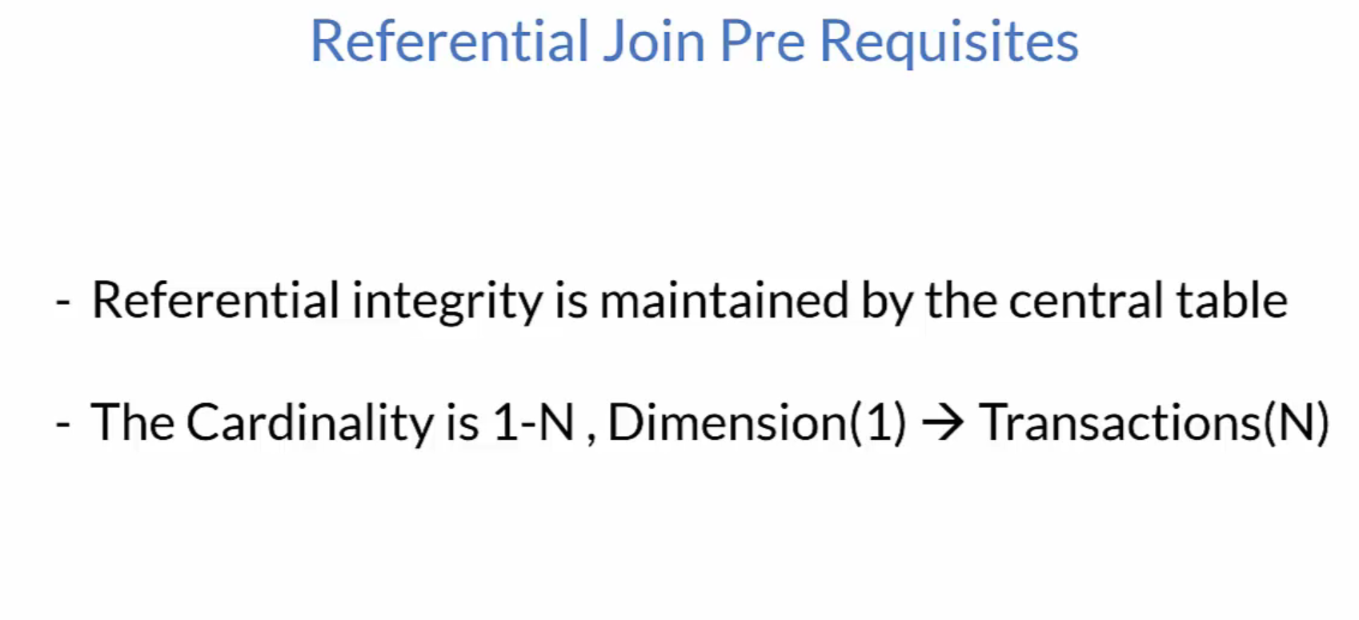

The central table is responsible for Referential Integrity

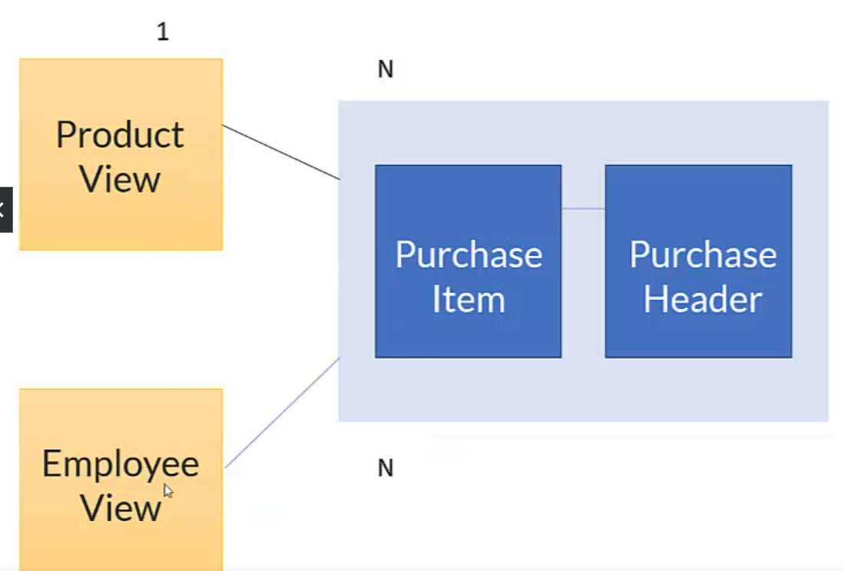

Figure Scenario of referential Integrity.

If we request data from all three things that are Product view, Employee View, and Cube(Purchase Item, Purchase Header) it performs inner join between all three things but in case we are requesting data from Product view and Cube it will run inner Join between Product view and Cube only it will increase the performance of our query.

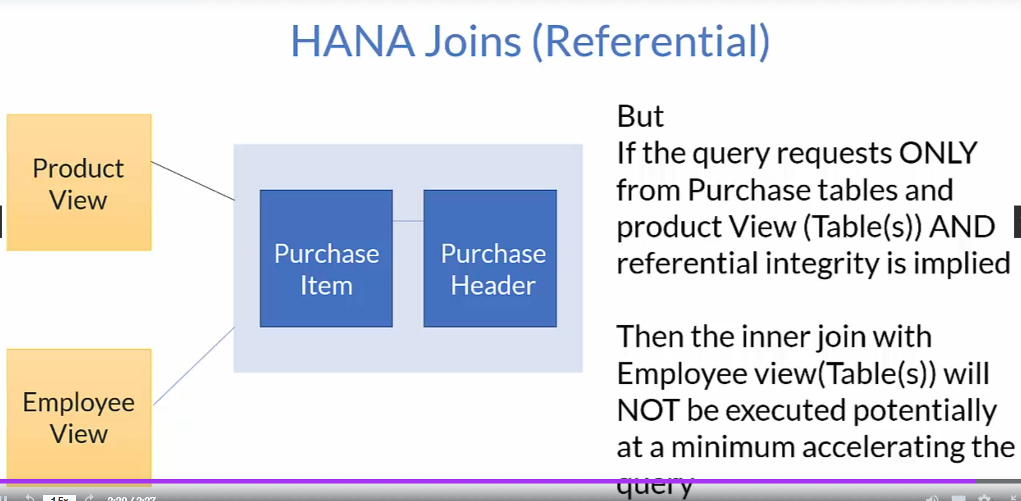

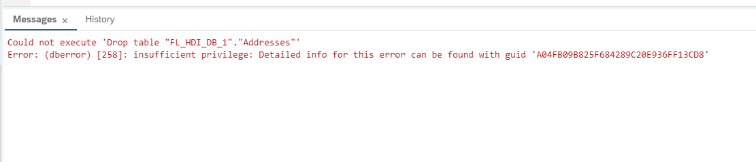

If this error is coming then you need to delete the hdbtable first from the BAS then it will automatically reflect here in the data explorer.

## Creation of Calculation View

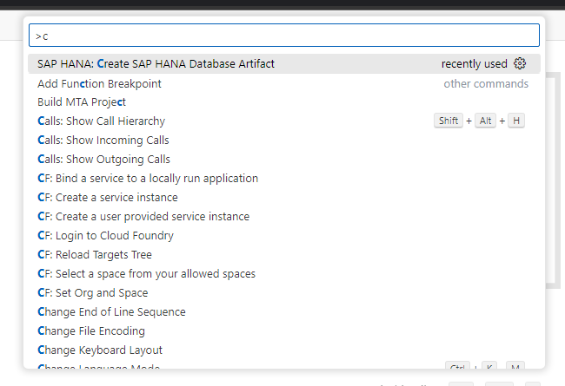

Figure Navigating to Console.

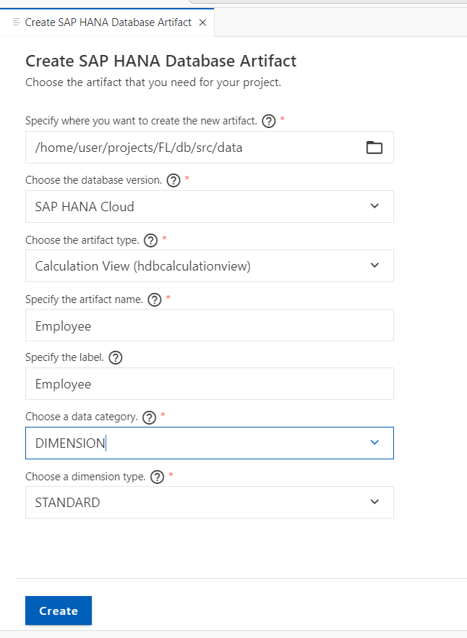

Figure Selecting the Calculation View and Dimension.

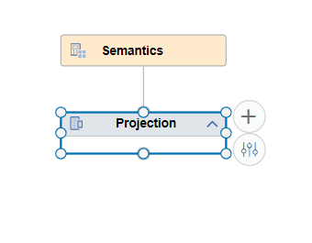

Figure Click on Add-to-add Table to Calculation View.

Figure Adding it to View.

Figure Drag the marked are for mapping.

Figure You can just drag and drop it in output column.

Figure Selecting multiple by using Shift and select and then add to output.

Figure By double clicking you can add to output.

Figure For removing single output Column.

* If you click on Remove mapping it will remove entire from data source also.
* Remove All Mapping Will Remove all the fields from the output column as well as source.
* Removing the output column will only remove the fields from the output column.
* Removing all the output columns will remove all the fields from the output column.
* We can also select the output column by shift + click multiple fields and right click and Removing Output Column

Figure Assigning the Key.

Figure We can double click and change the name of output field.

We can select multiple fields by using shift + click in sequence.

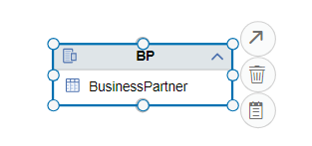

Figure Click on the arrow and drag it to join.

Figure Dragging it to join.

Figure For creation of join drag the arrow and drop it to appropriate node.

Figure If you want to swap the two node you can use them give the cardinality assign the type of join.

### Creation of Calculated Column.

Figure Go to calculated column and click on add.

Figure Giving name to calculated column and using Expression Editor.

Figure After Adding the expression validate the Syntax.

Figure If syntax is right, you will get the prompt.

Figure Syntax to Concatenate.

Figure Hybrid Calculation View using Product table and Bpartner View.

### Filter

Restricting the view to contain only the records from EMEA Region

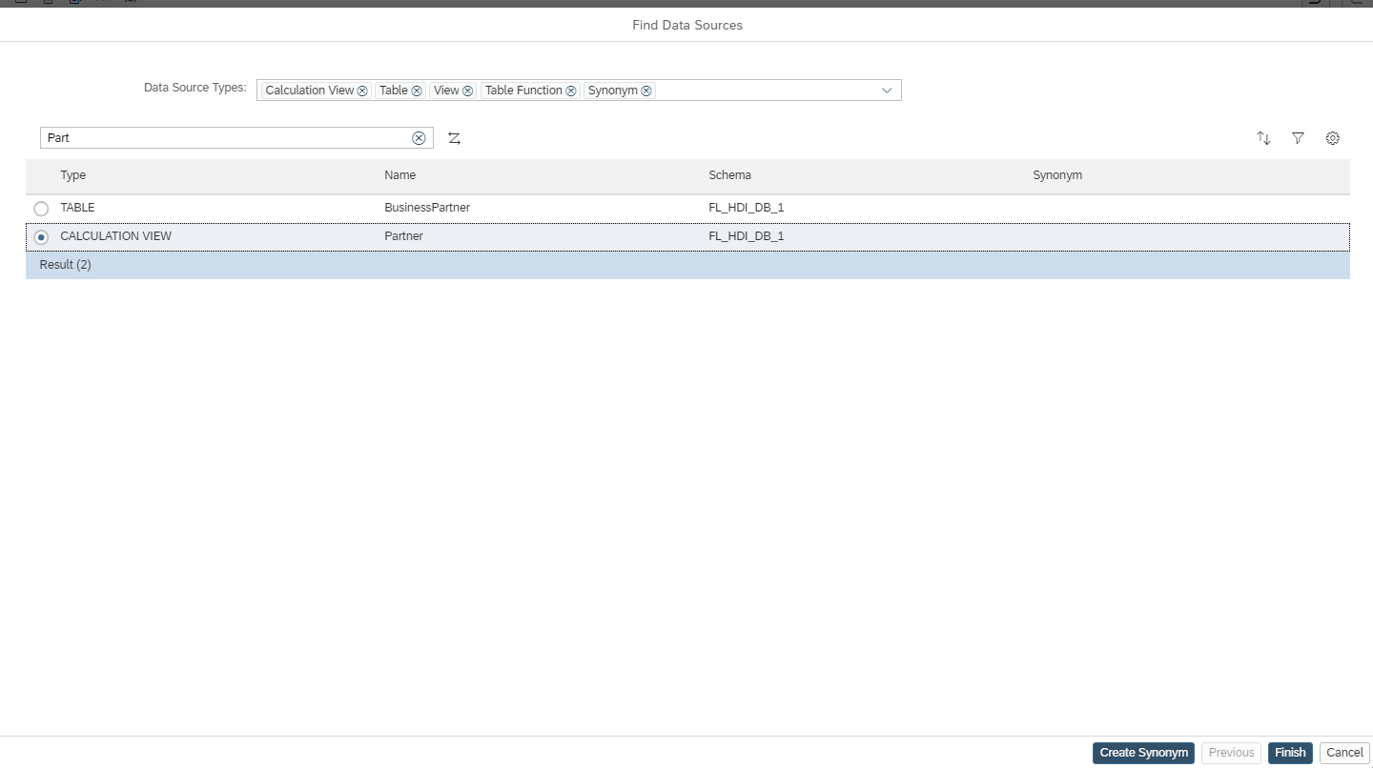

Figure Using Existing View in Projection.

Figure Adding Filter Expression to restrict the data.

Figure Verify the No of entries in Data Preview and in Explorer.

Figure In both the cases the number of entries are same.

Figure Creation of Purchase Cube.