C# Developer QuickStart

# Introduction

This document describes the controller, GUI and other code written in C# and using the .NET 3.5 framework. Before you start reading this you should preferably have read the conceptual introduction of the framework. The purpose of this document is to clarify the different C# projects and their use. Important concepts specific to a solution will be explained as well. For a more in depth explanation of the source code, head over to the code documentation.

When developing the framework, please make sure you have met all the requirements as described in the respective document.

Contents

Introduction 1

Opening the solution 2

Overview 3

Projects Overview 4

# Opening the solution

1. Browse to the directory containing the source code, this should be the directory /Final Product/Source
2. Double click the file: Elab.Rtls.Engines.WsnEngine.sln to open the Visual Studio Solution

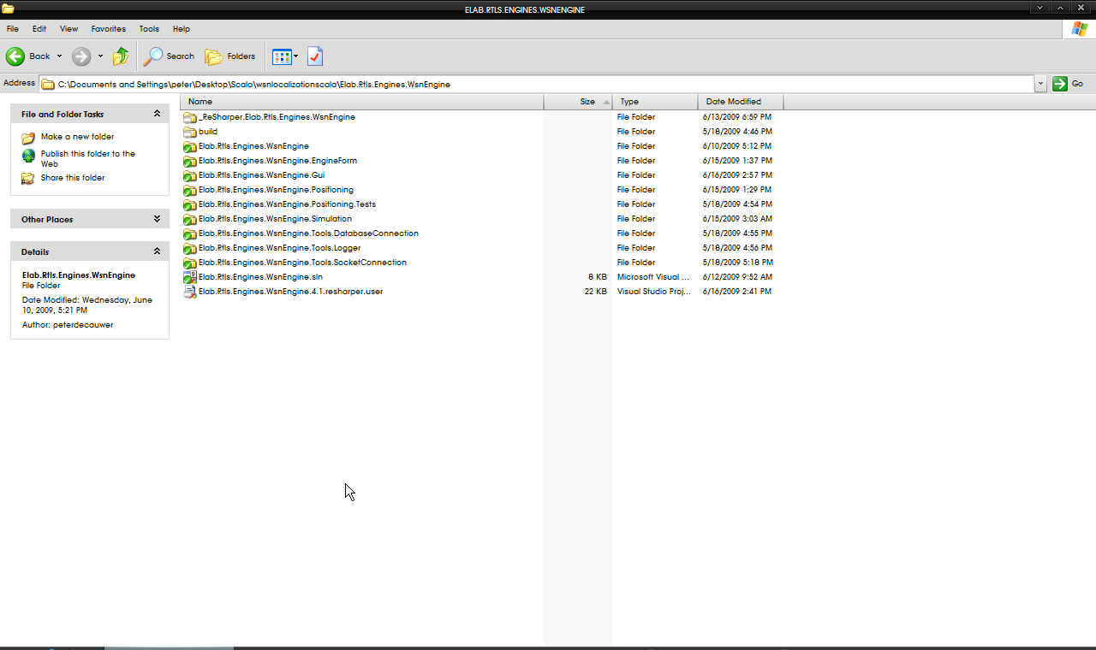

# Overview

This section explains the functionality of every project on a high level.

When you have opened the solution, you can see the solution and the projects in the solution explorer.

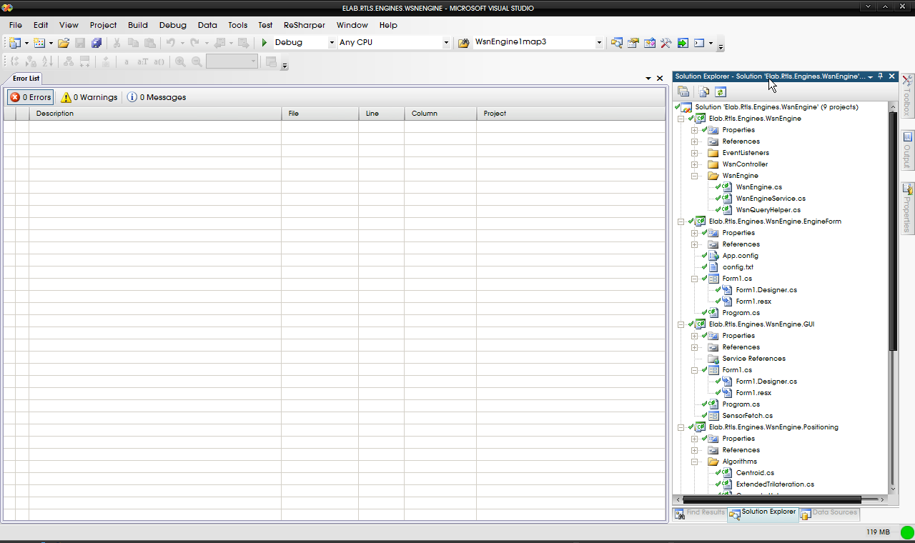

These projects can be divided into logical groups:

The GUI, Controller / Engine form the part of the framework as described in the conceptual overview. The other divisions serve other purposes

## Projects Overview

The GUI is constructed in the Elab.Rtls.Engines.WsnEngine.GUI project.

The Scala Engine / Controller consists out of 2 projects:

* Elab.Rtls.Engines.WsnEngine
* Elab.Rtls.Engines.WsnEngine.EngineForm

The attentive reader may notice that there are three more logical subdivisions; their respective projects are listed here:

* Tools
  + Elab.Rtls.Engines.WsnEngine.Tools.SocketConnection
  + Elab.Rtls.Engines.WsnEngine.Tools.Logger
  + Elab.Rtls.Engines.WsnEngine.Tools.DatabaseConnection
* Simulation
  + Elab.Rtls.Engines.WsnEngine.Simulation
* Localization
  + Elab.Rtls.Engines.WsnEngine.Positioning
  + Elab.Rtls.Engines.WsnEngine.Positioning.Tests

## Elab.Rtls.Engines.WsnEngine.GUI