**“Online examination system”**

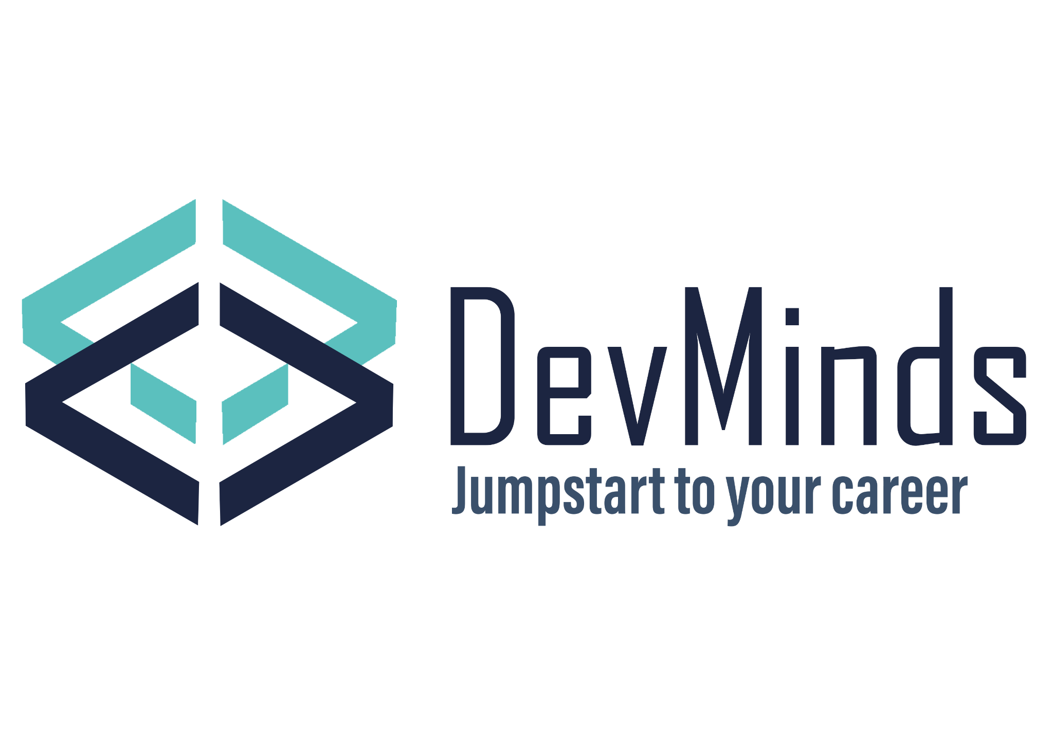

Supervised by:

Eng\ Nadia salah

Eng\ Rami Abou-Nagi

Team members:

Amar Fathy Mostafa

Reem Hassan Shehata

Maab Mostafa Saad

Marwa Mohamed Fikry

### List of contents

Introduction …………………………………………………………………………………………………… 3

Overview …………………………………………………………………………………………………… 4

Technical tools ……………………………………………………………………………………………… 4

Business scenario …………………………………………………………………….……………………… 5

ERD ………………………………………………………………………………………………….…………. 6

Mapping ………………………………………………………………………………………….………..… 7

Database Diagram ………………………………………………………………….……….………… 8

Cleaning ……………………………………………………………………………………..…………… 9

Azure cloud solution …………………………………………………………………………………. 10

Stored procedures …………………………………………………………..…………………………… 11

SSIS ……………………………………………………………………………………………………………. 18

SSRS and Report …………………………………………….…………………………………………… 19

Dashboards …………………………………………………………………………………………….……. 23

Acknowledgment ………………………………………………………………….………………………. 30

**Introduction**

DevMinds is an institution that offers students the opportunity to join tracks and learn programming and soft skills. Our institution is dedicated to providing a supportive and inclusive learning environment where students can develop their skills and reach their full potential.

Our tracks are designed to provide students with a comprehensive education in programming, covering a wide range of languages and technologies.

In addition to programming, we also place a strong emphasis on developing students' soft skills. Our curriculum includes modules on communication, teamwork, and leadership, helping students to become well-rounded professionals who can thrive in any workplace.

**At DevMinds, we believe that everyone should have access to high-quality education, regardless of his or her background or experience.**

**Overview**

Web application for online examination system to perform online exams by instructors of the institution of DevMinds, in addition to being auto-generated, is automatically corrected based on stored questions and model answers for each question.

It shows the students after each exam whether he/ she passed or not and his/her total grade and the grade of each question if it is right or wrong.

Started with making the business case itself followed by designing and building a database and linking it with the web application, and ending with system reports and dashboards that would help the managers and stakeholders to explore, track their performance over the years, see the performance for each branch and instructor to be able to take the proper discussion.

This project was done as a graduation project for the “Information Technology Institute –ITI”

For the intensive code camp program | track Power Bi developers.

**Technical tools**

* Draw.io 🡪 desktop application for drawing ERD
* SQL server database
* Azure virtual machine with SQL server as a shared server
* Excel
* SSIS for integration and data filling
* SSRS for generating reports and exams
* Microsoft Power BI for Dashboards

**Business scenario**

We sat with each other for one sitting to make brainstorm our business scenario and our desired institution. Our institution has many branches all around Egypt such as in Cairo, Alexandria, Mansoura and other cities. In each branch we have many instructors who teach one or more course for one or more track.

We have been opening since 2020 and we begin with 3 tracks which are digital marketing, soft skills and front end. We have 4 rounds in a year and the track has increased till it became 5 tracks in 2023 and each track has many courses. Students can apply for courses or for tracks, each course has a price that is different from the same course inside the track. Each track has many students, a supervisor for the track and many courses.

**ERD (Entity Relationship Diagram)**

We discussed our vision for the institution, our main entities, and our attributes which included several entities represented in the ERD

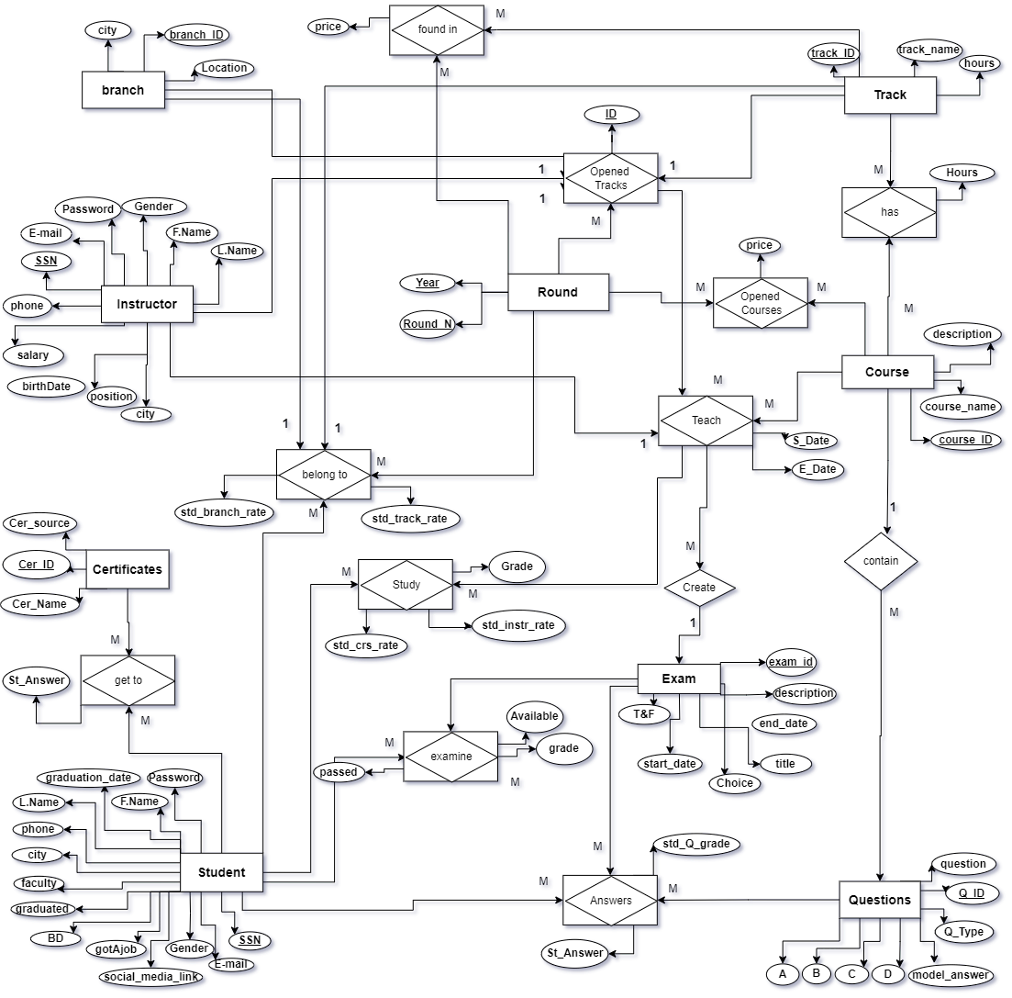

**Mapping**

This ERD mapping illustrates the database design for the examination system, including the entities, relationships, and data types used in the system.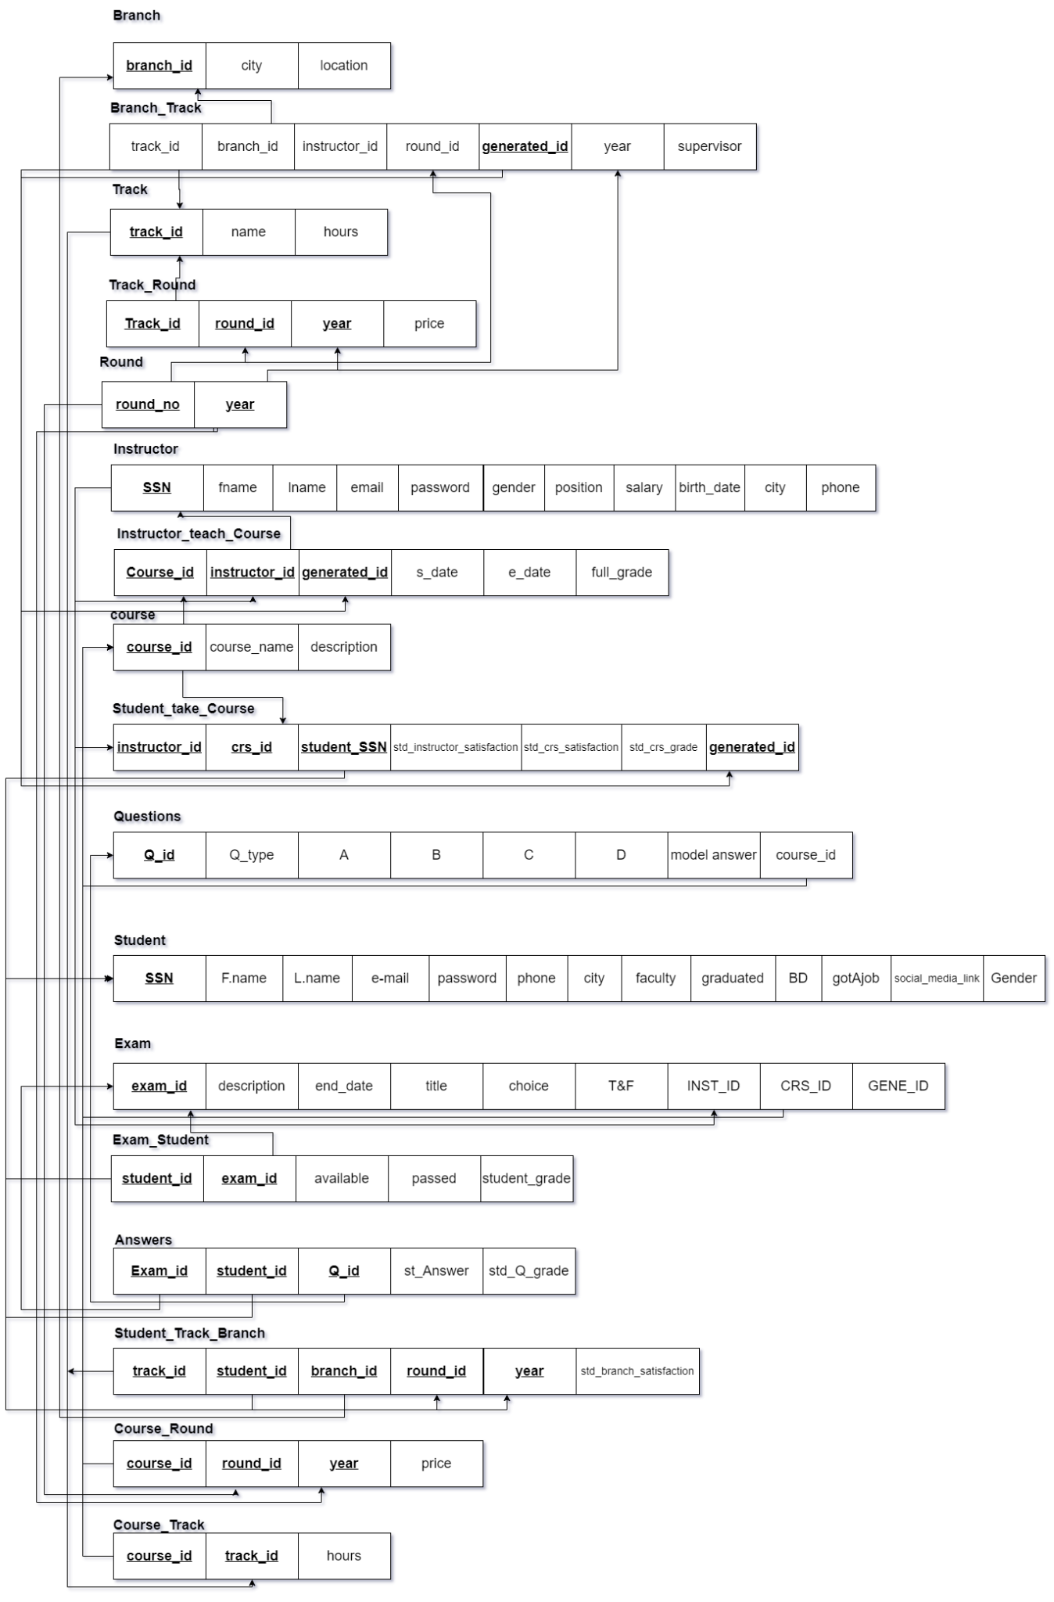

**Database Diagram**

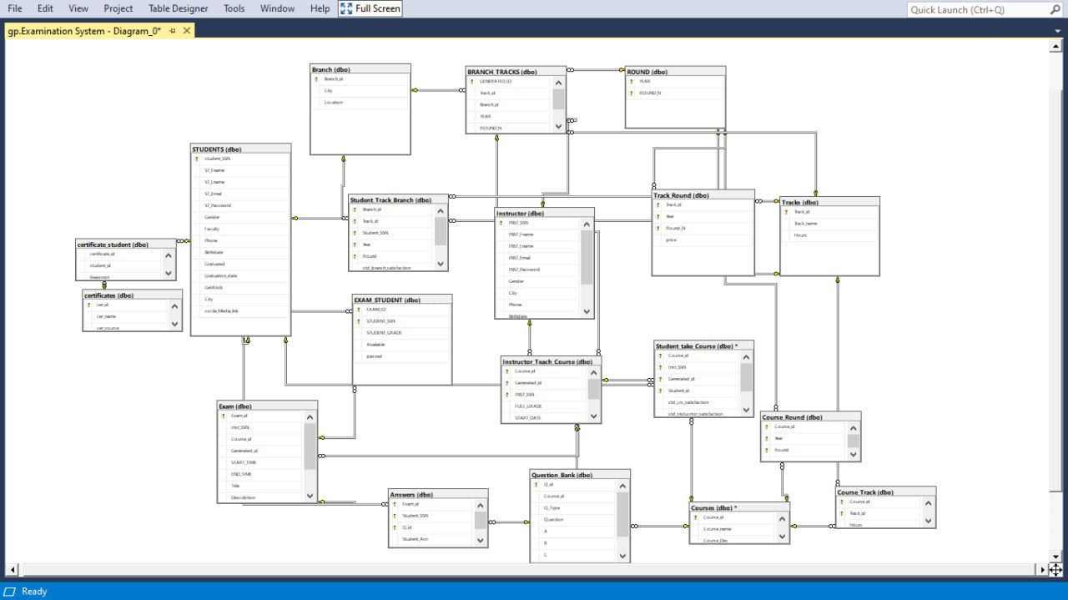

**Cleaning**

The question bank was initially provided in PDF format and was converted to Excel sheets using the website www.adobe.com/acrobat/online/pdf-to-excel.html. The integration process was carried out using SQL Server Integration Services (SSIS). However, the Excel sheets required some further processing as the questions, answers, and model answers were all contained within the same column. These needed to be separated so that each attribute could be assigned to its corresponding column in the questions table.

To achieve this, a macro was recorded that copied the rows and transpose them into the targeted cells, after which the original rows were deleted. Additionally, the formula =OFFSET ($A$1, COLUMNS($A1:A1)-1+(ROWS($1:1)-1)*5,0) was used on certain sheets to rearrange the rows into their desired positions.

Here’s one of the question bank sheets before cleaning:

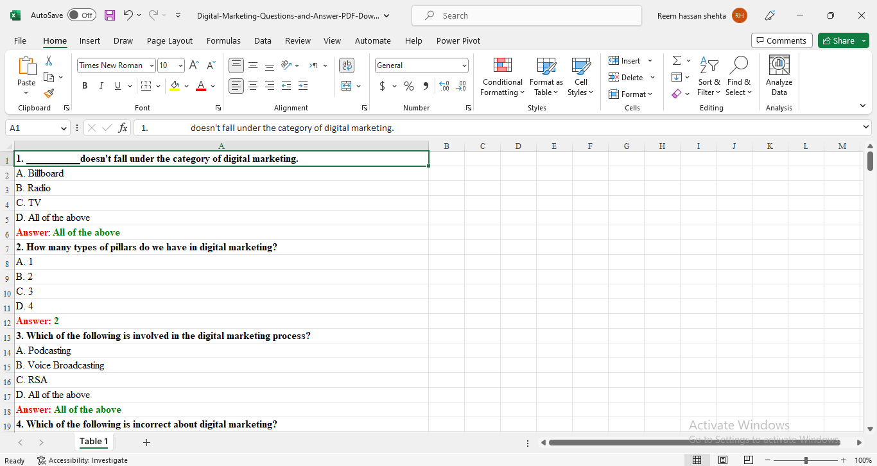

**Synchronized database**

We wanted to make the most out of the tools and technologies we had learned so, we needed to work in a synchronized database, and since we had a cloud course we decided to walk extra mile with Azure cloud solution and created a SQL server to host our database and gave permission to all the team members to work online together :

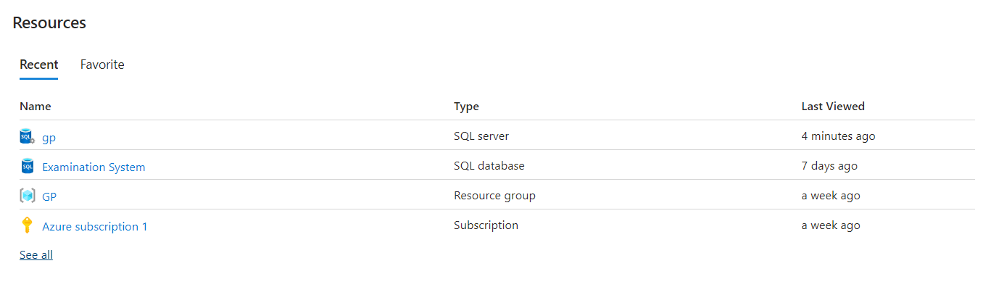

**Stored procedures**

**Generated exam**

In this procedure, we can generate random questions for the same exam name for each student.

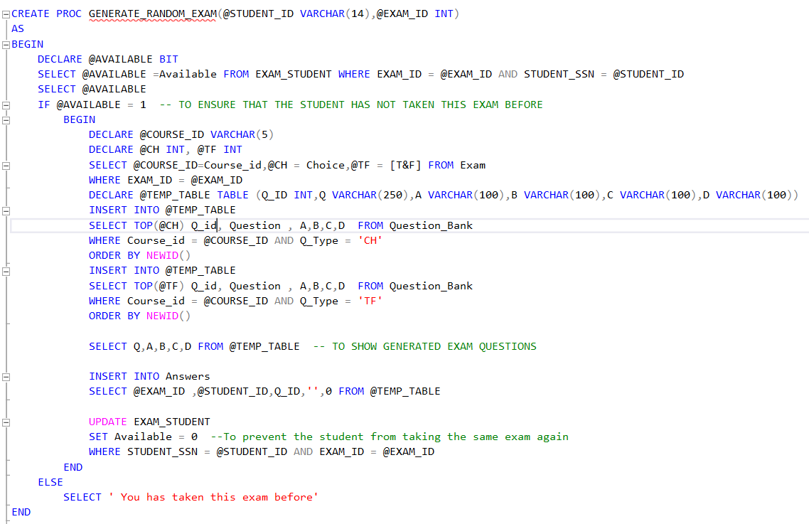

**EXAM ANSWER AND CORRECTION**

In this procedure, the student answers enter as a list, and student id and exam id, then store the student answer and correct his answer with answer model, then collect his grades and store his grade.

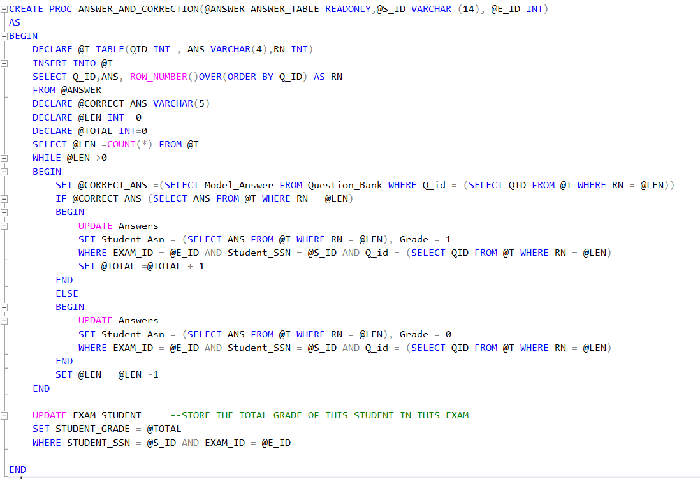

**INSERT RECORDS**

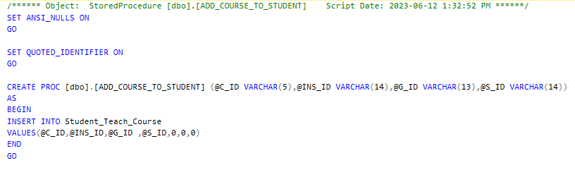

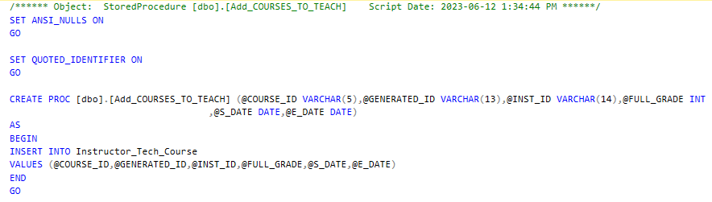

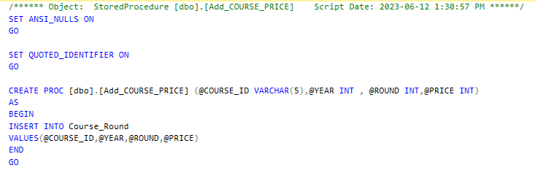

**SELECT RECORDS**

tow Stored procedure to show number of over all students , and only Graduated students

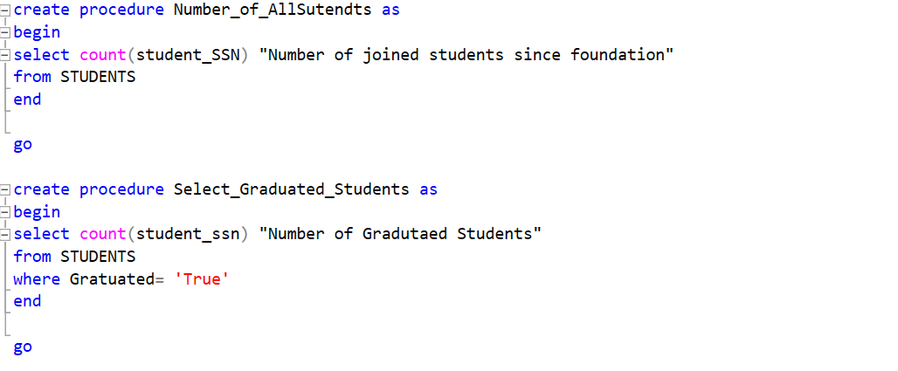

**UPDATE RECORDS**

Stored procedure to update students data.

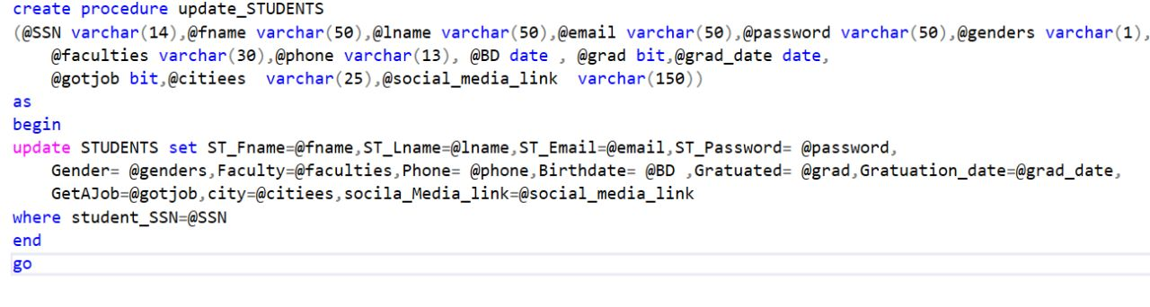

Stored procedure to update instructors data.

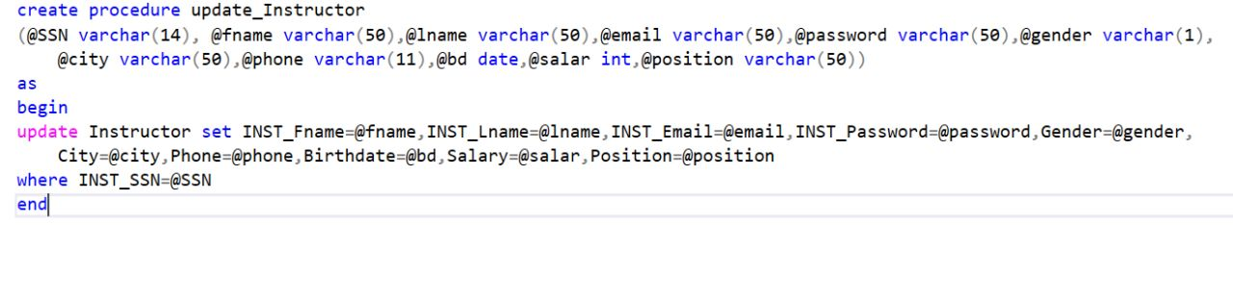

Stored procedure to update tracks.

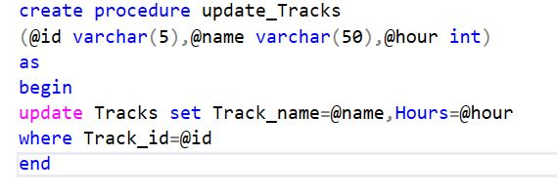

stored procedure to update branch location.

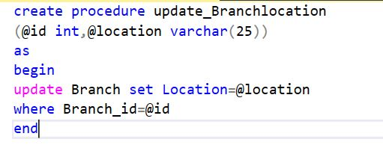

Stored procedure to update exam description and title.

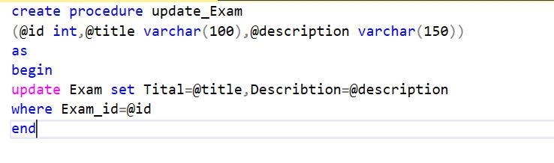

**DELETE RECORDS**

We used stored procedures to delete data from the tracks table if the track is no longer available in our institution.

So we started by deleting all the child tables and then deleting from the parent table

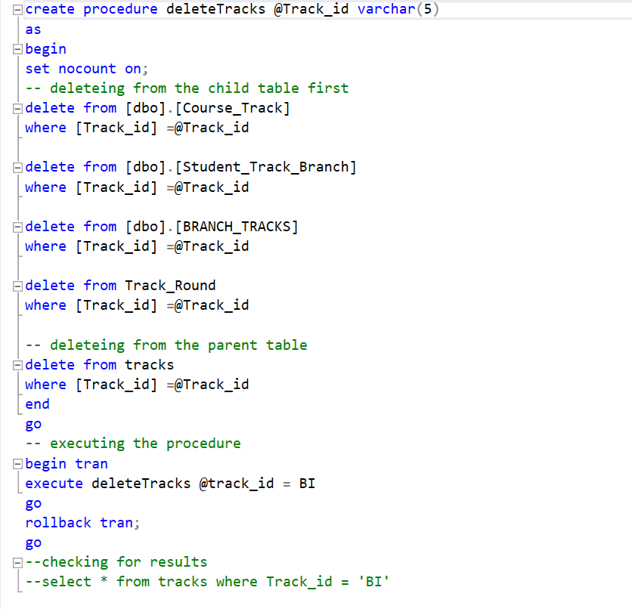

deleting a student that he is no longer a student in our institution or he dropped a track or a course and deleting an instructor he will not teach this course anymore.

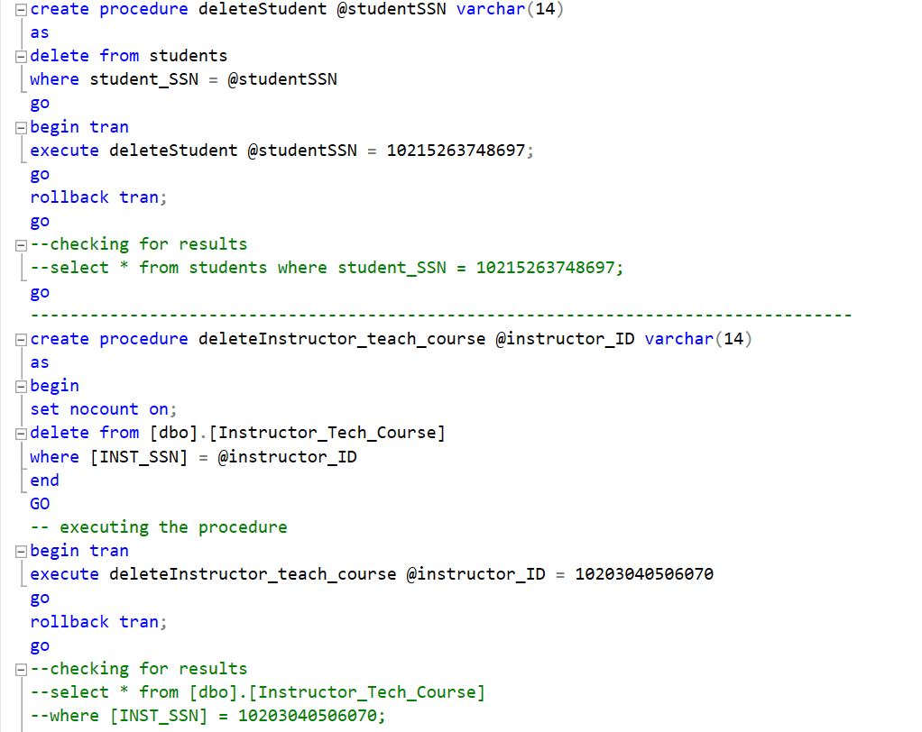

deleting course from a specific round

deleting a track that is no longer in this specific branch

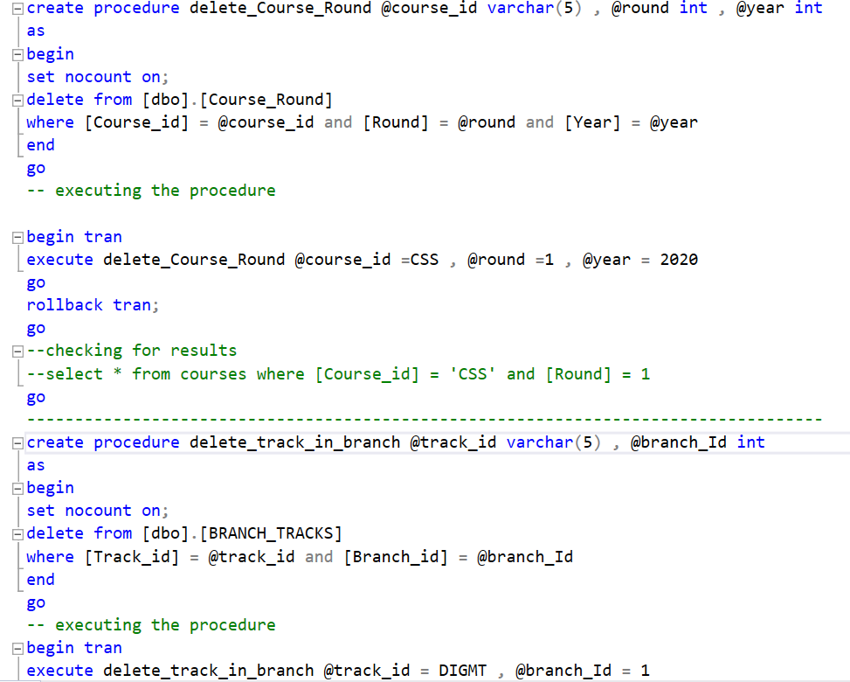

**SSIS**

We used SQL server integration service to import questions data into the database.

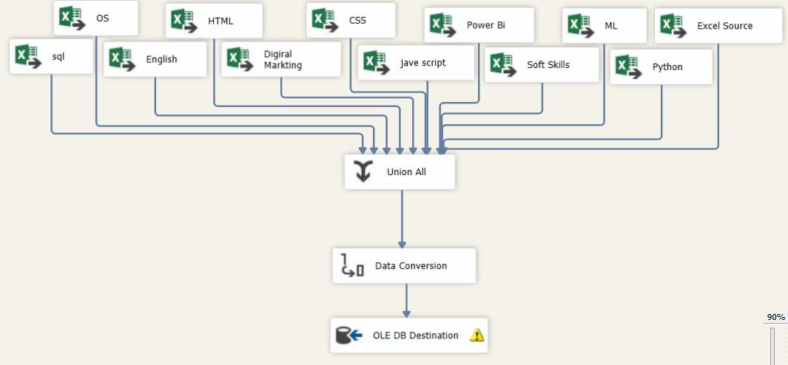

**SSRS and Reports**

**Tracks and student’s Data**

**The first report represents the students' information per track.**

**tracks shown as pages in the report.**

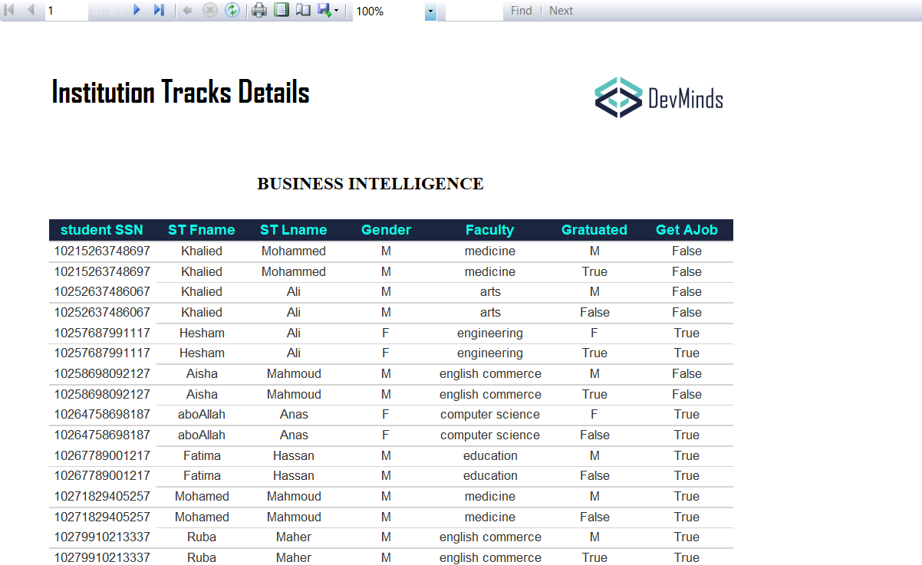

**Student grade per courses**

the second report takes parameter as student_id and shows his/ her data , his/ her grades in exams and courses

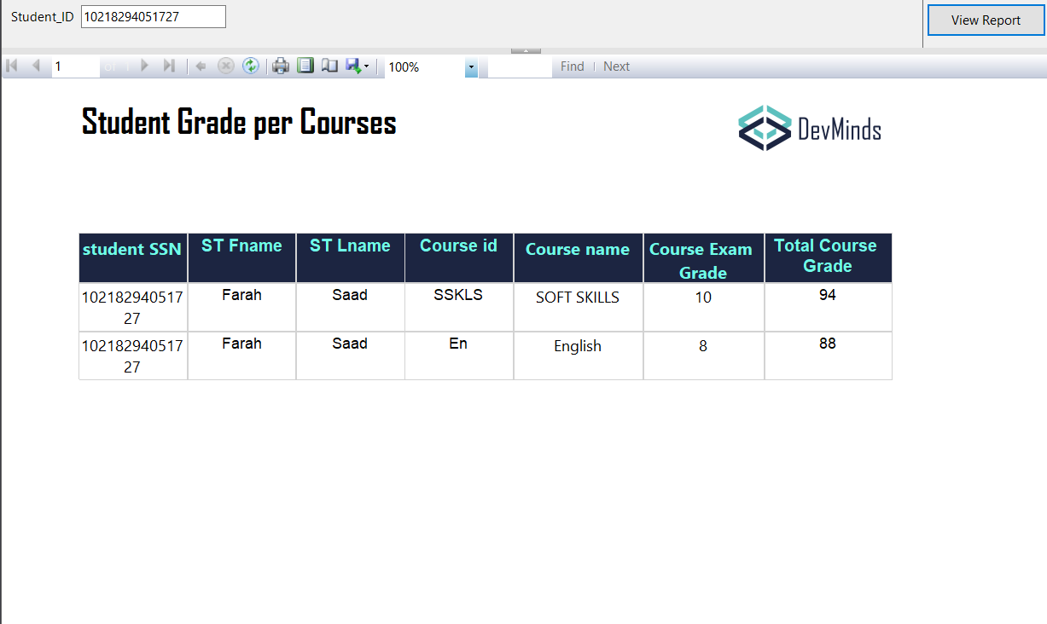

**Instructor, the courses that he teaches and the tracks that he supervises**

the third report represents the generated exam that is generated by the instructor and it is unique for each student per course

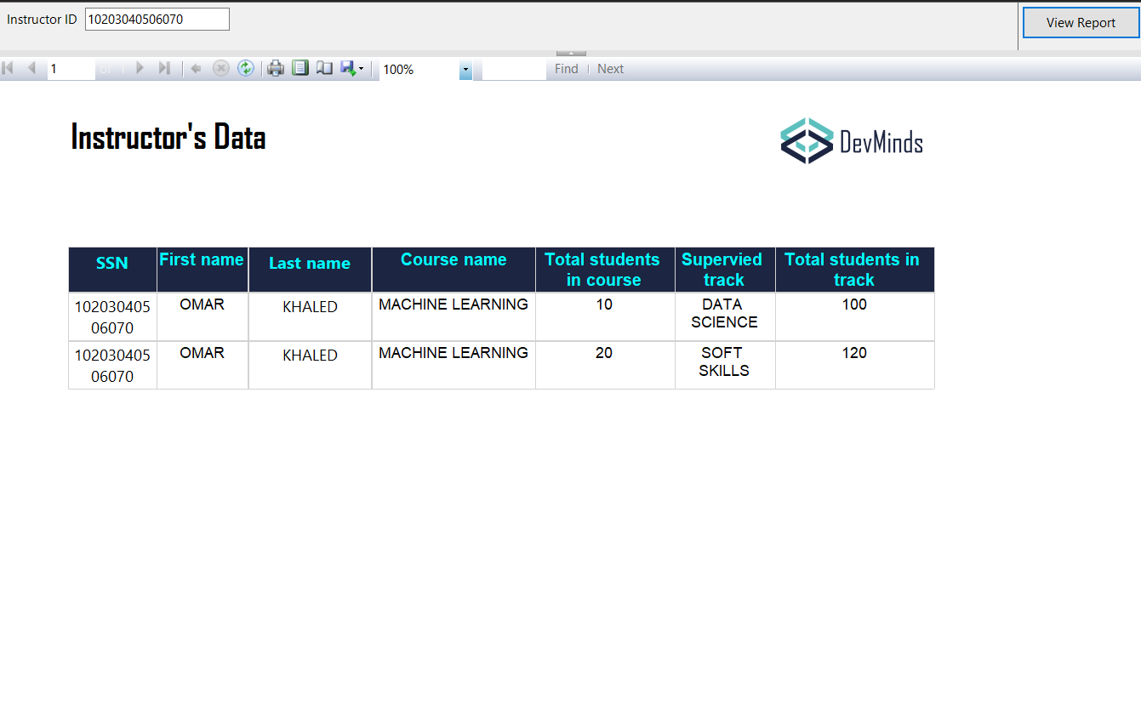

**Institution tracks and its courses**

The fourth report is to show the available tracks and the related courses that are being taught in it.

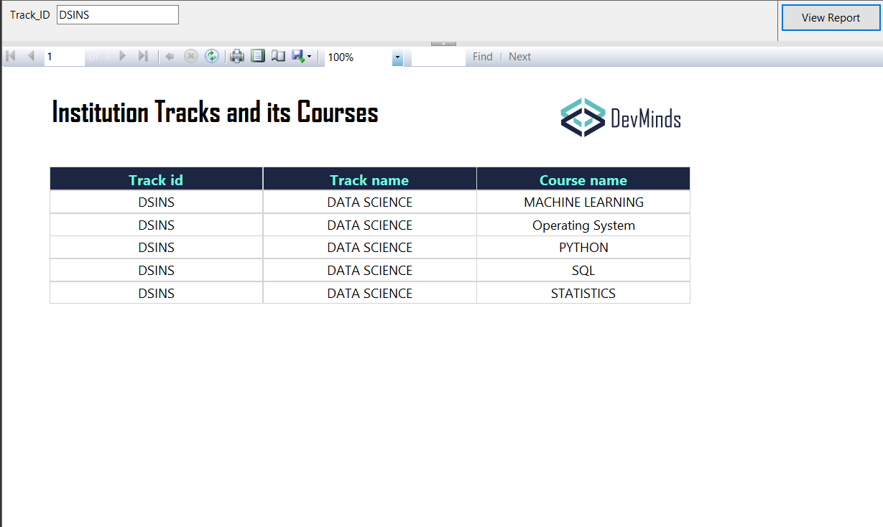

**Exam questions per courses**

the fifth report is to show the generated exams for each course, it takes the parameter for exam id and represents the question with its choices or true and false

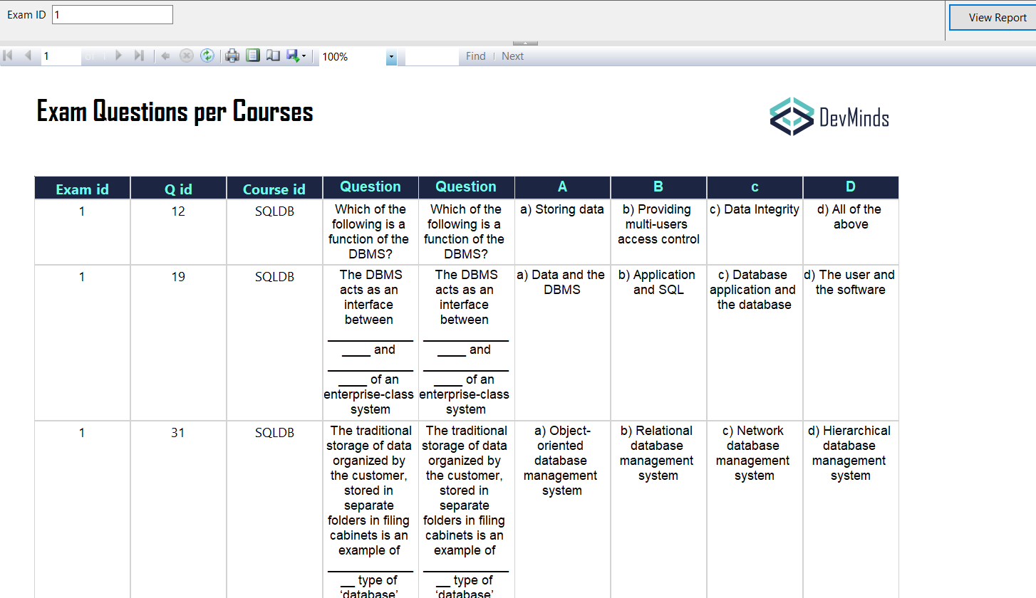

**Generated Exam for each student**

the sixth report shows the generated exam, its question and the chosen answer by the student, the grade for each question and the total grade for the exam grade student.

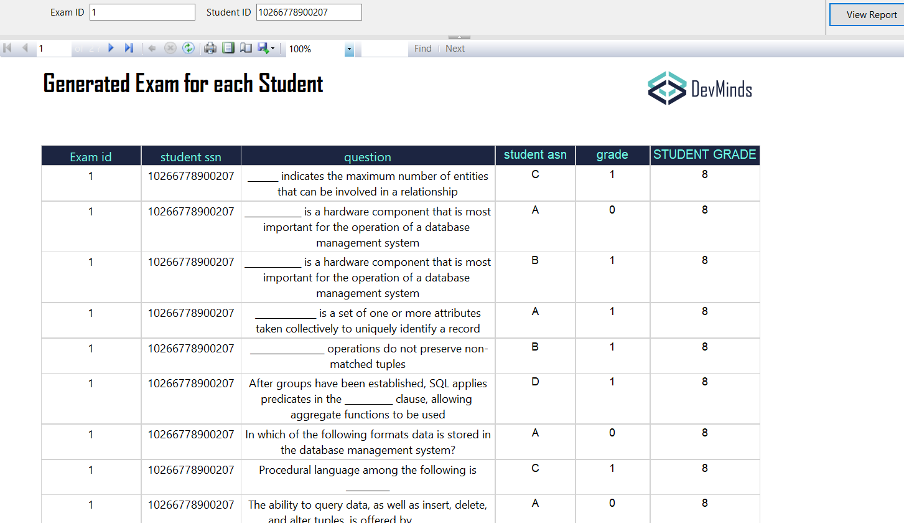

**Dashboards**

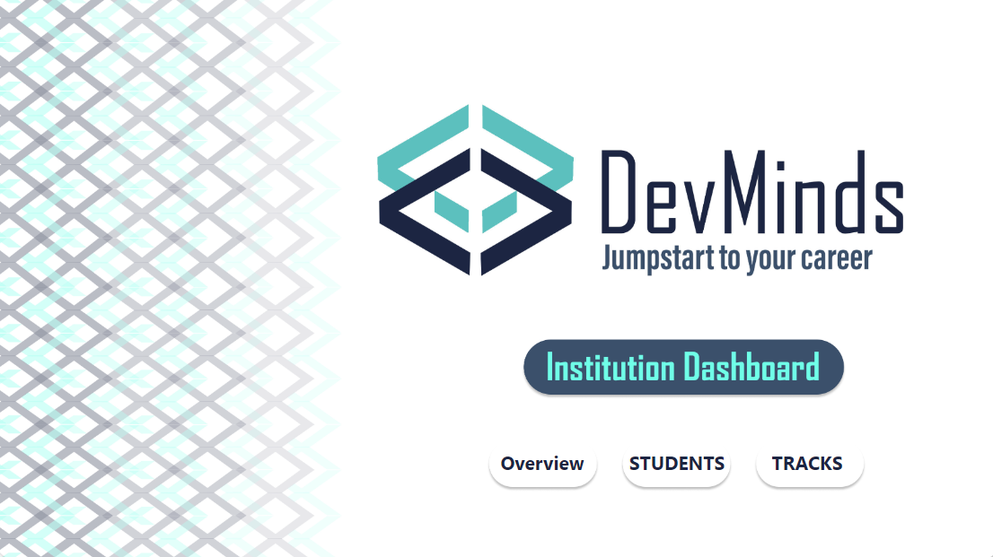

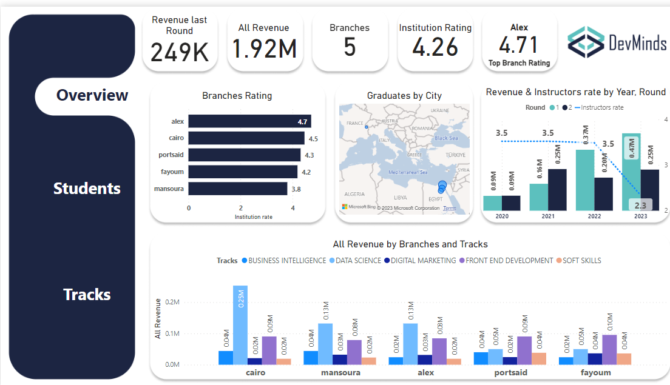

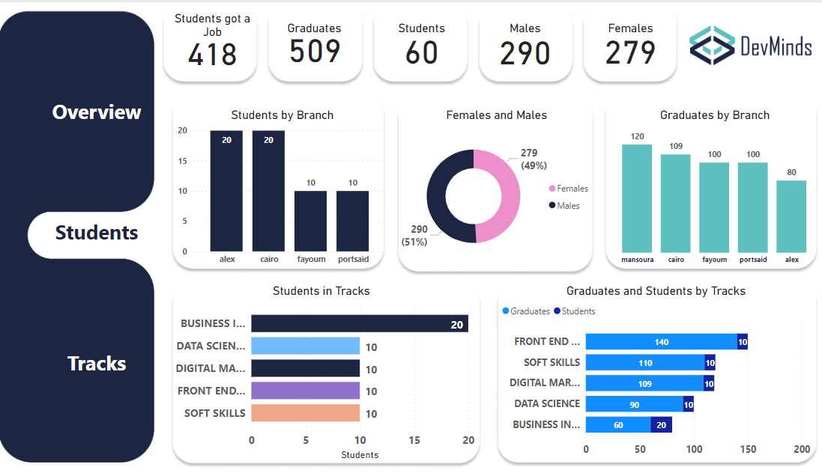

**Instructors Dashboard**

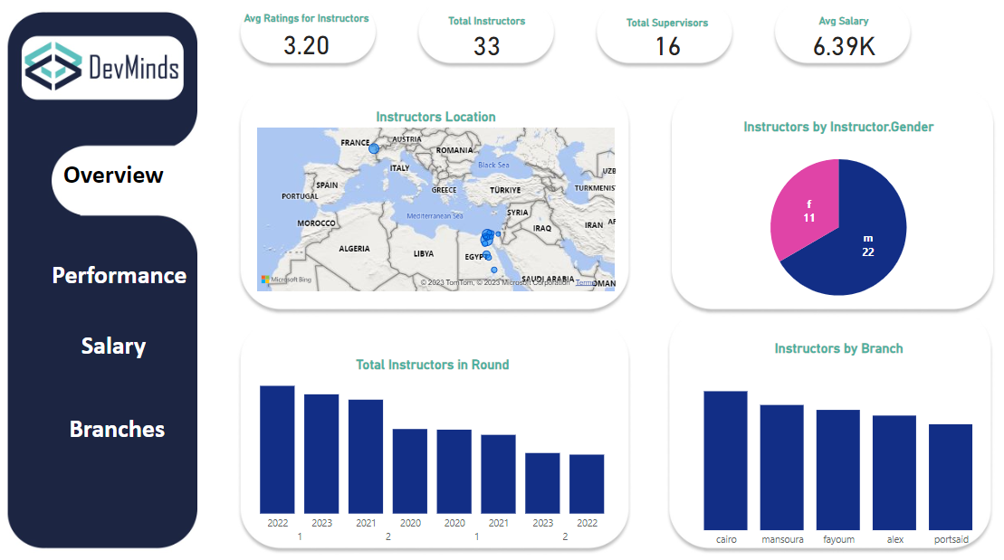

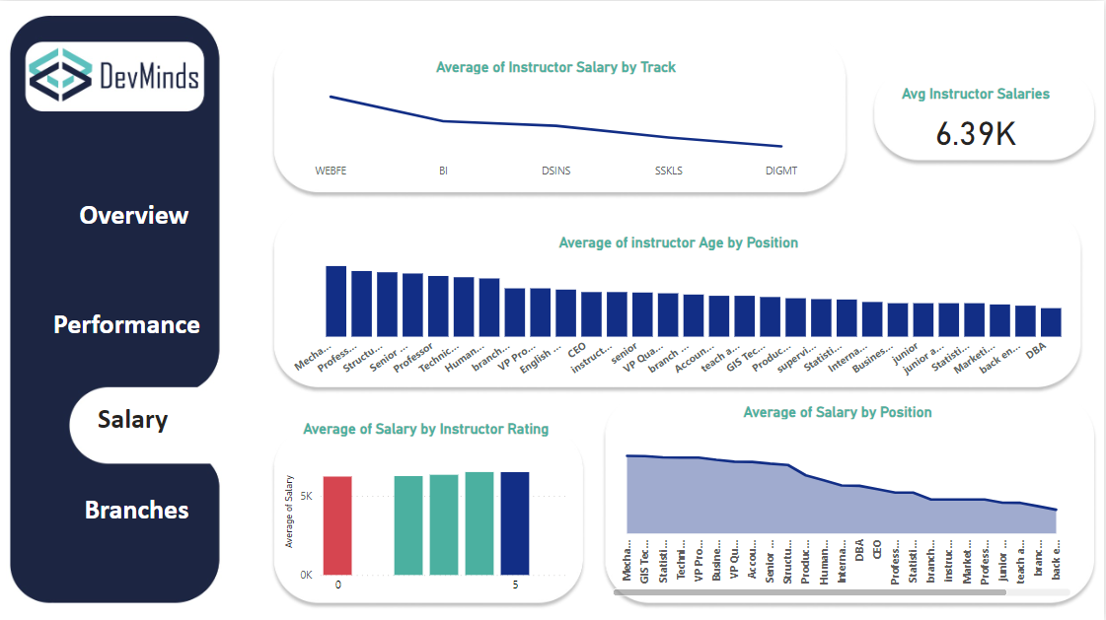

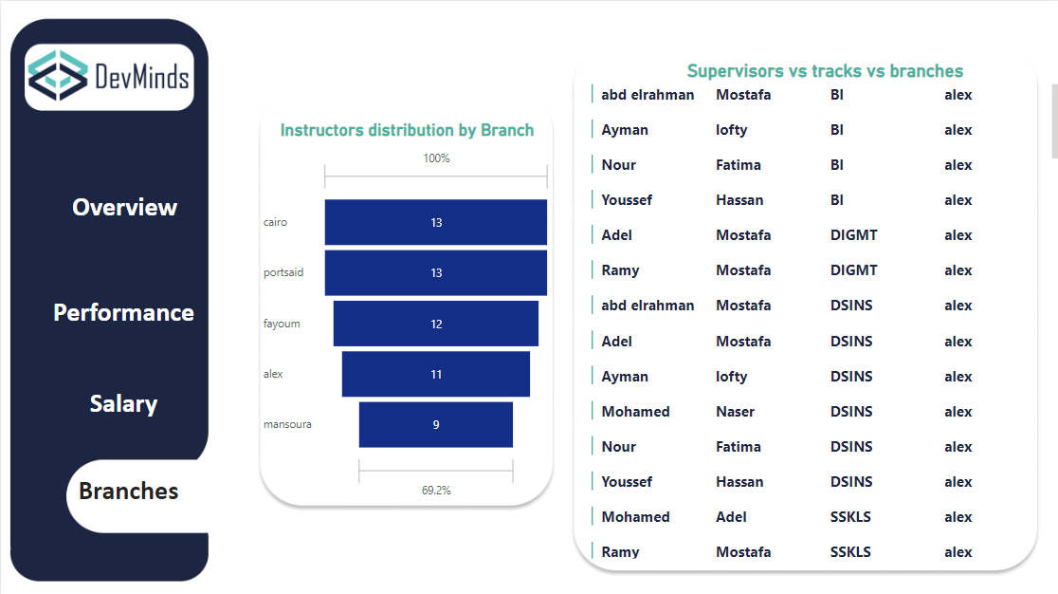

**Branches Dashboards**

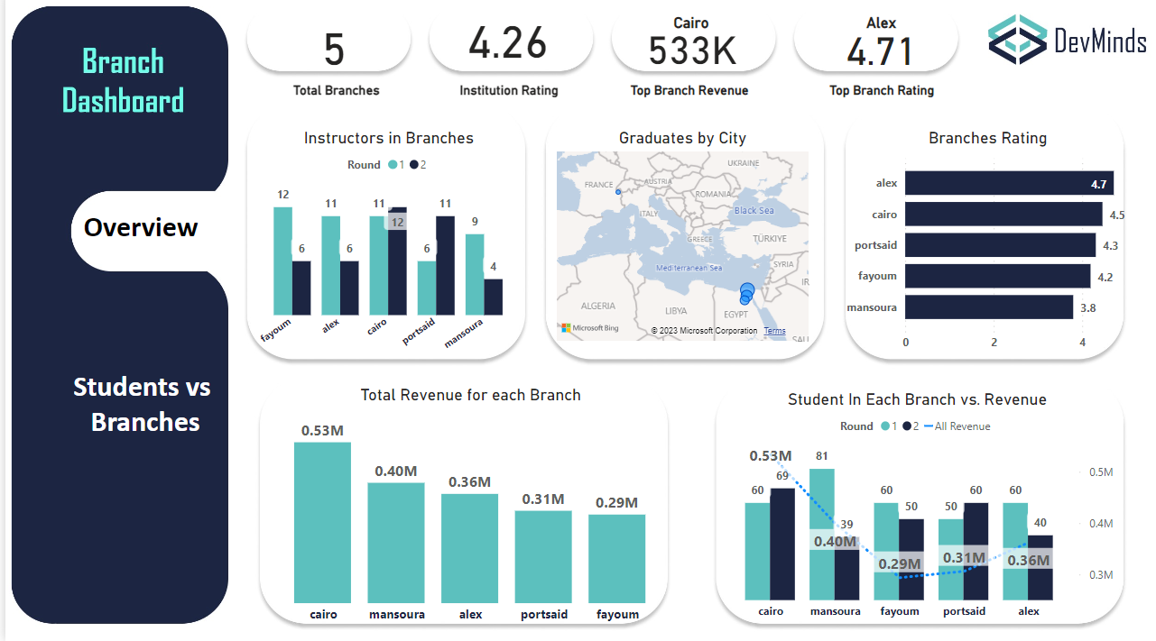

**Courses Dashboard**

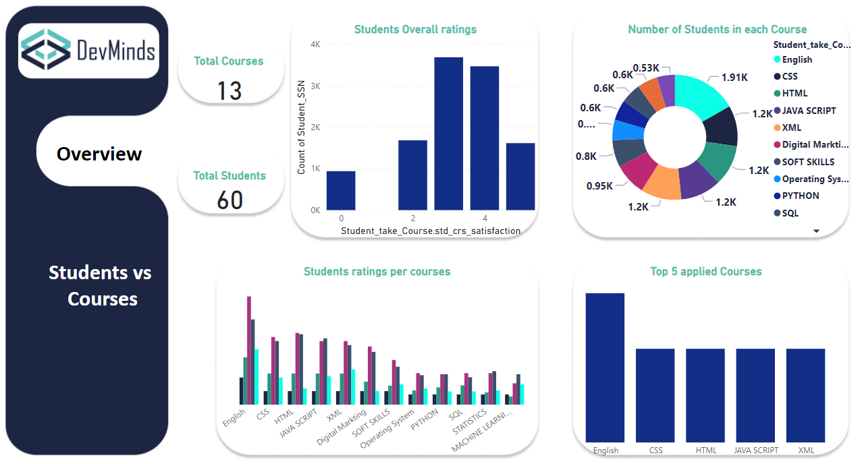

**Students Dashboard**

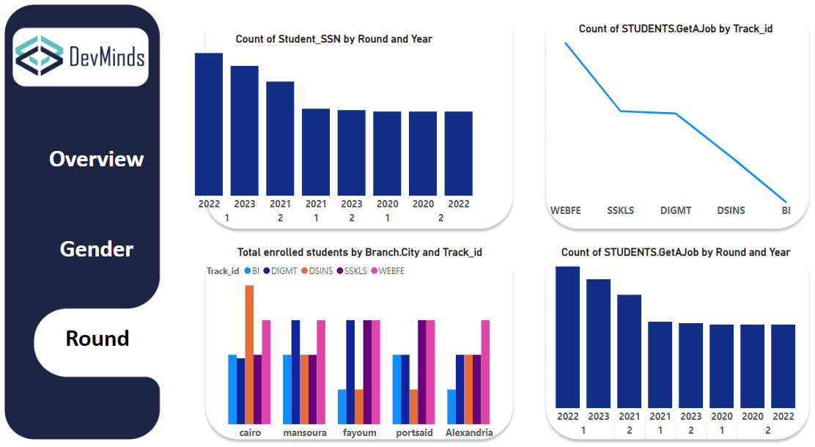

**Tracks Dashboard**

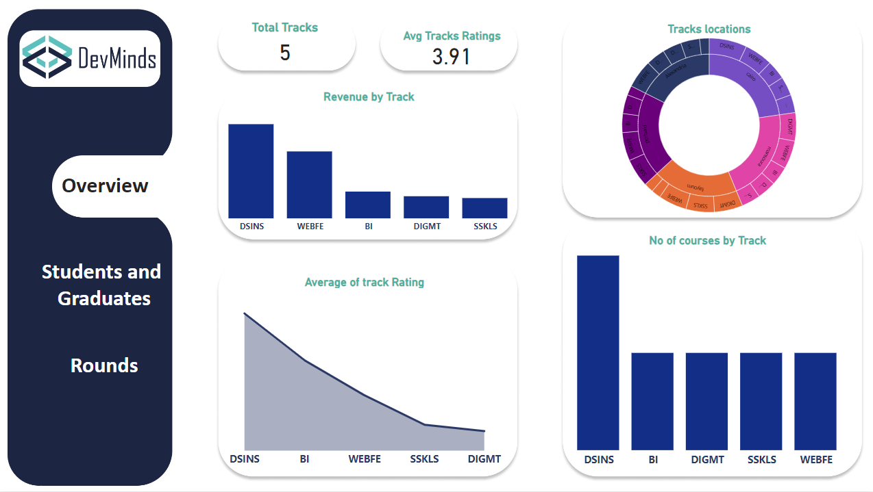

**Acknowledgment**

We are grateful for the opportunity to learn and collaborate with a diverse group of colleagues during our internship. Their unique perspectives and support have been invaluable in shaping my career.

We appreciate the technical knowledge and guidance provided by our colleagues, which will undoubtedly have a positive impact on our future endeavors.

As this project comes to a close, we are excited to begin on a new professional journey.