**Recursive Solution:**

The main idea here is to develop a function that will call itself, inching along to the right and down in all possible combinations, returning a value of 1 whenever it reaches the bottom-right. This approach takes a long time though and would take forever for a bigger grid size.

**import** time

gridSize = [20,20]

**def** recPath(gridSize):

"""

Recursive solution to grid problem. Input is a list of x,y moves remaining.

"""

*# base case, no moves left*

**if** gridSize == [0,0]: **return** 1

*# recursive calls*

paths = 0

*# move left when possible*

**if** gridSize[0] > 0:

paths += recPath([gridSize[0]-1,gridSize[1]])

*# move down when possible*

**if** gridSize[1] > 0:

paths += recPath([gridSize[0],gridSize[1]-1])

**return** paths

start = time.time()

result = recPath(gridSize)

elapsed = time.time() - start

**print** "result %s found in %s seconds" % (result, elapsed)

**The math approach (kinda lame tbh):**

We know that any path will have 40 moves (20 right + 20 down), so for C(n,r) – n will equal 40 and r (the number of right moves) will equal 20 – C(40,20). All you have to do is follow the formula:

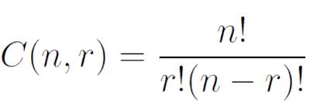

import math

n = 20

result = math.factorial(2*n)//(math.factorial(n)**2)

print(result)

**Efficient approach (many other approaches too):**

The recursive approach above does a lot of similar operations over and over again. Can we learn anything from the smaller cases and build up from there?

Consider a grid of rows **m** and columns **n**. Counting from the upper-left and starting at zero, denote the intersection/node in the **i-th** row and **j-th** column by $N_{i,j}$**.** Thus, the upper-left node is $N_{0,0}$., the bottom-left is $N_{m,0}$ and the bottom-right is $N_{m,n}$**.** Clearly, the number of paths from $N_{0,0}$ to any node along the far left or far top of the grid is only 1 (since we may only proceed down or left). In order to determine the total number of paths to any node $N_{i,j}$ we only need to sum together the total number of paths to $N_{i,j-1}$ and $N_{i-1,j}$ This is understood graphically in the following diagram, where each new integer represents the number of paths to a node.

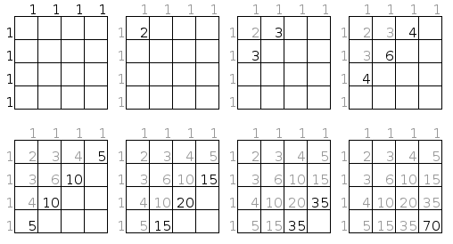

Thus, in a 4x4 grid (example above), there are 70 non-backtracking paths. So suppose $S_{i,j}$ is the number of paths to node $N_{i,j}$. If we write out the sequence for $S_{i,j}$ we obtain the lower diagonal sequence embedded in the diagram above.

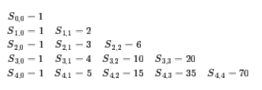

Implementation bellow:

**import** time

**def** route_num(cube_size):

L = [1] * cube_size

**for** i **in** range(cube_size):

**for** j **in** range(i):

L[j] = L[j]+L[j-1]

L[i] = 2 * L[i - 1]

**return** L[cube_size - 1]

start = time.time()

n = route_num(20)

elapsed = (time.time() - start)

**print** "%s found in %s seconds" % (n,elapsed)