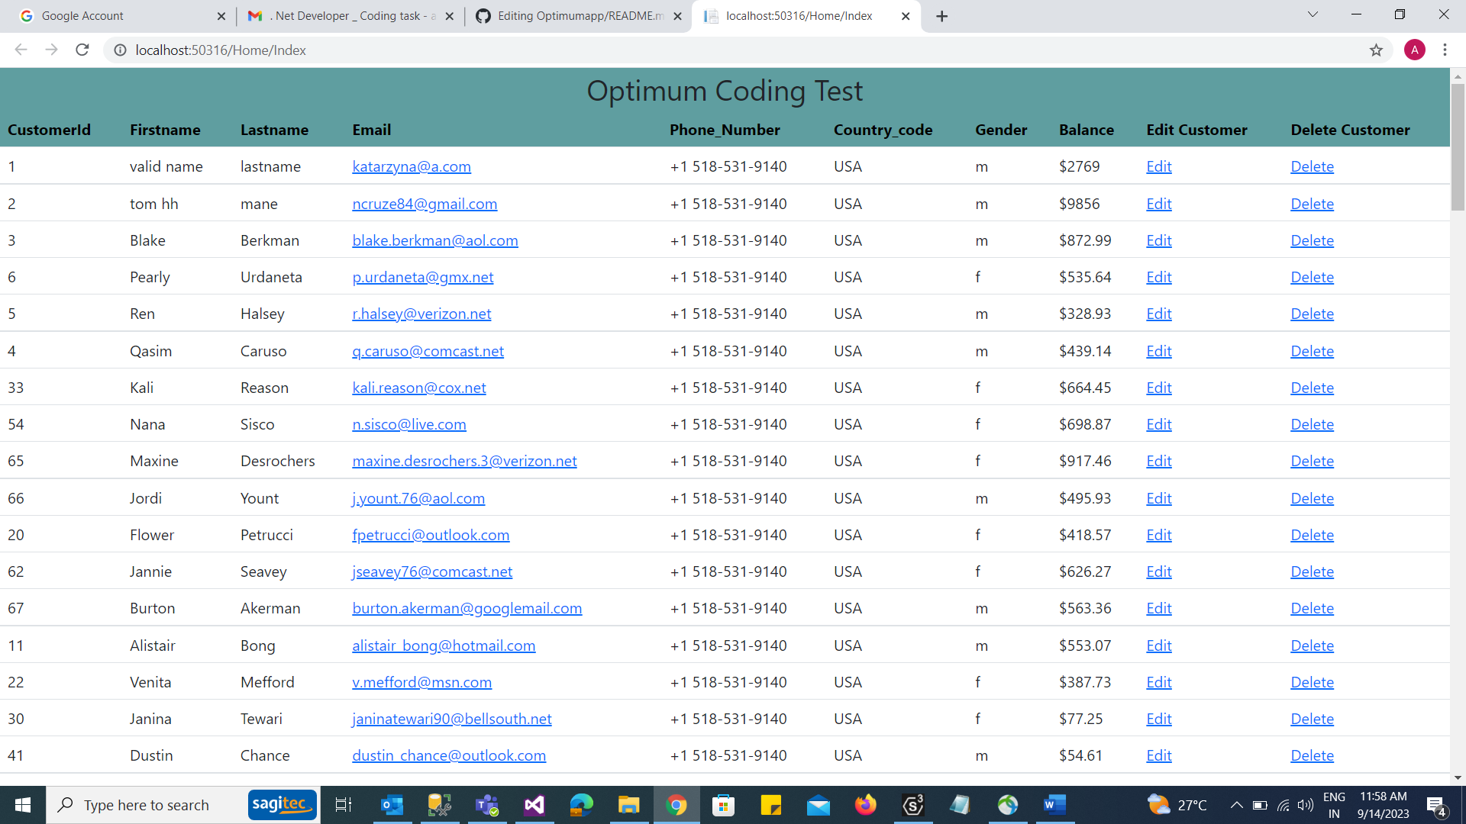

Click delete

Data deleted and grid refreshed

Click edit – Redirect to add/update screen

Data loaded in dom with id=1

Add invalid email

Add correct email

Data updated with valid email -check by click on view all customer

Add data

Click add customer

Verify data