

**IT 309 SOFTWARE ENGINEERING**

PROJECT DOCUMENTATION

EMPLOYEE MANAGEMENT SYSTEM

Prepared by:

**Amar Mujkić**

**Vedran Kilalić**

Proposed to:

**Nermina Durmić, Assist. Prof. Dr.**

**Aldin Kovačević, Teaching Assistant**

Date of submission

21.06.2023

TABLE OF CONTENTS

Generate your table of contents here.

Table of Contents

1. Introduction 2

1.1. About the Project 3

1.2. Project Functionalities and Screenshots 3

2. Project Structure 3

2.1. Technologies 3

Coding standards: 3

Third-party tools: 3

2.2. Database Entities 3

2.3. Design Patterns 4

2.4. Tests 4

3. Conclusion 4

# 1. Introduction

This document contains basic information about our project. Project is hosted at:

<http://165.227.169.215/views/login.html>

To use the app you can use these credentials:

- With Admin Rights: [janesmith@example.com](mailto:janesmith@example.com), password2;

- Without Admin Rights: [amarmujkic@example.com](mailto:amarmujkic@example.com), pass1;

## 1.1. About the Project

The employee management application is a comprehensive software solution that automates and simplifies various HR processes within organizations. It features a user-friendly interface for efficient employee onboarding, attendance tracking, performance evaluation, and leave management. Built with Java Spring Boot for the backend, HTML/CSS for the frontend, and MySQL for the database, the application enhances productivity and communication, enabling businesses to effectively manage their workforce.

You can access the page as admin employee or regular employee. The regular account can see his info edit status of attendance and edit his mail, name or phone. Admin account has different possibilities, creating new user, creating new attendance, deleting them, editing his own status, viewing everyone’s info and manage it. Regardless which user is logged in, time entry is created for that particular attendance and when user logs out time of leaving is also recorded.

## 1.2. Project Functionalities and Screenshots

Viewing info of all users as admin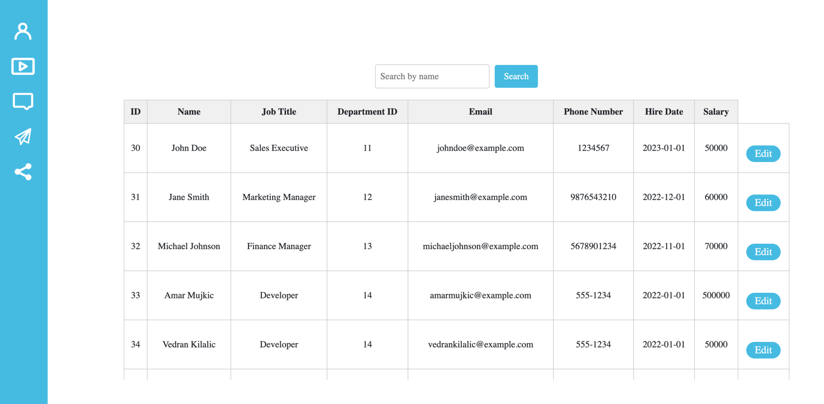

Creating new employee or department

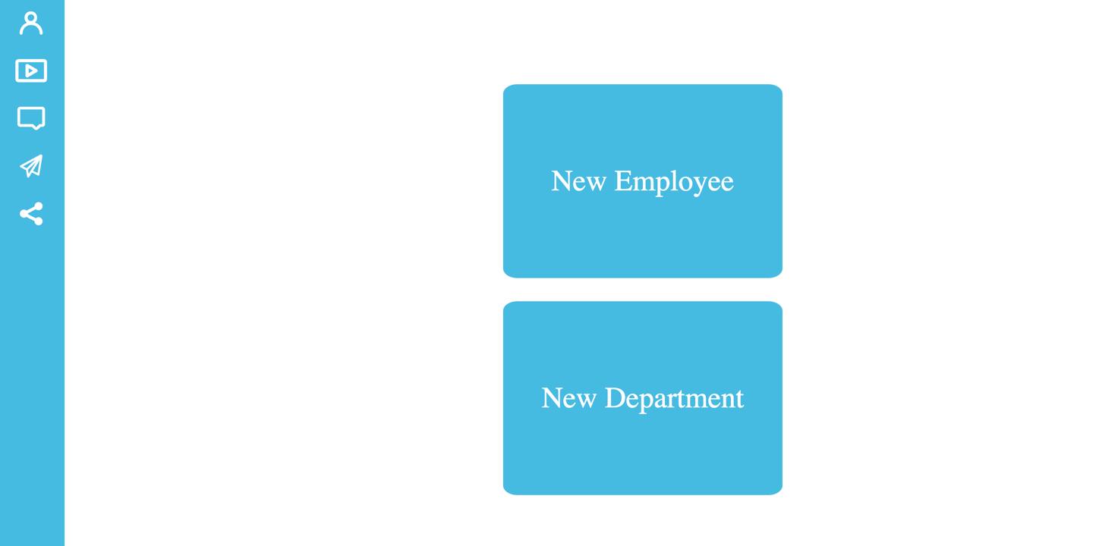

Editing employee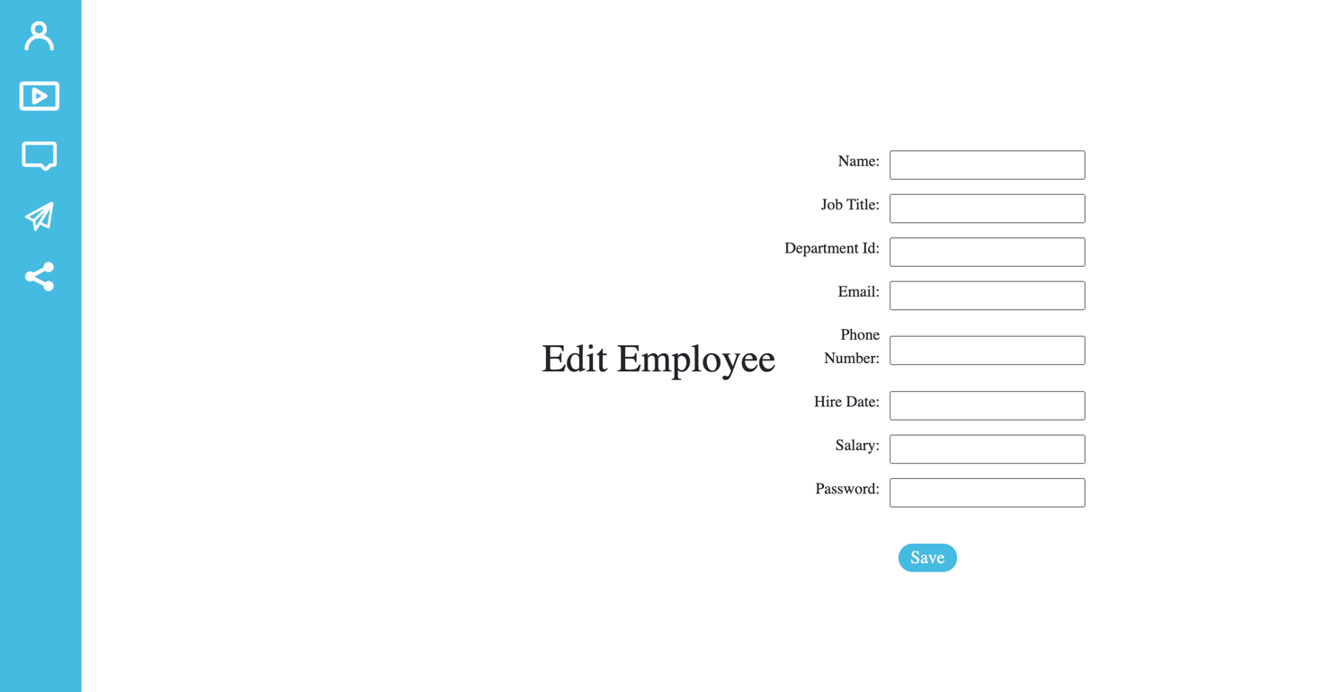

Editing department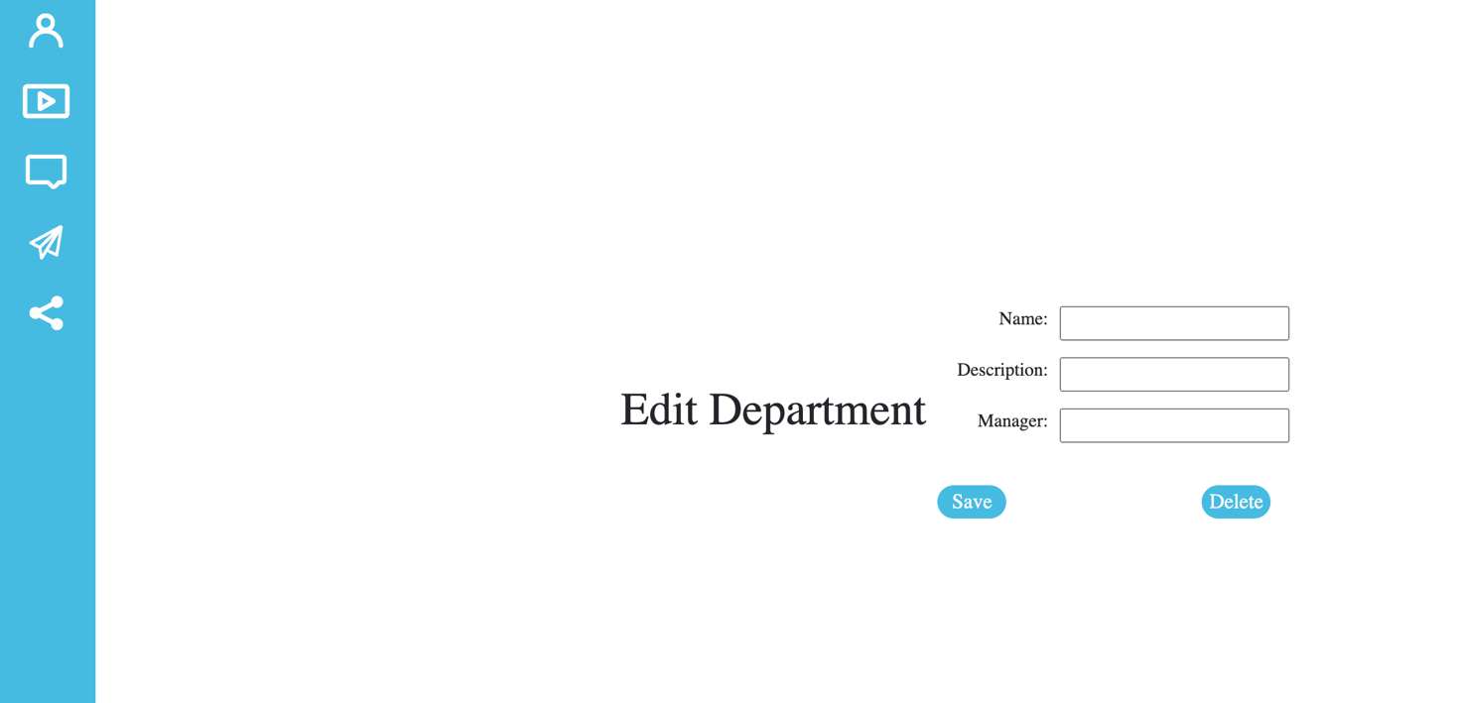Profile info, name, email and phone are editable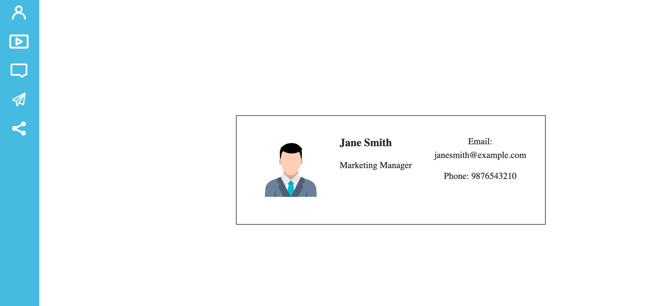Attendance table view, able to change own attendance (should fix this so status is shown somewhere else and not for every attendance of one employee because its ment to be like green available for work and red away or on vacation or similar) 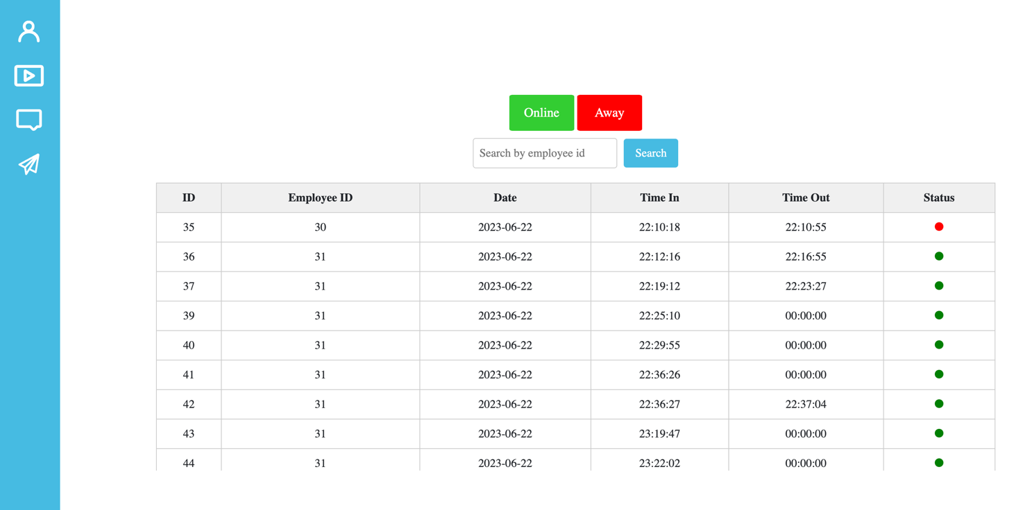

Similar screens ar for non admin user too just without so much control.

# 

# 2. Project Structure

## 2.1. Technologies

Backend:

Java: The backend of the application was developed using Java programming language.

Spring Boot: The Spring Boot framework was utilized to create a robust and scalable backend infrastructure.

MySQL: MySQL was chosen as the database management system for storing and retrieving data.

Frontend:

HTML: HTML (Hypertext Markup Language) was used to structure the content and elements of the user interface.

CSS: CSS (Cascading Style Sheets) was employed to handle the visual presentation and styling of the application's frontend.

Integration:

AJAX: AJAX (Asynchronous JavaScript and XML) was utilized for seamless communication between the frontend and backend, enabling dynamic updates without page refreshes.

## Coding standards:

Backend: Java code in the backend follows industry-standard coding conventions, such as those prescribed by Oracle's Java Code Conventions or Google's Java Style Guide. Consistent indentation, proper naming conventions, and meaningful comments are examples of coding practices adhered to in the backend development.

Frontend: HTML and CSS code in the frontend were structured following best practices and maintainable coding standards, including consistent indentation, clear naming conventions, and commenting where necessary.

## 

## Third-party tools:

Maven: Maven was used as a build automation and dependency management tool for the Java backend.

Apache Tom Cat Server

Spring JPA

## 2.2. Database Entities

Our database for this project is called employees and here are the tables in this database:

payroll

attendance

employee

department

employee_password

## 2.3. Design Patterns

We used REST API.

## 2.4. Tests

We used JUnit testing in our web application. We tested Api methods from our controllers. Our tests are located in test folder.

# 3. Conclusion

In conclusion, the implementation of the employee management application using Java Spring Boot for the backend, HTML/CSS for the frontend, and MySQL for the database has been a rewarding experience. The application successfully addresses the core requirements of streamlining employee management processes, centralizing data, and enhancing communication within the organization.

Overall, We are satisfied with the implementation as it fulfills the intended functionalities and provides a user-friendly interface. The use of Java Spring Boot facilitated rapid development and ensured a robust backend infrastructure. HTML and CSS were effective in creating an intuitive and visually appealing frontend. The integration of AJAX further improved the user experience by enabling seamless data exchange between the frontend and backend. We are glad we had a chance to do this project since we learned a lot especially about the deployment part which was not that hard in general but full of unexpected situations.