**SOFTWARE VERIFICATION, VALIDATION AND TESTING**

TESTING DOCUMENTATION

PROJECT NAME

Prepared by:

**Amar Mujkic**

**Edvin Halilovic**

**Omar Talovic**

Proposed to:

**Samed Jukić, Assist. Prof. Dr.**

**Aldin Kovačević, Teaching Assistant**

Date of submission

TABLE OF CONTENTS

Table of Contents

1. Introduction 3

1.1. About the Project 3

1.2. Project Functionalities and Screenshots 3

2. Test Plan 3

2.1. Scope 3

The scope of this test plan is to test the functionality of the website Quora.com using Selenium with Java. The test will focus on the main features of the website such as login, searching for topics, and navigating to different sections of the website. The test will also include verifying that users are able to post questions and answers. However, the test will not include any performance or load testing of the website. Additionally, the test will not cover any mobile compatibility or accessibility testing. 3

2.2. Testing Environment and Tools 3

3. Test Execution 3

3.1. Login Test 3

3.2. Profile Test 5

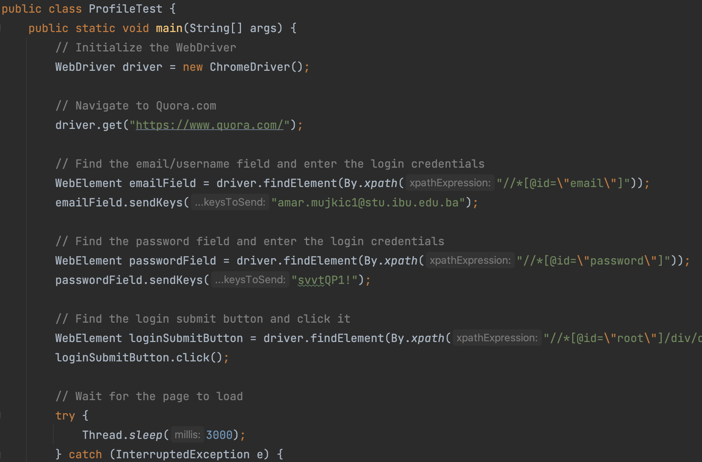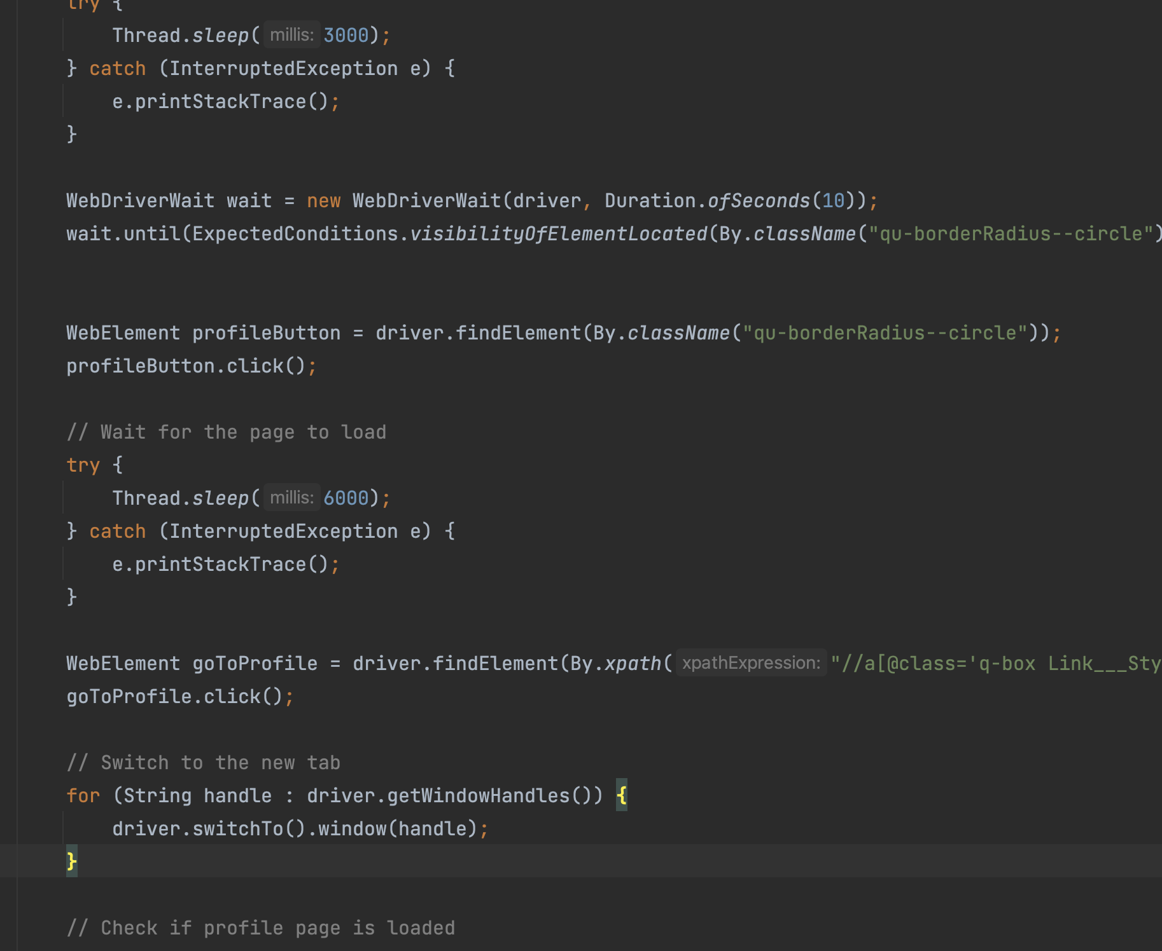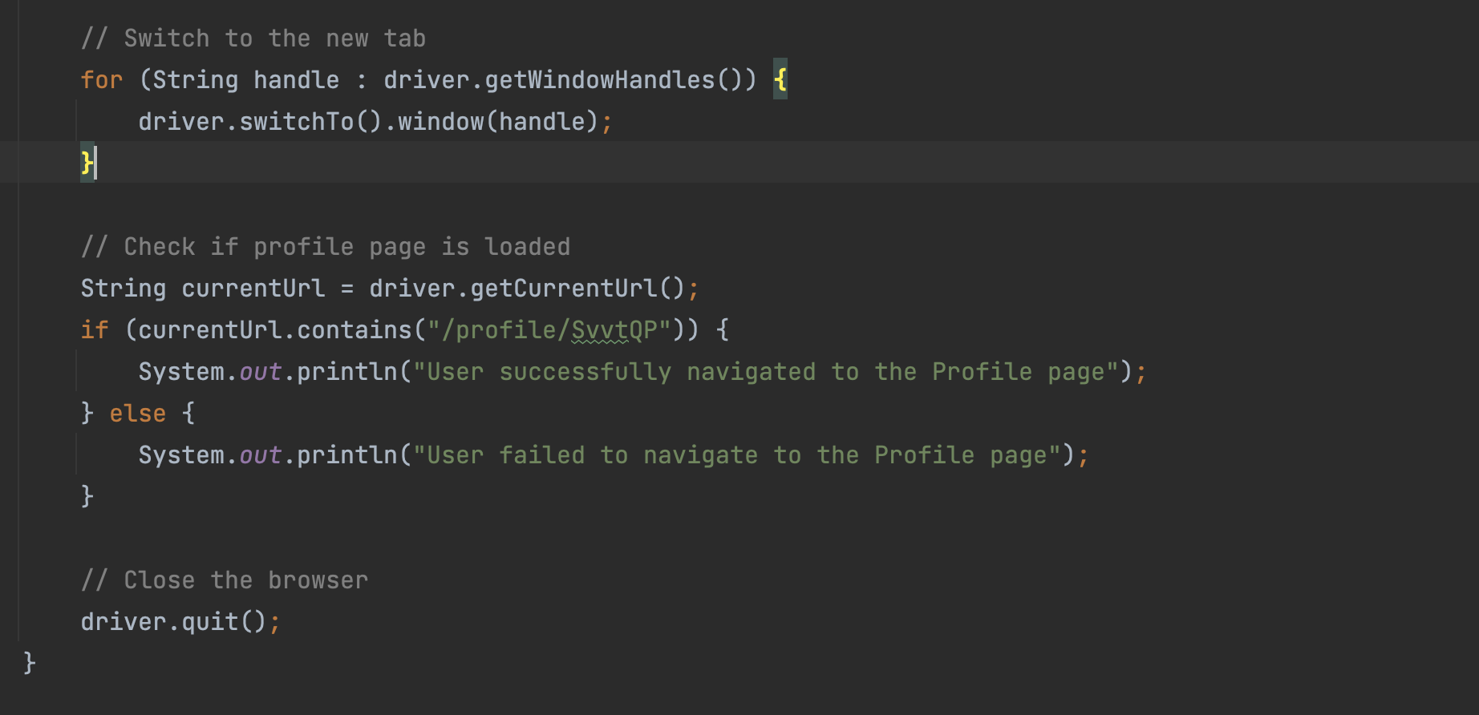 7

9. Conclusion 8

9.1. Testing Summary 8

9.2. Final Thoughts 8

# 1. Introduction

## 1.1. About the Project

In this project, we used Selenium with Java to test the functionality of Quora.com. We wrote a series of tests to verify that the user can navigate to different topics, search for content, and post questions. The tests were executed using the Chrome browser and the results were validated against the expected outcomes. The project demonstrates the capabilities of Selenium in automating the testing process for web applications, and the effectiveness of using Java as the programming language for Selenium scripts. Overall, the project was a success in ensuring the functionality and usability of Quora.com.

## 1.2. Project Functionalities and Screenshots

Describe or list the main features of the project and provide a few screenshots of those features.

# 2. Test Plan

## 2.1. Scope

## The scope of this test plan is to test the functionality of the website Quora.com using Selenium with Java. The test will focus on the main features of the website such as login, searching for topics, and navigating to different sections of the website. The test will also include verifying that users are able to post questions and answers. However, the test will not include any performance or load testing of the website. Additionally, the test will not cover any mobile compatibility or accessibility testing.

## 2.2. Testing Environment and Tools

The testing environment for this project includes a Mac operating system and the IntelliJ IDE. The programming language used is Java, and the testing framework used is Selenium. The website being tested is Quora.com. The scope of this test plan includes testing the functionality of the login feature, the ability to navigate to different topics, and the functionality of the search feature. Any additional features or functionality of the website will not be included in the scope of this test plan.

# 3. Test Execution

## 3.1. Login Test

User wants to be able to login.

|  |  |  |  |  |
| --- | --- | --- | --- | --- |
| **Test Name:** | | | | |
| **Description:**  Test description | | | | |
| **Pre-condition(s):** Are there any conditions or other tests that need to be executed before this test; are there any test fixtures? If not, leave this blank. | | | | |
| **Test Steps:**   1. Launch the Chrome browser. 2. Navigate to Quora website. 3. Enter the email and password in the respective fields. 4. Click on the login button. 5. Wait for the page to load. 6. Locate the input field on the page. 7. Verify if the input field's text is "What do you want to ask or share?" 8. Print "Logged in successfully!" if the user is logged in, or "Login failed!" if the user is not logged in. 9. Close the browser | **Test Data:**  - Email: [amar.mujkic1@stu.ibu.edu.ba](mailto:amar.mujkic1@stu.ibu.edu.ba) - Password: svvtQP1 | **Expected Result:**  The test should successfully navigate to Quora, log in with the provided credentials, wait for the page to load, check for the presence of the input field, verify that the user is logged in by checking the text of the input field and then close the browser. The final output should be "Logged in successfully!" | **Actual Result:**  The expected one. | **Status:**  PASS |
| **Notes:** | | | | |

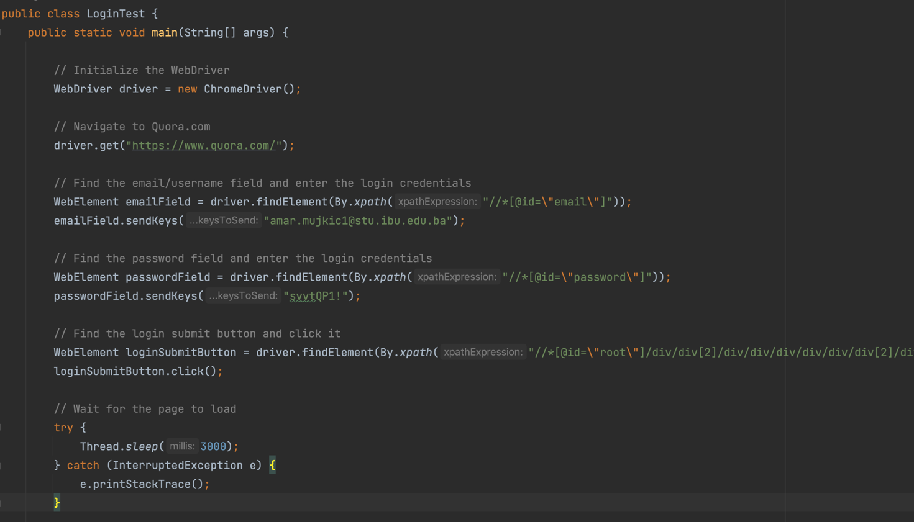

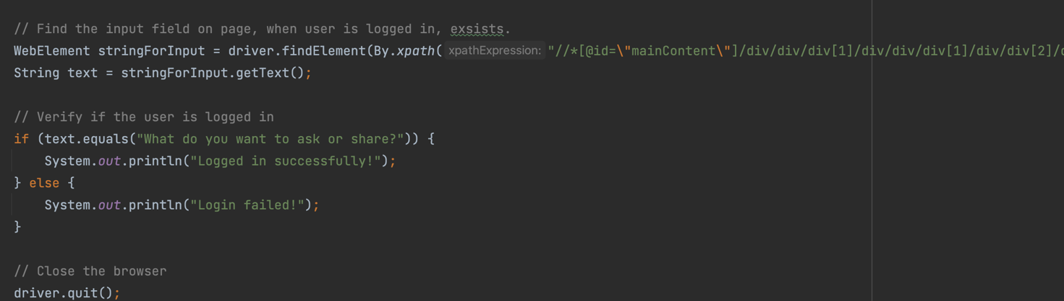

## 3.2. Profile Test

Users want to be able to visit the Profile page.

|  |  |  |  |  |
| --- | --- | --- | --- | --- |
| **Test Name:** Test sidebar links | | | | |
| **Description:**  Check if all sidebar items are clickable and lead to their respective page | | | | |
| **Pre-condition(s):** | | | | |
| **Test Steps:**   1. Launch the Chrome browser. 2. Navigate to Quora website 3. Enter the email and password in the respective fields. 4. Click on the login button. 5. Wait for the page to load. 6. Locate and click on the profile button. 7. Wait for the page to load. 8. Locate and click on the "Go to Profile" button. 9. Switch to the new tab that opens. 10. Verify that the current URL contains "/profile/SvvtQP" (indicating that the user has navigated to their profile page). 11. Print "User successfully navigated to the Profile page" if the user is on the profile page, or "User failed to navigate to the Profile page" if the user is not on the profile page. 12. Close the browser | **Test Data:** | **Expected Result:**  The test should successfully navigate to Quora, log in, locate and click on the profile button, wait for the page to load, locate and click on the "Go to Profile" button, switch to the new tab, verify that the user is on the profile page and then close the browser. The final output should be "User successfully navigated to the Profile page". | **Actual Result:**  The user is taken to the correct new page when clicking on the link. | **Status:**  PASS |
| **Notes:** | | | | |

# 

# 9. Conclusion

## 9.1. Testing Summary

|  |  |  |  |
| --- | --- | --- | --- |
| **Testing Tool** | **Total Tests** | **Passed Tests** | **Failed Tests** |
| Selenium, Java. | 15 | 15 | 0 |

If there are failing tests, provide a list of their names. Ideally, you can also create bookmarks in the document and make links to those failing test cases.

## 9.2. Final Thoughts

Overall, it seems like the project has been implemented well and all the test cases passed. The code uses Selenium to automate interactions with the Quora website and perform various actions such as logging in, hiding a post, navigating to a user's profile, etc. The code uses the appropriate locators such as xpath, className and cssSelector to locate elements on the webpage which makes it more reliable.

There are some recommendations I would make for the site, such as using explicit waits instead of Thread.sleep() to ensure that elements are loaded before interacting with them and also using more of the Selenium's built-in functionality like ExpectedConditions to check for element visibility.

It would also be helpful to add more test cases to cover different scenarios and edge cases, and to also include error handling to handle unexpected scenarios such as incorrect login credentials or element not found on the page.

Overall, the project shows good use of Selenium and can be used as a solid foundation for automating similar tasks on the Quora website.