**PAPER RETRIEVAL GUIDELINE FOR THE EFFECTS OF FIRE ON MYCORRHIZAL COMMUNITIES**

* **Research questions:** 
  1. What are the overall impacts of wildfires on ectomycorrhizal communities?
  2. Do these impacts vary across regions?
* **Keywords** for the search in the Web of Science**\***:

**\*Ensure to search in “ALL DATABASES”.**

* Based on three pillars: FOREST, WILDFIRES, ECTOMYCORRHIZAL FUNGI:

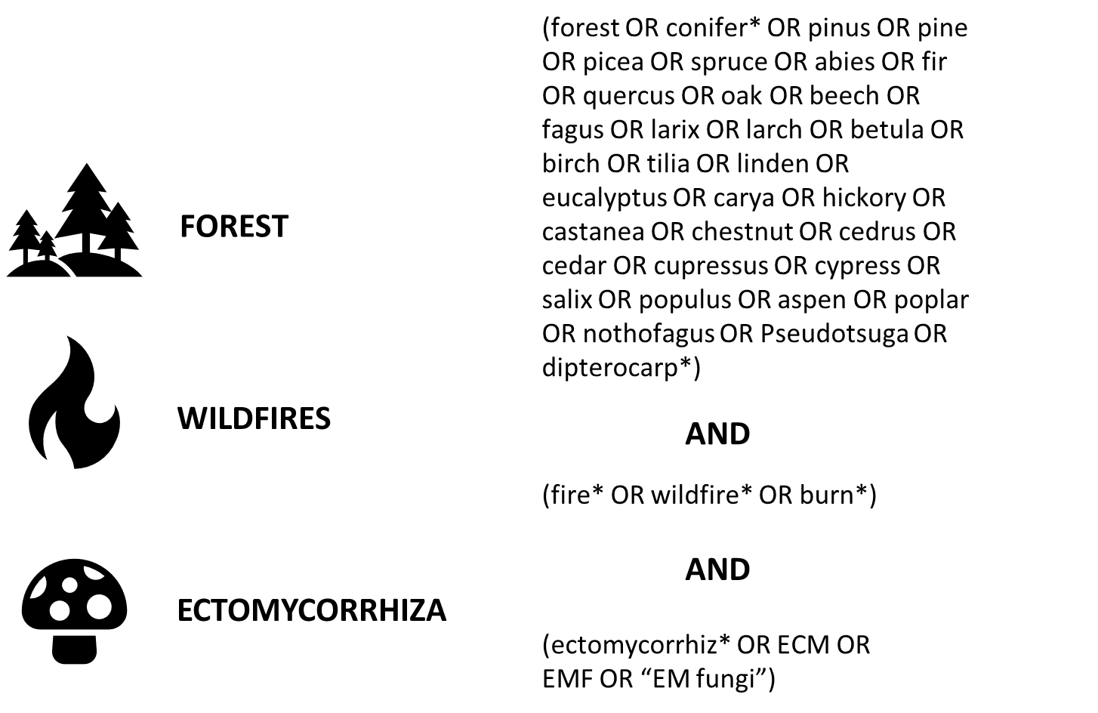

* We retrieved 573 documents in this initial search.
* Export 🡪 tab delimited file 🡪 open this .txt in Excel 🡪 get rid of the columns we do not need. We just want: AUTHORS, TITLE, JOURNAL, VOLUME, INITIAL_PAGE, END_PAGE, DOI, PUBLICATION_YEAR, ABSTRACT.
* **Remove duplicates:** I performed this in R by sorting out articles with the same title. First, standardize all titles by converting them to lowercase and removing punctuation.
* **Abstract screening:** was conducted with the “abstract_screener” function of the *metagear* R package (two rounds of abstract screening were completed: INCLUSION 1 = First round; INCLUSION 2 = Second round).
* 215 documents were retained after abstract screening. Selection was based solely on the topic; any document not discussing wildfires or ectomycorrhiza was discarded.
* **Document retrieval:** Selected documents were downloaded manually. Titles were entered into Google. Additionally, specific searches were conducted on ResearchGate and Google Scholar. When titles did not match any published articles, searches were performed using the authors' names.
* If the document found was a thesis (PhD, Master’s, Bachelor’s, etc.) and a related paper by the same first author was available, the thesis was rejected (INCLUSION 2 = “NO”).
* 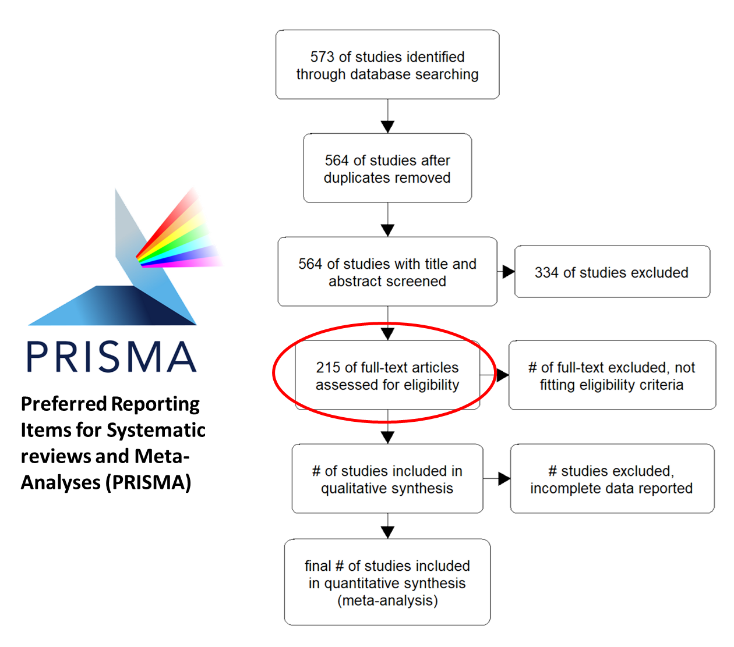All reviews identified during this process were saved and downloaded for further evaluation but were not counted as documents to be included in the meta-analysis.