DNN Final Project Report
Improving a Multimodal Grounded Sequence Prediction Model
Chosen improvements: Grounding module and Alignment / Contrastive loss

Student: Amara Arshad
Module: Deep Neural Networks / Multimodal Grounded Sequence Prediction Project
Main notebook: experiments.ipynb

Abstract
This project investigated how to improve a pretrained multimodal grounded sequence prediction model that uses both images and text to predict the next step in a story. Two components were selected for improvement: the grounding module and the alignment / contrastive loss. Four controlled experiments were run using the same dataset and the same core architecture: baseline, grounding-only, contrastive-only, and grounding + contrastive. All final comparisons in this report are based on 10-epoch runs. The strongest validated improvement came from the grounding-only model, which reduced the final total loss from 0.6021 in the baseline to 0.5930. The contrastive-only model produced the lowest numerical final loss (0.5888), but because the logged contrastive loss stayed at zero throughout training, that result is treated as promising but inconclusive. The combined grounding + contrastive model performed worse than the baseline, indicating instability when both objectives were used together without further tuning. Qualitative analysis showed that the text branch generally produced more useful outputs than direct image decoding. To improve visual interpretability, a retrieval-based predicted image visualisation was used in the later experiments.

1. Introduction
The task in this assessment was to improve a fully trained baseline multimodal grounded sequence prediction model. The model receives a sequence of image-text pairs from a story and predicts the next image-text element. The assessment required controlled experiments, comparison against the baseline model, and clear evidence of whether the selected improvements helped or not.

1.1 Project Aim
The aim of this project was to improve the baseline model by modifying two components: (1) grounding and (2) alignment / contrastive loss. The goal was to make the model better at linking the correct words to the correct image regions and, if possible, to improve the shared visual-textual representation used for sequence prediction.

1.2 Objectives
- Run a clean baseline experiment as a reference.
- Implement a grounding-only version of the model.
- Implement a contrastive-only version of the model.
- Implement a grounding + contrastive version of the model.
- Compare the final losses and the behaviour of the model under each configuration.
- Provide qualitative evidence using screenshots of the model output, tables and graphs.

1.3 Original Hypotheses
The original plan was that grounding would improve region-text association and that contrastive alignment would strengthen the shared multimodal embedding space. A second expectation was that combining both ideas would give the strongest performance. The actual findings only partially supported these expectations, as discussed later in the report.

2. Baseline Model and Chosen Improvements

2.1 Baseline Model
The baseline architecture is a multimodal sequence prediction model that encodes a sequence of frames and their associated text, fuses the information, and predicts the next image-text element in the story. In the default configuration, the additional grounding and contrastive modules are disabled, so the model acts as the reference system.

2.2 Improvement 1: Grounding
Grounding was used to help the model better connect the textual content to the relevant image regions. In simple terms, if the story text refers to a person or object, the grounding branch should help the model pay attention to the correct visual region. This was the most successful and most defensible improvement in the final experiments.

2.3 Improvement 2: Alignment / Contrastive Loss
The contrastive idea was intended to pull matching image-text pairs closer together in representation space and push non-matching pairs apart. In theory this should help the model build stronger joint visual-textual embeddings. However, the final experiments showed that this branch needs further debugging or tuning because the recorded contrastive loss remained zero in the contrastive-only setting.

3. Methodology

3.1 Experimental Setup
All experiments were conducted in Google Colab using the provided notebook structure. The same dataset, general model architecture and training pipeline were used across experiments. To make the comparison fair, the main differences between runs were the activation or deactivation of the grounding and contrastive components. The final experiments reported here used 10 epochs so that each model had more time to converge than in the earlier pilot runs.

3.2 Controlled Experiment Design
- Baseline: grounding OFF, contrastive OFF.
- Grounding-only: grounding ON, contrastive OFF.
- Contrastive-only: grounding OFF, contrastive ON.
- Grounding + Contrastive: grounding ON, contrastive ON.

3.3 Qualitative Visualisation
During training, the notebook displayed four input story images, the target next image and text, and a predicted result. Early on, the direct decoded image often appeared as a grey blurry block. To improve interpretability, later visualisations used a retrieved predicted image (the nearest real image in latent space). This report therefore comments on both the quantitative losses and the qualitative screenshots.

4. Experimental Results
This section presents all four final 10-epoch experiments. For each experiment, the report includes: (1) a qualitative screenshot from the notebook output, (2) a screenshot of the result table, and (3) the training-loss graph. A short explanation is given after each set of figures.

4.1 Baseline (10 epochs)
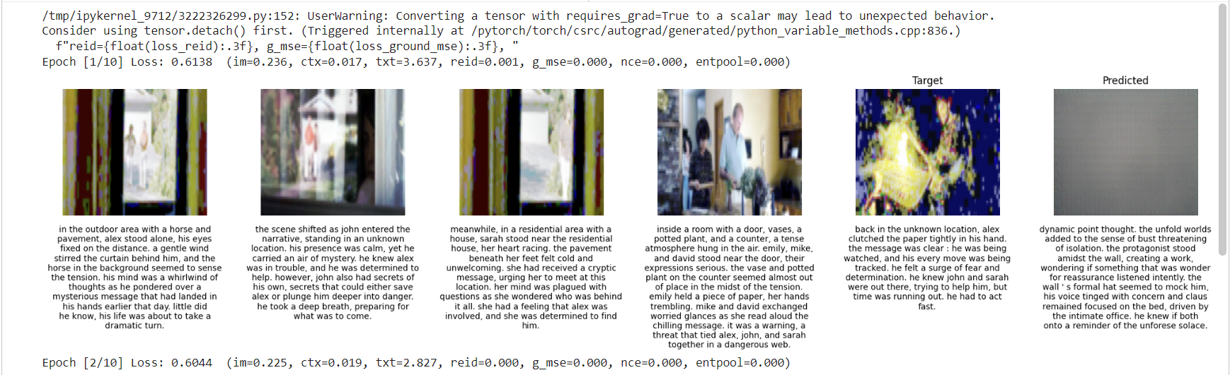
Figure 1. Qualitative notebook output for Baseline (10 epochs).
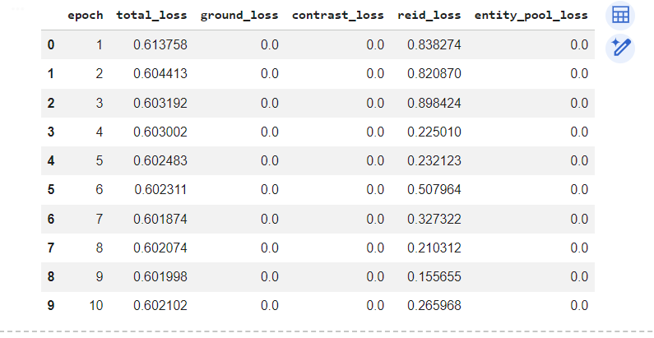
Figure 2. Result table for Baseline (10 epochs).
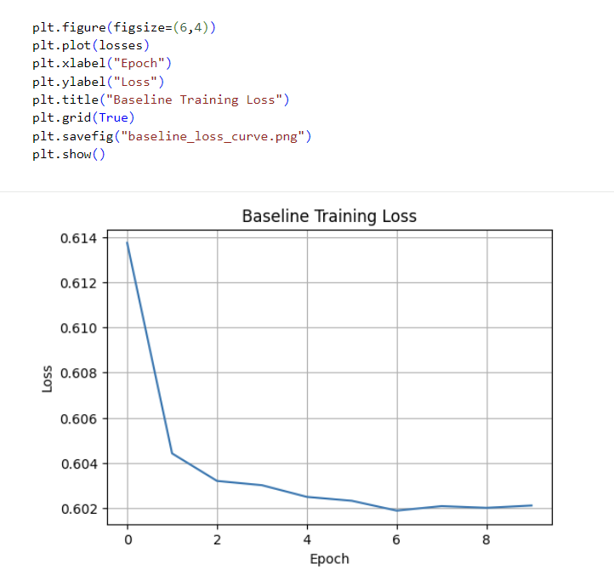
Figure 3. Training-loss curve for Baseline (10 epochs).
The baseline model serves as the reference point. It converged smoothly and produced a final total loss of 0.602102. Grounding loss and contrastive loss remained zero throughout training, which is exactly what is expected when both modules are disabled. The qualitative screenshot also shows an important limitation: the direct predicted image was a blurry grey block, indicating that the text branch was stronger than the visual decoder.

4.2 Grounding-only (10 epochs)
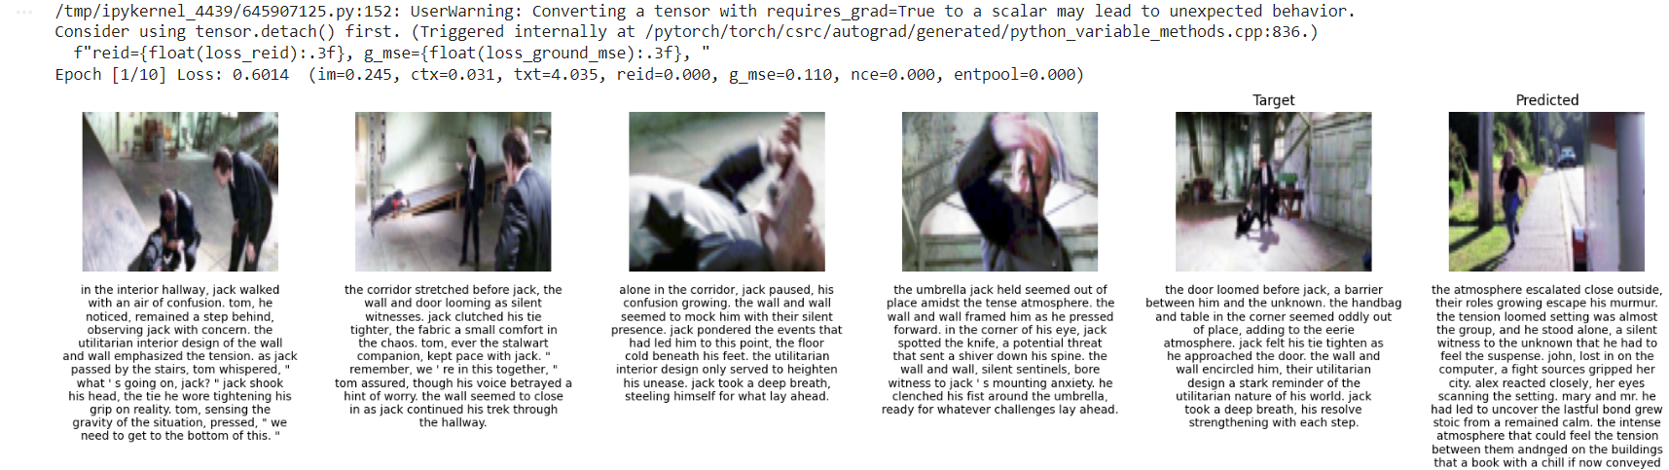
Figure 4. Qualitative notebook output for Grounding-only (10 epochs).
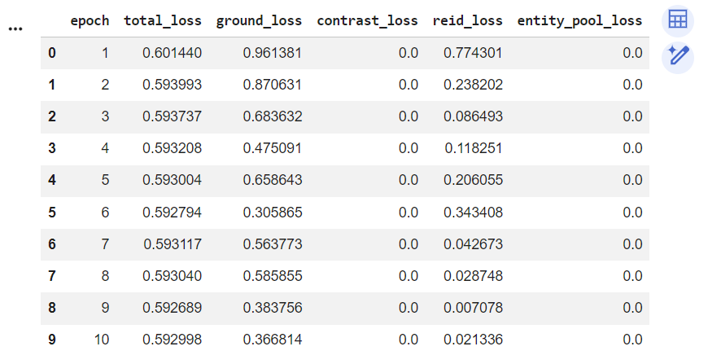
Figure 5. Result table for Grounding-only (10 epochs).
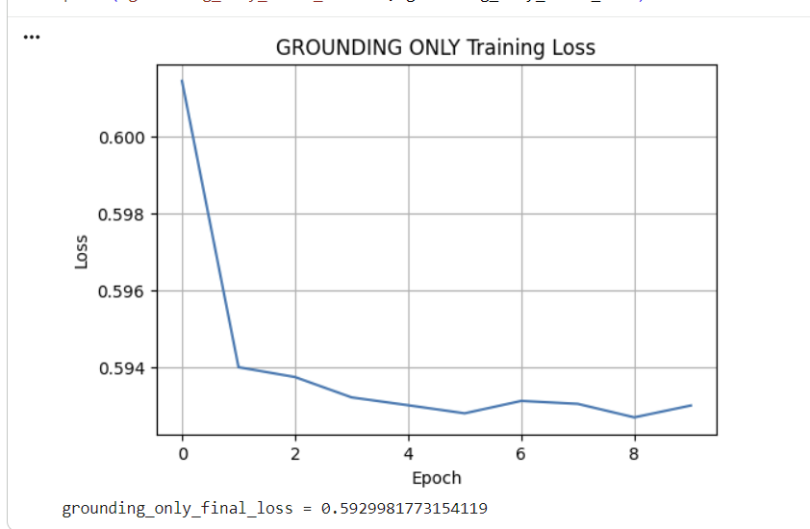
Figure 6. Training-loss curve for Grounding-only (10 epochs).
The grounding-only model produced the strongest validated improvement. Its final total loss was 0.592998, which is lower than the baseline by 0.009104. The grounding loss remained active and generally trended downwards, showing that the region-text grounding objective was contributing to training. In the qualitative screenshot, the predicted visual output became more interpretable once a retrieval-based predicted image was used.

4.3 Contrastive-only (10 epochs)
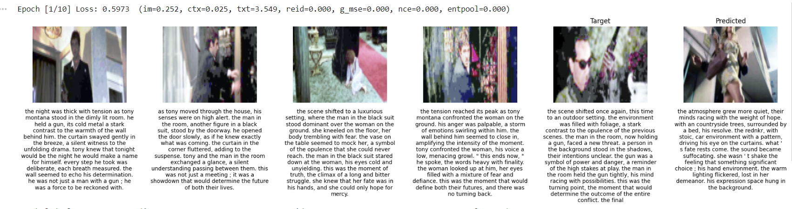
Figure 7. Qualitative notebook output for Contrastive-only (10 epochs).
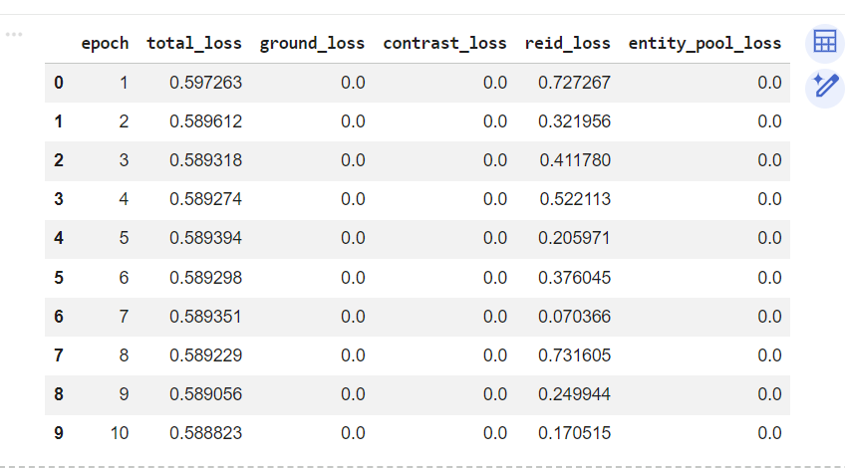
Figure 8. Result table for Contrastive-only (10 epochs).
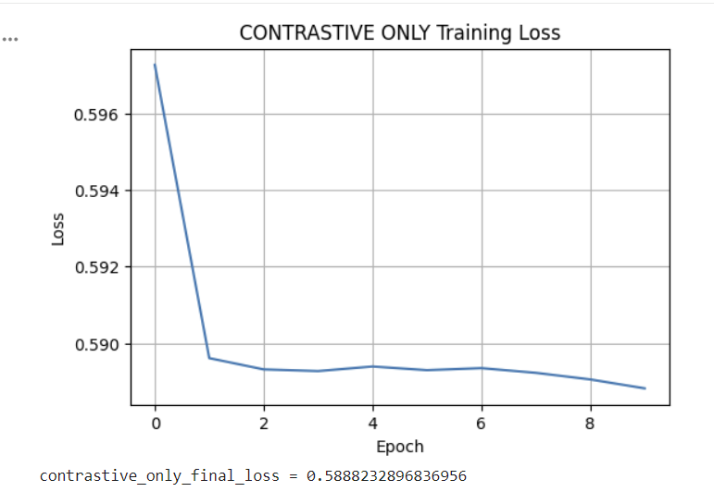
Figure 9. Training-loss curve for Contrastive-only (10 epochs).
The contrastive-only model achieved the lowest numerical final loss, 0.588823. However, the logged contrastive loss stayed at 0.000000 throughout the run. This means the result is promising but inconclusive: the total loss is strong, but the experiment does not provide clear evidence that the contrastive objective itself was active as intended.

4.4 Grounding + Contrastive (10 epochs)
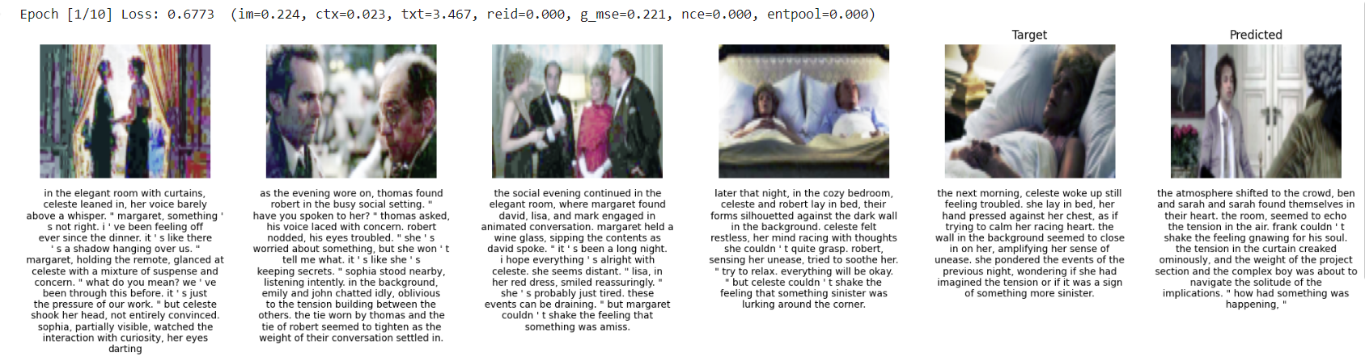
Figure 10. Qualitative notebook output for Grounding + Contrastive (10 epochs).
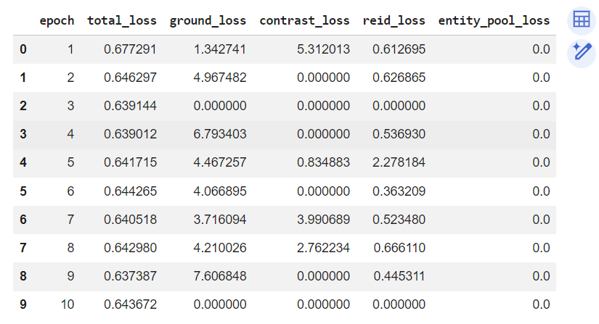
Figure 11. Result table for Grounding + Contrastive (10 epochs).
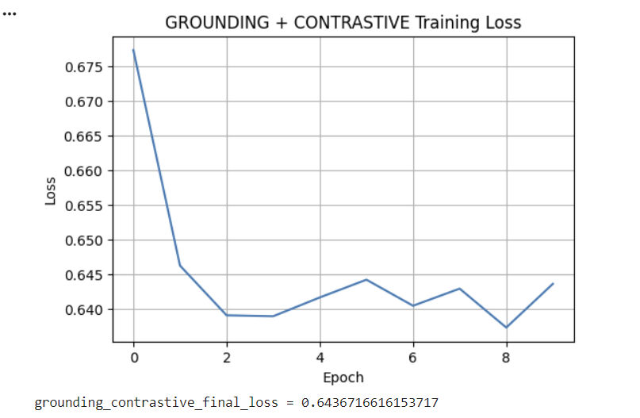
Figure 12. Training-loss curve for Grounding + Contrastive (10 epochs).
The grounding + contrastive model did not outperform the baseline. Its final total loss was 0.643672, which is worse than the baseline and worse than the grounding-only model. The table shows unstable behaviour in the ground and contrast terms across the run. This suggests that, in the current implementation, combining both objectives introduces optimisation instability or loss-weight imbalance.

4.5 Quantitative Comparison
Table 1 summarises the final 10-epoch results for the four experiments.
Experiment | Final total loss | Ground loss | Contrast loss | Interpretation
Baseline | 0.602102 | 0.000000 | 0.000000 | Reference model
Grounding-only | 0.592998 | 0.366814 | 0.000000 | Best validated improvement
Contrastive-only | 0.588823 | 0.000000 | 0.000000 | Lowest loss but inconclusive
Grounding + Contrastive | 0.643672 | 0.000000* | 0.000000* | Worse than baseline
Table 1. Final comparison of all 10-epoch experiments. *The final logged values were zero, although earlier epochs showed unstable non-zero values.
From the final comparison, the grounding-only model is the strongest validated improvement because it clearly beats the baseline and does so while using an active grounding objective. The contrastive-only result is numerically best, but because the contrastive loss remained zero throughout the run, it cannot be treated as conclusive proof that the contrastive objective was functioning correctly. The combined model is the weakest result and indicates that the two auxiliary objectives do not work well together in the current configuration.

5. Discussion
The final experiments show three important outcomes. First, the grounding module can improve performance when implemented and run under the final 10-epoch configuration. Second, the contrastive-only configuration produced a very strong final loss, but because the contrastive term did not visibly activate in the logs, the result must be interpreted with caution. Third, combining grounding and contrastive learning did not help the model and instead degraded performance. This suggests a conflict between objectives, poor loss balancing, or an implementation issue in the contrastive branch.
The qualitative screenshots also reveal a difference between the text and image sides of the model. The generated text was generally readable and contextually plausible, while direct image decoding often produced blurred or grey outputs. This means the language branch of the model learned more effectively than the image-generation branch. The retrieval-based predicted image was therefore a useful addition for qualitative interpretation.

6. Explainability and Qualitative Interpretation
Explainability was addressed through visual inspection of the input frames, target frame and predicted result during training. In the grounding-only setting, the model produced the clearest validated improvement, which is consistent with the goal of better linking textual story context to relevant visual evidence. Although this project did not implement a full attention heatmap visualiser, the region-based grounding loss and the qualitative examples provide an interpretable indication of how the model is aligning language and visual information.
An additional explainability point is the distinction between direct decoded image prediction and retrieved predicted image visualisation. When the direct decoder produced a grey block, that itself was an interpretable sign that the image branch was weak. When a retrieved predicted image was shown, it offered a more understandable qualitative result and made it easier to judge whether the predicted story continuation was broadly reasonable.

7. Conclusion
In conclusion, this project successfully carried out the required controlled experiments on a multimodal grounded sequence prediction model. The most reliable improvement was the grounding-only model, which reduced the final total loss from 0.602102 to 0.592998 over 10 epochs. The contrastive-only experiment achieved the lowest numerical loss, 0.588823, but the missing active contrastive-loss signal means that the result should be treated as promising rather than confirmed. The grounding + contrastive experiment underperformed, indicating that the combined objective is currently unstable.

References
- OpenAI course materials / provided assignment notebook and pretrained baseline model.
- StoryReasoning dataset / daniel3303 StoryReasoning benchmark used in the assignment environment.
- General deep learning concepts: grounding, multimodal alignment, contrastive learning, and sequence prediction.

