
Operating System (OS)
Name: Thorng Amara
Gender: Female
Group: COSC 331 001
Mock Test (MT) 1h20mn
- Explain 4 types of memory (Register, Cache, RAM, HDD) in speed and cost? (25 pts)
- Base conversion: 1) 536₈ = ?₁₀ , 2) 95₁₀ = ?₂ , and 3) 11111₂ + 1001₂ = ?₂ (25 pts)
- Look at the 2 different code (EX1 and EX2) and 4 segments of memory below. Answer the following questions for each code: (50 pts)
  - Map all variables to correct place of each segment of memory. (6 pts each)
  - How many bytes are allocated in the “Heap” segment? (4 pts each)
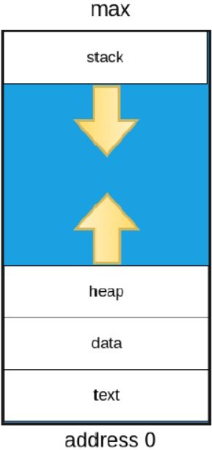
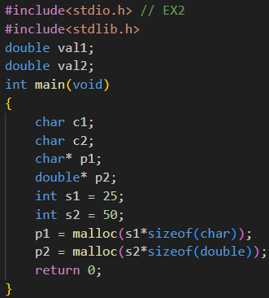
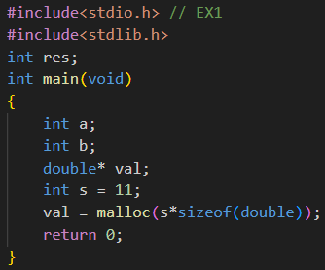
  - How many bytes does the memory (RAM) need during the runtime of this code? Explain how to get the final result as well? (15 pts each)

Answer
- The four types of memory in speed and cost are:
- Register
Registers are the fastest type of memory in a computer. They are located inside the CPU and are used to store small amounts of data that the CPU is currently processing. Because they are directly part of the processor, the CPU can access them extremely quickly. However, registers are very small in size and very expensive per byte.
- Cache Memory
Cache memory is the second fastest memory and is located between the CPU and RAM. Its purpose is to store frequently used instructions and data so the CPU can access them faster than accessing RAM. Cache memory helps improve system performance, but it is still expensive and usually small in size compared to RAM.
- RAM (Random Access Memory)
RAM is the main memory used by the computer to store programs and data that are currently in use. It allows the CPU to quickly read and write data while running applications. RAM is slower than cache and registers, but it has larger capacity and moderate cost. RAM is also volatile, meaning the data is lost when the computer is turned off.
- HDD (Hard Disk Drive)
HDD is used for long-term storage of data such as the operating system, applications, and user files. It has much larger storage capacity than RAM but is much slower because it uses mechanical parts to read and write data. However, HDD is the cheapest type of storage per GB, making it suitable for storing large amounts of data.
- Base Conversion:
1). 536₈ = ?₁₀
536₈ = (5 × 8²) + (3 × 8¹) + (6 × 8⁰)
= 350₁₀
Thus. 536₈ = 350₁₀
2). 95₁₀ = ?₂
95 ÷ 2 = 47 remainder 1
47 ÷ 2 = 23 remainder 1
23 ÷ 2 = 11 remainder 1
11 ÷ 2 = 5 remainder 1
5 ÷ 2 = 2 remainder 1
2 ÷ 2 = 1 remainder 0
1 ÷ 2 = 0 remainder 1
95₁₀ = (1011111)₂
Thus. 95₁₀ = (1011111)₂
3). 11111₂ + 1001₂ = ?₂
11111
+ 01001
---------
101000
Thus, ​11111₂ + 1001₂ = 101000₂
- Answer the following questions for each code below
  - Map all variables to correct place of each segment of memory:
Variables | Segment | Reason
res | Data | Global variable
a | Stack | Local variable inside `main()`
b | Stack | Local variable inside `main()`
val | Stack | Local pointer variable inside `main()`
s | Stack | Local variable inside `main()`
val (point block) | Heap | Allocated via `malloc()`
  - Heap Bytes Allocated
val = malloc(s * sizeof(double))
= malloc(11 * 8)
= malloc(88)
So. 88 bytes allocated on the Heap
  - Total RAM During Runtime
Segment | Variable(s) | Size
Data | Compiled instructions | ~varies
Stack | res (int, global) | 4 bytes
Stack | a (int) | 4 bytes
Stack | b (int) | 4 bytes
Stack | val (double*) | 8 bytes (pointer = 8B on 64-bit)
Stack | s (int) | 4 bytes
Stack total |  | 20 bytes
Heap | *val block | 88 bytes
Total = 4 + 20 + 88 = 112 bytes

