
Bachelor of Computer Applications
Semester – V
Deep Learning

Title: Comparison of Deep Learning Architectures

Submitted By:
Name: Amaraiah C
Reg. No: 2411021240026
Date: 22-08-2026

Submitted To:
Faculty Name: Nagasri P

Department of Computer Application
Alliance University
Chandapura - Anekal Main Road, Anekal
Bengaluru – 562106

Introduction
Deep Learning is a branch of Machine Learning that uses layered, artificial neural networks to automatically learn patterns from data. Instead of relying on hand-crafted rules, a deep learning model discovers useful representations directly from raw input, whether that input is a number, an image, or a sequence of words. Over the past decade, several distinct network architectures have emerged, each designed to handle a particular type of data and a particular kind of problem.
This project studies three foundational architectures: the Feedforward Neural Network (FNN), the Convolutional Neural Network (CNN), and the Recurrent Neural Network (RNN). For each architecture, we examine its internal structure, the type of data it is best suited to process, and the real-world applications where it is commonly used. Finally, the three architectures are compared side by side so that their strengths, weaknesses, and typical use cases become clear.

Task 1: Basic Architecture of FNNs, CNNs, and RNNs
Every deep learning architecture is built from the same basic building block: the artificial neuron, which takes a set of weighted inputs, adds a bias, and passes the result through a non-linear activation function. What differs between architectures is how these neurons are organized and connected to one another. This organization determines what kind of data the network can process efficiently and what patterns it can learn.

1.1 Feedforward Neural Network (FNN)
A Feedforward Neural Network, also called a Multi-Layer Perceptron (MLP), is the simplest and oldest type of artificial neural network. Data enters through an input layer, passes through one or more hidden layers, and produces a result at the output layer. Every neuron in one layer is typically connected to every neuron in the next layer, which is why these are called “fully connected” or “dense” layers.
The defining feature of a feedforward network is that information travels in only one direction: from input to output. There are no loops or cycles, and the network has no memory of previous inputs. Each prediction is made independently, based only on the current input. Training is performed using the backpropagation algorithm, which adjusts the weights of the connections to reduce the difference between the predicted output and the true output.
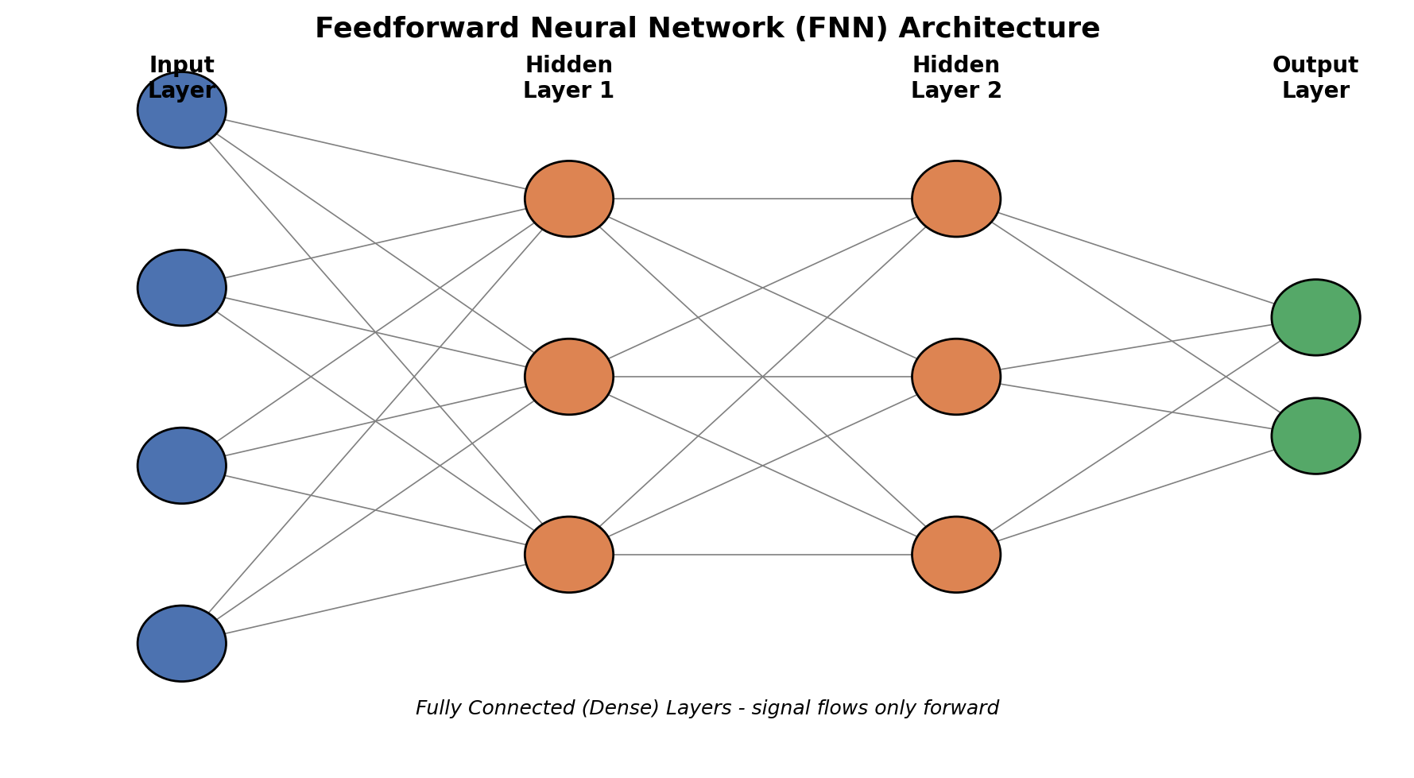
Figure 1. A Feedforward Neural Network with an input layer, two hidden layers, and an output layer. Every neuron connects to all neurons in the next layer.
Because it has no way to model order, sequence, or spatial structure, an FNN treats its input as a flat, fixed-size vector of numbers. This makes it a good general-purpose tool for structured, tabular data, but a poor choice for raw images or sequences, where the position and order of values carries important meaning.

1.2 Convolutional Neural Network (CNN)
A Convolutional Neural Network is designed specifically to work with data that has a grid-like, spatial structure, most commonly images. Instead of connecting every neuron to every input value, a CNN uses small filters (also called kernels) that slide across the input and detect local patterns such as edges, textures, and shapes. This operation is called convolution, and it allows the network to reuse the same small set of weights across the entire image, dramatically reducing the number of parameters compared to a fully connected network.
A typical CNN alternates between convolutional layers, which extract features, and pooling layers, which reduce the spatial size of the feature maps while keeping the most important information. As data moves deeper into the network, the features detected become more abstract: early layers detect edges and colors, while deeper layers detect shapes, textures, and eventually whole objects. After several rounds of convolution and pooling, the resulting feature maps are flattened and passed into one or more fully connected layers that perform the final classification or prediction.
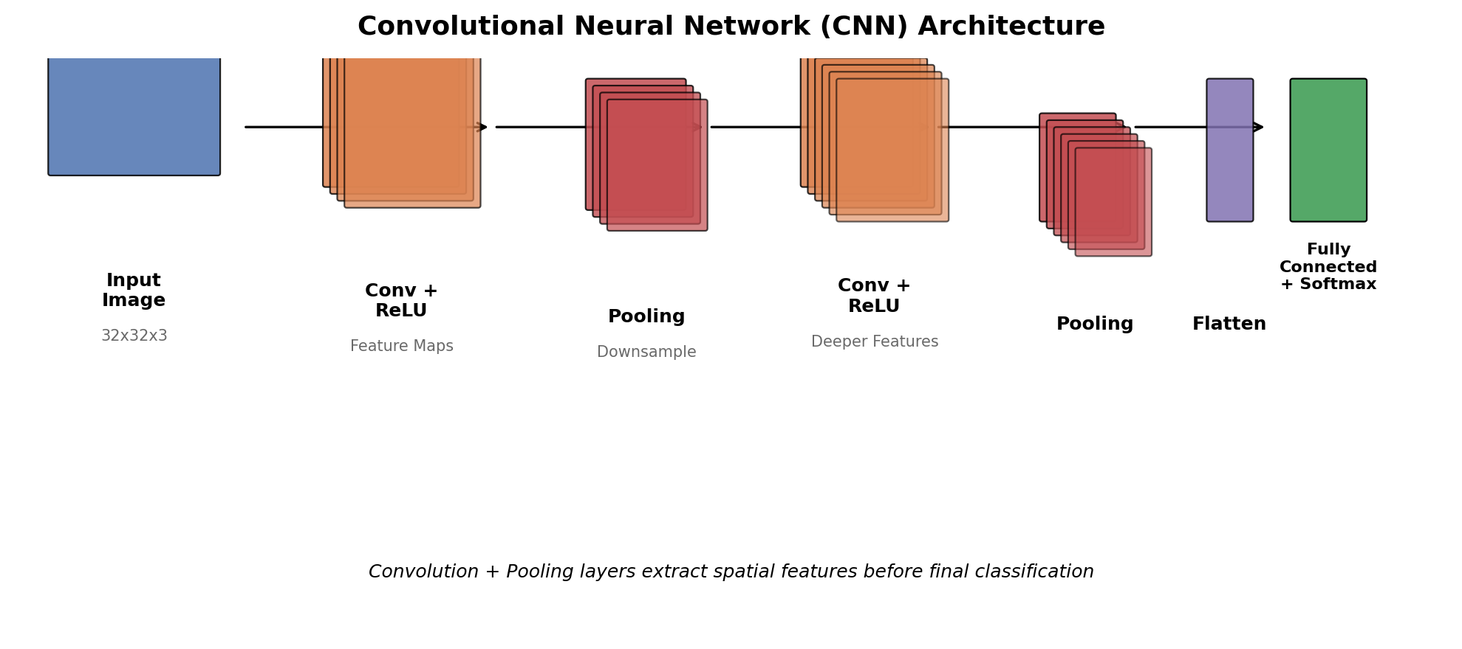
Figure 2. A Convolutional Neural Network extracts spatial features through alternating convolution and pooling layers before a final fully connected classifier.
The key architectural properties of a CNN are local connectivity (each neuron looks at only a small region of the input), weight sharing (the same filter is applied everywhere), and spatial hierarchy (features become progressively more abstract with depth). These properties make CNNs extremely efficient and effective for any data where nearby values are related to one another, such as pixels in an image.

1.3 Recurrent Neural Network (RNN)
A Recurrent Neural Network is built to handle sequential data, where the order of the input matters, such as a sentence, a time series, or an audio signal. Unlike an FNN or a CNN, an RNN contains a loop: the output of a neuron at one time step is fed back into the network as part of the input for the next time step. This feedback loop gives the network a form of memory, allowing it to retain information about earlier elements of a sequence while processing later ones.
At every time step, the RNN combines the current input with its previous “hidden state” to produce a new hidden state and, optionally, an output. Although the network technically contains a cycle, it is often easier to understand when it is “unrolled” across time, showing one copy of the network for each step in the sequence, all sharing the same weights.
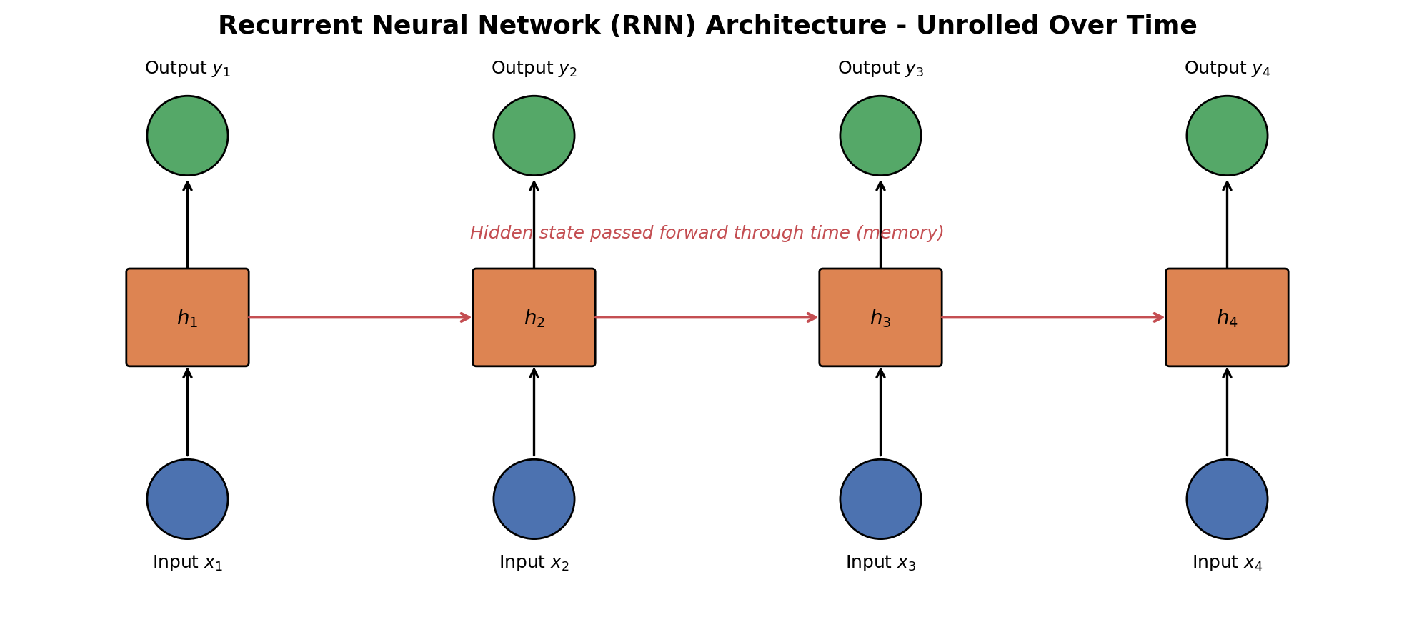
Figure 3. An RNN unrolled across four time steps. The hidden state carries information forward, giving the network memory of past inputs.
A well-known limitation of simple RNNs is that they struggle to remember information over long sequences, a problem known as the vanishing gradient problem. To address this, more advanced variants such as Long Short-Term Memory (LSTM) networks and Gated Recurrent Units (GRUs) introduce gating mechanisms that control what information is kept, updated, or forgotten at each step, allowing them to learn longer-range dependencies.

Task 2: Suitable Applications for Each Architecture
Because each architecture organizes its neurons differently, each one is naturally suited to a different category of real-world problem.

2.1 Applications of Feedforward Neural Networks
- Predicting numeric outcomes from structured/tabular data, such as house price prediction.
- Credit scoring and loan default prediction using customer financial records.
- Basic classification tasks, such as spam email detection based on extracted features.
- Medical diagnosis support systems that use structured patient measurements.
- Acting as the final classification layer inside larger CNN or RNN models.

2.2 Applications of Convolutional Neural Networks
- Image classification, such as identifying objects, animals, or handwritten digits.
- Object detection and localization in photographs and video frames.
- Facial recognition and biometric identification systems.
- Medical image analysis, including detecting tumors in X-rays, MRIs, and CT scans.
- Self-driving car perception systems, for lane detection and obstacle recognition.

2.3 Applications of Recurrent Neural Networks
- Natural language processing tasks such as text generation and sentiment analysis.
- Machine translation, converting a sentence in one language to another.
- Speech recognition, converting spoken audio into text.
- Time-series forecasting, such as predicting stock prices or weather patterns.
- Music generation, where new notes are predicted based on previous notes in a sequence.

Task 3: Comparative Analysis
The table below summarizes how the three architectures differ in terms of structure, the type of input data they are built for, and the applications where each one excels.
Aspect | Feedforward Neural Network | Convolutional Neural Network | Recurrent Neural Network
Core Structure | Fully connected layers; data flows in a single forward direction | Convolutional and pooling layers followed by fully connected layers | Layers with feedback loops that pass a hidden state across time steps
Connectivity | Every neuron connects to every neuron in the next layer | Local, sparse connectivity via small sliding filters with shared weights | Neurons connect to themselves across time steps via the hidden state
Memory | None – each input is processed independently | None between separate inputs, only spatial context within one input | Yes – retains information from previous elements in a sequence
Ideal Input Data | Structured / tabular, fixed-size numeric vectors | Grid-like spatial data, such as images or 2D signals | Sequential/ordered data, such as text, speech, or time series
Parameter Efficiency | Can require very many parameters for large inputs | Efficient due to weight sharing across the input | Efficient for sequences due to weight sharing across time steps
Typical Applications | Tabular prediction, credit scoring, simple classification | Image classification, object detection, medical imaging | Language modeling, speech recognition, time-series forecasting
Key Limitation | Cannot exploit spatial or sequential structure in data | Not naturally suited to sequential or variable-length data | Difficult to train on very long sequences (vanishing gradients)

3.1 Discussion
Structurally, the three architectures represent three different assumptions about data. The FNN assumes no particular structure in the input and treats every value independently, which makes it flexible but inefficient for data with spatial or temporal patterns. The CNN assumes that nearby values in the input are related, an assumption that holds true for images, and it exploits this through local filters and weight sharing. The RNN assumes that the order of values matters, an assumption that holds true for language, speech, and time series, and it exploits this through a hidden state that is passed from one step to the next.
In practice, real-world deep learning systems often combine these architectures. For example, a video captioning system may use a CNN to extract visual features from each frame and then feed those features into an RNN to generate a coherent sentence describing the video. Understanding the individual strengths of each architecture makes it possible to choose the right building block, or combination of building blocks, for a given problem.

Conclusion
Feedforward, Convolutional, and Recurrent Neural Networks each solve a different piece of the deep learning puzzle. The FNN provides a simple, general-purpose foundation for structured data. The CNN adds spatial awareness that makes it the standard choice for image and vision-related tasks. The RNN adds memory over time, making it well suited to language, speech, and other sequential data. Together, these three architectures form the foundation on which much of modern deep learning, including today's large language models and vision systems, is built.

