Welcome To the Coffee Can

We wanted to create a business that felt unique to our town. With coffee shop dreams and travels it didn’t take long to realize a small coffee shop with a big punch felt like a perfect fit. When we think of coffee, classic is what comes to mind. A classic cup a coffee started so many of our hard working loved one’s days. Early midwestern mornings were started with a hot cup of coffee while sitting at the table to read the local paper. Even our small town has caught up with the coffee craze. And why not?! What’s not to love about a great cup of coffee. With a mix of classic and quirk The Coffee Can was born. A huge labor of love. Made the old fashion way, hand crafted to every curve that all Airstream enthusiasts will enjoy. Our 1963 Land yacht airstream was found in French Lick Indiana. She was completed gutted and polished to be custom built with the finest coffee equipment. From local Amish cabinetry to a beautiful Italian espresso machine, no curve was left untouched with only the finest and a whole lot of love….

We know we aren’t the only coffee shop in town. Our goal is to simply be the best coffee shop in town. We wanted to ensure we had the finest beans in the area. Intelligentsia is a specialty coffee pioneer, rising from Chicago roots to a company driven by curiosity, and the never- ending quest for extraordinary coffee. Our beans our roasted to order and delivered fresh every week. Our goal is to provide the community with a wide array of coffee and tea products that were decidedly unique to the town and give people a reason to come back again and again. Our donuts are made to order so they are hot and have a variety of toppings to fit your mood no matter what kind of day you are having. Our Seasonal Specials are created in house with hours of trial and error until we come up with a delicious and unique product guaranteed to make people smile when they try one.

We love our customers, our community and our business. We would love to see you soon!

Coffee Menu:

Where it says – Espresso, it should read instead

Our Intelligentsia Black Cat Analog espresso is luxuriously creamy, with notes of dark chocolate, cola and molasses. We carefully measure each shot to ensure your drink has perfect balance!

Then this information should be in the green box

* These colors that you see are much closer to our actual colors. All the Green and Pinks should feel a little more poppy
* I will also be sending new pictures of the coffee menu. I will be removing the words from those pictures as it is redundant

Cold Brew

Where it says Cold Brew, it should read instead

Our Intelligentsia Cold Brew is a high caffeine low acidic iced coffee. This brew has a nutty chocolatey undertone creating a sweet and smooth profile. You can enjoy it black or pair it with your favorite flavor, creamer, or cold foam!

In the green box it should read

Sm- 3.50 M- 4.00 Lg- 4.50 Epic – 5.00

Add Any Flavor or Cold Foam - .50

Donuts

Where it says Donuts, it should read instead

Our mini donuts are hot, delicious and always made fresh! We have 4 different flavor options. You can enjoy them with a classic cinnamon and sugar, Nutella drizzled, maple drizzled, powdered or enjoy them plain! These may be the freshest most delicious donuts you’ve ever tasted!

In the green box

Cinnamon Sugar

Nutella

Maple

Powdered

½ Dozen - $3.00 Dozen - 6.00

Party Box – ½ Dozen 4.00 Dozen – 7.00

Mood Ring

Where it says Mood Ring it should instead read

The Mood Ring is our signature drink here at The Coffee Can! Delicious lemonade with your choice of flavor topped with our exquisite butterfly pea tea! This unique drink will make your taste buds tingle with every sip!

Raspberry

Sm- 3.25 M- 3.75 Lg- 4.25 Epic- 4.75

Original

Sm- 2.75 M- 3.25 Lg- 3.75 Epic- 4.25

Ice Coffee

* This Ice Coffee needs changed to Drip Brew
* I will also send a new picture for this as well

Where it says Ice Coffee it should instead read

House Blend- Our Intelligentsia House Blend is a medium roast bean with notes of apple, citrus and milk chocolate. It has a mellow, rich, deep taste that can be enjoyed black or paired with any flavor you favor. Have our house blend hot or on ice its always nice.

-El Diablo- Our Intelligentsia El Diablo is a dark roast bean with notes of molasses, cola, cocoa and raisin. It has a bold, rich, full-bodied flavor with a toasty aftertaste that can be enjoyed black or paired with your favorite flavor or creamer!

House Blend : Sm -2.50 M- 2.75 Lg-3.25

El Diablo: Sm – 2.50 M- 2.75 Lg – 3.25

Iced House Blend – Sm- 2.50 M- 3.00 Lg- 3.50

Add any flavor or cold foam .50

Tea

Where it says Tea it should say instead

Our Kilogram Tea can be enjoyed hot or iced! Our exquisite flavor profiles always taste better than the other teas you may remember!

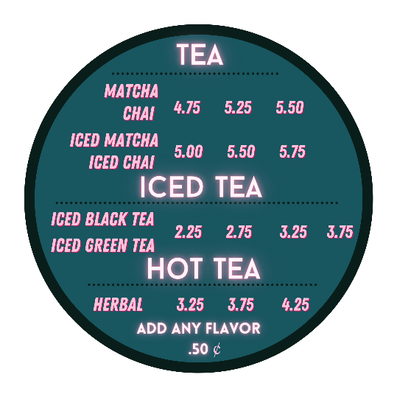

Seasonal Specials

I will Send a picture for the sesaonal box

Wording:

This summer season we decided on a summer classic twist of cherry pie! Warm hot donuts dusted with cinnamon and sugar, then topped with cherry pie filling. Wash it down with a refreshing Mood Ring with any flavor your heart desires.