Game Design Document

Fill up the Following document

1. Write the title of your project.

The Biological Obstacle

1. What is the goal of the game?

To review concepts

1. Write a brief story of your game?

There was a curious boy or a girl and they are trying to test their knowledge about nature. They answer multiple questions. They are placed inside a jungle. As each level of the game is ending they reach home.

1. Which are the playing characters of this game?

* Playing characters are the ones which respond to the user based on the input from the user
* Cars, monkeys, dinos, wizards etc, are the playing characters in the game.

|  |  |  |
| --- | --- | --- |
| Number | Character Name | What can this character do? |
| 1 | Life Scientist | Can play |
| 2 |  |  |
| 3 |  |  |
| 4 |  |  |
| 5 |  |  |
| 6 |  |  |
| 7 |  |  |
| 8 |  |  |

1. Which are the Non Playing Characters of this game?

* Non Playing characters are the ones which don't have an action or a behaviour when the user interacts with the game.
* Hurdles, stones, bananas, coins, etc are non playing characters in the game.

|  |  |  |
| --- | --- | --- |
| Number | Character Name | What can this character do? |
| 1 | Obstacles_1 | questions |
| 2 | Obstacles_2 | Obstacles |
| 3 | JungleBackground | Keeps on changing |
| 4 | HomeBackground |  |
| 5 | grassyGround |  |
| 6 |  |  |
| 7 |  |  |
| 8 |  |  |

Draw your imagination of this game. What does this game look like?

* Draw the game either on your computer or on paper,
* Add images of scenes of the game to show each of the playing and non-playing characters at least once.

 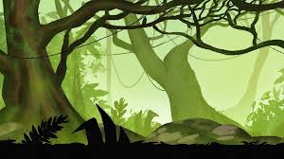

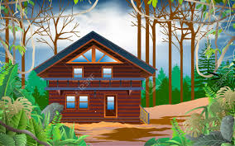





How do you plan to make your game engaging?

There will be rewards (+1 health) and thee will be a losing of a life if the person answers incorrectly. This will get the player motivated.