NC State University
Department of Electrical and Computer Engineering
ECE 463/521: Fall 2014
Project #2: Branch Prediction

by

<< AMARESH SUBBURAJ >>

NCSU Honor Pledge: "I have neither given nor received unauthorized aid on this test or assignment."

Student’s electronic signature: __Amaresh Subburaj__________________________

Course number: _______521__________

PART-1 BIMODAL PREDICTOR:

The following three graphs provide the simulated behaviour of bimodel predictor, a hardware branch prediction mechanism used to minimise the branch control hazard.
These three graphs are plotted with index size as the x axis and branch prediction rate as the y axis. We can infer that as index size increases the size of the branch prediction table also increases and the relation between them is 2^{m} .

The following three graphs are simulated from the gcc ,jpeg ,bimodal trace for bimodal predictor.
Bimodal Figure 1
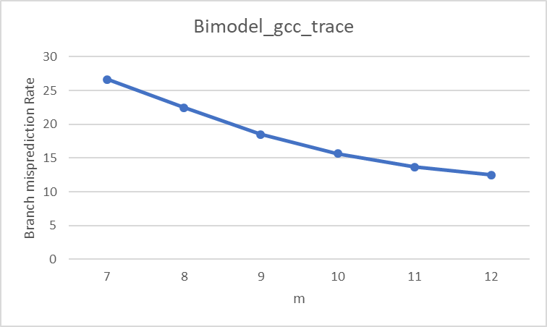

Bimodal Figure 1
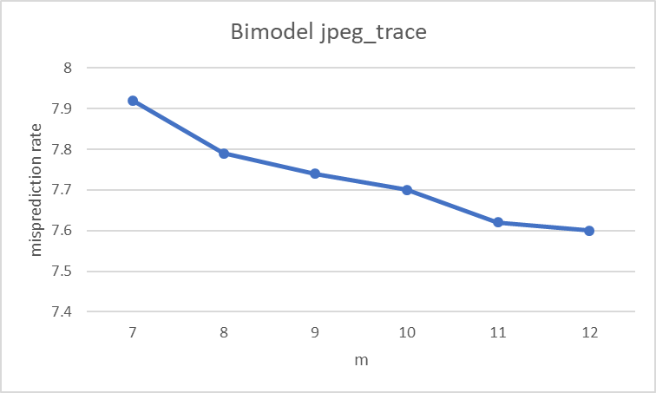

Bimodal Figure 2
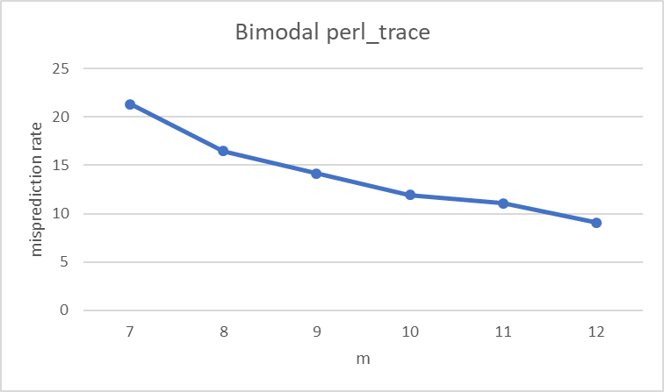

Conclusion: It can be seen from the graphs that misprediction rate decreases as the branch prediction table size increases.
It follows the same trend for all the three traces. But the cost of making the hardware increases, as increase in table size is exponential with increase in m and the returns in terms of decreased misprediction rate are minimal as m increases.

Design:
Gcc_trace: Here m=11 provides a good balance between the prediction rate and the size. The difference in prediction rate between m=10 and m =11 is in order of approx. 3%.But if m=12 then the difference is approx. 1%.But the table size is doubled. Hence it is not worth the increase in hardware cost.

Jpeg_trace: Here the improvement in misprediction rate is meagre between successive increase in m size and m =8 seems a good balanced option.

Perl_trace: Here m = 10 seems reasonable since the successive increment in m does not provide much improvement in prediction rate after this value.

PART-2 GSHARE PREDICTOR:

Conclusion: It can be seen from the graphs that misprediction rate decreases as the branch prediction table size increases. All the traces follow similar trend. But as n is increased above a certain level then misprediction rate decreases, till then the increase in n leads to mixed results in all traces (i.e) for certain value of n increases and for others it decreases. It is due to fact that an increased n leads to more unique XORed index values.
Gshare Figure 1
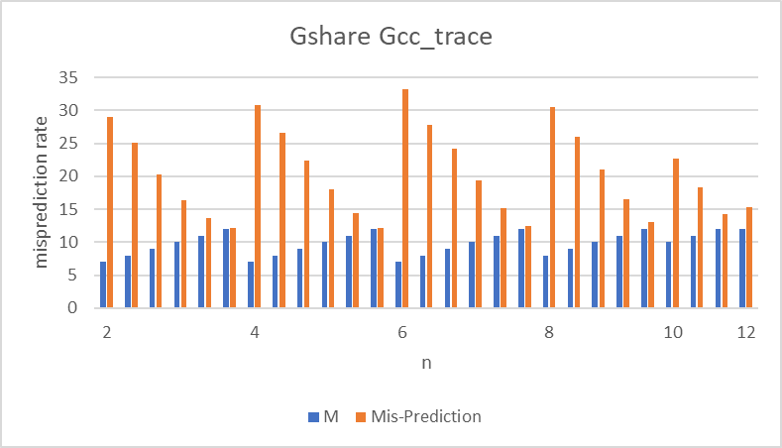

Design:
Gcc_trace: Drawing conclusion from above statement I have chosen n = 8 and For m=11 misprediction rate is about 13.7 and further increase in m leads to a decrease of a approx. 1%. This must not justify the increase in size of the prediction table. Hence choosing the configurations n =8 and m=11

Gshare Figure 2
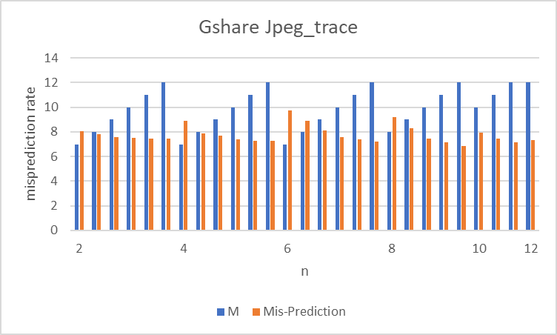

Jpeg_trace: Increase in n leads to better prediction rate in case of jpeg trace n=8 and m=10 has misprediction rate of 7.45 and seems to be better than other configurations.
Even if n=12 and m=12 the improvement over above config is just .10%.

Gshare Figure 3
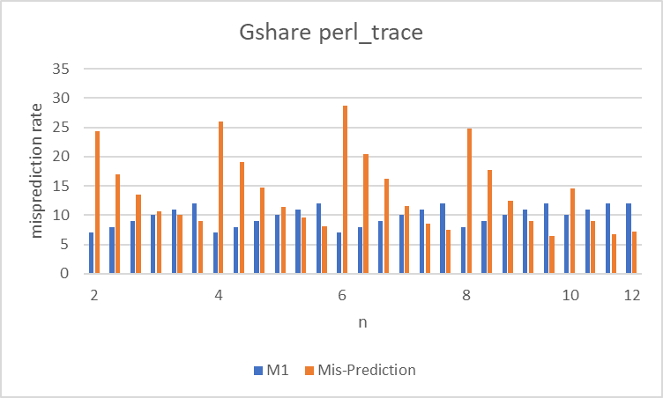

Perl_trace: In case of perl trace also the increase in n leads to improvement in prediction rate. n=8 and m=11 proves the best possible result ( 9% misprediction).For further increase in m the area is doubled and hence not justifying the approx. 1.5% improvement.

