EPPs and Shocks

Amare

2025-05-19

Table of contents

## Abstract

## 1. Introduction

### 1.1. Context & Motivation

* Dynamics of polycrisis (Delannoy et al., 2024)
* Objective: to investigate which shocks cause and are caused by EPP outbreaks, especifically outbreaks of human pathogens.

### 1.2. Research questions

* Does disease outbreak precede or follow other shocks?
* How persistent are the lagged effects of shocks on disease outbreak?
* How do these dynamics differ across spatial scales?

## 2. Data Sources and Preprocessing

### 2.1. Raw Data

We use two datasets:

* Shocks count database
* Disease outbreak news (DON) database

Each database consists of events by year and country

Features:

* Shock categories
* Shock types
* Infectious disease
* Total cases
* Total deaths
* Country
* Continent
* Year

### 2.2. Data Cleaning

## Show info

### Describe data

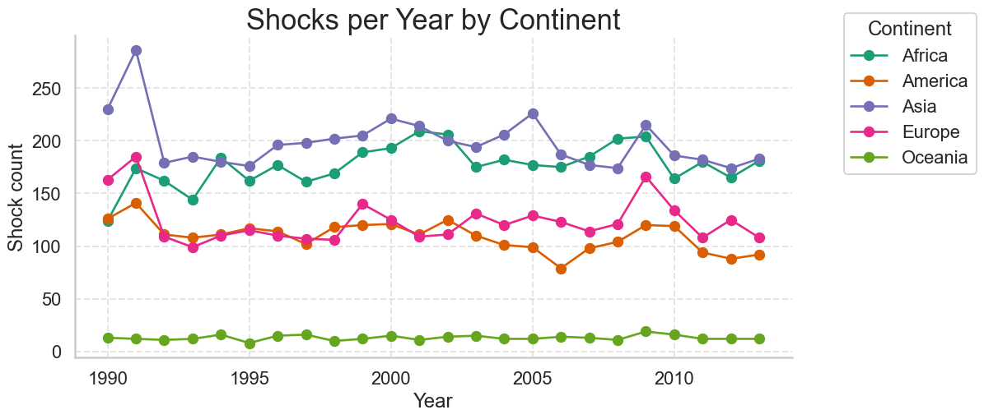

### Preprocessing steps included:

## 3. Exploratory Analysis

### 3.1. Global Trends

### 3.2. Regional Patterns

## Trend

# Baseline: Poisson FE + Year Trend

# Baseline: Negative-Binomial FE + Year Trend

# Figures

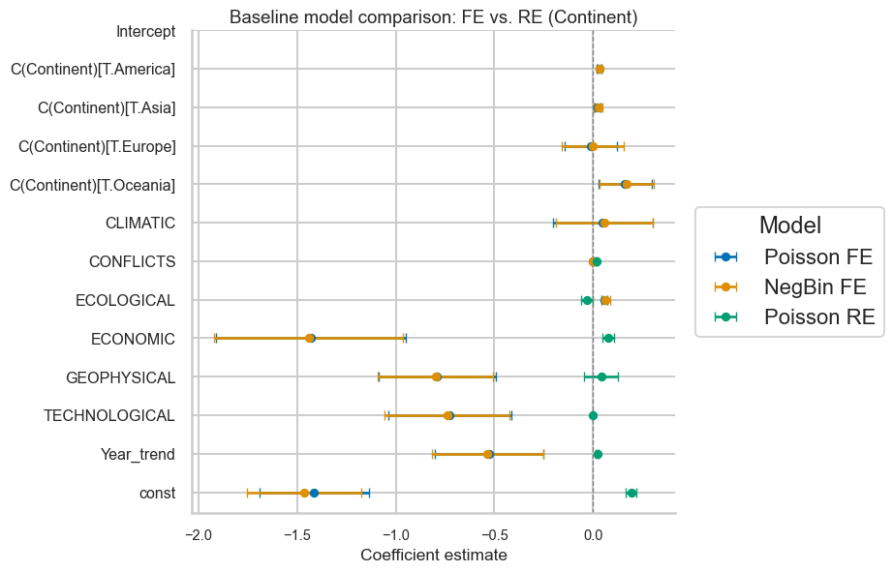

# Lagged coefficients

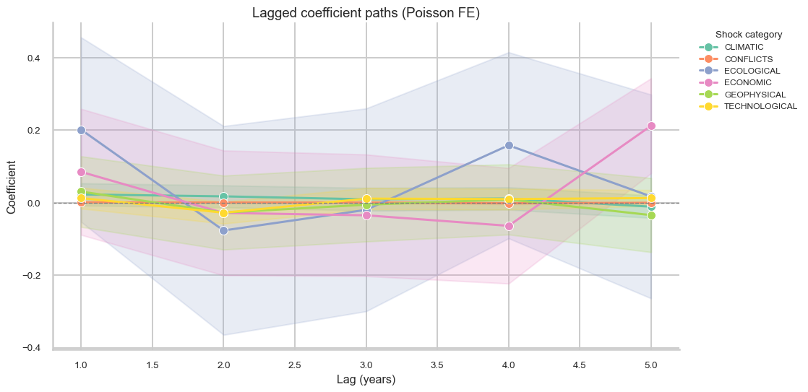

# Tables

'<table class="simpletable">\n<tr>\n <td></td> <th>Poisson FE</th> <th>NegBin FE</th> <th>Poisson RE</th>\n</tr>\n<tr>\n <th>Intercept</th> <td>-1.413***</td> <td>-1.463***</td> <td></td> \n</tr>\n<tr>\n <th></th> <td>(0.141)</td> <td>(0.147)</td> <td></td> \n</tr>\n<tr>\n <th>C(Continent)[T.America]</th> <td>-0.528***</td> <td>-0.536***</td> <td></td> \n</tr>\n<tr>\n <th></th> <td>(0.140)</td> <td>(0.144)</td> <td></td> \n</tr>\n<tr>\n <th>C(Continent)[T.Asia]</th> <td>-0.726***</td> <td>-0.739***</td> <td></td> \n</tr>\n<tr>\n <th></th> <td>(0.158)</td> <td>(0.162)</td> <td></td> \n</tr>\n<tr>\n <th>C(Continent)[T.Europe]</th> <td>-0.791***</td> <td>-0.798***</td> <td></td> \n</tr>\n<tr>\n <th></th> <td>(0.151)</td> <td>(0.150)</td> <td></td> \n</tr>\n<tr>\n <th>C(Continent)[T.Oceania]</th> <td>-1.429***</td> <td>-1.442***</td> <td></td> \n</tr>\n<tr>\n <th></th> <td>(0.246)</td> <td>(0.244)</td> <td></td> \n</tr>\n<tr>\n <th>CLIMATIC</th> <td>0.056***</td> <td>0.063***</td> <td>0.023***</td> \n</tr>\n<tr>\n <th></th> <td>(0.008)</td> <td>(0.011)</td> <td>(0.004)</td> \n</tr>\n<tr>\n <th>CONFLICTS</th> <td>0.000</td> <td>0.000</td> <td>-0.000</td> \n</tr>\n<tr>\n <th></th> <td>(0.000)</td> <td>(0.000)</td> <td>(0.000)</td> \n</tr>\n<tr>\n <th>ECOLOGICAL</th> <td>0.049</td> <td>0.056</td> <td>0.041</td> \n</tr>\n<tr>\n <th></th> <td>(0.128)</td> <td>(0.125)</td> <td>(0.044)</td> \n</tr>\n<tr>\n <th>ECONOMIC</th> <td>0.162**</td> <td>0.170**</td> <td>0.077***</td> \n</tr>\n<tr>\n <th></th> <td>(0.069)</td> <td>(0.070)</td> <td>(0.015)</td> \n</tr>\n<tr>\n <th>GEOPHYSICAL</th> <td>-0.013</td> <td>-0.001</td> <td>-0.033**</td> \n</tr>\n<tr>\n <th></th> <td>(0.068)</td> <td>(0.081)</td> <td>(0.015)</td> \n</tr>\n<tr>\n <th>TECHNOLOGICAL</th> <td>0.021***</td> <td>0.026**</td> <td>0.020***</td> \n</tr>\n<tr>\n <th></th> <td>(0.008)</td> <td>(0.012)</td> <td>(0.003)</td> \n</tr>\n<tr>\n <th>Year_trend</th> <td>0.031***</td> <td>0.033***</td> <td></td> \n</tr>\n<tr>\n <th></th> <td>(0.006)</td> <td>(0.006)</td> <td></td> \n</tr>\n<tr>\n <th>const</th> <td></td> <td></td> <td>0.192***</td> \n</tr>\n<tr>\n <th></th> <td></td> <td></td> <td>(0.014)</td> \n</tr>\n<tr>\n <th>R-squared</th> <td></td> <td></td> <td>0.049</td> \n</tr>\n<tr>\n <th>R-squared Adj.</th> <td></td> <td></td> <td>nan</td> \n</tr>\n</table><br/>\nStandard errors in parentheses.<br/>\n* p<.1, ** p<.05, ***p<.01'

Optimization terminated successfully.  
 Current function value: 0.508384  
 Iterations 6

'<table class="simpletable">\n<tr>\n <td></td> <th>Logit FE</th> \n</tr>\n<tr>\n <th>Intercept</th> <td>-1.637***</td>\n</tr>\n<tr>\n <th></th> <td>(0.173)</td> \n</tr>\n<tr>\n <th>C(Continent)[T.America]</th> <td>-0.590***</td>\n</tr>\n<tr>\n <th></th> <td>(0.166)</td> \n</tr>\n<tr>\n <th>C(Continent)[T.Asia]</th> <td>-0.841***</td>\n</tr>\n<tr>\n <th></th> <td>(0.184)</td> \n</tr>\n<tr>\n <th>C(Continent)[T.Europe]</th> <td>-0.842***</td>\n</tr>\n<tr>\n <th></th> <td>(0.159)</td> \n</tr>\n<tr>\n <th>C(Continent)[T.Oceania]</th> <td>-1.436***</td>\n</tr>\n<tr>\n <th></th> <td>(0.277)</td> \n</tr>\n<tr>\n <th>CLIMATIC</th> <td>0.087***</td> \n</tr>\n<tr>\n <th></th> <td>(0.018)</td> \n</tr>\n<tr>\n <th>CONFLICTS</th> <td>0.000</td> \n</tr>\n<tr>\n <th></th> <td>(0.000)</td> \n</tr>\n<tr>\n <th>ECOLOGICAL</th> <td>0.105</td> \n</tr>\n<tr>\n <th></th> <td>(0.185)</td> \n</tr>\n<tr>\n <th>ECONOMIC</th> <td>0.212***</td> \n</tr>\n<tr>\n <th></th> <td>(0.074)</td> \n</tr>\n<tr>\n <th>GEOPHYSICAL</th> <td>0.022</td> \n</tr>\n<tr>\n <th></th> <td>(0.094)</td> \n</tr>\n<tr>\n <th>TECHNOLOGICAL</th> <td>0.055***</td> \n</tr>\n<tr>\n <th></th> <td>(0.018)</td> \n</tr>\n<tr>\n <th>Year_trend</th> <td>0.049***</td> \n</tr>\n<tr>\n <th></th> <td>(0.007)</td> \n</tr>\n</table><br/>\nStandard errors in parentheses.<br/>\n* p<.1, ** p<.05, ***p<.01'

## 4. Modelling Approaches

### 4.1. Binary Probit/Logit Models

Logistic regression models shock occurrence using 1-year lagged predictors:

## Modelling

## Model Performance Metrics  
  
| | Value |  
|------|---------|  
| RMSE | 0.6 |  
| R2 | -0.26 |  
  
  
## Regression Coefficients  
  
| Variable | Coef. | Std.Err. | p-value |  
|-------------------------|---------|------------|-----------|  
| Intercept | -0.923 | 0.129 | 0 |  
| C(Continent)[T.America] | -0.679 | 0.18 | 0 |  
| C(Continent)[T.Asia] | -0.731 | 0.151 | 0 |  
| C(Continent)[T.Europe] | -0.674 | 0.141 | 0 |  
| C(Continent)[T.Oceania] | -1.293 | 0.263 | 0 |  
| ECONOMIC_lag5 | 0.225 | 0.073 | 0.002 |  
| TECHNOLOGICAL_lag2 | -0.034 | 0.014 | 0.015 |  
| TECHNOLOGICAL_lag5 | 0.021 | 0.009 | 0.023 |  
| CLIMATIC_lag1 | 0.027 | 0.015 | 0.06 |  
| GEOPHYSICAL_lag5 | -0.064 | 0.039 | 0.097 |  
| ECONOMIC_lag1 | 0.12 | 0.074 | 0.107 |  
| ECOLOGICAL | 0.204 | 0.135 | 0.13 |  
| ECOLOGICAL_lag4 | 0.184 | 0.127 | 0.148 |  
| TECHNOLOGICAL_lag1 | 0.015 | 0.012 | 0.227 |  
| CLIMATIC_lag2 | 0.019 | 0.016 | 0.246 |  
| ECONOMIC_lag3 | -0.1 | 0.088 | 0.257 |  
| CONFLICTS_lag3 | 0.001 | 0.001 | 0.258 |  
| GEOPHYSICAL_lag3 | -0.051 | 0.046 | 0.264 |  
| CONFLICTS_lag1 | 0.001 | 0.001 | 0.266 |  
| ECOLOGICAL_lag1 | 0.175 | 0.162 | 0.281 |  
| TECHNOLOGICAL_lag3 | 0.012 | 0.012 | 0.304 |  
| CLIMATIC_lag4 | 0.017 | 0.018 | 0.331 |  
| GEOPHYSICAL_lag1 | 0.052 | 0.056 | 0.346 |  
| GEOPHYSICAL | 0.042 | 0.049 | 0.396 |  
| ECONOMIC_lag2 | -0.081 | 0.098 | 0.41 |  
| ECONOMIC | 0.06 | 0.076 | 0.432 |  
| ECOLOGICAL_lag3 | 0.094 | 0.143 | 0.512 |  
| CONFLICTS_lag4 | -0.001 | 0.001 | 0.543 |  
| CLIMATIC | 0.011 | 0.02 | 0.589 |  
| CONFLICTS | -0 | 0.001 | 0.603 |  
| CONFLICTS_lag5 | -0 | 0.001 | 0.618 |  
| TECHNOLOGICAL_lag4 | 0.005 | 0.012 | 0.671 |  
| ECONOMIC_lag4 | -0.03 | 0.077 | 0.694 |  
| ECOLOGICAL_lag5 | 0.045 | 0.125 | 0.718 |  
| TECHNOLOGICAL | -0.004 | 0.014 | 0.748 |  
| ECOLOGICAL_lag2 | -0.046 | 0.168 | 0.785 |  
| CONFLICTS_lag2 | 0 | 0.001 | 0.798 |  
| CLIMATIC_lag3 | 0.002 | 0.012 | 0.889 |  
| CLIMATIC_lag5 | -0.002 | 0.015 | 0.916 |  
| GEOPHYSICAL_lag2 | -0.005 | 0.045 | 0.919 |  
| GEOPHYSICAL_lag4 | -0.003 | 0.041 | 0.934 |

## Regression Results

### 4.2. Poisson/Count Models

Negative binomial regression addresses overdispersion in shock counts:

## 5. Discussion

## 6. Conclusion

## References

Delannoy, L., Verzier, A., Bastien-Olvera, B. A., Benra, F., Nyström, M., & Jørgensen, P. S. (2024). *Dynamics of the polycrisis: Temporal trends, spatial distribution and interconnections of national shocks (1970-2019)*.