X.100R20
Stores – Procurement
System

Release 20, version 6.0

X.100R20
User Guide
Table of Contents

1.0 Overview 3
1.1 Login 4
1.2 User Management 6
1.2.1 Create New User 7
1.2.2 New User Approval 9
1.2.3 Reset User Password 12
1.2.3.1 Self Password Reset 14
1.3 XERP Procurement 16
1.3.1 Requisition Management 17
1.3.1.1 Cost Center Approval 22
1.3.1.2 Product Specification 24
1.3.2 Requisitions 25
1.3.2.1 Requisition Analysis 26
1.3.2.2 Requisition Assignment 28
1.3.3 Sourcing 31
1.3.3.1 Bidding Document 32
1.3.3.1.1 Requisition Pipeline 33
1.3.3.1.2 Bidding Document 36
1.3.3.1.3 Bidding Document Approval 36
1.3.3.1.4 Committee Approval 37
1.3.3.1.5 Award Decision Approval 40
1.3.3.1.6 Award Decision Approval - Management 43
1.3.3.1.7 Activity Approval 46
1.3.3.2 Quotations 49
1.3.3.2.1 Active and Draft Quotations 50
1.3.3.2.2 Internal Quote Approval 51

1.3.4 Purchasing 52
1.3.4.1 Orders 53
1.3.4.2 Receipts 55
1.4 XERP Inventory 58
1.4.1 Preferences 60
1.4.2 Profiles 62
1.4.3 Transactions 67
1.4.3.1 Receipts 68
1.4.3.2 Requisitions 70
1.4.3.3 Issues 73
1.4.3.4 Adjustments 75
1.4.4 Physical Inventory 78
1.4.4.1 Physical Inventory Cycle 79
1.4.4.2 Physical Inventory Types 81
1.4.4.3 Physical Inventory Count 84
1.4.4.4 Physical Count Sheets 86
1.4.4.5 Physical Inventory Tags 89
1.4.4.6 Physical Inventory Review 91
1.4.5 Approval 94
1.4.6 Enquiry 97
1.4.7 Reports 100
1.5 XERP Parameters 101
1.5.1 System Setup 102
1.5.2 Application Configuration 110

1.0 Course Overview

Welcome to this course on Procurement and Stores System which details the procedure for the following
- User Management,
- XERP Procurement,
- XERP Inventory and
- XERP Parameters
in the X.100_{R20} Procurement Application

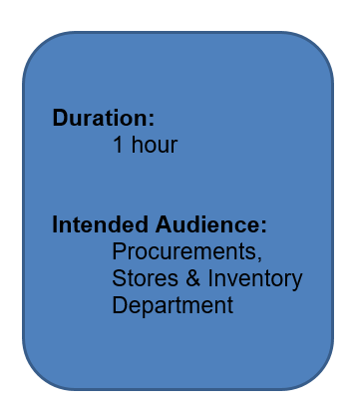

1.1 Log In

To be able to access the Procurement and Stores System Screens the user has to log into the system.

Note: every user must have a Staff ID to be able to log in to the Application; you need to contact the system administrator to get a User ID.

To login the system as a new user, you need to do the following:

- Enter the application URL in your browser or click the application shortcut on your desktop http://10.93.121.50:8181/ords/f?p=500:LOGIN_DESKTOP:1331048564879:::::

- Enter your staff id and the default password at the password field.
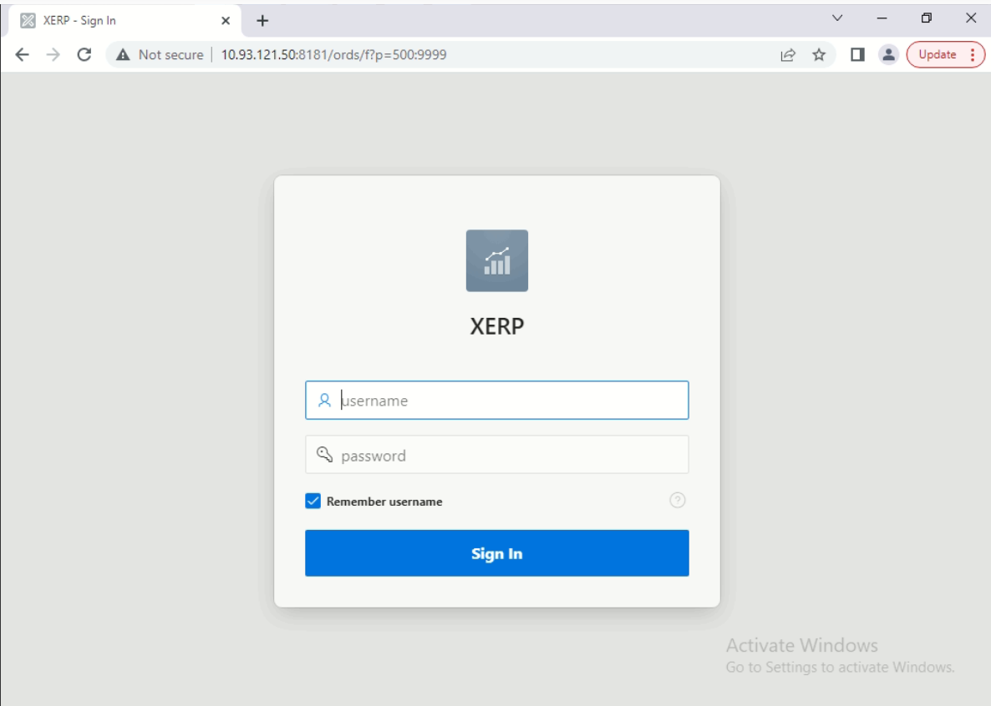
Enter Staff ID
Screenshot: View of the Login Screen

Note: every user’s password should be made up of capital letters, small letters, numbers and special characters and the length should be eight (8) or more characters

Enter User ID
- Enter your own password at the new password field and repeat your password at the confirm password.

- Press the enter key to activate the user id and password.

- This will take the user to the home page.
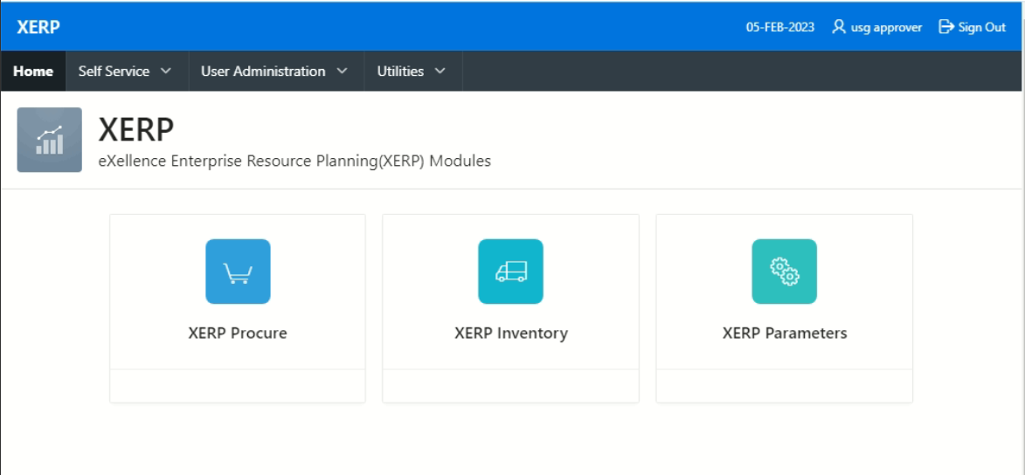

1.2 User Management

The User Management is an administrative role which is assigned to the system administrator to enable the user to create new users, reset user passwords and approve new user creation in the application.

To access this screen, the user must:

- Click on the ‘User Administration’ tab on the navigation menu bar.

- Click on the ‘User Maintenance’ and select the ‘Users Creation’.
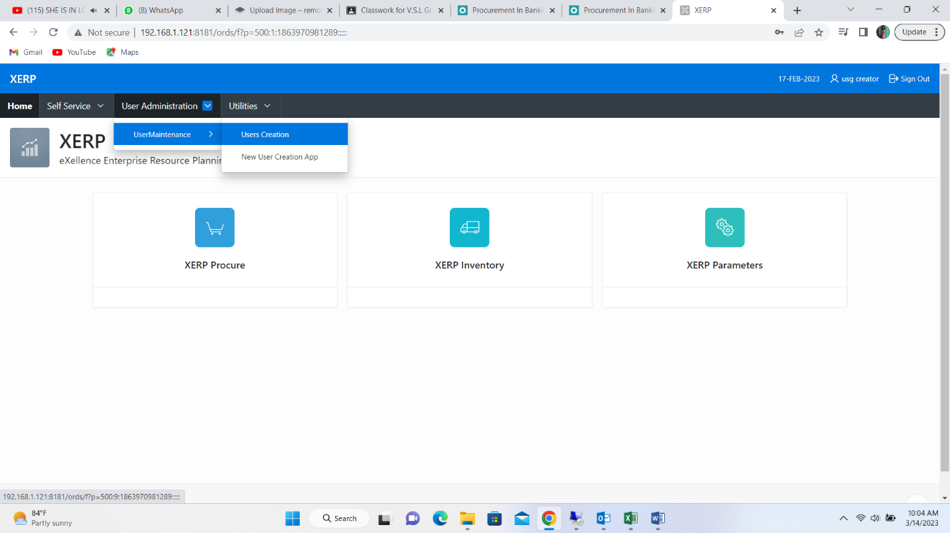
2
1

- This will display all the users and their details on the ‘User Management’ interface.
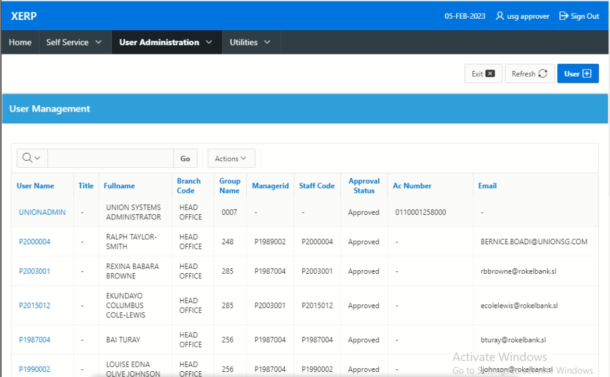
3
Screenshot: View of the User Management Screen

1.2.1 Create New User

The Create New User screen enables the system administrator to create new users in the application.

To create a new user, the administrator must:

- Click on the ‘User’ button.
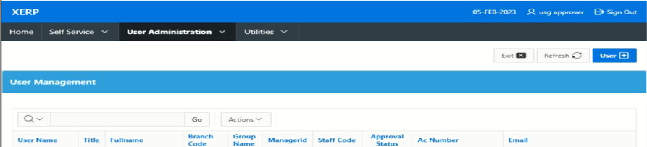
1

- This will display the ‘User Details’ interface.
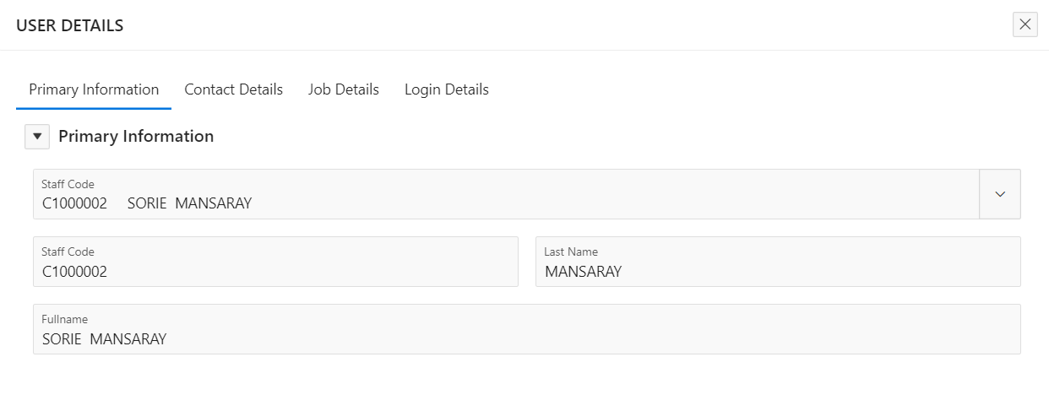
3
Screenshot: View of the New User Creation Screen

- Select the staff you want to create as a user by clicking on the LOV button at the ‘Staff Code’ field to display the staff details.

Note: click on the various tabs to enable the administrator capture the other details of the new user.

Contact Details

The Contact Details interface enables the administrator to capture the contact information of the new user in the application.

Job Details

The Job Details interface enables the administrator to capture the new user’s job information and the new user’s authority code in the application.

- Select the new user’s ‘Access Code’ on the ‘Login Details’ screen.

- Click on the LOV button at the ‘Additional Functionality’ field to select and add more functionality to the new user’s access.
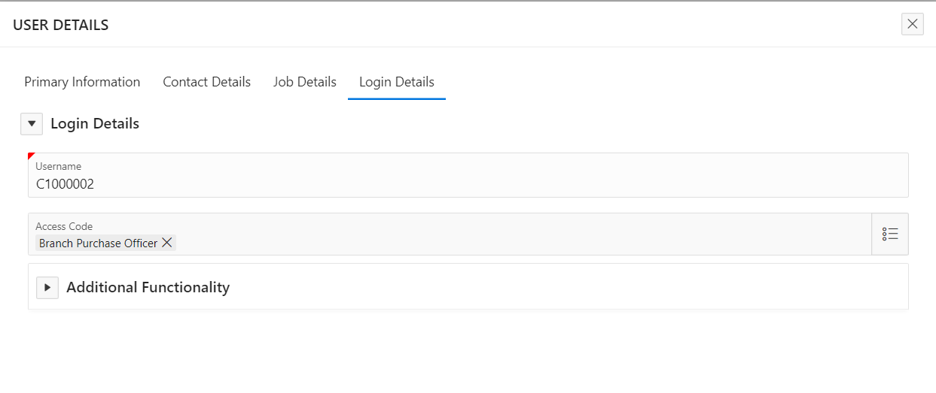
4
5

- Click on the field below the ‘Additional Access’ column to enable the administrator add a function to the user’s access.

- Click on the ‘Add Row’ button to release a new column to enable the administrator add more functions to the new user’s access.

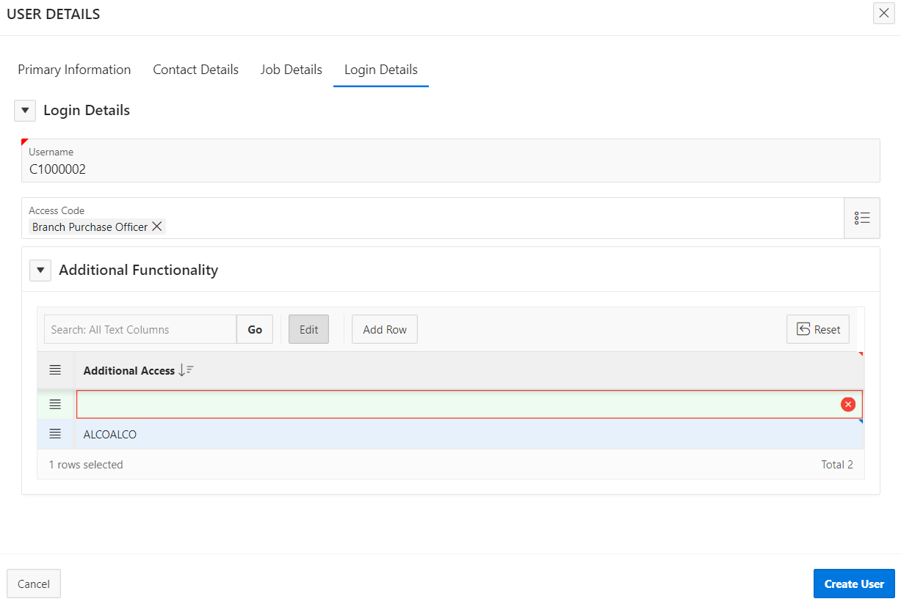
8
6
7

- Click on the ‘Create User’ button.

- Click on the ‘Yes, Continue’ button to save the records and send it for approval.

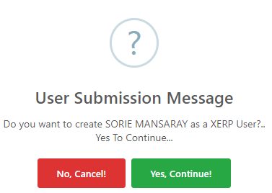

9

1.2.2 New User Approval

The New User Approval screen enables the authorizer to approve the details of newly created users in the application.

To approve a new user, the authorizer must:

      - Click on the ‘User Administration’ tab on the navigation menu bar.

      - Click on the ‘User Maintenance’ and select the ‘New User Creation App’.
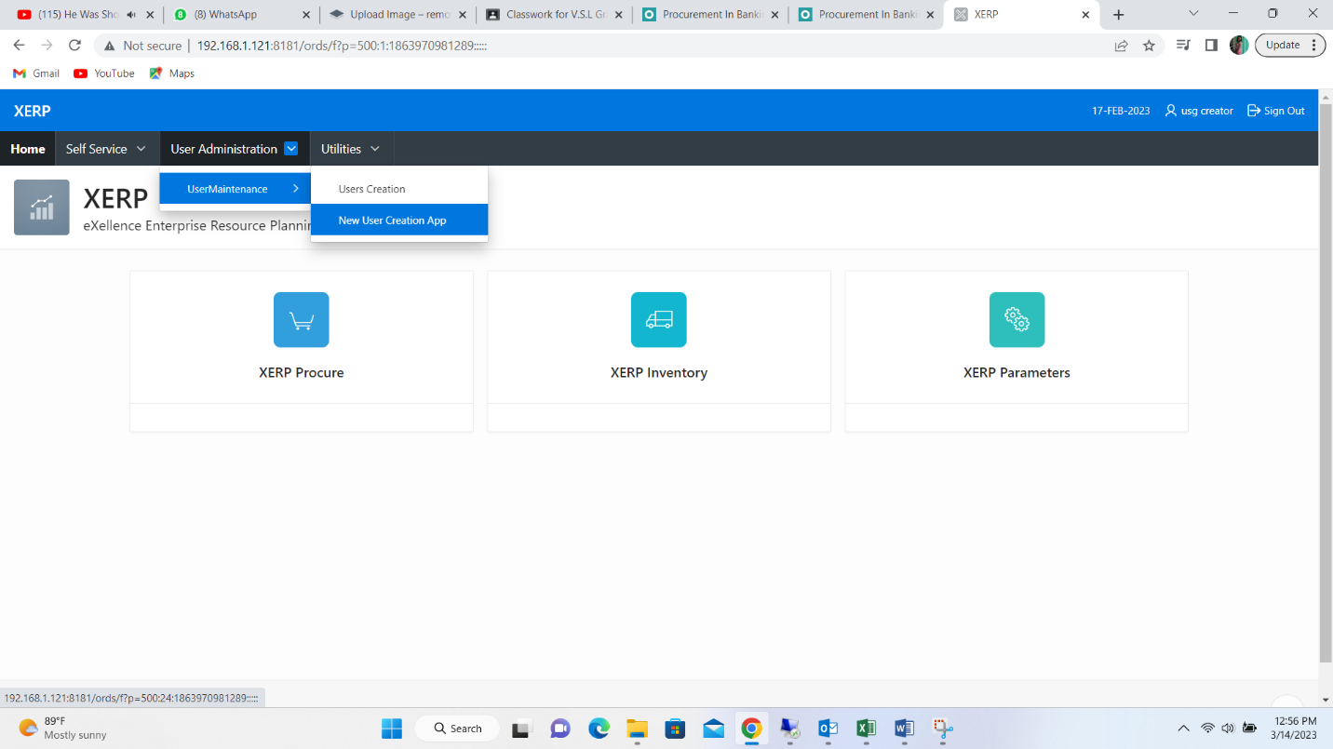
2
1

      - This will display all created users pending approval.

- Check in the box beside the user who’s details you want to approval.

- Click on the ‘Approve’ button to approve the new user’s details.

- Clicking on any of the codes under the ‘Staff Code’ column to open and view the user’s details.
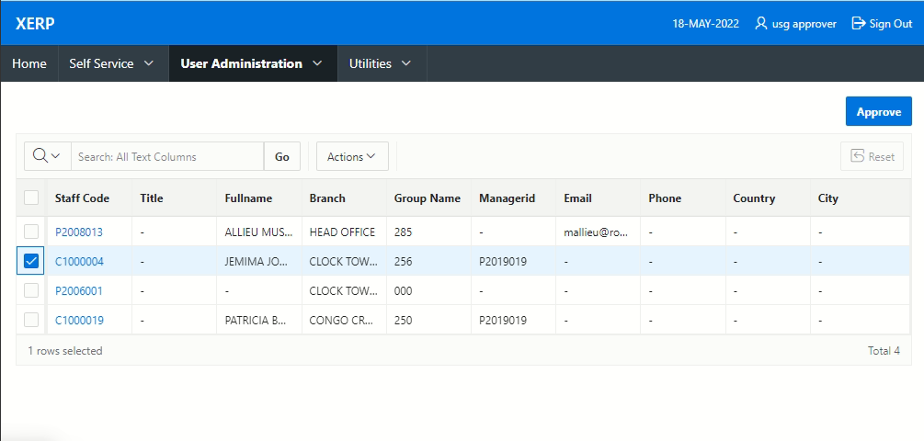
Screenshot: View of the User Creation Approval Screen
4
5

Note: this user is now created in the application.

1.2.3 Reset User Password

The Reset User Password screen enables the system administrator to reset a user’s password as and when it is necessary in the application.

To reset a user’s password, the administrator must:

- Click on the ‘User Administration’ tab on the navigation menu bar.

- Click on the ‘User Maintenance’ and select the ‘Users Creation’.

2
1

- This will display all the users and their details on the ‘User Management’ interface.
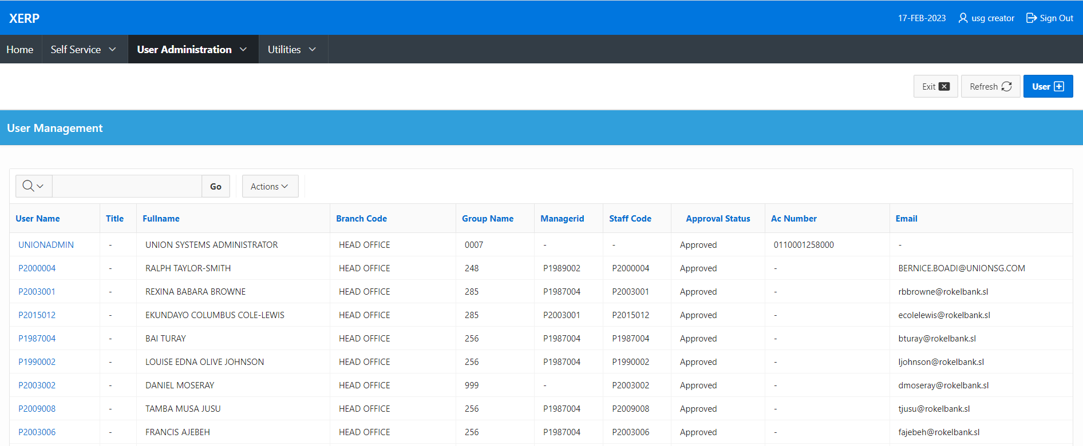
4

- Click on the ‘User Name’ of the user you want to reset the password for to display the ‘User Details’ interface.

- Click on the ‘Reset Password’ button.
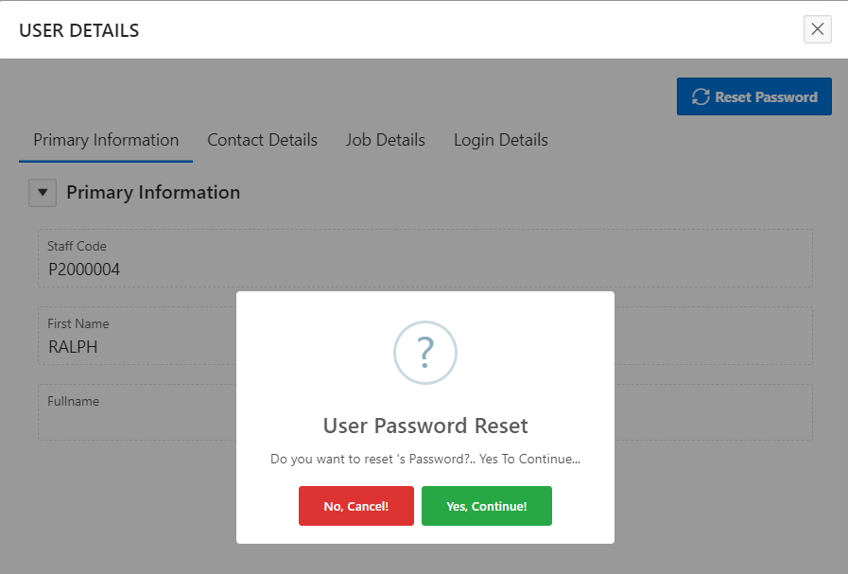
6
5

- Click on the ‘Yes, Continue’ button to reset the user’s password.

1.2.3.1 Self Password Reset

The Reset User Password screen enables the user to change their own passwords whenever they want to in the application.

To reset a user’s own password, the user must:

- Click on the ‘Self Service’ tab on the navigation menu bar.

- Click on the ‘Password Maintenance’ and select the ‘Password Maintenance’.
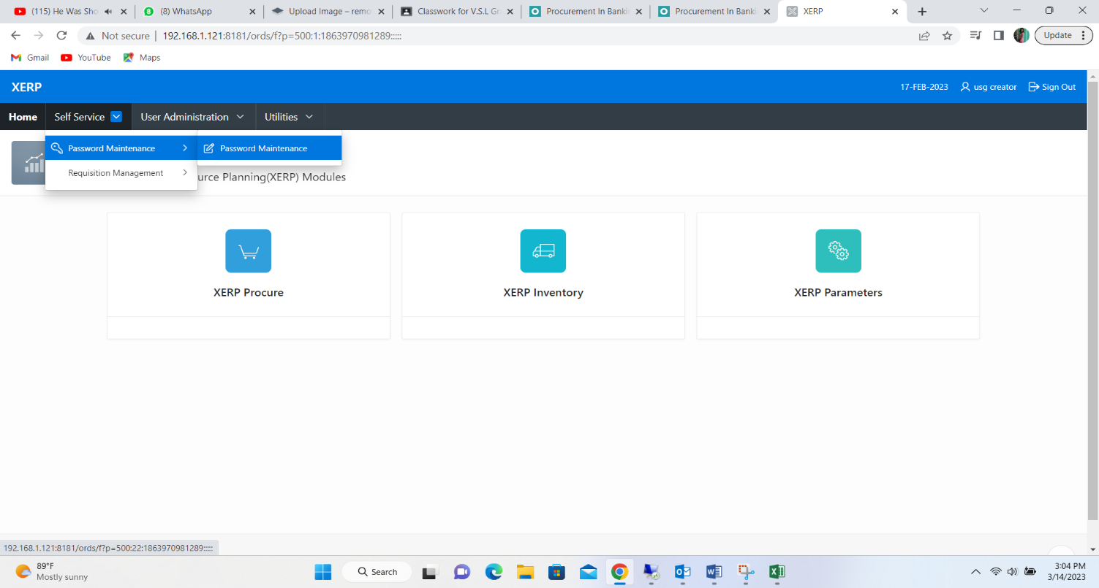
2
1

- This will display the ‘Password Reset’ interface.
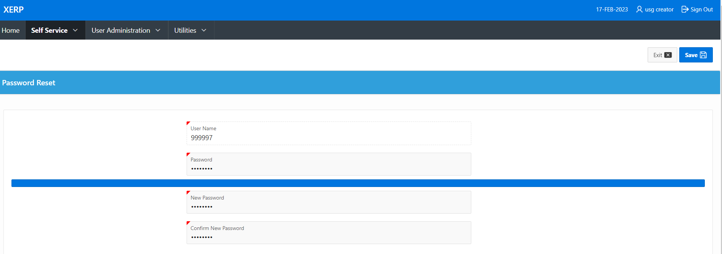
7
6
5
4

- Enter your old password at the ‘Password’ field.

- Enter the new password you want to use at the ‘New Password’ field.

- Repeat the new password at the ‘Confirm New Password’ field.

- Click on the ‘Save’ button to save your changed password.

1.3 XERP Procurement

Procurement is the process of obtaining goods and services from external sources. It is a vital part of the banking industry, as it ensures that the necessary goods and services are obtained in a timely and cost-effective manner.

From the home page, click on the ‘XERP Procurement’ button.


1

The XERP Procurement module is made up of the following:

- Requisition Management,
- Requisitions,
- Sourcing and
- Purchasing.

1.3.1 Requisition Management

The Requisition Management is used to request for items in the application.

To access this screen, the user must:

- Click on the ‘Self Service’ tab on the navigation menu bar.

- Click on the ‘Requisition Management’ and select ‘Requisition’.
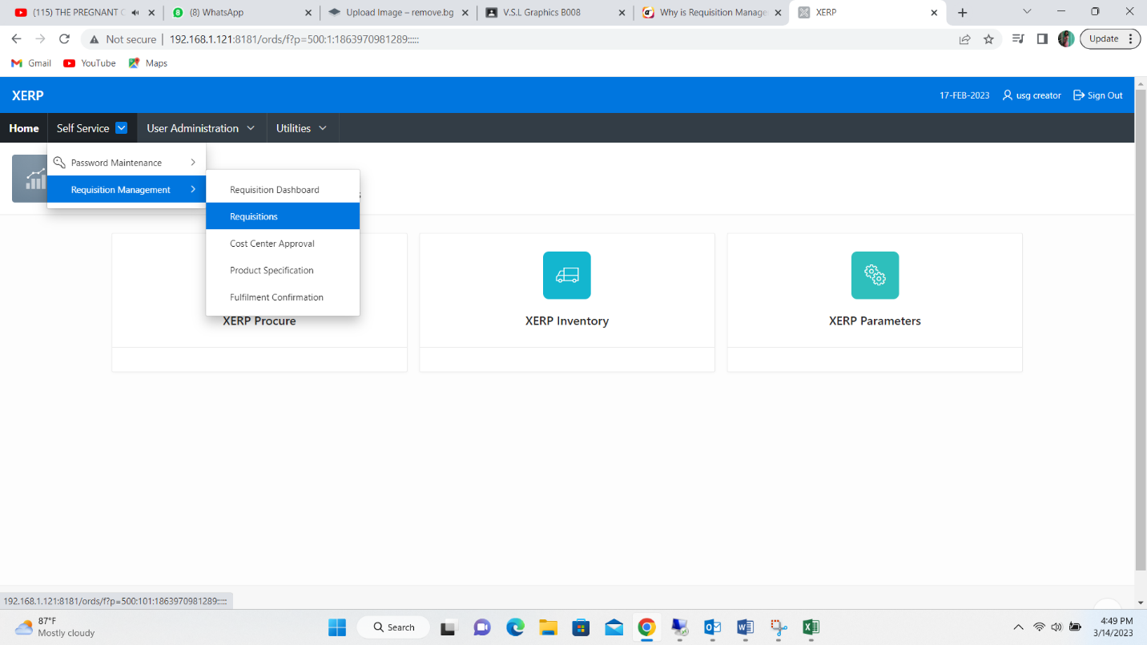
2
1
2

- This will display the ‘Self Service – Purchase Request’ interface.
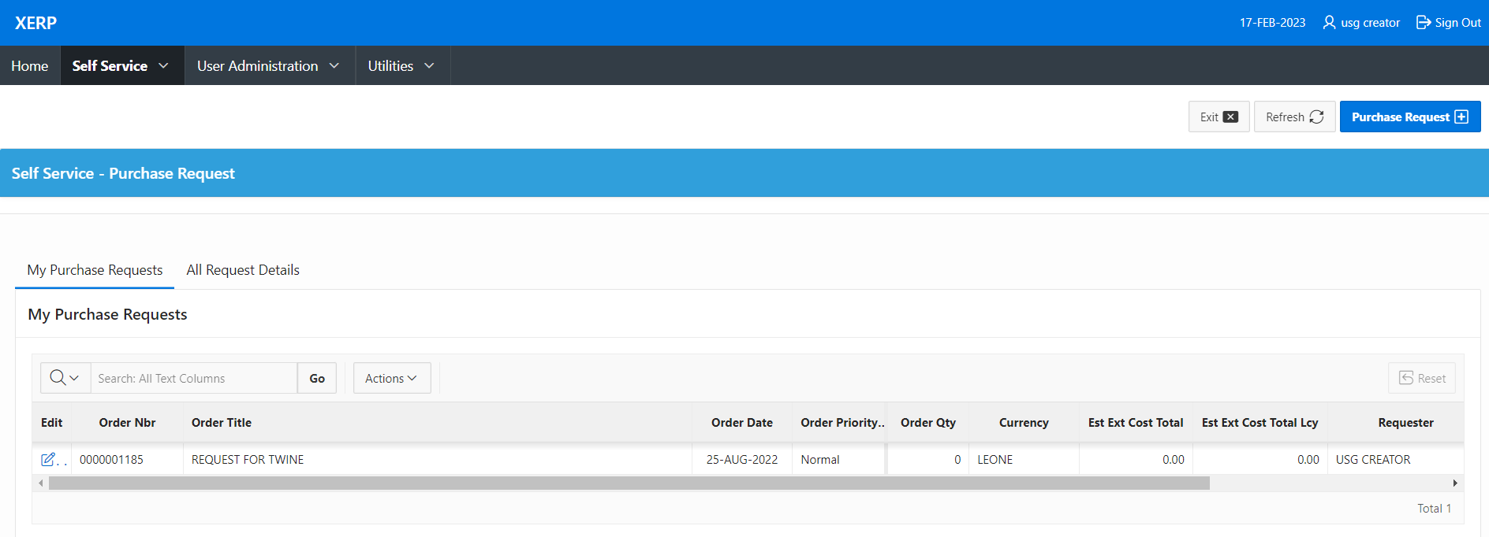

Screenshot: View of the Self Service – Purchase Request Screen

Note: To create a new request, click on the ‘Purchase Request’ button.

There are five sections on the purchase request screen, namely:
- Request Header,
- Request Summary,
- Document Details,
- Budget Validation and
- Attach Document.
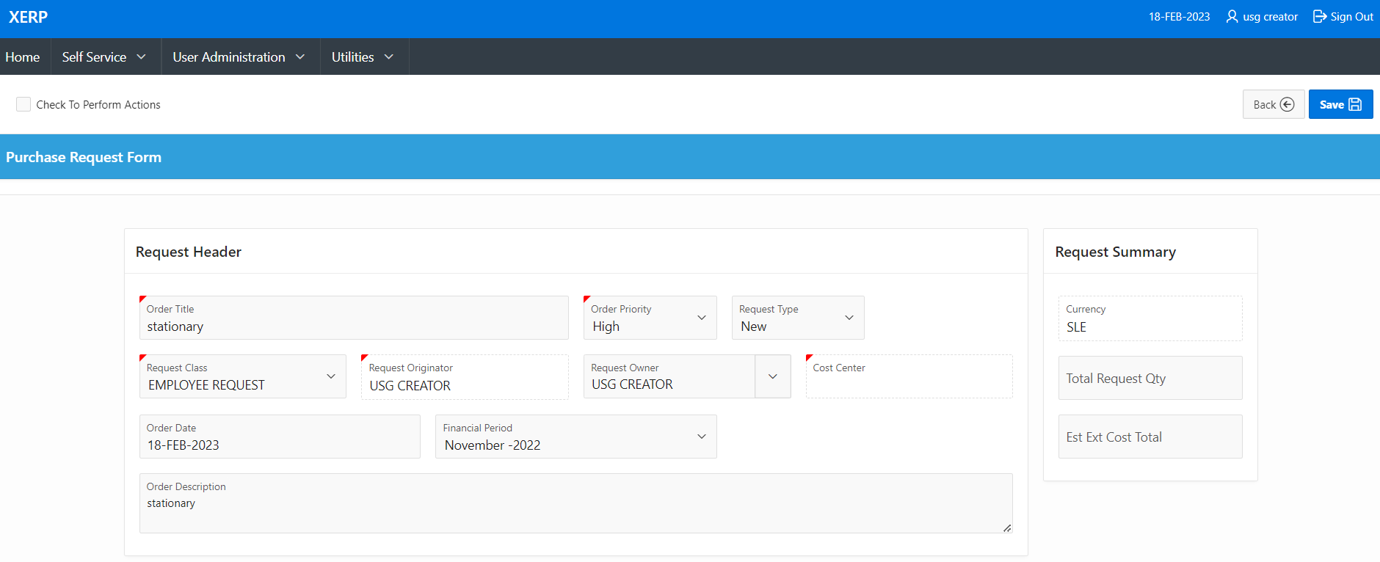
10
9
8
7
6
5
4
Screenshot: View of the Purchase Request Screen

- Indicate the title of the order at the ‘Order Title’ field’

- Click on the LOV button at the ‘Order Priority’ field to indicate how important the purchase is.

- Click on the LOV button at the ‘Request Type’ field to indicate if the purchase is new or not.

- Click on the LOV button at the ‘Request Class’ field to indicate if the class of the purchase.

- Click on the LOV button at the ‘Request Owner’ field to indicate who is requesting for the purchase.

- Indicate the date of the order at the ‘Order Date’ field.

- Indicate the period of purchase at the ‘Financial Period’ field.
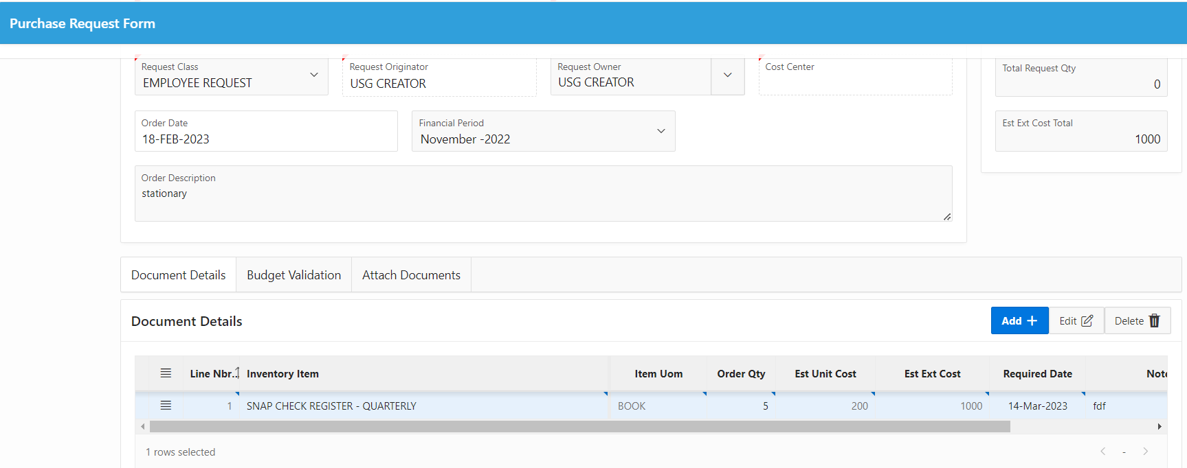
11
12
13

- Click on the ‘Add’ button to enable you capture the document details.

- Capture all the necessary details of the document under the ‘Document Details’ column.

- Click on the ‘Budget Validation’ tab.

Budget Validation

The Budget Validation and Request Summary sections display summary information and budget information of the purchase respectively.

- Click on the ‘Attach Documents’ tab.
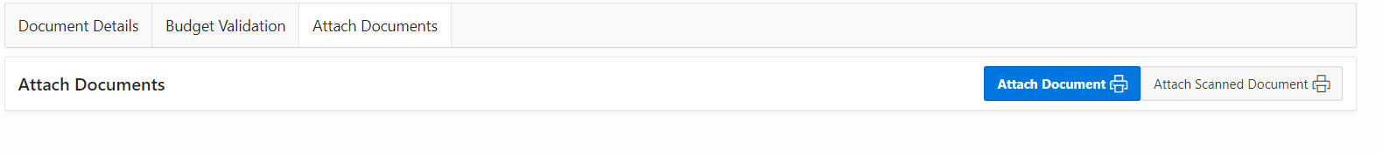
15
14
- To attach a document, click on the ‘Attach Document’ button to open the ‘Document Upload’ interface.
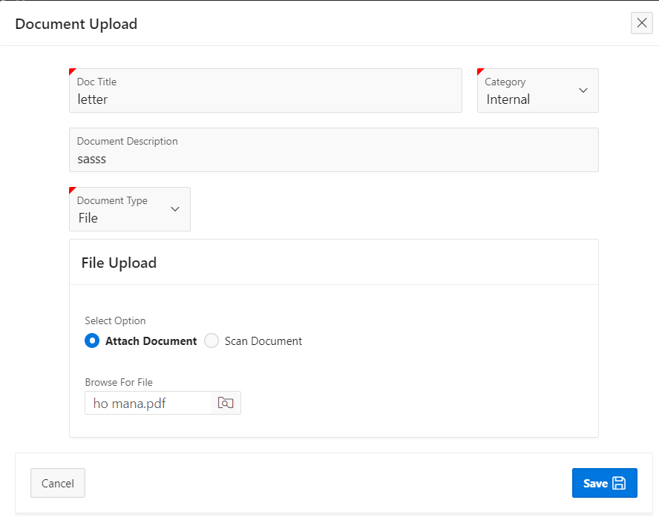
22
21
20
19
18
17
16

- Click on the LOV button at the ‘Doc Title’ field to select the title of the document that is being captured.

- Indicate if the document is an internal or external document at the ‘Category’ field.

- Indicate the name of the document at the ‘Document Description’ field.

- Indicate the type of document at the ‘Document Type’ field.

- Indicate if the document will be scanned or attached at the ‘Select Option’ field.

- Click on the button at the ‘Browse for File’ field to either scan or attach an already scanned document.

- Click on the ‘Save’ button to save the document and bring you back to the previous interface.

- Check in the box beside the ‘Check to perform actions’ field to enable the ‘Submit’ button.

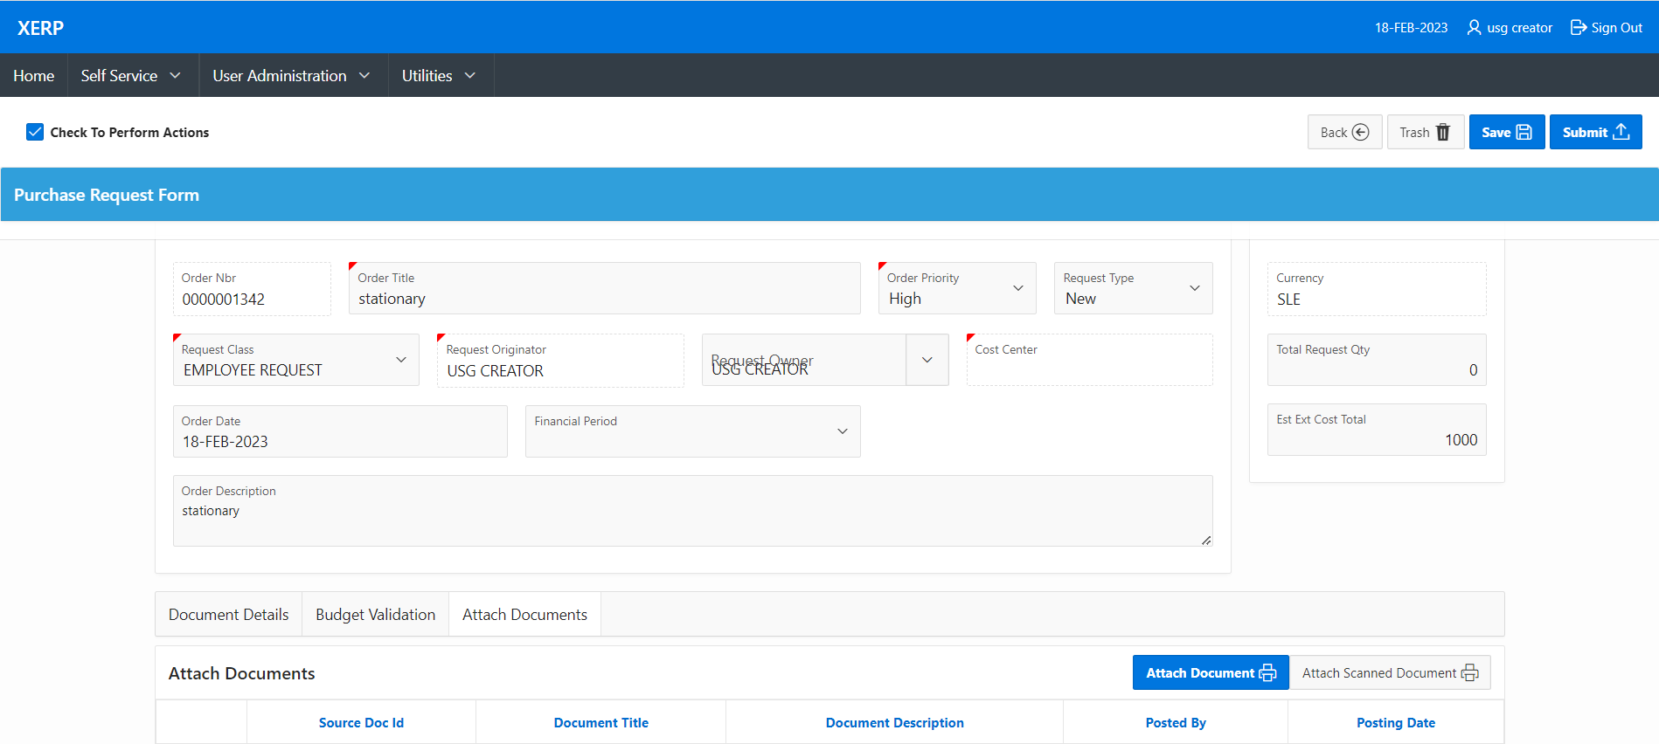
24
23

- Click on the ‘Submit’ button to save request and submit it for approval.

1.3.1.1 Cost Center Approval Screen

The Cost Center Approval screen enables the authorizer approve all purchase request in the application. This can be done only by cost center heads who see all the details entered at the purchase request stage. They can then approve, reject or cancel a request.

To access this screen, the user must:

- Click on the ‘Self Service’ tab on the navigation menu bar.

- Click on the ‘Requisition Management’ and select ‘Cost Center Approval’.
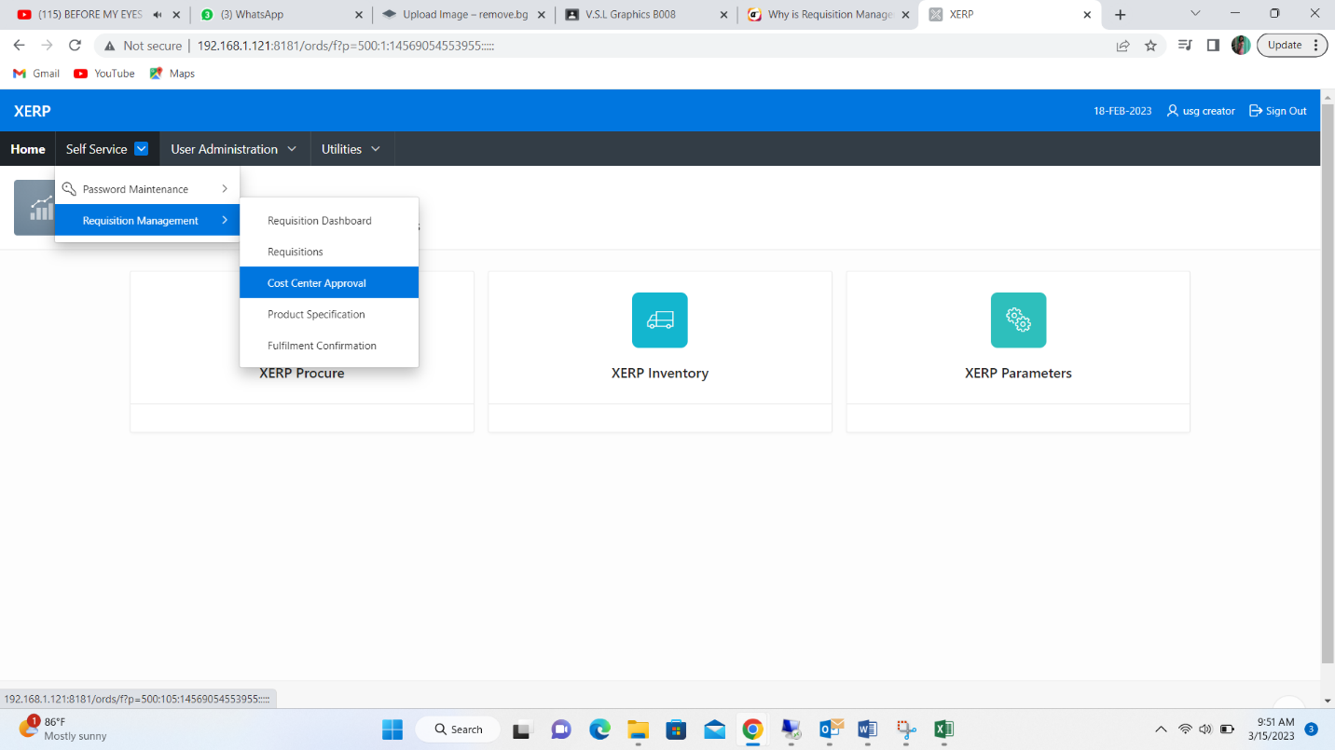
1
2
2

- This will display the ‘Purchase Request: Cost Center Approval’ interface.
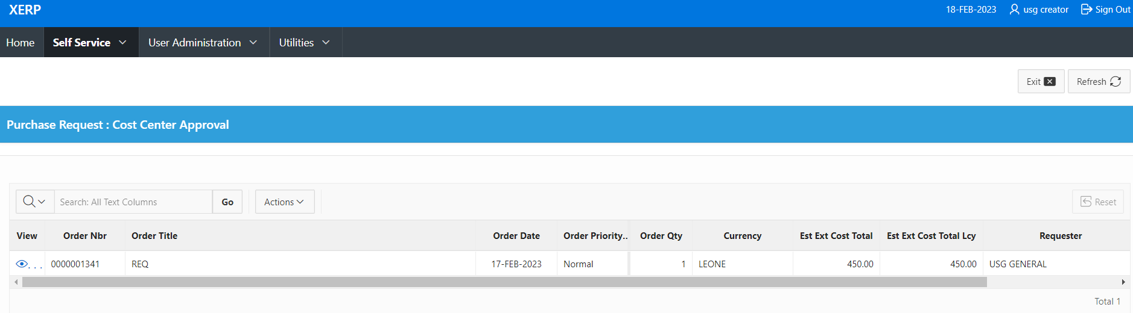
4
Screenshot: View of the Purchase Request: Cost Center Approval Screen

- Click on the ‘View’ button beside the request to be approved to display the details of the request.

- Check in the box beside the ‘Check to perform actions’ field to enable the ‘Approve’ button.

- Click on the ‘Approve’ button to approve the request.

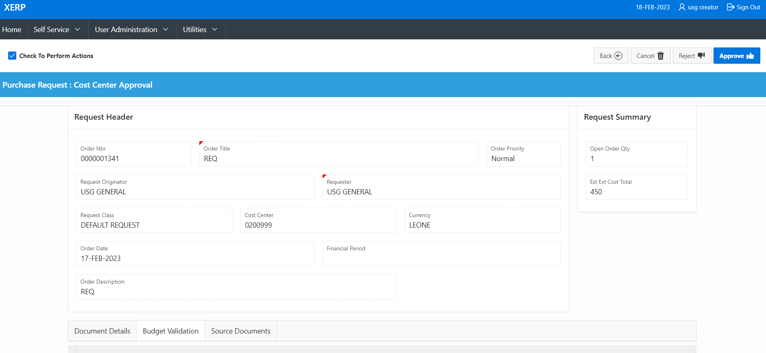

65
5

Note: to reject or cancel a request, click on the ‘Reject’ or ‘Cancel’ buttons where necessary.

1.3.1.2 Product Specification Screen

The Product Specification screen is available for products that require specification. Products that require specification move to this stage after cost center approval.

To access this screen, the user must:

- Click on the ‘Self Service’ tab on the navigation menu bar.

- Click on the ‘Requisition Management’ and select ‘Product Specification’.
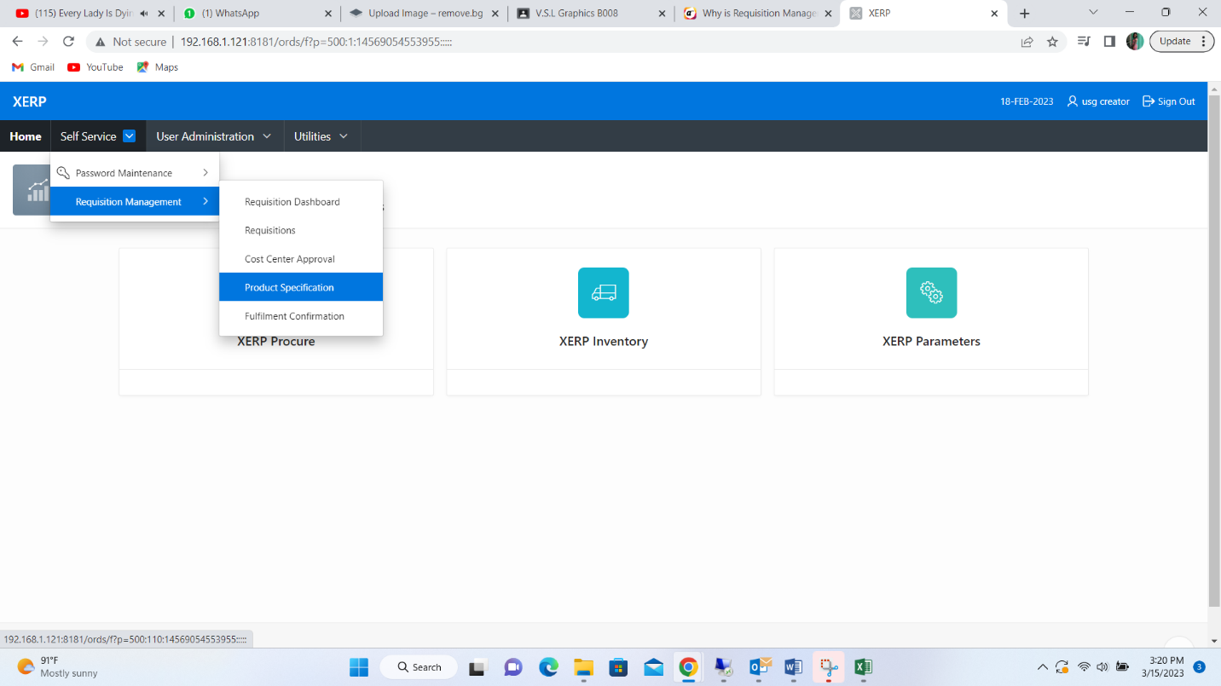
2
2
1

- This will display the ‘Purchase Request: Cost Center Approval’ interface.

1.3.2 Requisitions

To access this screen, the user must:

- Click on the ‘Home’ tab on the navigation menu bar.

- Click on the ‘XERP Procure’ button.
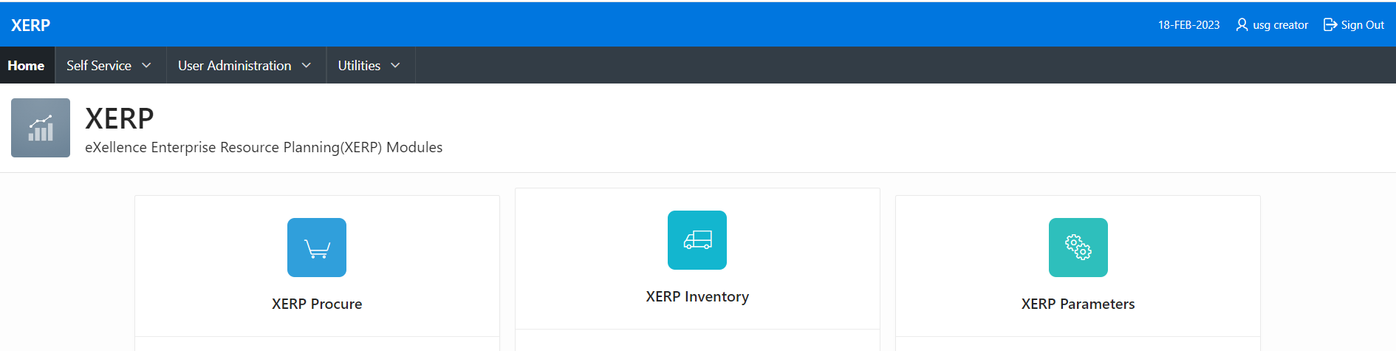
1
2

- This will open the ‘Procurement’ interface.
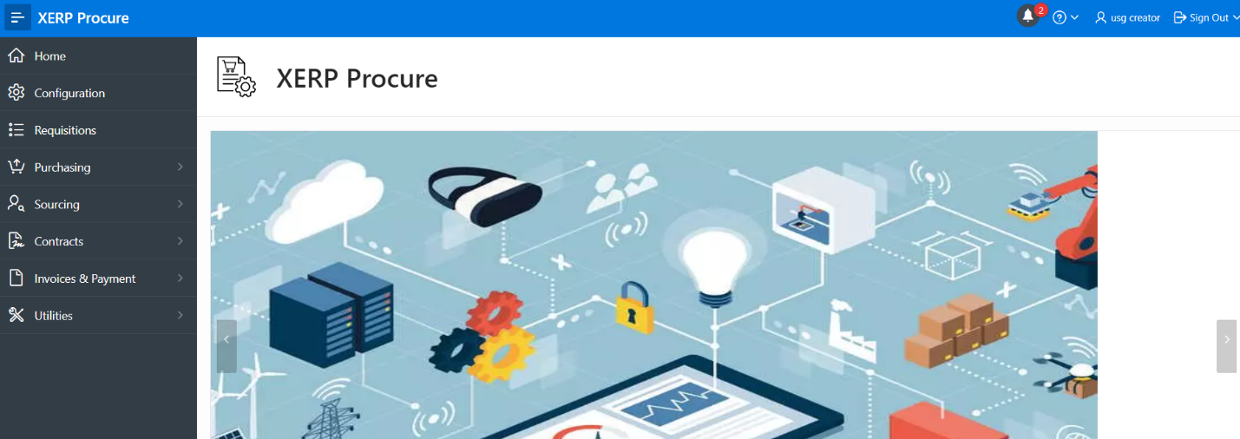

1.3.2.1 Requisition Analysis Screen

The Requisition Analysis screen is.

To access this screen, the user must:

      - Click on the ‘Requisitions’ tab to open the ‘Requisitions’ interface.
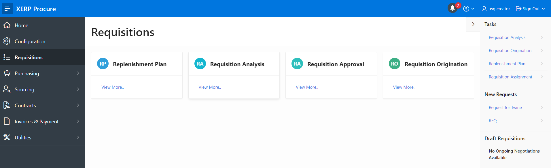
2
1

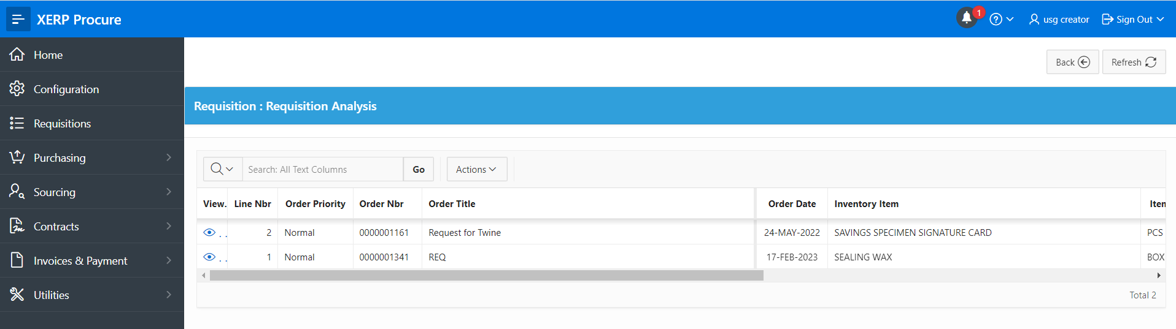
      - Click on the ‘Requisition Analysis’ button to open the ‘Requisition Analysis’ interface to view a list of requests.
3

      - Click on the icon below the ‘View’ column to view the details of a request.
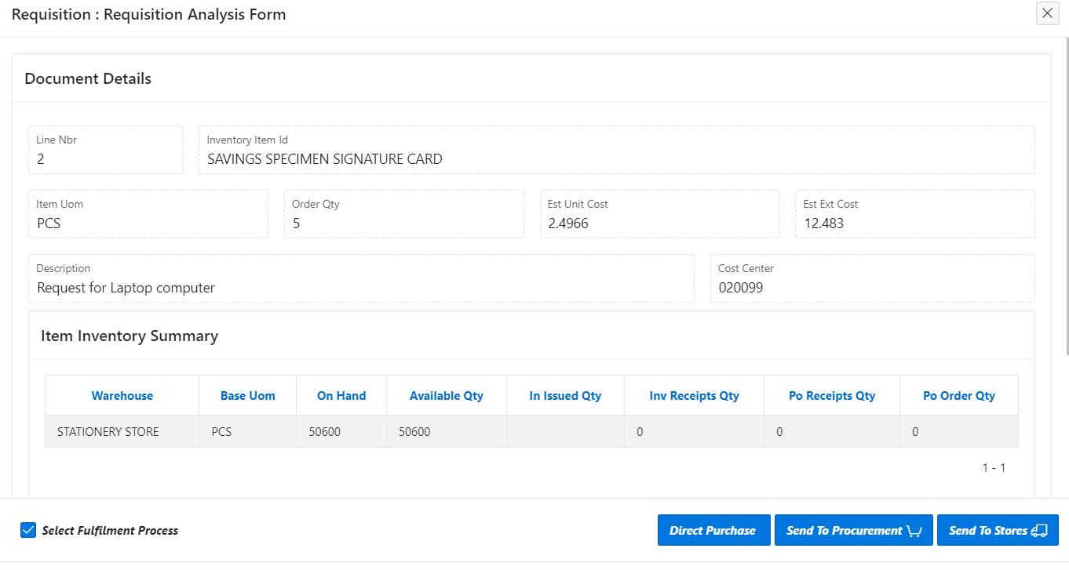

4

- Check in the box beside the ‘Select Fulfillment Process’ to display the ‘Direct Purchase’, ‘Send to Procurement’ and ‘Send to Stores’ buttons and select an action to complete the requisition analysis.

Note: when ‘Send to Procurement’ is selected, the requisition is sent to ‘Requisition Assignment’ for further process.

1.3.2.2 Requisition Assignment Screen

The Requisition Assignment screen holds all requisitions sent to procurement. These are assigned to a staff who oversees all processes associated to the procuring of that item.

To access this screen, the user must:

      - Click on the ‘Requisitions’ tab to open the ‘Requisitions’ interface.


1
2

      - Click on the ‘Requisition Assignment’ tab to open the ‘Requisition: Purchasing Officer Selection’ interface to view a list of requests.
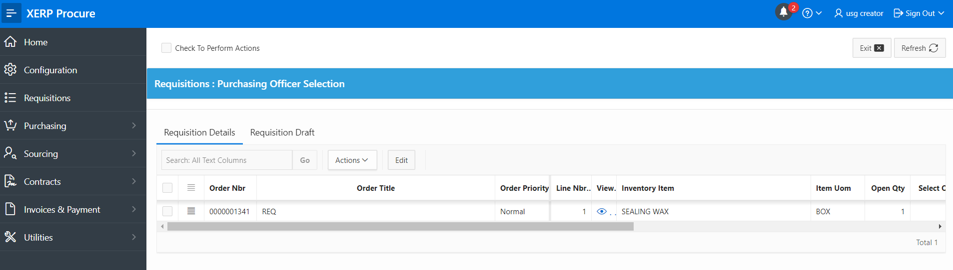
3

      - Click on the icon below the ‘View’ column to view the details of a request.
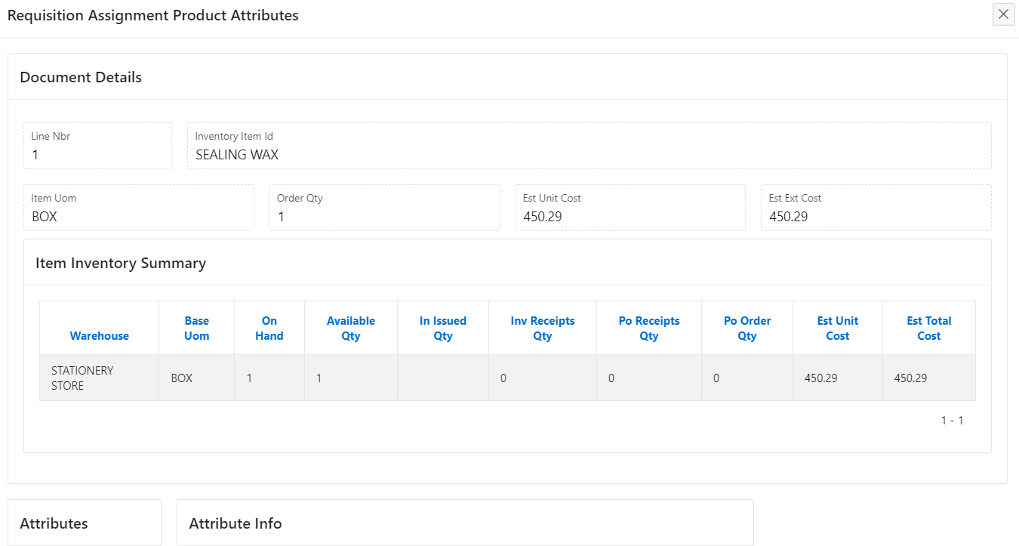
4

      - Click on the ‘Exit’ button to return to the previous interface.

      - Check in the box beside the details of the request.
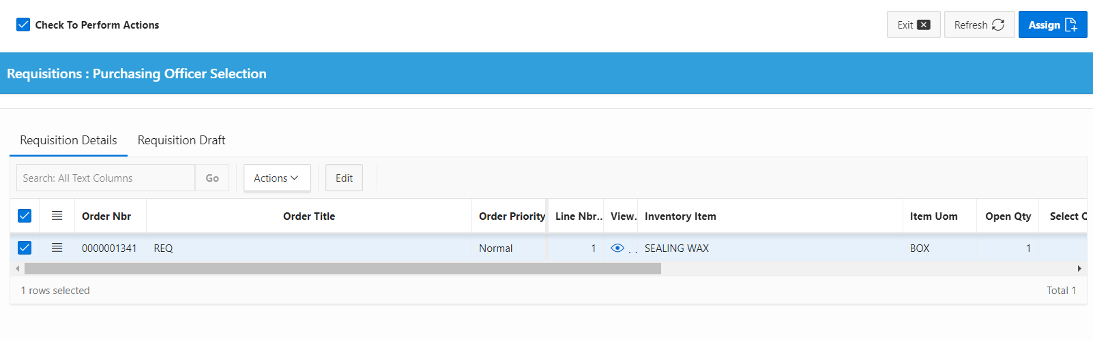
5

      - This will display the details on the ‘Purchase Requisition’ interface.

      - Check in the box beside the ‘Check to perform actions’ field.

      - Click on the ‘Save’ button.
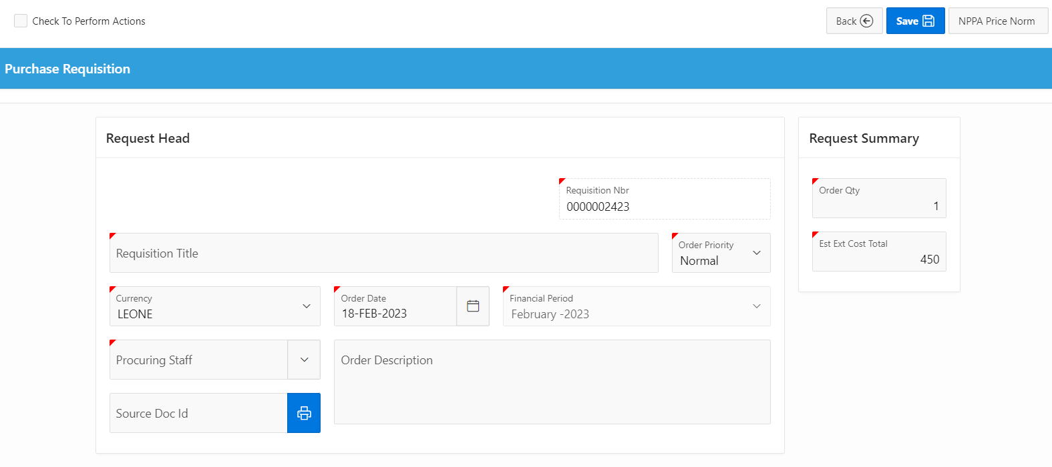
8
7

1.3.3 Sourcing

The Sourcing is made up of

- Bidding Documents and
- Quotations

To access this screen, the user must:

- Click on the ‘Home’ tab on the navigation menu bar.

- Click on the ‘XERP Procure’ button.

1
2

- This will open the ‘Procurement’ interface.


1.3.3.1 Bidding Document

The Bidding Document interface contains all details and activities performed on a bidding document in creating a bidding document, enter the details of the bidding document.

To access this screen, the user must:

      - Click on the ‘Sourcing’ tab.

      - Click on the ‘Bidding Document’ tab to open the ‘RFX/ Bidding’ interface.
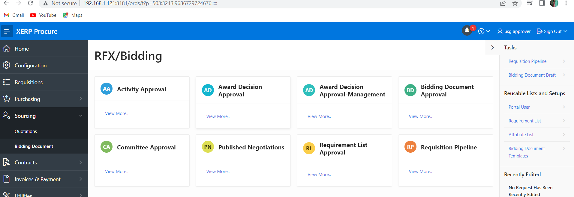
1
2
3

      - Click on the ‘Requisition Pipeline’ button to open the ‘PO Creation’ interface to view a list of requests.

1.3.3.1.1 Requisition Pipeline Screen

Requests that have been assigned to Purchasing staff are seen in this section. The user can select and proceed with the bidding document details. Completed bidding documents can then be sent for approval.

            - Click on the ‘View’ icon on the ‘Sourcing: PO Creation (Direct Purchase from Requisition’ interface to select a requisition to create a bidding document.
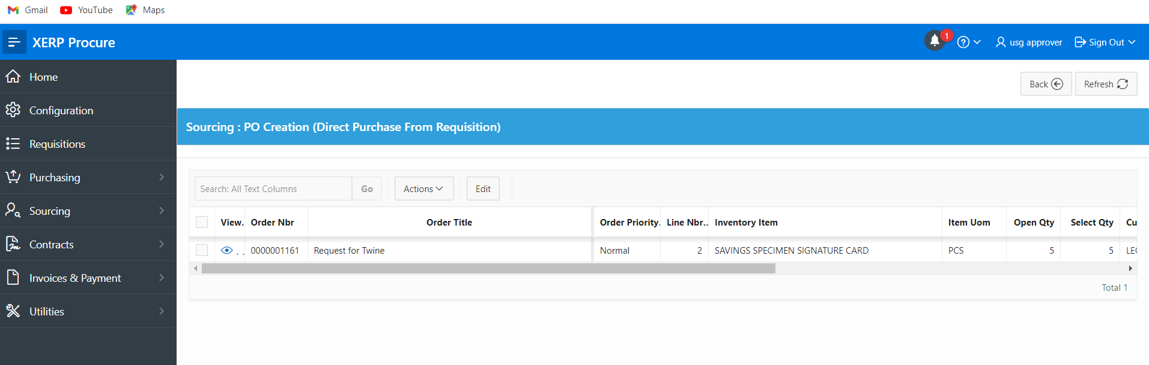
1

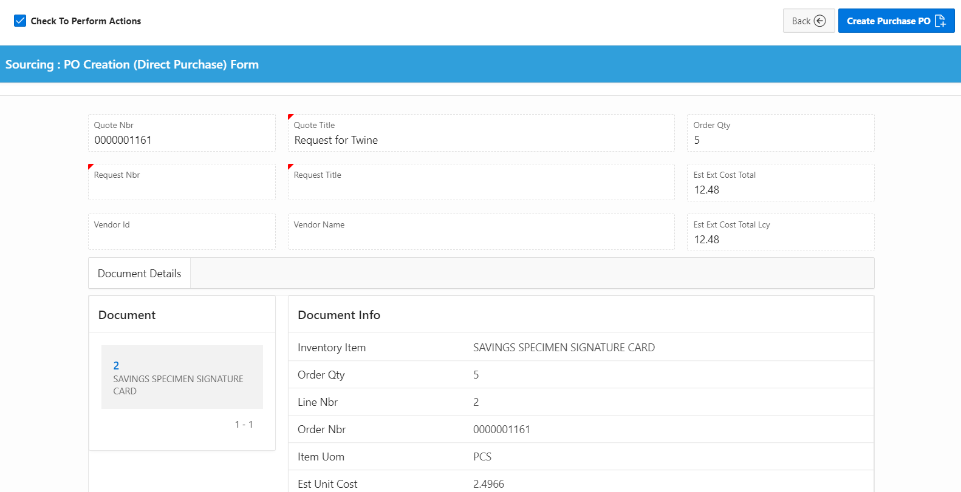
            - This will open the ‘Sourcing: PO Creation (Direct Purchase) Form’ interface.
3.
3.
            - Check in the box beside the ‘Check to perform actions’ to display the ‘Create Purchase PO’ button.

      - Click on the ‘Create Purchase PO’ button.
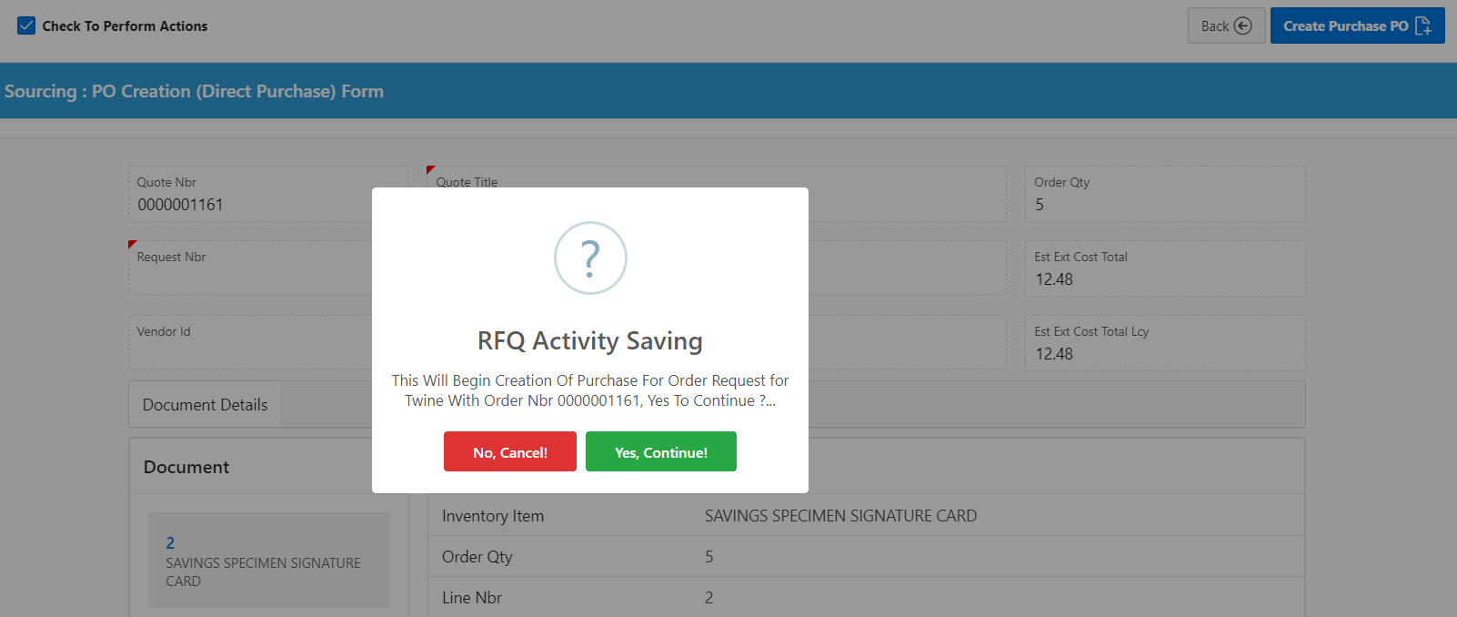
5.
4.

      - Press the ‘Yes, Continue’ button to create the purchase order.
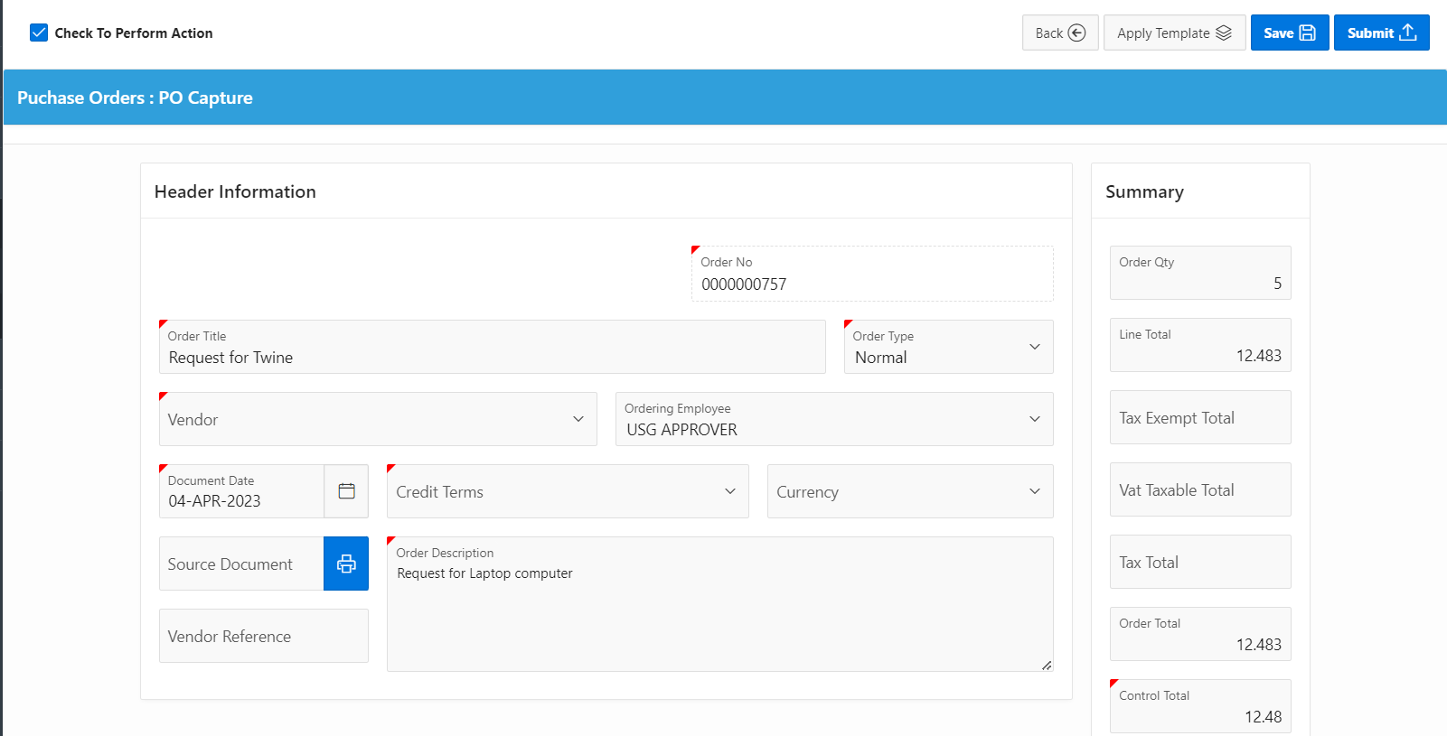
7.
6.

      - Click on the ‘Save’ button to save the purchase order.

      - Click on the ‘Submit’ button.

      - Click on the ‘Yes, Continue’ button to complete the process.
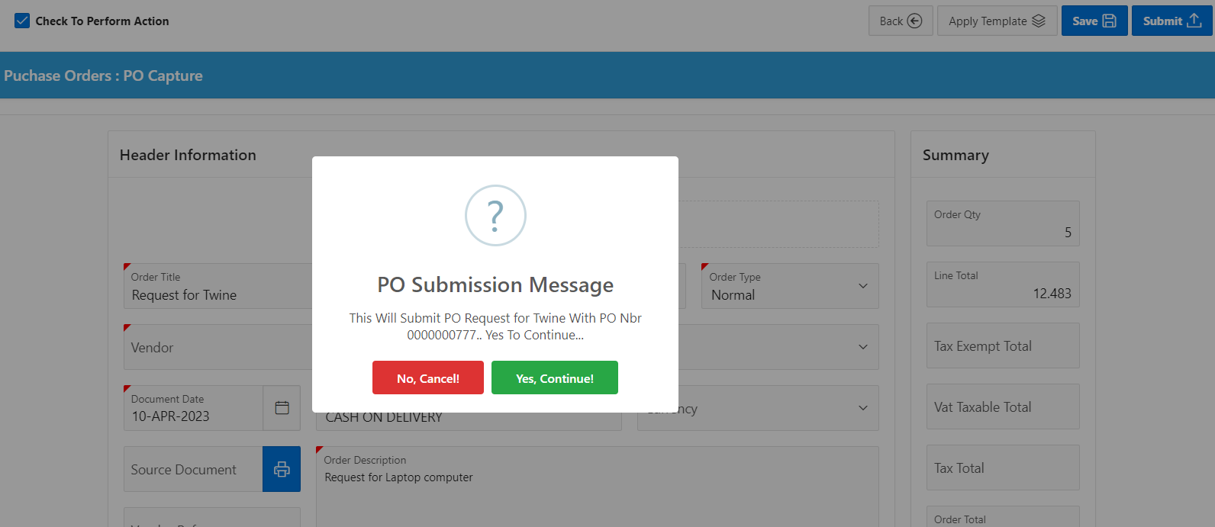
8.

Note: when ‘Send to Procurement’ is selected, the requisition is sent to ‘Requisition Assignment’ for further process.

1.3.3.1.2 Bidding Document Screen

In creating a bidding document, enter the details of the bidding document. There are six tabs on this page. Completed requests can then be sent for approval.

1.3.3.1.3 Bidding Document Approval Screen

Completed bidding documents are shown here to be approved and published.

To access this screen:

            - Click on the ‘Sourcing’ to display it drop down list.

            - Click on the ‘Bidding Document’.

            - This will display the ‘RFX/Bidding’ interface.

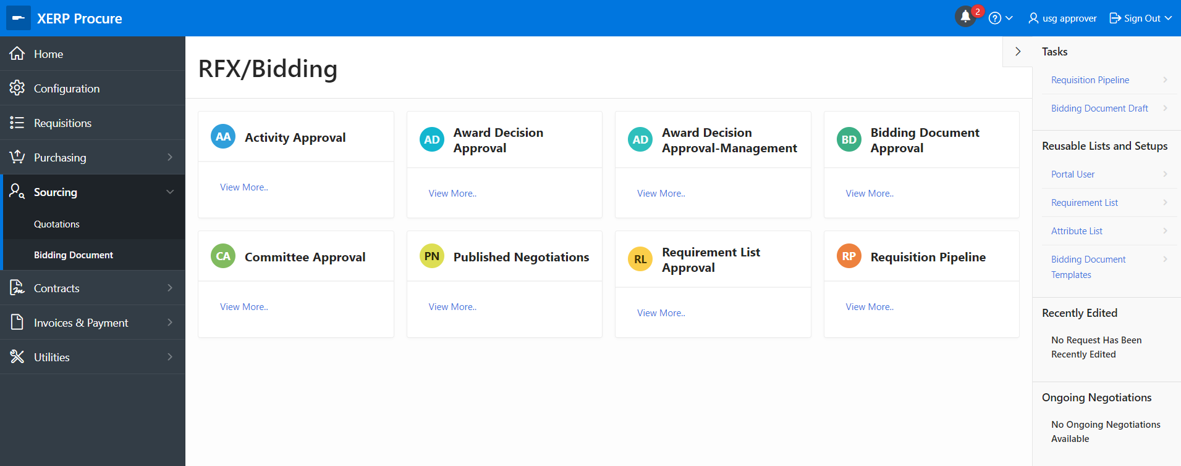
1
2
4

            - Click on the ‘Bidding Document Approval’ button.

            - A screen with all the ‘Unapproved Negotiations’ will be displayed.

            - Click on a request to approve and publish or reject.

1.3.3.1.4 Committee Approval Screen

Requests that have been assigned to Purchasing staff are seen in this section. The user can select and proceed with the bidding document details. Completed bidding documents can then be sent for approval.

            - Click on the ‘View’ icon on the ‘Sourcing: PO Creation (Direct Purchase from Requisition’ interface to select a requisition to create a bidding document.

1


            - This will open the ‘Sourcing: PO Creation (Direct Purchase) Form’ interface.
3.
3.
            - Check in the box beside the ‘Check to perform actions’ to display the ‘Create Purchase PO’ button.

            - Click on the ‘Create Purchase PO’ button.

5.
4.

- Press the ‘Yes, Continue’ button to create the purchase order.

7.
6.

- Click on the ‘Save’ button to save the purchase order.

- Click on the ‘Submit’ button.

- Click on the ‘Yes, Continue’ button to complete the process.

8.

1.3.3.1.5 Award Decision Approval Screen

Requests that have been assigned to Purchasing staff are seen in this section. The user can select and proceed with the bidding document details. Completed bidding documents can then be sent for approval.

            - Click on the ‘View’ icon on the ‘Sourcing: PO Creation (Direct Purchase from Requisition’ interface to select a requisition to create a bidding document.

1


            - This will open the ‘Sourcing: PO Creation (Direct Purchase) Form’ interface.
3.
3.
            - Check in the box beside the ‘Check to perform actions’ to display the ‘Create Purchase PO’ button.

      - Click on the ‘Create Purchase PO’ button.

5.
4.

      - Press the ‘Yes, Continue’ button to create the purchase order.

7.
6.

      - Click on the ‘Save’ button to save the purchase order.

      - Click on the ‘Submit’ button.

      - Click on the ‘Yes, Continue’ button to complete the process.

8.

1.3.3.1.6 Award Decision Approval Management Screen

Requests that have been assigned to Purchasing staff are seen in this section. The user can select and proceed with the bidding document details. Completed bidding documents can then be sent for approval.

            - Click on the ‘View’ icon on the ‘Sourcing: PO Creation (Direct Purchase from Requisition’ interface to select a requisition to create a bidding document.

1


            - This will open the ‘Sourcing: PO Creation (Direct Purchase) Form’ interface.
3.
3.
            - Check in the box beside the ‘Check to perform actions’ to display the ‘Create Purchase PO’ button.

            - Click on the ‘Create Purchase PO’ button.

5.
4.

            - Press the ‘Yes, Continue’ button to create the purchase order.

7.
6.

      - Click on the ‘Save’ button to save the purchase order.

      - Click on the ‘Submit’ button.

      - Click on the ‘Yes, Continue’ button to complete the process.

8.

1.3.3.1.7 Activity Approval Screen

Requests that have been assigned to Purchasing staff are seen in this section. The user can select and proceed with the bidding document details. Completed bidding documents can then be sent for approval.

            - Click on the ‘View’ icon on the ‘Sourcing: PO Creation (Direct Purchase from Requisition’ interface to select a requisition to create a bidding document.

1


            - This will open the ‘Sourcing: PO Creation (Direct Purchase) Form’ interface.
3.
3.
            - Check in the box beside the ‘Check to perform actions’ to display the ‘Create Purchase PO’ button.

            - Click on the ‘Create Purchase PO’ button.

5.
4.

            - Press the ‘Yes, Continue’ button to create the purchase order.

7.
6.

            - Click on the ‘Save’ button to save the purchase order.

            - Click on the ‘Submit’ button.

            - Click on the ‘Yes, Continue’ button to complete the process.

8.

1.3.3.2 Quotation Screen

The Quotations section has activities on internal quotations and quotation approval.

To access this screen, the user must:

      - Click on the ‘Sourcing’ tab to display the drop down list.

      - Click on the he ‘Requisitions’ interface.
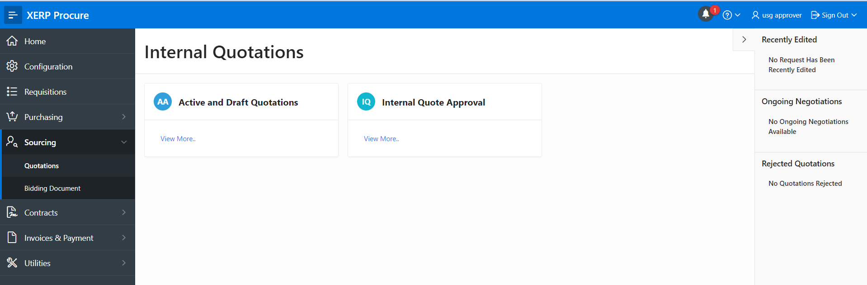
2
1

1.3.3.1 Active & Draft Quotation Screen

Requests that have been assigned to Purchasing staff are seen in this section. The user can select and proceed with the bidding document details. Completed bidding documents can then be sent for approval.

            - Click on the ‘View’ icon on the ‘Sourcing: PO Creation (Direct Purchase from Requisition’ interface to select a requisition to create a bidding document.

1


            - This will open the ‘Sourcing: PO Creation (Direct Purchase) Form’ interface.
3.
3.
            - Check in the box beside the ‘Check to perform actions’ to display the ‘Create Purchase PO’ button.

            - Click on the ‘Create Purchase PO’ button.

5.
4.

            - Press the ‘Yes, Continue’ button to create the purchase order.

7.
6.

            - Click on the ‘Save’ button to save the purchase order.

            - Click on the ‘Submit’ button.

1.3.4 Purchasing

The Requisitions

To access this screen, the user must:

- Click on the ‘Home’ tab on the navigation menu bar.

- Click on the ‘XERP Procure’ button.

1
2

- This will open the ‘Procurement’ interface.


1.3.4.1 Purchase Orders Screen

The Purchase Orders screen has all details on purchase orders.

To access this screen, the user must:

      - Click on the ‘Purchasing’ tab to open the ‘Requisitions’ interface.

      - Click on the ‘Purchase Orders’ button to open the ‘Purchase Orders’ interface.
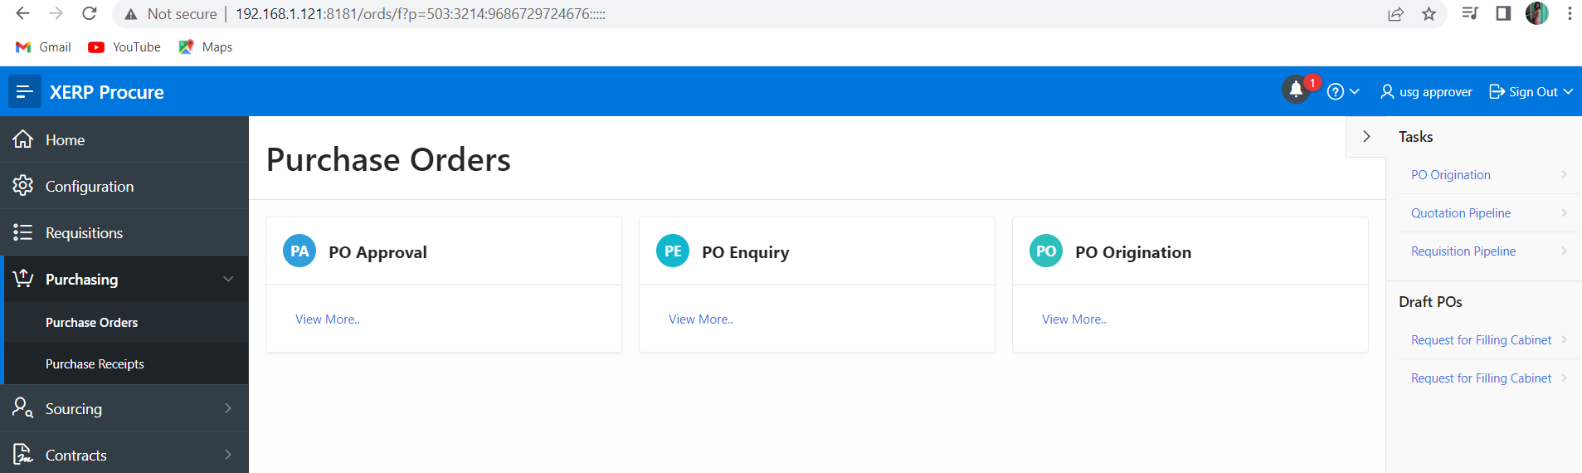
1
2
3

      - Click on the ‘Quotation Pipeline’ in the task panel.

Quotation Pipeline

Bids that have been awarded and approved are seen in this section. Purchase receipts can be created for such purchase orders in this section.

- Select a Request from the Completed and Awarded Quotations to create a Purchase Order



4

- Check in the box beside the ‘Select Fulfillment Process’ to display the ‘Direct Purchase’, ‘Send to Procurement’ and ‘Send to Stores’ buttons and select an action to complete the requisition analysis.

Note: when ‘Send to Procurement’ is selected, the requisition is sent to ‘Requisition Assignment’ for further process.

1.2.4.2 Purchasing Receipt Screen

The Requisition Assignment screen holds all requisitions sent to procurement. These are assigned to a staff who oversees all processes associated to the procuring of that item.

To access this screen, the user must:

      - Click on the ‘Requisitions’ tab to open the ‘Requisitions’ interface.


1
2

      - Click on the ‘Requisition Assignment’ tab to open the ‘Requisition: Purchasing Officer Selection’ interface to view a list of requests.

3

      - Click on the icon below the ‘View’ column to view the details of a request.

4

      - Click on the ‘Exit’ button to return to the previous interface.

      - Check in the box beside the details of the request.

5

      - This will display the details on the ‘Purchase Requisition’ interface.

      - Check in the box beside the ‘Check to perform actions’ field.

      - Click on the ‘Save’ button.

8
7

1.4 XERP Inventory

Inventory refers to all the items, goods, merchandise and materials obtained by a financial institution for their day to day activities.

From the home page,

            - Click on the ‘XERP Inventory’ button.

1

            - This will display the ‘XERP Inventory’ interface.
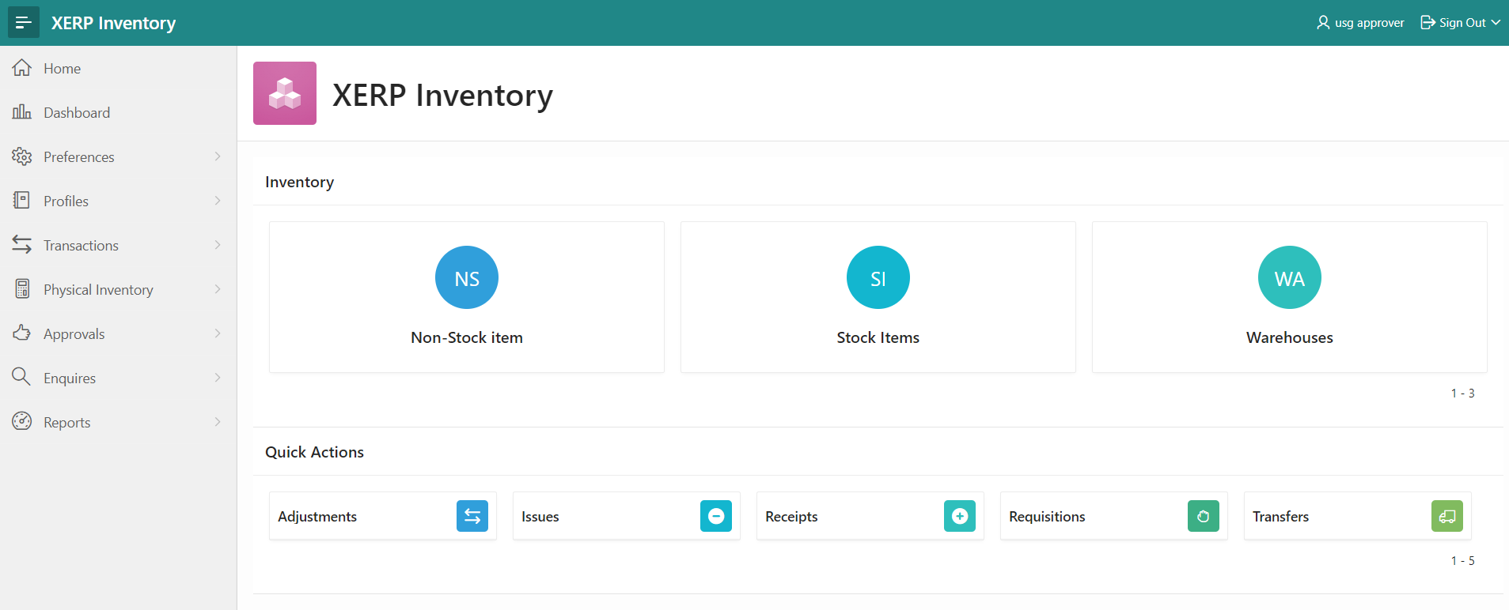
2

The XERP Inventory module is made up of the following:

- Preferences
- Profiles
- Transactions
- Physical Inventory
- Approval
- Enquiry and
- Reports

1.4.1 Preferences

The Preferences section enables the user to setup items such as ABC codes, Boxes, Item Classes, Movement Classes and Posting classes.

To access this screen, the user must:

      - Click on the ‘Preferences’ tab on the navigation menu bar.

      - Click on the ‘Origination Preferences.IVM’ tab to display the main interface.
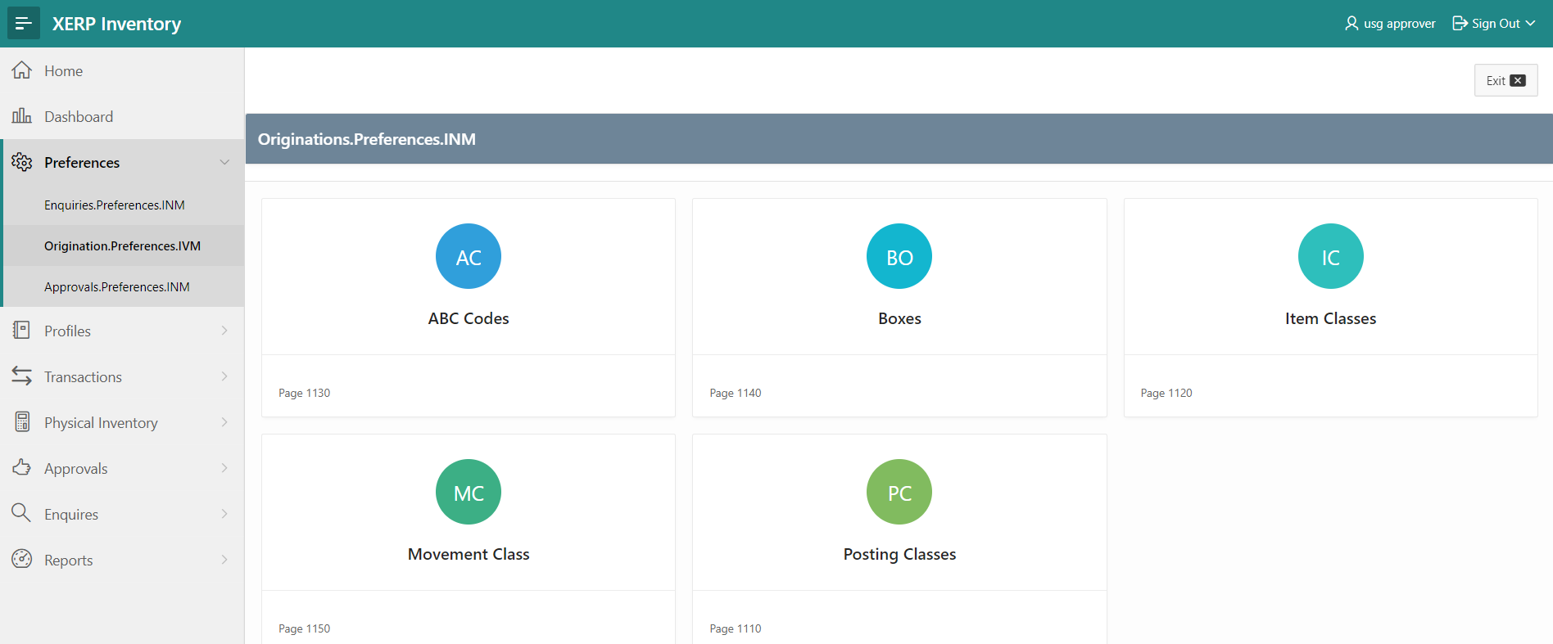
1
2

ABD Codes

This interface allows the user to create branches on the stores and procurement application and also amend the details of an already created branch.

Boxes

This interface allows the user to capture information of the financial institution on the stores and procurement application and also amend already captured details of bank.

Item Classes

This interface allows the user to create the main codes of the various LOV buttons on the stores and procurement application.

Movement Class

This interface allows the user to create the sub codes of the various main codes on the stores and procurement application.

Posting Classes

This interface allows the user to capture all holidays in the year in the stores and procurement application to enable the system recognize those days and act on them as such.

1.4.2 Profiles

In this section, stock items, non-stock items and warehouses are set up. There are originations, enquiries and approval available for stock items, non-stock items and warehouses. To access these screens,

To access this screen, the user must:

      - Click on the ‘Self Service’ tab on the navigation menu bar.

      - Click on the ‘Requisition Management’ and select ‘Requisition’.

2
1
2

      - This will display the ‘Self Service – Purchase Request’ interface.


Screenshot: View of the Self Service – Purchase Request Screen

Note: To create a new request, click on the ‘Purchase Request’ button.

There are five sections on the purchase request screen, namely:
- Request Header,
- Request Summary,
- Document Details,
- Budget Validation and
- Attach Document.

10
9
8
7
6
5
4
Screenshot: View of the Purchase Request Screen

      - Indicate the title of the order at the ‘Order Title’ field’.

      - Click on the LOV button at the ‘Order Priority’ field to indicate how important the purchase is.

      - Click on the LOV button at the ‘Request Type’ field to indicate if the purchase is new or not.

      - Click on the LOV button at the ‘Request Class’ field to indicate if the class of the purchase.

      - Click on the LOV button at the ‘Request Owner’ field to indicate who is requesting for the purchase.

      - Indicate the date of the order at the ‘Order Date’ field.

      - Indicate the period of purchase at the ‘Financial Period’ field.

11
12
13

      - Click on the ‘Add’ button to enable you capture the document details.

      - Capture all the necessary details of the document under the ‘Document Details’ column.

      - Click on the ‘Budget Validation’ tab.

Budget Validation

The Budget Validation and Request Summary sections display summary information and budget information of the purchase respectively.

      - Click on the ‘Attach Documents’ tab.

15
14
      - To attach a document, click on the ‘Attach Document’ button to open the ‘Document Upload’ interface.

22
21
20
19
18
17
16

      - Click on the LOV button at the ‘Doc Title’ field to select the title of the document that is being captured.

      - Indicate if the document is an internal or external document at the ‘Category’ field.

      - Indicate the name of the document at the ‘Document Description’ field.

      - Indicate the type of document at the ‘Document Type’ field.

      - Indicate if the document will be scanned or attached at the ‘Select Option’ field.

      - Click on the button at the ‘Browse for File’ field to either scan or attach an already scanned document.

      - Click on the ‘Save’ button to save the document and bring you back to the previous interface.

      - Check in the box beside the ‘Check to perform actions’ field to enable the ‘Submit’ button.


24
23

      - Click on the ‘Submit’ button to save request and submit it for approval.

1.4.3 Transactions

The Requisitions

To access this screen, the user must:

            - Click on the ‘Home’ tab on the navigation menu bar.

            - Click on the ‘XERP Procure’ button.

1
2

            - This will open the ‘Procurement’ interface.


1.4.3.1 Receipts Screen

The Requisition Analysis screen is.

To access this screen, the user must:

            - Click on the ‘Requisitions’ tab to open the ‘Requisitions’ interface.

2
1


2. Click on the ‘Requisition Analysis’ button to open the ‘Requisition Analysis’ interface to view a list of requests.
3

      - Click on the icon below the ‘View’ column to view the details of a request.


4

            - Check in the box beside the ‘Select Fulfillment Process’ to display the ‘Direct Purchase’, ‘Send to Procurement’ and ‘Send to Stores’ buttons and select an action to complete the requisition analysis.

Note: when ‘Send to Procurement’ is selected, the requisition is sent to ‘Requisition Assignment’ for further process.

1.4.3.2 Requisition Screen

The Requisition Assignment screen holds all requisitions sent to procurement. These are assigned to a staff who oversees all processes associated to the procuring of that item.

To access this screen, the user must:

            - Click on the ‘Requisitions’ tab to open the ‘Requisitions’ interface.


1
2

            - Click on the ‘Requisition Assignment’ tab to open the ‘Requisition: Purchasing Officer Selection’ interface to view a list of requests.

3

            - Click on the icon below the ‘View’ column to view the details of a request.

4

      - Click on the ‘Exit’ button to return to the previous interface.

      - Check in the box beside the details of the request.

5

      - This will display the details on the ‘Purchase Requisition’ interface.

      - Check in the box beside the ‘Check to perform actions’ field.

      - Click on the ‘Save’ button.

8
7

1.4.3.3 Issues Screen

The Requisition Analysis screen is.

To access this screen, the user must:

      - Click on the ‘Requisitions’ tab to open the ‘Requisitions’ interface.

2
1


      - Click on the ‘Requisition Analysis’ button to open the ‘Requisition Analysis’ interface to view a list of requests.
3

      - Click on the icon below the ‘View’ column to view the details of a request.


4

      - Check in the box beside the ‘Select Fulfillment Process’ to display the ‘Direct Purchase’, ‘Send to Procurement’ and ‘Send to Stores’ buttons and select an action to complete the requisition analysis.

Note: when ‘Send to Procurement’ is selected, the requisition is sent to ‘Requisition Assignment’ for further process.

1.4.3.4 Adjustment Screen

The Requisition Assignment screen holds all requisitions sent to procurement. These are assigned to a staff who oversees all processes associated to the procuring of that item.

To access this screen, the user must:

            - Click on the ‘Requisitions’ tab to open the ‘Requisitions’ interface.


1
2

- Click on the ‘Requisition Assignment’ tab to open the ‘Requisition: Purchasing Officer Selection’ interface to view a list of requests.

3

- Click on the icon below the ‘View’ column to view the details of a request.

4

- Click on the ‘Exit’ button to return to the previous interface.

- Check in the box beside the details of the request.

5

- This will display the details on the ‘Purchase Requisition’ interface.

- Check in the box beside the ‘Check to perform actions’ field.

- Click on the ‘Save’ button.

8
7

1.4.4 Physical Inventory

The Requisitions

To access this screen, the user must:

- Click on the ‘Home’ tab on the navigation menu bar.

- Click on the ‘XERP Procure’ button.

1
2

- This will open the ‘Procurement’ interface.


1.4.4.1 Physical Inventory Cycle Screen

The Requisition Analysis screen is.

To access this screen, the user must:

      - Click on the ‘Requisitions’ tab to open the ‘Requisitions’ interface.

2
1


      - Click on the ‘Requisition Analysis’ button to open the ‘Requisition Analysis’ interface to view a list of requests.
3

      - Click on the icon below the ‘View’ column to view the details of a request.


4

      - Check in the box beside the ‘Select Fulfillment Process’ to display the ‘Direct Purchase’, ‘Send to Procurement’ and ‘Send to Stores’ buttons and select an action to complete the requisition analysis.

Note: when ‘Send to Procurement’ is selected, the requisition is sent to ‘Requisition Assignment’ for further process.

1.3.4.2 Physical Inventory Types Screen

The Requisition Assignment screen holds all requisitions sent to procurement. These are assigned to a staff who oversees all processes associated to the procuring of that item.

To access this screen, the user must:

            - Click on the ‘Requisitions’ tab to open the ‘Requisitions’ interface.


1
2

            - Click on the ‘Requisition Assignment’ tab to open the ‘Requisition: Purchasing Officer Selection’ interface to view a list of requests.

3

            - Click on the icon below the ‘View’ column to view the details of a request.

4

      - Click on the ‘Exit’ button to return to the previous interface.

      - Check in the box beside the details of the request.

5

      - This will display the details on the ‘Purchase Requisition’ interface.

      - Check in the box beside the ‘Check to perform actions’ field.

      - Click on the ‘Save’ button.

8
7

1.4.4.3 Physical Inventory Count Screen

The Requisition Analysis screen is.

To access this screen, the user must:

      - Click on the ‘Requisitions’ tab to open the ‘Requisitions’ interface.

2
1


      - Click on the ‘Requisition Analysis’ button to open the ‘Requisition Analysis’ interface to view a list of requests.
3

      - Click on the icon below the ‘View’ column to view the details of a request.


4

      - Check in the box beside the ‘Select Fulfillment Process’ to display the ‘Direct Purchase’, ‘Send to Procurement’ and ‘Send to Stores’ buttons and select an action to complete the requisition analysis.

Note: when ‘Send to Procurement’ is selected, the requisition is sent to ‘Requisition Assignment’ for further process.

1.4.4.4 Physical Count Sheets Screen

The Requisition Assignment screen holds all requisitions sent to procurement. These are assigned to a staff who oversees all processes associated to the procuring of that item.

To access this screen, the user must:

            - Click on the ‘Requisitions’ tab to open the ‘Requisitions’ interface.


1
2

- Click on the ‘Requisition Assignment’ tab to open the ‘Requisition: Purchasing Officer Selection’ interface to view a list of requests.

3

- Click on the icon below the ‘View’ column to view the details of a request.

4

- Click on the ‘Exit’ button to return to the previous interface.

- Check in the box beside the details of the request.

5

- This will display the details on the ‘Purchase Requisition’ interface.

- Check in the box beside the ‘Check to perform actions’ field.

- Click on the ‘Save’ button.

8
7

1.3.4.5 Physical Count Tags Screen

The Requisition Analysis screen is.

To access this screen, the user must:

      - Click on the ‘Requisitions’ tab to open the ‘Requisitions’ interface.

2
1


      - Click on the ‘Requisition Analysis’ button to open the ‘Requisition Analysis’ interface to view a list of requests.
3

      - Click on the icon below the ‘View’ column to view the details of a request.


4

      - Check in the box beside the ‘Select Fulfillment Process’ to display the ‘Direct Purchase’, ‘Send to Procurement’ and ‘Send to Stores’ buttons and select an action to complete the requisition analysis.

Note: when ‘Send to Procurement’ is selected, the requisition is sent to ‘Requisition Assignment’ for further process.

1.4.4.6 Physical Inventory Review Screen

The Requisition Assignment screen holds all requisitions sent to procurement. These are assigned to a staff who oversees all processes associated to the procuring of that item.

To access this screen, the user must:

            - Click on the ‘Requisitions’ tab to open the ‘Requisitions’ interface.


1
2

- Click on the ‘Requisition Assignment’ tab to open the ‘Requisition: Purchasing Officer Selection’ interface to view a list of requests.

3

- Click on the icon below the ‘View’ column to view the details of a request.

4

- Click on the ‘Exit’ button to return to the previous interface.

- Check in the box beside the details of the request.

5

- This will display the details on the ‘Purchase Requisition’ interface.

- Check in the box beside the ‘Check to perform actions’ field.

- Click on the ‘Save’ button.

8
7

1.4.5 Approvals

The Requisitions

To access this screen, the user must:

- Click on the ‘Home’ tab on the navigation menu bar.

- Click on the ‘XERP Procure’ button.

1
2

- This will open the ‘Procurement’ interface.


To access this screen, the user must:

      - Click on the ‘Requisitions’ tab to open the ‘Requisitions’ interface.

2
1


      - Click on the ‘Requisition Analysis’ button to open the ‘Requisition Analysis’ interface to view a list of requests.
3

      - Click on the icon below the ‘View’ column to view the details of a request.


4

- Check in the box beside the ‘Select Fulfillment Process’ to display the ‘Direct Purchase’, ‘Send to Procurement’ and ‘Send to Stores’ buttons and select an action to complete the requisition analysis.

Note: when ‘Send to Procurement’ is selected, the requisition is sent to ‘Requisition Assignment’ for further process.

1.4.6 Enquiry

The Requisitions

To access this screen, the user must:

- Click on the ‘Home’ tab on the navigation menu bar.

- Click on the ‘XERP Procure’ button.

1
2

- This will open the ‘Procurement’ interface.


To access this screen, the user must:

      - Click on the ‘Requisitions’ tab to open the ‘Requisitions’ interface.

2
1


      - Click on the ‘Requisition Analysis’ button to open the ‘Requisition Analysis’ interface to view a list of requests.
3

      - Click on the icon below the ‘View’ column to view the details of a request.


4

- Check in the box beside the ‘Select Fulfillment Process’ to display the ‘Direct Purchase’, ‘Send to Procurement’ and ‘Send to Stores’ buttons and select an action to complete the requisition analysis.

Note: when ‘Send to Procurement’ is selected, the requisition is sent to ‘Requisition Assignment’ for further process.

1.4.7 Reports

The Requisitions

To access this screen, the user must:

- Click on the ‘Home’ tab on the navigation menu bar.

- Click on the ‘XERP Procure’ button.

1
2

- This will open the ‘Procurement’ interface.


To access this screen, the user must:

      - Click on the ‘Requisitions’ tab to open the ‘Requisitions’ interface.

2
1


      - Click on the ‘Requisition Analysis’ button to open the ‘Requisition Analysis’ interface to view a list of requests.
3

      - Click on the icon below the ‘View’ column to view the details of a request.


4

- Check in the box beside the ‘Select Fulfillment Process’ to display the ‘Direct Purchase’, ‘Send to Procurement’ and ‘Send to Stores’ buttons and select an action to complete the requisition analysis.

Note: when ‘Send to Procurement’ is selected, the requisition is sent to ‘Requisition Assignment’ for further process.

1.5 XERP Parameters

XERP Parameters holds all the configuration and setup interfaces for the Procurement and Inventory applications.

From the home page:

      - Click on the ‘XERP Parameters’ button.


1

The XERP Parameters module is made up of the following:

- System Setup and
- Application Configuration

1.5.1 System Setups

The System Setups section enables the user to perform system setups such as menu access management.

To access this screen, the user must:

            - Click on the ‘System Setup’ button on the XERP Parameters interface.

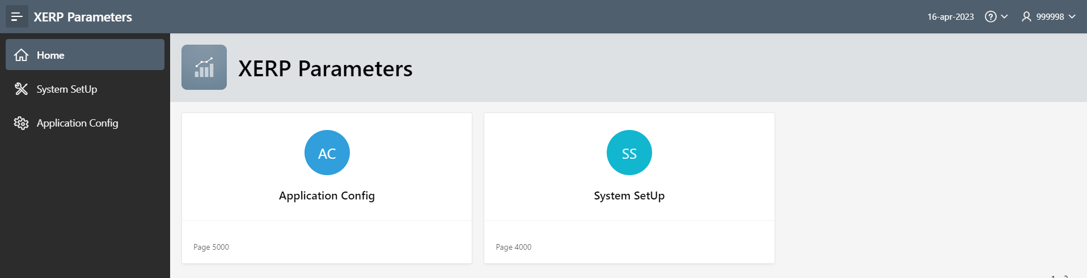
1

      - This will display the ‘System Setup’ interface.
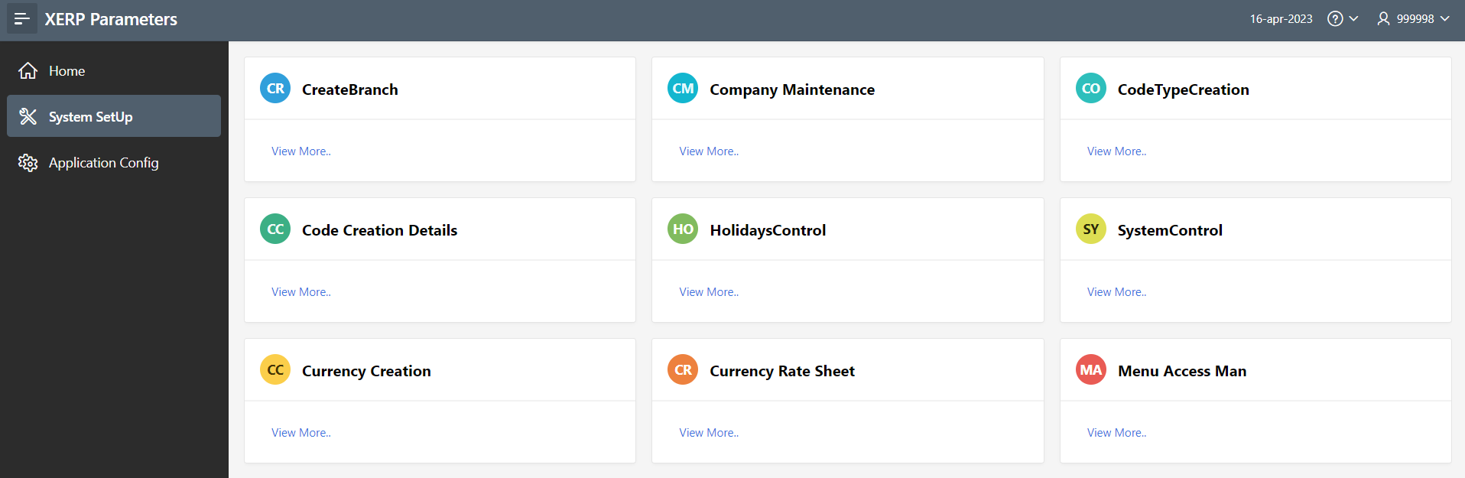
2
Screenshot: View of the System Setup Screen

The System Setups has various setup interfaces such as:

- Create Branch
- Company Maintenance
- Code Type Creation
- Code Creation Details
- Holidays Control
- System Control
- Currency Creation
- Currency Rate Sheet

Create Branch

This interface allows the user to create branches on the stores and procurement application and also amend the details of an already created branch.

Company Maintenance

This interface allows the user to capture information of the financial institution on the stores and procurement application and also amend already captured details of bank.

Code Type Creation

This interface allows the user to create the main codes of the various LOV buttons on the stores and procurement application.

Code Creation Details

This interface allows the user to create the sub codes of the various main codes on the stores and procurement application.

Holidays Control

This interface allows the user to capture all holidays in the year in the stores and procurement application to enable the system recognize those days and act on them as such.

System Control

This interface allows the user to capture information of the financial institution on the stores and procurement application and also amend already captured details of bank.

Currency Creation

This interface allows the user to create the various currencies to be used by the financial institution on the stores and procurement application and also amend already created currency details.

Currency Rate Sheet

This interface allows the user to capture the financial institution’s rates on the stores and procurement application and also amend already captured rates.

To setup menus and assign user groups to them, the user must:
            - Click on the ‘Menu Access Management’ button on the ‘System Setup’ interface.

1

            - This will display the ‘Menu Maintenance’ interface.

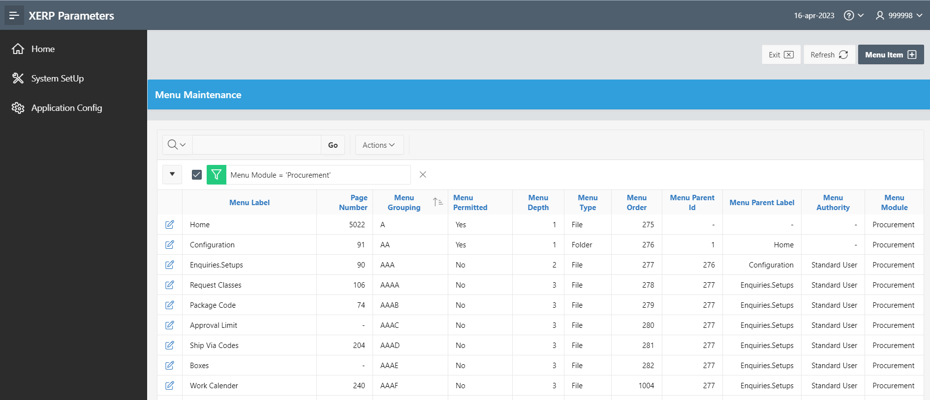
3
2

To create a new menu item, the user must:

      - Click on the ‘Menu Item’ button to display the ‘Menu Settings’ interface.
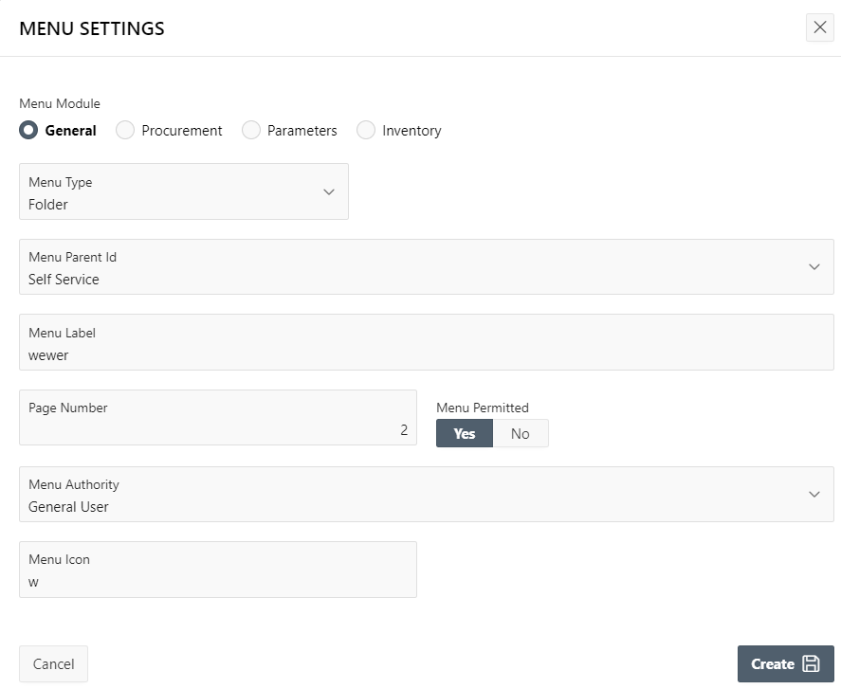
5
4

      - Capture all the necessary details on this interface.

      - Click on the ‘Create’ button to create the menu.

To edit an existing menu item, the user must:

      - Locate the menu item to be amended under the ‘Menu Label’ column.

      - Click on the edit button beside the menu label to be edited.

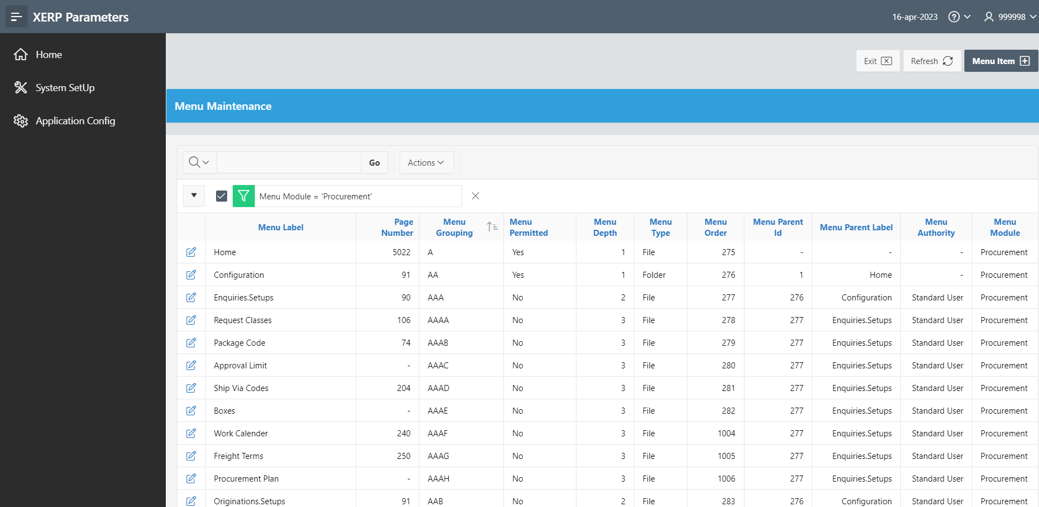
1
2

      - This will display the ‘Menu Settings’ interface.

      - Make all the necessary amendments where necessary.

      - Click on the ‘Save’ button to save the records

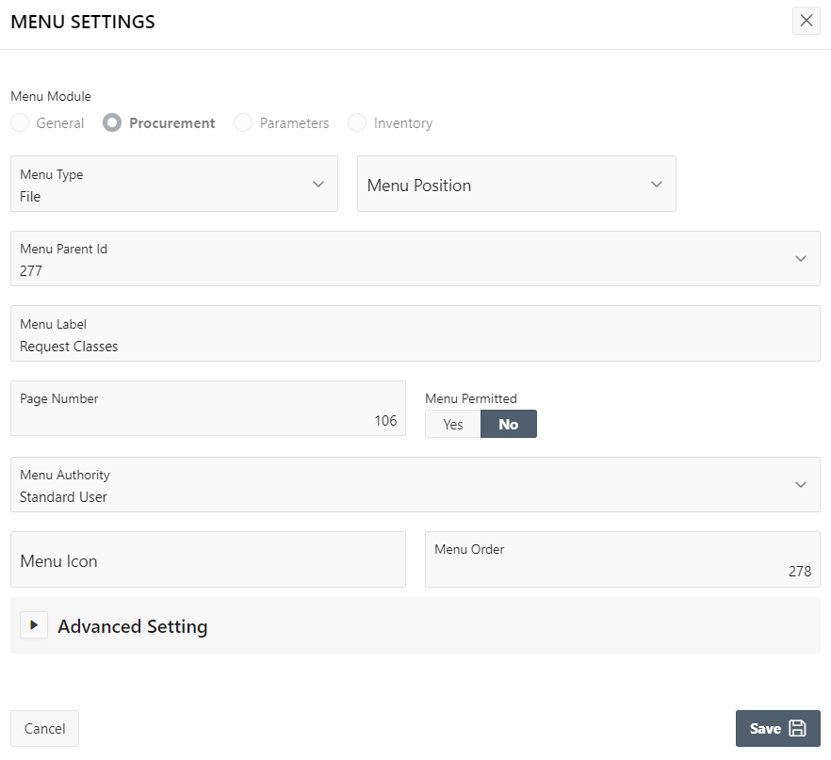
5

1.5.2 Application Configuration

The Application Configuration section enables the user to perform setups for the entire application.

To access this screen, the user must:

            - Click on the ‘Application Configuration’ button on the XERP Parameters interface.


1

- This will display the ‘Application Configuration’ interface.
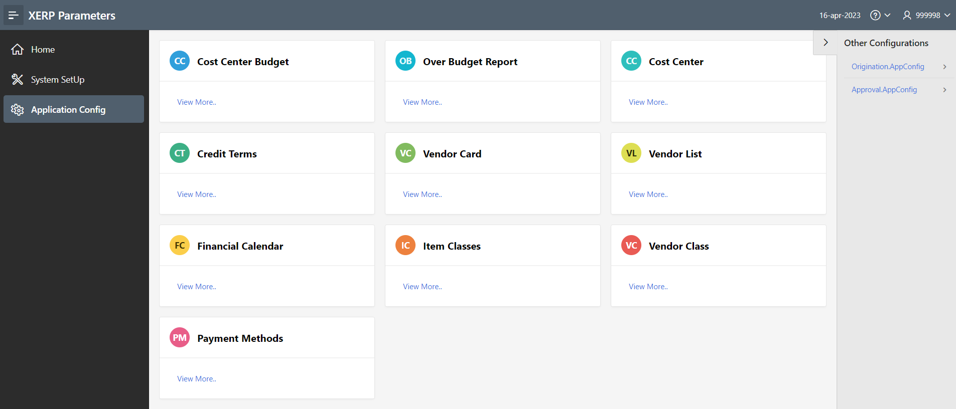
2
Screenshot: View of the Application Configuration Screen

The Application Configuration has various setup interfaces such as:

- Cost Center Budget
- Over Budget Report
- Cost Center
- Credit Terms
- Vendor Card
- Vendor List
- Financial Calendar
- Item Classes
- Vendor Class
- Payment Methods

Cost Center Budget

This interface allows the user to setup budgets for the cost center and also view cost center budgets that have already been set.

Over Budget Report

This interface provides the user with an over budget report for all cost centers in the stores and procurement application.

Cost Center

This interface allows the user to view a list of all the cost centers in the stores and procurement application.

Credit Terms

This interface allows the user to create all the credit terms in the stores and procurement application.

Vendor Card

This interface allows the user to create all the vendor details in the stores and procurement application.

Vendor List

This interface allows the user to setup vendor lists or vendor groups for easy access in the stores and procurement application.

Financial Calendar

This interface allows the user to setup a financial calendar in the stores and procurement application.

Item Classes

This interface allows the user to setup item classification in the stores and procurement application.

Vendor Class

This interface allows the user to setup vendor classification in the stores and procurement application.

Payment Methods

This interface allows the user to setup payment methods in the stores and procurement application.

