# **Lab 4: Working with Cronjob**

## **Installing metrics-server in the kubernetes cluster to aggregate resource usage data in our cluster**

1. Create a yaml called cron.yaml

Use the content given below to fill the file

$ vi cron.yaml



apiVersion: batch/v1beta1 kind: CronJob

metadata: name: hello

spec:

schedule: "*/1 * * * *" jobTemplate:

spec:

template: spec:

containers:

* name: hw image: busybox args:
  + /bin/sh
  + -c
  + echo Hello World! restartPolicy: OnFailure

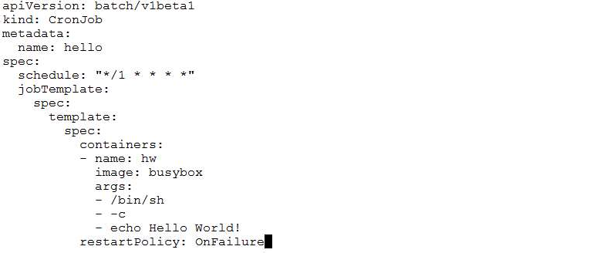

1. Create the cronjob using the yaml from previous step

$ kubectl create -f cron.yaml



1. View the status of the cronjob

$ kubectl get cronjobs

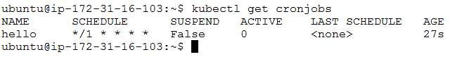

Wait for about a minute and run the same command again and notice that the **LAST SCHEDULE** field is now populated.

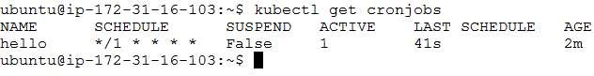

1. View the pods created by the job. Use the pod name to view its logs and verify that the jobs has run successfully

$ kubectl get pods

$ kubectl logs <pod_name>

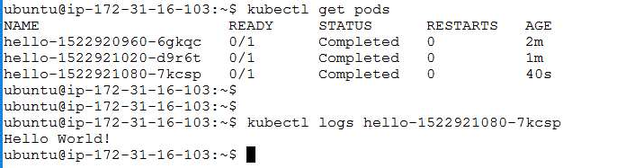

1. Delete the job created in this lab

$ kubectl delete -f cron.yaml

