Request Tracking Program

Created with Java Programing by Amariliz Gonzalez Pineiro

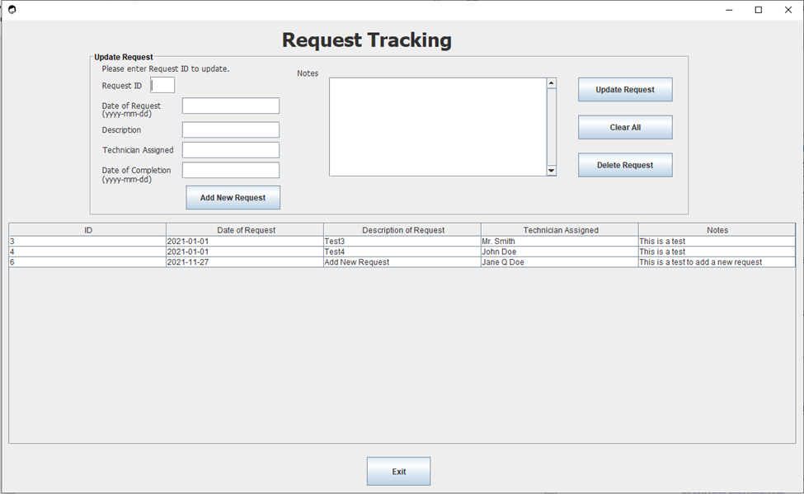

I. Overview 3

II. Request ID 3

III. Date of Request 3

IV. Description 3

V. Technician Assigned 3

VI. Date of Completion 3

VII. Notes 3

VIII. Buttons 4

IX. Report Table 4

X. Getting Started 5

XI. Report Structure 6

# Overview

## This document will be able to explain in full detail how to use Request Tracking Program works. Request Tracking Program connects to MySQL Database in which contains a view ‘open_request_view’ which tracks open requests items. You will be able to add a new request, select the request, update request, clear all items, delete request and exit the program.

# Request ID

## At the textbox of the Request ID you may enter the ID of your request to select the request you would like to update.

### Once you have selected the request, you will then be able to view all the information from the request inside the Update Request Panel. That includes, Date of Request, Description, Technician Assigned, Notes and Date of Completion. The Date of Completion will always be empty because the request has not yet been completed.

# Date of Request

## The date in which the request was placed. You will not be able to update this date.

# Description

## The description of the request.

# Technician Assigned

## The name of the technician the request has been assigned to.

# Date of Completion

## When the request has been complete you may add the date in the format ‘yyyy-mm-dd’ and click on the button ‘Update the Request’ to update. Once you updated the date of completion, you will not see it on your open request report any longer.

# Notes

## The notes contain information about the request, what is needed and any additional information.

# Buttons

## Add New Request

### Add new request button will allow you to add a new request. However, because the Request ID is incremented automatically you cannot add a request ID. Also, you cannot add a completion date. You may add a completion date after the request has been added.

### When you add a new request, it will add it in the requests table.

## Update Request

### This button will update the request. When the request has been completed, you may add date under Date of Completion in the format ‘yyyy-mm-dd’. Also, you may add any extra notes about the request and then click on ‘Update Request’ to update the request. This will set the request status to ‘CLOSE’ and you will no longer see the request on the report.

### You may not edit any other items. Only Date of Completion and Notes can me edited.

### When you update the request, it will update it in the requests table.

## Clear All

### Clears all items selected on the Update Request box.

## Delete Request

### Deletes the request selected on the Update Request box.

### When you delete the request, it will delete it from the requests table.

## Exit

### Exits the program.

# Report Table

## The report contains a view of open requests. The view comes from a view called ‘open_request_view’ in MySQL database in which the view comes from a table called ‘request_status’. The ‘request_status’ table comes from a table called ‘request’ in which contains all the request. The open_request_view is set up to only view the request that are open and not completed.

## The following are the columns are viewed:

### ID = This is the primary key

### Date of Request = The date the request was made.

### Description of the Request = This describes the request.

### Technician Assigned = This is the name of the assigned technician.

### Notes = This is where the requesters and the Technicians add notes.

# Getting Started

## To Update Request

### To select the request, click on the Request ID textbox and type the ID # of the request you would like to select and click on Update Request.

## To Add a request

### Clear All Items. Enter the Date of Request, Description, Technician Assigned and add to notes. Click on Add New Request.

## To Delete Request

### To select the request, click on the Request ID textbox and type the ID # of the request you would like to delete. Click on Delete Request.

# Report Structure

|  |
| --- |
| **MySQL Database** |
| request_tracking |

|  |
| --- |
| **Table:** requests |
| **Columns:**  ID int AI PK  Date_of_Req date  Desc_of_Req varchar(50)  Name_of_Tech varchar(50)  Comp_Date date  Notes varchar(500) |

|  |
| --- |
| **View:** open_request_view |
| **Columns:**  ID int  Date of Request date  Description of Request varchar(50)  Technician Assigned varchar(50)  Notes varchar(500)  WHERE  (`request_tracking`.`open_requests`.`Req_Status` = 'OPEN')  ORDER BY `request_tracking`.`open_requests`.`Date_of_Req` |

|  |
| --- |
| **Stored Procedure:** open_request_update |
| CREATE DEFINER=`root`@`localhost` PROCEDURE `open_request_update`()  BEGIN  TRUNCATE TABLE request_status;  INSERT INTO request_status (ID, Date_of_Req, Desc_of_Req, Name_of_Tech, Comp_Date, Notes)  SELECT  requests.ID,  requests.Date_of_Req,  requests.Desc_of_Req,  requests.Name_of_Tech,  requests.Comp_Date,  requests.Notes  FROM requests;  SELECT * FROM request_tracking.request_status;  Update request_status set Req_Status = 'OPEN' Where Comp_Date IS NULL;  Update request_status set Req_Status = 'CLOSE' Where Comp_Date IS NOT NULL;  END |

|  |
| --- |
| **Table:**  request_status |
| **Columns:**  ID int AI PK  Date_of_Req date  Desc_of_Req varchar(50)  Name_of_Tech varchar(50)  Comp_Date date  Notes varchar(500)  Req_Status varchar(6) |