Amaris Gray
Professor Eppenger
Software Development lifecycle
April 16, 2023, 2023
Scrum-Agile Retrospective
Over the better part of two months my team and I have been working on the SNHU Travel website project using an agile approach versus our usual waterfall approach. Using this approach, we were able to create a website that met all of our clients’ requirements. We created a website that was both beautiful and easy to use for our client’s user base. During our time using an agile approach I found myself thinking of how using this method could greatly help us in the future. In this sprint review and retrospective, I will be discussing how we can move forward with agile methodology for future projects.
When using the agile method, they are four major roles to consider the scrum master, the product owner, one or multiple testers and one or multiple developers. Each role plays a specific part in completing each project. The product owner was our main communication between us and the client. They communicated to us what was needed through user stories that provided us with priority needs vs normal needs. This helped put our work into perspective, especially how we should tackle each sprint. As the scrum master I needed to create a collaborative environment and ensured that communication is happening between everyone. Our daily 15 min start up meeting helped everyone see where each was at. Whether a sprint was done or whether a set of code needed peer-programming. If there were needs from the team or concerns, they would bring them to me and from there I work on fixing their issues or clarifying concerns as soon as possible.
As a tester I was able to test code and give feedback on how we could improve it or how it doesn’t meet the clients’ criteria. I had to email the product owner on multiple occasions to figure out if the product was up to the client’s standards. As a developer creating the right code during each sprint is very important. I had to be flexible with my programming because the client could easily add or remove attributes that they didn’t like with the final product. Midway through I did have to change from a list to a slideshow and I had to make sure that the deals and prices etc. still matched what the client was looking for. I needed some clarification which I got when I emailed asking specific things that I wasn’t sure about. If I still needed clarification afterwards, I would just send a follow up email.
My time on the scrum-agile team has shown me that the scrum-agile approach helps tremendously with the software development lifecycle. It makes larger more complex projects easier to manage and complete. The project is easier when split into sprints as well, once sprints are completed the client can see the progress being made and see the program without having to wait so long to make changes. For instance, if the client wasn’t able to see the project as it progressed and had to wait until the end, we would have to rework the entire program from start to finish instead of being able to tweak it as we go, saving us valuable time. While we were working to complete the SNHU Travel website the client decided that instead of a listing they would prefer a slideshow for their top destinations for you. We were already halfway through finishing the project, so it was slightly stressful to change it. However, because we were working under a scrum-agile approach it was relatively easy to go back through the code and reprogram it to the slideshow version that they wanted. If we were under a waterfall approach, we would have had to start from the beginning simply because we would be working in a non-flexible way. This would intern set us back a few days or weeks due to us having to restart, but with the agile approach we were able to finish everything in the same time frame.
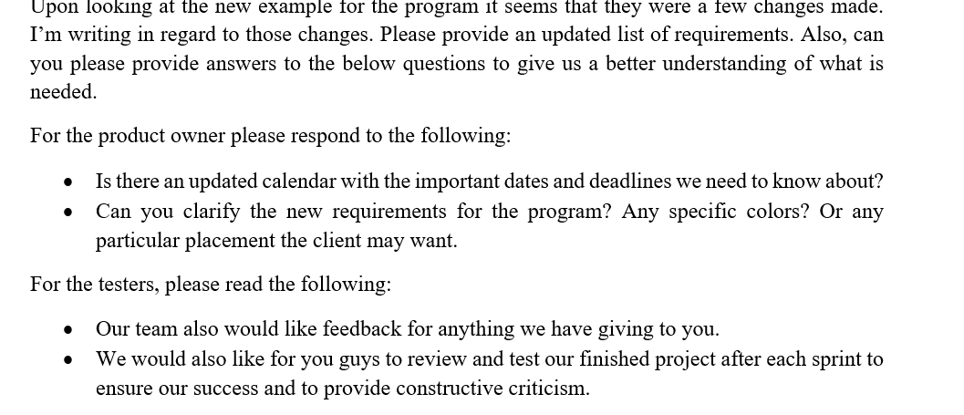
When we had the change in the direction of the project and needed more instruction on how we should be tackling everything, I communicated my needs as a developer to the product owner using an email detailing what I needed to know in order to finish my part of the programming. Below is a sample:
As the sample shows I asked for the new requirements needed to complete the project. I also made sure to request an updated calendar with dates for completion and any other important dates that may have changed or been added. Making sure that the clients other requests were met. Next, I made sure to ask the testers for their findings in our programming, requesting that they send us any feedback they may have. Finally, I requested that any other finished projects be tested and provide constructive criticism and feedback to help improve code.
The scrum-agile principles we used to help the team be successful were “Principle 2: Welcome changing requirements, even late in development. Agile processes harness change for the customer’s competitive advantage.” Keeping this in mind we were able to change direction when needed and still keep the same pace without having to start over from scratch, setting us back days in finishing the project. It also helped us to be stress free and navigate better. We also used “Principle 1: Our highest priority is to satisfy the customer through early and continuous delivery of valuable software.” and “Principle 5: Build projects around motivated individuals. Give them the environment and support they need and trust them to get the job done.” Because we were using an agile approach getting the finished product to the customer was far easier than expected and they were able to give us instant feedback on whether to move forward in our current direction or begin in a new direction. As the scrum master I made sure to keep everyone on the team motivated and made sure to address anything that was a concern for them. When they needed new blinds to cut down on the glare to the computer screens, I was able to get them in a timely manner. I was also able to advocate for time to finish add-ons that the client may have wanted. Showing where they were located on our to do list. By keeping these principles in mind our team was able to fully utilize what it means to work with an agile approach.
Working on the SNHU Travel project with a scrum agile approach allowed me to see the benefits that the approach brings to a company like ours. For one, we are able to complete projects faster and keep on schedule because there is no hard deadline for it. Should the client decide they don’t like the direction we are taking the project we can change without losing valuable time and resources. This is because Scrum-agile works in sprints and after each sprint is finished the client can take a look at it as it progresses, versus if we give them a final project and they decide that they don’t like it and we have to start from scratch. The disadvantage of using a scrum-agile approach is that it would take time to get everyone trained with the necessary skills to switch over completely to an agile approach. On an organizational level it is necessary that we do a full transformation to make sure it works successfully. Not only that, but we would also need to come up with a way to integrate it with our current project management team to ensure that everyone is on board with making the switch.
For this project the scrum agile approach was the best way to go in terms of having the best outcome and the best quality of work in a reasonable amount of time. Mid way through the project the client decided they didn’t like the direction the team was going in and changed it, if we were still using a waterfall method, we would’ve ended up having to start over four weeks in, versus just being able to recode a singular part of the project. That’s thanks to us using sprints and having a flexible approach to how we program the project. For a project like this you want to be able to be that flexible as this application has to be able to bring in the necessary people the company is looking for and you don’t want to produce something that looks and works just like other travel websites. You want to be able to stand out and using an agile approach allowed us to deliver a product that did exactly that.

